General Chromatographic Concepts

- Consider a plot that has the concentration of analyte in the stationary phase on the Y-axis and the concentration of analyte in the mobile phase on the X-axis.
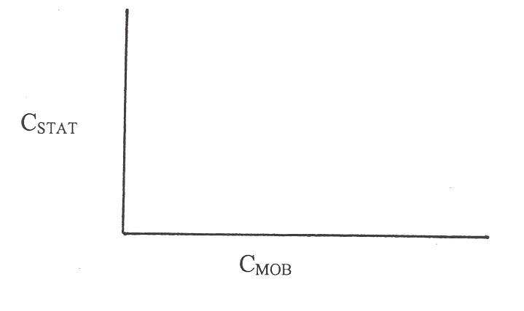
- Draw an idealized plot as greater concentrations of analyte are injected into the
chromatographic column.

- Draw what you suspect would really happen.

c) What might the peaks look like in the real versus ideal situations?

- What term would we use to describe the movement of a molecule in a liquid stationary phase?

- What processes would account for the movement of a molecule through a region of interstitial volume in a mobile phase?

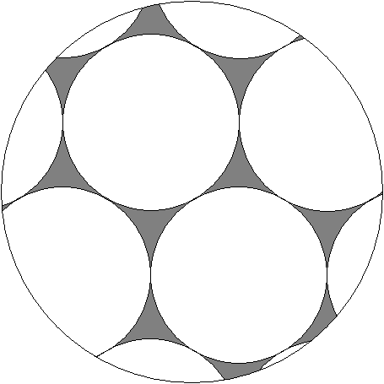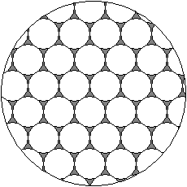
Interstitial
Volume

- Tswett used starch as his stationary phase.

- What is the dominant surface functionality of starch?

- The two other common solid stationary phases are silica gel (SiO₂) and alumina (Al₂O₃). What do you think are the surface functionalities of these materials?

- Draw a plot of the distribution of enthalpies of adsorption for a molecule on the surface of starch, silica gel, or alumina.
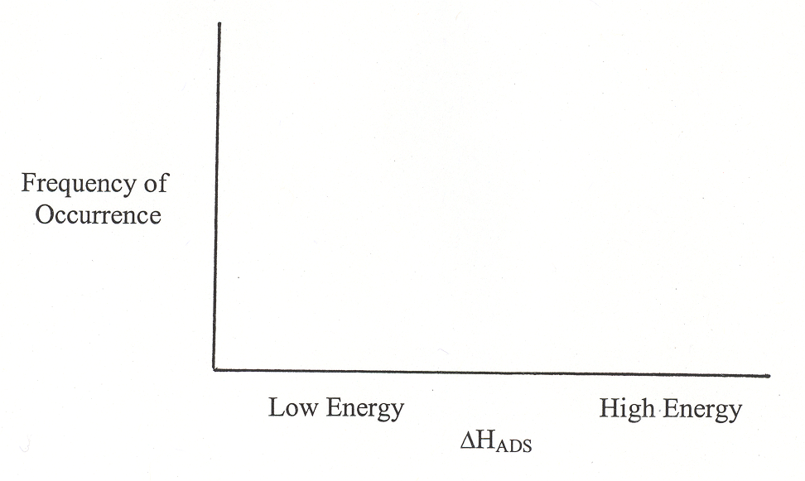

- What would a chromatographic peak look like on such a phase with such a plot of adsorption enthalpies?

- What is the problem with your peak?

