In-class Assignment 1: Mass Spectrometry

Mass spectrometry is a useful technique for compound identification. As the name implies, it is a method that allows you to determine the mass of a species. Mass spectrometric techniques require the formation of gas-phase ions, and most involve the formation and analysis of cations.

Q1. Why do you think it is necessary to have ions instead of neutral species?

Most mass spectrometers also are run at high vacuum conditions.

Q2. Why do you think mass spectrometers operate under high vacuum conditions?

One component of a mass spectrometer is known as an ion source. There are a number of different methods that are used to generate ions in mass spectrometry. A common one when analyzing relatively small molecules (e.g., most of the organic chemicals you studied in a sophomore-level organic chemistry course) is to bombard compounds in the gas phase with a high-energy beam of electrons – this is known as electron ionization (EI).

The figure below shows a mass analyzer system known as a sector instrument. Even though this mass analyzer is not commonly used today, the way it works is helpful in understanding some basic factors that allow a mass spectrometer to distinguish ions. In addition to the magnetic sector, the figure shows the location of the ion source and detector.

In the sector analyzer, a magnetic field (B) is applied that deflects the path of the ions. The picture below also shows the paths of several ions moving through the curved path. Note how one makes it all the way through to the detector. Others strike the walls of the channel.
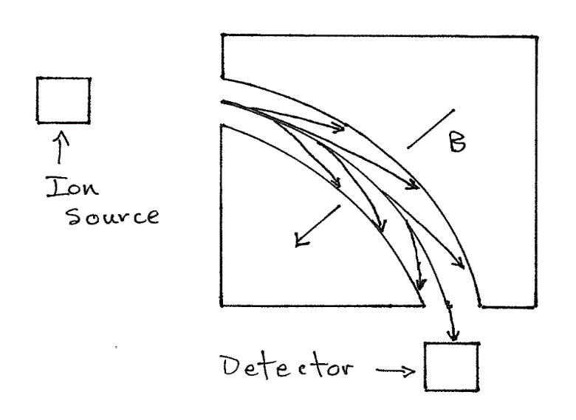

Q3. What would be needed between the ion source and magnetic sector if the goal is to analyze cations?

Q4. What aspects of (a) the chemical species and (b) operating parameters of the mass spectrometer would influence the angle of deflection? For each variable you identify, indicate what would make the deflection of an ion smaller or larger.
Note that at any specific group of settings (acceleration voltage, magnetic field, mass of the ion, charge of the ion), only very particular species will make their way through the open channel of the sector device to the detector. Because of the influence of mass and charge in determining which species makes it through the device, a mass spectrometer actually measures the mass-to-charge ratio (m/z) for the species. Fortunately, it is exceedingly rare in an EI source to produce ions that have anything other than a +1 charge, which simplifies the analysis of a mass spectrum.

Q5. What could you vary to obtain a mass spectrum for a chemical compound using an EI source and sector mass analyzer? A mass spectrum is a plot of isotopic abundance (Y-axis) versus m/z (X-axis).

In-class Assignment 2: Fragmentation in Mass Spectrometry

An important aspect of electron ionization is that it can generate fragment ions for a molecule. Almost all the cations created in a conventional mass spectrometer have a +1 charge. Consider the molecule acetophenone, consisting of three parts labeled A, B, and C. The dotted lines represent the division of the different parts.

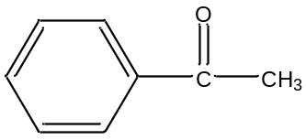
A B C
Acetophenone

Q1. List all cationic fragments that are hypothetically possible, along with their respective masses.

Q2. Which of these fragments do you think are likely to form? Are there any fragments that are unlikely to form? Explain why.

On a mass spectrum the most intense ion is given a value of 100 and the intensity of each other ion is reported relative to it.

Q3. In the space below, draw what you think the spectrum of acetophenone might look like with relative intensity on the y-axis and m/e on the x-axis. Be sure to account for both of these factors when drawing your peaks.

Q4. What would be the masses of the major fragments of benzeneacetaldehyde?

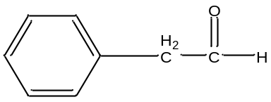
A B C

benzeneacetaldehyde

Q5. Would a mass spectrometer allow you to distinguish benzeneacetaldehyde from acetophenone? Explain why or why not.

Below are the official NIST (National Institute of Standards and Technology) spectra for acetophenone and benzeneacetaldehyde.

Q6. Are the two spectra considerably different?

Q7. Are the major fragments in your spectra the same as those in the NIST spectra?

Q8. Are there any additional intense fragments?

Q9. What is the chemical formula of any of these additional fragments?

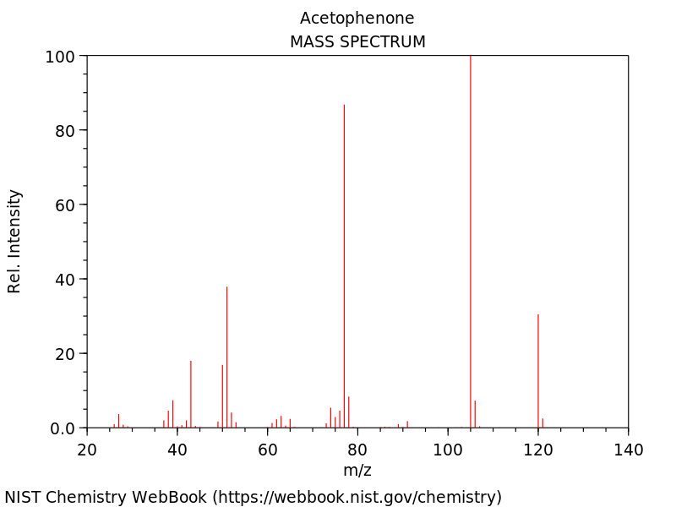

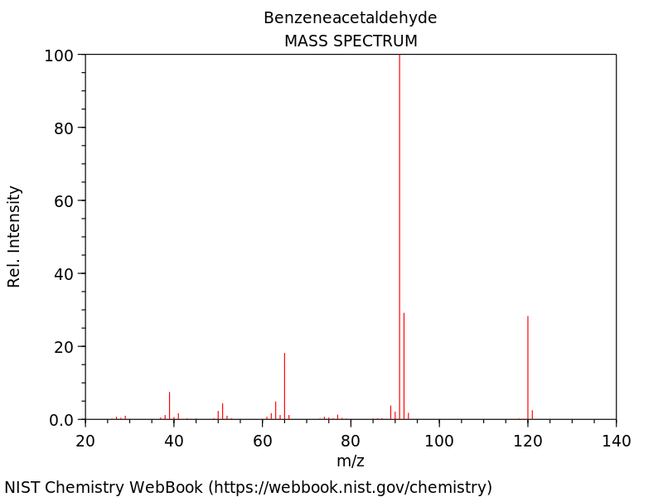

An enlargement of the most intense peak within the mass spectrum of acetophenone is shown below.

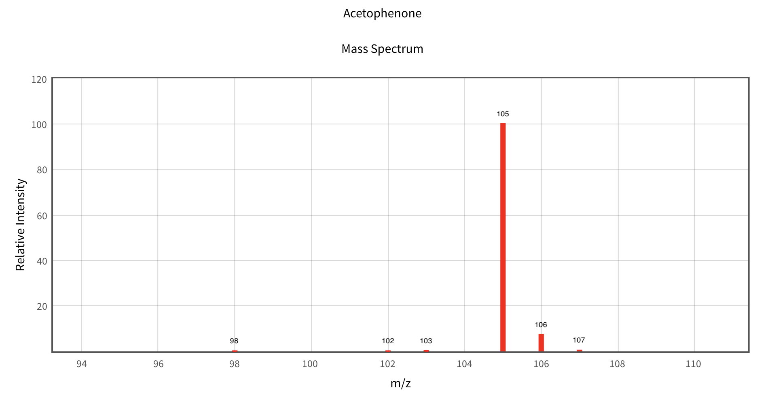

Q10. How would you account for the peaks at 106 and 107?

Q11. Why is the peak at 107 so much smaller than the peak at 106?

Isotopes

Q12. What is the relative abundance of C-13. (Looking at the atomic mass of carbon on the periodic table may provide a hint.) About how many carbon atoms out of 100 are C-13?

Q13. The 105 fragment has the following formula: C₆H₅CO. What percentage of these fragments will have a C-13 isotope?

Q14. Examine the relative intensity of the 105 and 106 peaks. Is this consistent with your answer to the previous questions?

Q15. If a carbon-based fragment of mass m has an intensity of 100 and a fragment with the same formula but a mass of m+1 has an intensity of 10, how many carbon atoms are in that fragment?

Q16. About one in every four Cl atoms has a mass of 37 amu rather than the typical 35. (Note: this explains the somewhat unusual atomic weight of chlorine of 35.453). Draw the approximate relative intensities of the m and m+2 peaks of CH₃Cl?

(Spectrum to be shown after)
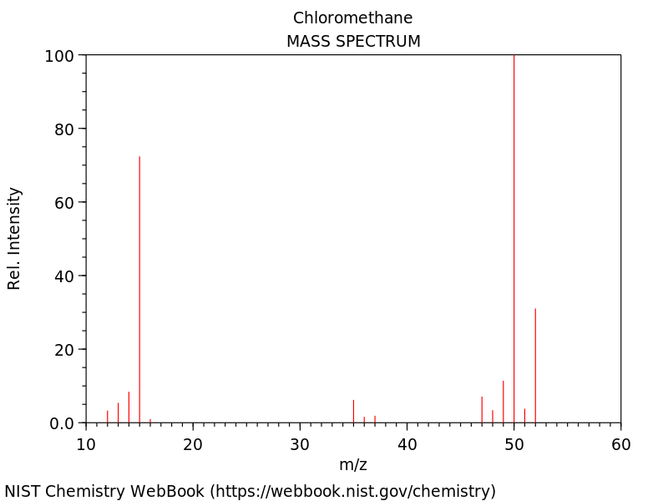

In-class Assignment 3: Isotopes and Delta Values in Mass Spectrometry

The atomic weight reported in the periodic table for an element (e.g., chlorine = 35.453 g/m) is a weighted average based on the abundance and specific weights of each of the isotopes of that element. An implication of these atomic weights is that the abundance of each specific isotope of an element is identical in every sample of that element. However, the actual situation is that isotopic abundances for a particular element can vary slightly from sample to sample.

These variations in abundances are expressed in what are known as δ-values (e.g., δ¹³C for carbon-13). These values are calculated using the following equation:

$$∂X=\frac{\left(R_{sample}-R_{Standard}\right) }{R_{Standard}} × 1000$$

Where X is the isotope and R is the ratio of heavy-to-light isotope.

Below is a table of standard ratio values for different elements. (reproduced from O’Brien, D. M., Stable isotope ratios as biomarkers of diet for health research, Annual Reviews of Nutrition, 2015, 35, 565-594).

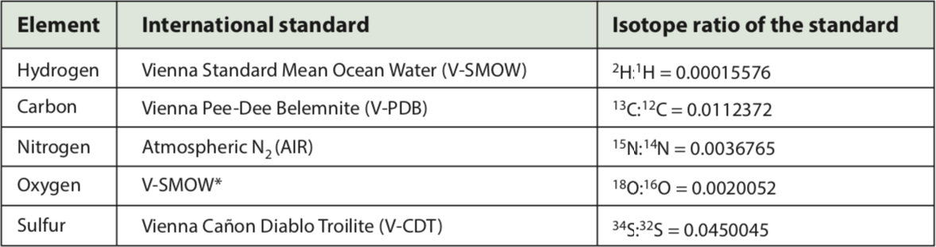

Plants exhibit differences in their ¹³C-¹²C ratios compared to the international standard. Plants get their carbon from carbon dioxide in the atmosphere – a process referred to as fixing. Plants use an enzyme known as rubisco to fix carbon dioxide from the atmosphere. Rubisco is better at fixing ¹²CO₂ than ¹³CO₂ – the slight mass difference between ¹²C and ¹³C causes ¹²CO₂ to have a slightly faster diffusion rate and therefore faster rate constant than ¹³CO₂.

Q1. Based on the properties of rubisco, will the δ¹³C values for plants be positive or negative?

Q2. R values are measured for a sample of corn (R = 0.0110911) and wheat (R = 0.0109338). Calculate the δ¹³C values for corn and wheat.

Q3. Which plant has a higher amount of ¹³C?

Corn, sugarcane and sorghum are known as C4 plants. Wheat, rice, beans and most fruits and vegetables are known as C3 plants. During photosynthesis, C3 plants incorporate carbon into a 3-carbon sugar whereas C4 plants incorporate carbon into a 4-carbon sugar. Also, C4 plants have a second enzyme involved in the fixation of carbon dioxide that is not as selective for carbon-12 as rubisco. The figure below shows the results of approximately 1000 measurements of δ¹³C values for C3 and C4 plants (reproduced from O’Leary, M. H., Carbon isotopes in photosynthesis, Bio Science, 1988, 38, 328-336).

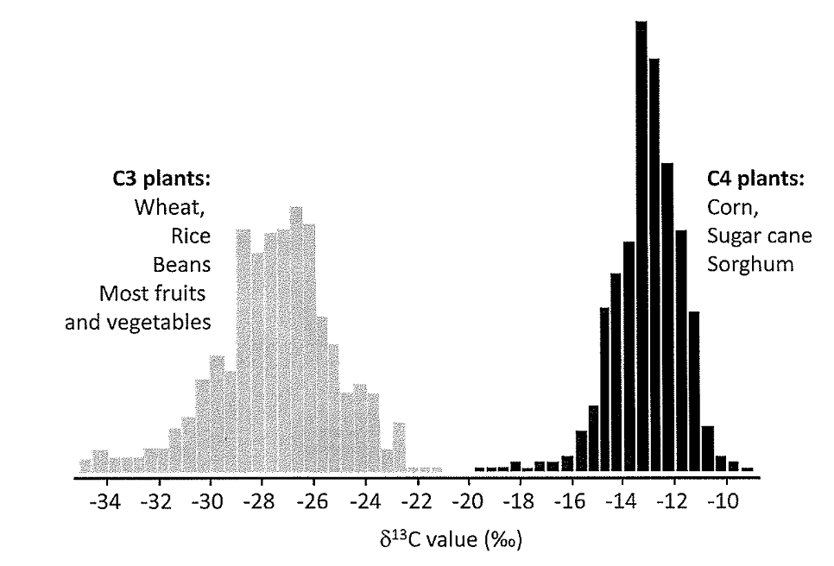

Q4. The R value of a sample of blood plasma collected from a college student in the United States is measured and found to be 0.0110038. What does this say about the diet of this student?

Q6. Does this value surprise you? You might wish to think about sources of corn in a typical American diet.

OUT-OF-CLASS QUESTIONS

Article: D.A. Schoeller, M. Minagawa, R. Slater, and I.R, Kaplan, “Stable isotopes of carbon, nitrogen and hydrogen in the contemporary North American human food web,” Ecology of Food and Nutrition, 1986, 18, 159-170.
From the Abstract:
- What is investigated in this paper?

- What samples are gathered from the subjects in this study?

- What is the final conclusion of this study?

From the Introduction:
- What is the general aim of this study?

- What was the primary justification for conducting this study?

- What was a potential difficulty with the investigators approach?

  - Why didn’t they use this approach?

  - How did they try to overcome this difficulty?

From the Experimental Methods:
- How are the lipid, protein and carbohydrate fractions isolated?

  - What is meant by a mixed-bed ion exchange column?

- Is the separation of glucose effective?

  - Is this a problem when analyzing blood plasma? Why or why not?

From the Results and Discussion:
- Which animal products had the highest ¹³C abundances? Why would this be?

- Which animal products had the lowest ¹³C abundance? Why would this be?

- What other foods are rich in ¹³C? Why would this be?

- Does ¹³C distribute the same or differently between lipids, proteins and carbohydrates? Give an example to support your answer.

- How are differences in ¹³C in plasma protein and hair protein explained?

IN-CLASS QUESTIONS
- Why are the samples combusted to carbon dioxide?

- What do you think it means to have a dual collector isotope ratio mass spectrometer?

  - Sketch what you think such an instrument might look like.

  - Why is it possible/preferable to use such a device for isotope ratio mass spectrometry?

- Table 1 has date on isotopic fractionation and contamination.
  - How is this analysis performed?

  - Why is this analysis necessary?

- Summarize the purpose of Table 3. Explain why weighted means are obtained for the δ¹³C values.

- Corn, corn products and sugar cane (C4 plants) comprise about 15% of total carbon in a North American diet. Yet the measurements indicate a much higher proportion of C4 plants in the diet.
  - How do the authors justify the extra amount?

  - That justification still does not account for all of the extra C4 plants in the diet. How to the authors justify this difference.

