Voltammetric Methods

1. How can electrostatic migration be eliminated in an electrochemical cell?

2. Samples subjected to voltammetric methods are usually purged with nitrogen or another inert gas before the analysis and maintained under an inert atmosphere during the analysis. Why is this done?

Anodic Stripping Voltammetry

1. Suppose you are analyzing a solution that contains Cd(II) and Pb(II) using anodic stripping voltammetry. Considering the voltage profile that is applied as a function in time in anodic stripping voltammetry, draw a plot of the current you would observe in the deposition step (applied voltage is –1.00 V) and in the stripping step. Remember, the procedure uses a microelectrode, which is particularly important to consider in the deposition step.

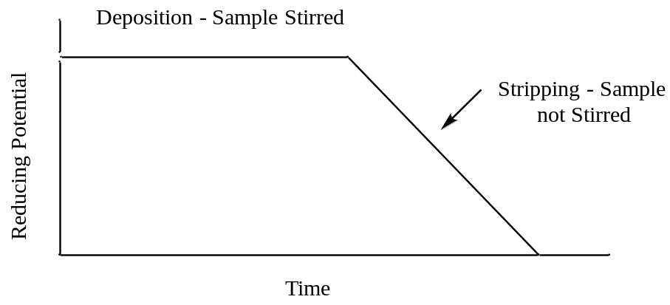

2. What feature of the plot can be related to the concentration of the metal?

3. What advantage(s) does anodic stripping voltammetry offer over coulometry or electroplating?

Linear Sweep Voltammetry

1. Draw the current that would be measured for a solution consisting of Cd(II) and Zn(II) for the voltage profile that is applied in a linear sweep experiment. Assume that the concentration of Cd(II) is about twice as large as that of Zn(II) and that the solution is stirred.

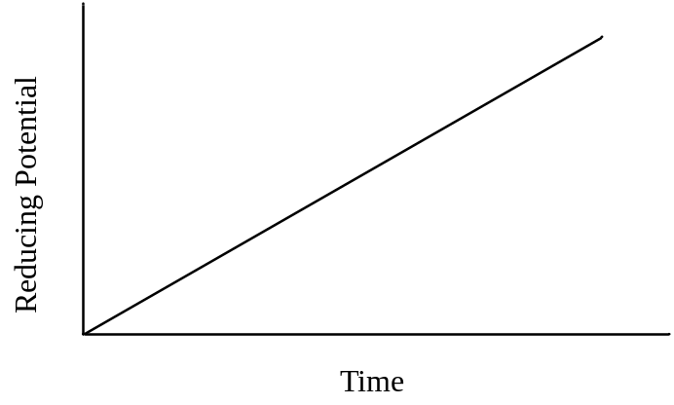

2. What feature of the plot could be related to concentration?

3. What feature of the plot can be used for species identification?

4. For the exact same solution of Cd(II) and Zn(II), draw the current that would be observed if the solution is not stirred.

5. Consider a voltage profile in a linear sweep experiment where a small, increased voltage pulse is superimposed over a voltage ramp. The current is sampled twice: (1) just before the pulse is applied and (2) just before the pulse ends. The two measurements are substracted [(2) – (1)] and the difference is plotted. Draw the resulting plot for the sample in question 1. What do you think is the name of this method?

Reducing Potential
Time

6. What advantage(s) does the method in question 5 have over regular linear sweep measurements?
Cyclic Voltammetry

1. Draw a plot of the current (y-axis) versus voltage (x-axis) that you would measure for a solution in which Fe(III) in ferricyanide (Fe(CN)₆³⁻) is reduced to Fe(II) during the reducing phase of the CV voltage profile shown below. The half reaction is chemically and electrochemically reversible and the solution is not stirred.

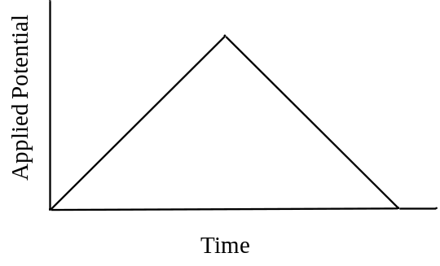

2. Draw a plot that could be obtained for an electrochemical reaction that is chemically irreversible and forms an electrochemically inactive product.

3. Draw the plot of current vs. potential that would be obtained for a reversible chemical reaction in which only the reverse reaction has an overpotential, but the potential eventually is sufficient to complete the reverse reaction.

4. Propose a reaction mechanism that would explain the following cyclic voltammogram. The first voltage cycle is shown as a solid line. The second voltage cycle is shown as a dotted line. A third voltage cycle gives the same output as the dotted line. Assume that a reducing potential is applied.
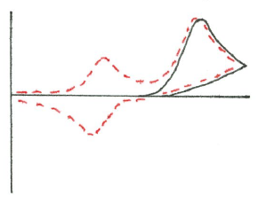
Potential
i

