6. ATOMIC SPECTROSCOPY

6.1. Introduction

It is likely that most people studying chemistry have seen a demonstration where a solution of a metal salt was sprayed into a Bunsen burner and gave off a color that depended on the particular metal in the salt. Metal salts are used to create the different colors observed in firework displays. Analysis of the emission from the flame using a device called a spectroscope would further show the characteristic line emission spectrum of the metal species. The atomic emission observed in the flame involves a process whereby the metal ions in the salt are converted into neutral, excited atoms. These atoms then emit electromagnetic radiation corresponding to valence electron transitions.

Earlier we discussed the difference between atomic spectra, which only consist of electronic transitions and therefore appear as sharp lines, and molecular spectra, which because of the presence of lower energy vibrational and rotational energy states appear as a broad continuum. Provided we have atoms present in a sample, it is possible to analyze them spectroscopically using either absorption or emission measurements. One problem is that most samples we analyze do not consist of atoms but instead consist of molecules with covalent or ionic bonds. Therefore, performing atomic spectroscopy on most samples involves the utilization of an atomization source, which is a device that has the ability to convert molecules to atoms.

It is also important to recognize that the absorption or emission spectrum of a neutral atom will be different than that of its ions (e.g., Cr⁰, Cr³⁺, Cr⁶⁺ all have different lines in their absorption or emission spectra). Atomic absorbance measurements are performed on neutral, ground-state atoms. Atomic emission measurements can be performed on either neutral atoms or ions, but are usually performed on neutral atoms as well. It is important to recognize that certain metal species exist in nature in various ionic forms. For example, chromium is commonly found as its +3 or +6 ion. Furthermore, Cr³⁺ is relatively benign, whereas Cr⁶⁺ is a carcinogen. In this case, an analysis of the particular chromium species might be especially important to determine the degree of hazard of a sample containing chromium. The methods we will describe herein cannot be used to distinguish the different metal species in samples. They will provide a measurement of the total metal concentration. Metal speciation would require a pre-treatment step involving the use of suitable chemical reagents that selectively separate one species from the other without altering their distribution. Metal speciation is usually a complex analysis process and it is far more common to analyze total metal concentrations. Many environmental regulations that restrict the amounts of metals in samples (e.g., standards for drinking water, food products and sludge from wastewater treatment plants) specify total metal concentrations instead of concentrations of specific species.

The measurement of atomic absorption or emission requires selection of a suitable wavelength. Just like the selection of the best wavelength in molecular spectroscopic measurements, provided there are no interfering substances, the optimal wavelength in atomic spectroscopic measurements is the wavelength of maximum absorbance or emission intensity.
6.2. Atomization Sources

There are a variety of strategies that can be used to create atoms from molecular substances. The three main methods involve the use of a flame, a device known as a graphite furnace or a plasma. These three atomization methods are commonly used with liquid samples. While there are various plasma devices that have been developed, only the most common one – the inductively coupled plasma – will be discussed herein. Some specialized techniques that have been designed for especially important elements (e.g., mercury, arsenic) will be described as well. Since many samples do not come in liquid form (e.g., soils, sludges, foods, plant matter), liquid samples suitable for introduction into flames, furnace or plasma instruments are often obtained by digestion of the sample. Digestion usually involves heating the sample in concentrated acids to solubilize the metal species. Digestion can be done in an appropriate vessel on a hotplate or using a microwave oven. Microwave digesters are specialized instruments designed to measure the temperature and pressure in sealed chambers so that the digestion is completed under optimal conditions. In some cases it is desirable to measure a sample its solid form. There are arc or spark sources that can be used for the analysis of solid samples.

6.2.1. Flames

As alluded to earlier, flames can be used as an atomization source for liquid samples. The sample is introduced into the flame as an aerosol mist. The process of creating the aerosol is referred to as nebulization. Common nebulizer designs include pneumatic and ultrasonic devices, the details of which we will not go into here. The most common flame atomization device, which is illustrated in Figure 6.1, is known as a laminar flow or pre-mix burner. Note the unusual design of the burner head, which instead of having the shape of a common Bunsen burner, has a long, thin flame that is 10 cm long. Radiation from the course passes through the 10 cm distance of the flame. Often the monochromator is placed after the flame and before the detector. If atomic emission is being measured, there is no light source. The burner design provides a much longer path length to increase the sensitivity of the method.

Figure 6.1. Illustration of a laminar flow or pre-mix burner.
A flame requires a fuel and oxidant. In the laminar flow burner, the fuel and oxidant are pre-mixed at the bottom of a chamber. The force created by the flowing gases draws sample up through a thin piece of tubing where it is nebulized into the bottom of the chamber. The chamber has a series of baffles in it that creates an obstructed pathway up to the burner head. The purpose of the baffles is to allow only the finest aerosol particles to reach the flame. Larger particles strike the baffles, collect and empty out by the drain tube. Even using the best nebulizers that have been developed, only about 2% of the sample actually makes it through the baffles and to the flame. The remaining 98% empties out the drain.

At first it might seem counterintuitive to discard 98% of the sample and instead seem preferable to introduce the entire sample into the flame, but we must consider what happens to an aerosol droplet after it is created and as it enters the flame. Remembering that the solution has molecules but we need atoms, there are several steps required to complete this transformation. The first involves evaporating the solvent (Eq 1). Many metal complexes form hydrates and the next step involves dehydration (Eq. 2). The metal complexes must be volatilized (Eq 3) and then decomposed (Eq. 4). Finally, the metal ions must be reduced to neutral atoms (Eq. 5). Only now are we able to measure the absorbance by the metal atoms. If the measurement involves atomic emission, then a sixth step (Eq. 6) involves the excitation of the atoms.

ML(aq) = ML.xH₂O (s) (1)
ML.xH₂O (s) = ML(s) (2)
ML(s) = ML(g) (3)
ML(g) = M⁺ + L⁻ (4)
M⁺ + e- = M (5)
M + heat = M* (6)

The problem with large aerosol droplets is that they will not make it through all of the necessary steps during their lifetime in the flame. These drops will contribute little to the signal, but their presence in the flame will create noise and instability in the flame that will compromise the measurement. Hence, only the finest aerosol droplets will lead to atomic species and only those are introduced into the flame.

The various steps outlined in Equations 1-6 also imply that there will be a distinct profile to the flame. Profiles result because of the efficiency with which neutral and excited atoms are formed in a flame. Therefore, a specific section of the flame will have the highest concentration of ground state atoms for the metal being analyzed. The absorbance profile that shows the concentration of ground state atoms in the flame is likely to be different than the emission profile that shows the concentration of excited state atoms in the flame.

Figure 6.2 shows representative absorption profiles for chromium, magnesium and silver. Magnesium shows a peak in its profile. The increase in the lower part of the flame occurs because exposure to the heat creates more neutral ground state atoms. The decrease in the upper part of the flame occurs due to the formation of magnesium oxide species that do not absorb the atomic line. Silver is not as easily oxidized and its concentration continually increases the longer the sample is exposed to the heat of the flame. Chromium forms very stable oxides and the concentration of ground state atoms decreases the longer it is exposed to the heat of the flame.

Figure 6.2. Representation of the flame profiles for chromium, magnesium and silver.

When performing atomic absorbance or emission measurements using a flame atomization source, it is important to measure the section of the flame with the highest concentration. There are controls in the instrument to raise and lower the burner head to insure that the light beam passes through the optimal part of the flame.

An important factor in the characteristics of a flame is the identity of the fuel and oxidant. Standard Bunsen burner flames use methane as the fuel and air as the oxidant and have a temperature in the range of 1,700-1,900ºC. A flame with acetylene as the fuel and air as the oxidant has a temperature in the range of 2,100-2,400ºC. For most elements, the methane/air flame is too cool to provide suitable atomization efficiencies for atomic absorbance or emission measurements, and an acetylene/air flame must be used. For some elements, the use of a flame with acetylene as the fuel and nitrous oxide (N₂O) as the oxidant is recommended. The acetylene/nitrous oxide flame has a temperature range of about 2,600-2,800ºC. There are standard reference books on atomic methods that specify the type of flame that is best suited for the analysis of particular elements.

It is also important to recognize that some elements do not atomize well in flames. Flame and other atomization methods are most suitable for the measurement of metals. Non-metallic elements rarely atomize with enough efficiency to permit analysis of trace levels. Metalloids such as arsenic and selenium have intermediate atomization efficiencies and may require specialized atomization methods for certain samples with trace levels of the elements. Mercury is another atom that does not atomize well and often requires the use of a specialized atomization procedure. Flame methods are usually used for atomic absorbance measurements because most elements do not produce high enough concentrations of excited atoms to facilitate sensitive detection based on atomic emission. Alkali metals can be measured in a flame by atomic emission. Alkaline earth metals can possibly be measured by flame emission as well provided the concentration is high enough.

6.2.2. Electrothermal Atomization – Graphite Furnace

The graphite furnace, which is pictured in Figure 6.3, is a small, hollow graphite tube about 2 Inches long by ¼ inch in diameter with a hole in the top. Graphite furnaces are used for atomic absorbance measurements. Radiation from the source shines through the tube to the detector. A small volume of sample (typically 0.5 to 10 ul) is introduced through the hole into the tube either through the use of a micropipette or a spray system. The entire furnace system is maintained under an argon atmosphere.

Figure 6.3. Illustration of a graphic furnace atomization device.

After introduction of the sample into the furnace, a three step heating process is followed. The first step (heating to about 100ºC) evaporates the solvent. The second (heating to about 800ºC) ashes the sample to a metal power or metal oxide. The third (heating to between 2,000-3,000ºC) atomizes the sample. The first two steps are on the order of seconds to a minute. The third step occurs over a few milliseconds to seconds. The atomization step essentially creates a “puff” of gas phase atoms in the furnace and the absorbance is measured during this time, yielding a signal similar to what is shown in Figure 6.4. This “puff” of atoms only occurs over a second or so before the sample is swept from the furnace. The area under the curve is integrated and related back to the concentration through the use of a standard curve.

Figure 6.4. Absorbance signal from a graphic furnace measurement.

What are the relative advantages and disadvantages of using a flame or furnace as an atomization source?

Sample size: One obvious difference is the amount of sample needed for the analysis. Use of the flame requires establishing a steady state system in which sample is introduced into the flame. A flame analysis usually requires about 3-5 ml of sample for the measurement. Triplicate measurements on a furnace require less than 50 ul of sample. In cases where only small amounts of sample are available, the furnace is the obvious choice.

Sensitivity: The furnace has a distinct advantage over the flame with regards to the sensitivity and limits of detection. One reason is that the entire sample is put into the furnace whereas only 2% of the sample makes it into the flame. Another is that the furnace integrates signal over the “puff” of atoms whereas the flame involves establishment of a steady state reading. A disadvantage of the flame is that atoms only spend a brief amount of time (about 10⁻⁴ seconds) in the optical path. Finally, for certain elements, the atomization efficiency (what percentage of the elements end up as ground state atoms suitable for absorption of energy) is higher for the furnace than the flame.

Reproducibility: The flame has a distinct advantage over the furnace in terms of reproducibility of measurements. Remember that more reproducible measurements mean that there is better precision. One concern is whether the amount of sample being introduced to the atomization source is reproducible. Even though we often use micropipettes and do not question their accuracy and reproducibility, they can get out of calibration and have some degree of irreproducibility from injection to injection. Introduction of the sample into the flame tends to be a more reproducible process.

Another concern with atomic methods is the presence of matrix effects. The matrix is everything else in the sample besides the species being analyzed. Atomic methods are highly susceptible to matrix effects. Matrix effects can enhance or diminish the response in atomic methods. For example, when using a flame, the response for the same concentration of a metal in a sample where water is the solvent may be different when compared to a sample with a large percentage of alcohol as the solvent (e.g., a hard liquor). One difference is that alcohol burns so it may alter the temperature of the flame. Another is that alcohol has a different surface tension than water so the nebulization efficiency and production of smaller aerosol particles may change. Another example of a matrix effect would be the presence of a ligand in the sample that leads to the formation of a non-volatile metal complex. This complex may not be as easy to vaporize and then atomize. While it is somewhat sample dependent, matrix effects are more variable with a furnace than the flame. An issue that comes up with the furnace that does not exist in the flame is the condition of the interior walls of the furnace. These walls “age” as repeated samples are taken through the evaporation/ash/atomize steps and the atomization efficiency changes as the walls age. The furnace may also exhibit memory effects from run to run because not all of the material may be completely removed from the furnace. Evaporation of the solvent in the furnace may lead to the formation of salt crystals that rupture with enough force to spew material out the openings in the furnace during the ashing step. This observation is why some manufacturers have developed spray systems that spread the sample in a thinner film over more of the interior surface than would occur if adding a drop from a micropipette. These various processes that can occur in the furnace often lead to less reproducibility and reduced precision (relative precision on the order of 5-10%) when compared to flame (relative precision of 1% or better) atomization.

6.2.3. Specialized Atomization Methods

There are a few elements where the atomization efficiencies with other sources are diminished to the point that trace analysis sometimes requires specialized procedures. The most common element where this is done is mercury. Mercury is important because of its high toxicity. The procedure is referred to as a cold vapor method. One design of a cold vapor system consists of a closed loop where there is a pump to circulate air flow, a reaction vessel, and a gas cell. The sample is placed in the reaction vessel and all of the mercury is first oxidized to the +2 state through the addition of strong acids. When the oxidation is complete, tin(II)chloride is added as a reducing agent to reduce the mercury to neutral mercury atoms. Mercury has sufficient vapor pressure at room temperature that enough atoms enter the gas phase and distribute throughout the system including the gas cell. A mercury hollow cathode lamp shines radiation through the gas cell and absorbance by atomic mercury is measured.

Two other toxic elements that are sometimes measured using specialized techniques are arsenic and selenium. In this process, sodium borohydride is added to generate arsine (AsH₃) and selenium hydride (SeH₂). These compounds are volatile and are introduced into the flame. The volatile nature of the complexes leads to a much higher atomization efficiency.

Commercial vendors sell special devices that have been developed for the cold vapor or hydride generation processes.

6.2.4. Inductively Coupled Plasma

A plasma is a gaseous mixture in which a significant proportion of the gas-phase species are ionized. An illustration of an inductively coupled plasma (ICP) is shown in Figure 6.5. The device consists of a quartz tube (about ¾ inch in diameter), the end of which is wrapped in a high power radiofrequency (RF) induction coil. Argon gas flows down the quartz tube at a high rate (about 15 liters/minute). A current of electricity is run through the RF coil, which produces a magnetic field inside the end of the quartz tube. Sparking the argon creates some Ar⁺ ions, which are now paramagnetic and absorb energy from the magnetic field. The argon ions absorb enough energy that a plasma is created in the area of the tube covered by the RF induction coil. The nature of the magnetic field causes the plasma to flow in a closed annular path (basically a donut shape). What is especially impressive is that enough energy is absorbed from the magnetic field to heat the plasma up to a temperature of about 6,000 K. As a comparison, this temperature is about the same as the temperature of the surface of the sun. The hot temperature means that new argon flowing into the plasma is ionized, which maintains the plasma. The plasma is kept from melting the walls of the quartz tube by an additional tangential flow of argon along the walls of the tube. Finally, the sample is nebulized and sprayed as an aerosol mist into the center of the plasma.

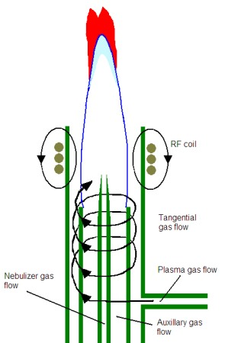

Figure 6.5. Illustration of an inductively coupled plasma. From: http://www.asdlib.org/learningModules/AtomicEmission/index.html
An ICP offers several advantages over flame and furnace atomization sources. One is that it is so hot that it leads to a more complete atomization and leads to the formation of many excited state atoms. Because sufficient numbers of atoms are excited, they can be detected by emission instead of absorbance. The illustration in Figure 6.5 shows the plume that forms in an ICP above the RF coil. Above the plasma is a zone in which argon regeneration occurs. A continuum background emission is given off in this zone. Above this zone in the plume, there are excited atoms that emit the characteristic lines of each particular element in the sample. In our discussion of fluorescence spectroscopy, we learned that emission methods have an inherent sensitivity advantage over absorbance methods. This occurs because emission entails measuring a small signal over no background and absorbance entails measuring a small difference between two large signals. This same sensitivity advantage exists for measurements of atomic emission over atomic absorbance. Light emitted by atoms in the plume can be measured either radially (off to the side of the plume) or axially (looking down into the plume. Axial measurements are often more sensitive because of the increase in path length. However, in some cases, depending on the element profile in the plasma, radial measurements may be preferable. Instruments today often allow for either axial or radial measurements.

A second advantage of an ICP is that all of the elements can be measured simultaneously. All metals in the sample will be atomized at the same time and all are emitting light. Some instruments measure elements in a sequential arrangement. In this case, the operator programs in the elements to be measured, and the monochromator moves one-by-one through the specific wavelengths necessary for the measurement of each element. Other instruments use an array detector with photoactive pixels that can measure all of the elements at once. Array instruments are preferable as the analysis will be faster and less sample is consumed. Figure 6.6 shows the printout of the pixels on a array detector that include and surround the lead emission that occurs at 220.353 nm. The peak due to the lead emission from the four different samples is apparent. Also note that there is a background emission on the neighboring pixels and the intensity of this background emission must be subtracted from the overall emission occurring at the lead wavelength.
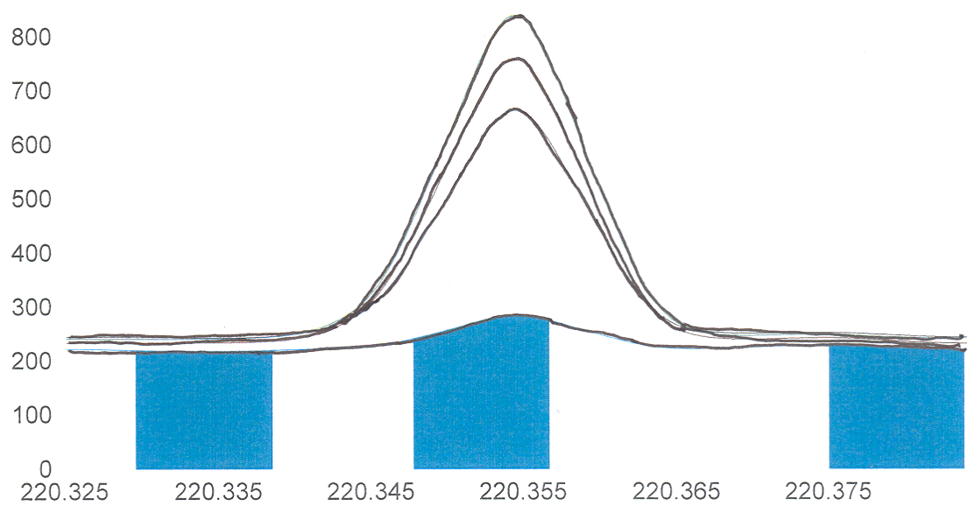
Figure 6.6. Array elements showing the lead-220.353 nm emission line.
An observation with emission spectroscopy to be aware of is the possibility of self-absorption. We already discussed this in the unit on fluorescence spectroscopy. Self-absorption refers to the situation in which an excited state atom emits a photon that is then absorbed by another atom in the ground state. If the photon was headed toward the detector, then it will not be detected. Self-absorption becomes more of a problem at higher concentrations as the emitted photons are more likely to encounter a ground state atom. The presence of self-absorption can lead to a diminishment of the response in a calibration curve at high concentrations as shown in Figure 6.7. Atomic emission transitions always correspond with absorption transitions for the element being analyzed so the likelihood of observing self-absorption is higher in atomic emission spectroscopy than in fluorescence spectroscopy. For a set of samples with unknown concentrations of analyte, it may be desirable to test one or two after dilution to insure that the concentration decreases by a proportional factor and that the samples are not so high in concentration to be out in the self-absorption portion of the standard curve.

Figure 6.7. Calibration curve for atomic emission showing self-absorption at higher concentration.

Another advantage is that the high number of Ar⁺ ions and free electrons suppress the ionization of other elements being measure, thereby increasing the number of neutral atoms whose emission is being measured. The argon used to generate the plasma is chemically inert compared to the chemical species that make up a flame, which increases the atomization efficiency. The inductively coupled plasma tends to be quite stable and reproducible. The combination of high temperature with chemically inert environmental reduces matrix effects in the plasma relative to other atomization sources, but it does not eliminate them and matrix effects must always be considered. Some elements (e.g., mercury, arsenic, phosphorus) that are impractical to analyze on a flame or furnace instrument without specialized atomization techniques can often be measured on an ICP.

A final advantage of the plasma is that there are now methods to introduce the atoms into a mass spectrometer (MS). The use of the mass spectrometer may further reduce certain matrix effects. Also, mass spectrometry usually provides more sensitive detection than emission spectroscopy.

6.2.5. Arcs and Sparks

Arc and spark devices can be used as atomization sources for solid samples. Figure 6.8 illustrates the setup for an arc device. A high voltage applied across a gap between two conducting electrodes causes an arc or spark to form. As the electrical arc or spark strikes the positively charged electrode, it can create a “puff” of gas phase atoms and emission from the atoms can be measured. The arc also creates a plasma between the two electrodes. Depending on the nature of the solid material to be measured, it can either be molded into an electrode or coated onto a carbon electrode.

Figure 6.8. Illustration of an arc atomization source with a plasma (shown in blue). From: http://www.asdlib.org/learningModules/AtomicEmission/index.html

6.3. Instrument Design Features of Atomic Absorption Spectrophotometers

6.3.1. Source Design

While ICP devices do offer certain advantages over flame atomic absorption (AA) spectrophotometers, flame AAs are still widely used for measurement purposes. They are cheaper to purchase and operate than an ICP and, for someone only needing to measure a few specific elements on a regular basis, a flame AA may be the better choice. There are a variety of instrumental design features on AA spectrophotometers that are worth consideration.

One of these concerns the radiation source. Most atomic absorption spectrophotometers use a separate source lamp, called a hollow cathode lamp, for each individual element that you wish to measure. An illustration of a hollow cathode lamp is shown in Figure 6.9. The hollow cathode is coated with the element you wish to measure. The interior is filled with a relatively low pressure (1 Torr) of an inert gas such as argon or helium. A voltage is applied across the anode and cathode. The filler gas (e.g., argon) is ionized to Ar⁺ at the anode. The Ar⁺ ions are drawn toward the cathode and when they strike the surface, sputter off some of the coated atoms into the gas phase. In the sputtering process, some of the atoms are excited and emit the characteristic lines of radiation of the atoms. Hollow cathode lamps cost about $200 a piece, so buying lamps for many elements can get a bit expensive.

Figure 6.9. Illustration of a hollow cathode lamp.

Why is the cathode designed with a hollow configuration?

There are two reasons for the hollow cathode design. One is that the configuration helps to focus the light beam allowing a higher intensity of photons to be directed toward the flame or furnace. The second is that it helps prolong the lifetime of the lamp. It is desirable to have sputtered atoms coat back onto the cathode, since it is only those atoms that can be excited by collisions with the Ar⁺ ions. Over time the number of atoms coated onto the cathode will diminish and the intensity of the lamp will decrease. The lamps also have an optimal current at which they should be operated. The higher the current, the more Ar⁺ ions strike the cathode. While a higher current will provide a higher intensity, it will also reduce lamp lifetime. (Note: There is another reason not to use high currents that we will explore later after developing some other important concepts about the instrument design). The lifetime of a hollow cathode lamp run at the recommended current is about 500 hours. The need to use a separate line source for each element raises the following question.

Why is it apparently not feasible to use a conventional broadband continuum source with a monochromator when performing atomic absorption spectroscopy?

One thing you might consider is whether conventional continuum lamps have enough power in the part of the electromagnetic spectrum absorbed by elements.

In what part of the electromagnetic spectrum do most atoms absorb (or emit) light?

Recollecting back to the emission of metal salts in flames, or the light given off in firework displays, it turns out that atoms emit, and hence absorb, electromagnetic radiation in the visible and ultraviolet portions of the spectrum.

Do powerful enough continuum sources exist in the ultraviolet and visible region of the spectrum?

Yes. We routinely use conventional continuum sources to measure the ultraviolet/visible spectrum of molecules at low concentrations, so these sources certainly have enough power to measure corresponding concentrations of atomic species.

Another thing to consider is the width of an atomic line. What are two contributions to the broadening of atomic lines? (Hint: We went over both of these earlier in the course).

Earlier in the course we discussed collisional and Doppler broadening as two general contributions to line broadening in spectroscopic methods. When these contributions to line broadening are considered, the width of an atomic line is observed to be in the range of 0.002-0.005 nm.

Using information about the width of an atomic line, explain why a conventional continuum source will not be suitable for measuring atomic absorption.

The information provided above indicates that atomic lines are extremely narrow. If we examine the effective bandwidth of a common continuum ultraviolet/visible source/monochromator system, it will be a wavelength packet on the order of 1 nm wide. Figure 6.10 superimposes the atomic absorption line onto the overall output from a conventional continuum source. What should be apparent is that the reduction in power due to the atomic absorbance is only a small fraction of the overall radiation emitted by the continuum source. In fact, it is such a small portion that it is essentially non-detectable and lost in the noise of the system.

Figure 6.10. Atomic absorption line superimposed onto the overall output of a conventional continuum source/monochromator system.

What is the problem with reducing the slit width of the monochromator in a conventional continuum source to get a narrower line?

The problem with reducing the slit width in a conventional continuum course is that it reduces the number of photons or source power reaching the sample. Reducing the slit width on a continuum source to a level that would provide a narrow enough line to respond to atomic absorption would reduce the power so that it would not be much above the noise. Therefore, hollow cathode lamps, which emit intense narrow lines of radiation specific to the element being analyzed, are often used for atomic absorption measurements.

Can continuum sources ever be used in atomic absorption spectroscopy?

Yes, provided the source has sufficient power over the entire range of wavelengths that are absorbed by atoms and that the resolution of the monochromator is such that the bandwidth is less than or equal to the width of the atomic line at half its height. Sufficient power can be achieved with a specialized xenon arc lamp. A commercially available instrument that uses a continuum source has a double monochromator design that provides a sufficiently narrow bandwidth. One advantage of performing AAS with a continuum source is the possibility of using an array detector and simultaneously measuring multiple elements.

With this understanding we can ask why the hollow cathode lamp has a low pressure of argon filler gas.

The pressure of the argon is low to minimize collisions of argon atoms with sputtered atoms. Collisions of excited state sputtered atoms with argon atoms will lead to broadening of the output of the hollow cathode lamp and potentially lead to the same problem described above with the use of a continuum source. A low pressure of argon in the lamp insures that the line width from the hollow cathode lamp is less than the line width of the absorbing species.

6.3.2. Interferences of Flame Noise

Background signal from the flame is measured at the detector and is indistinguishable from the source power. Flame noise in the form of emission from the flame or changes in the flame background as a sample is introduced can cause a significant interference in atomic methods.

Can you design a feature that could be incorporated into a flame atomic absorption spectrophotometer to account for flame noise?

We can account for flame noise and changes in the flame noise by using a device called a chopper. A chopper is a spinning wheel that alternately lets source light through to the flame and then blocks the source light from reaching the flame. Figure 6.11 illustrates several chopper designs.

Figure 6.11. Illustration of several chopper designs.

Figure 6.12 shows the output from the detector when using a chopper. When the chopper blocks the source, the detector only reads the background flame noise. When the chopper lets the light through, both flame noise and source noise is detected. The magnitude of Po and P is shown on the diagram. By subtracting the combined source/flame signal from only the flame background it is possible to measure the magnitudes of Po and P and to determine whether the introduction of the sample is altering the magnitude of the flame background.

Figure 6.12. Output at the detector of a flame AA when using a chopper.
6.3.3. Spectral Interferences

Particulate matter in a flame will scatter light from the hollow cathode lamp. Some metals are prone to forming solid refractory oxides in the flame that scatter radiation. Organic matter in a flame may lead to carbonaceous particles that scatter radiation. This is a problem since the detector cannot distinguish the difference between light that is scattered and light that is absorbed.

Similarly, molecular species in a flame exhibit broadband absorption of light. Figure 6.13 shows a plot of an atomic absorption line superimposed over molecular absorption. As with scattered radiation, the detector cannot distinguish broadband absorption from molecular species from line absorption by atomic species.

Figure 6.13. Plot showing an atomic absorption line superimposed over molecular absorption.

Can you design a feature that could be incorporated into an atomic absorption spectrophotometer than can account for both scattered light and light absorbed by molecular species?

To address this question, we need to think back to the previous discussion of the source requirement for atomic absorption spectrophotometers. Earlier we saw that it was not possible to use a continuum source with a monochromator since the atomic absorption was so negligible as to be non-detectable. However, a continuum source will measure molecular absorption and will respond to any scattered radiation. The answer is to alternately send the output from the hollow cathode lamp and a continuum source (the common one used in AA instruments is a deuterium lamp) to the flame. The output of the hollow cathode lamp will be diminished by atomic absorption, molecular absorption and scatter. The continuum lamp will only be diminished by molecular absorption and scatter, since any contribution from atomic absorption is negligible. By comparing these, it is possible to correct the signal measured when the hollow cathode lamp passes through the flame for scattered radiation and molecular absorption. In atomic absorption spectroscopy, this process is referred to as background correction.

An alternative way of getting a broadened source signal to pass through the flame is known as the Smith-Hieftje method (named after the investigators who devised this method). The Smith-Hieftje method only uses a hollow cathode lamp. Earlier, when we discussed hollow cathode lamps, we learned that the argon pressure inside the lamp was kept low to avoid collisional broadening. We also learned that the current was not set to a high value because it would sputter off too many atoms and shorten the lamp lifetime. Another observation when running a hollow cathode lamp at a high current is that the lamp emission lines broaden. This occurs because, at a high current, so many atoms get sputtered off into the hollow cathode that they collide with each other and broaden the wavelength distribution of the emitted light. The Smith-Hieftje method relies on using a pulsed lamp current. For most of the time, the lamp is run at its optimal current and emits narrow lines that would diminish when passing through the flame due to atomic absorption, molecular absorption and scatter. For a brief pulse of time, the current is set to a very high value such that the lamp emits a broadened signal. When this broadened signal passes through the flame, atomic absorption is negligible and only molecular absorption and scatter decrease the intensity of the beam.

A third strategy is to use what is known as the “two-line” method. This can be used in a situation where you have a source that emits two narrow atomic lines, one of which is your analysis wavelength and the other of which is close by. Looking back at Figure 13, the analysis wavelength is diminished in intensity by atomic absorption, molecular absorption and scattering. A close by line does not have any atomic absorption and only is reduced in intensity by molecular absorption and scattering. While it might at first seem difficult to see how it is possible to get nearby atomic lines for many elements, there is something known as the Zeeman Effect that can be used for this purpose. Without going into the details of the Zeeman Effect, what is important to know is that exposing an atomic vapor to a strong magnetic field causes a slight splitting of the energy levels of the atom causing a series of closely spaced lines for each electronic transition. The neighboring lines are about 0.01 nm from each other, making them ideal for monitoring background molecular absorption and scatter. Corrections using the Zeeman Effect are more reliable than those using a continuum source. The magnetic field can be applied either to the hollow cathode lamp or the atomization source. The method is useful in flame and graphite furnace measurements.

6.4. Other Considerations

6.4.1. Chemical Interferences

It is also possible to have chemical processes that interfere with atomic absorption and emission measurements. It is important to realize that the chemical interferences described herein can potentially occur in flame, furnace and plasma devices. One example of a chemical interference occurs for metal complexes that have low volatility. These are often difficult to analyze at trace concentrations because the atomization efficiency is reduced to unacceptably low levels.

Can you devise a strategy or strategies for eliminating the problem of a non-volatile metal complex?

One possibility is to use a higher temperature flame. Switching from an acetylene/air flame to an acetylene/nitrous oxide flame may overcome the volatility limitations of the metal complex and produce sufficient atomization efficiencies.

Another strategy is to add a chemical that eliminates the undesirable metal-ligand complex. One possibility is to add a ligand that preferentially binds to the metal to form a more volatile complex. This is referred to as a protecting agent. The sensitivity of calcium measurements is reduced by the presence of aluminum, silicon, phosphate and sulfate. Ethylenediaminetetraacetic acid (EDTA) complexes with the calcium and eliminates these interferences. The other strategy is to add another metal ion that preferentially binds to the undesirable ligand to free up the desired metal. This is known as a releasing agent. The presence of phosphate ion decreases the sensitivity of measurements of calcium. Excess strontium or lanthanum ions will complex with the phosphate and improve the sensitivity of the calcium measurement.

Another potential problem that can occur in flames and plasmas is to have too high a concentration of the analyte metal exist in an ionic form. Since neutral atoms are usually being measured (sometimes when using an ICP it may actually be preferable to measure emission from an ionic species), the presence of ionic species reduces the sensitivity and detection limits.

Can you devise a strategy to overcome unwanted ionization of the analyte?

One possibility might be to use a cooler atomization source, although there are limitations on the range to which this is feasible. The RF power used in an inductively coupled plasma does influence the temperature of the plasma, and there are recommendations for specific elements about the recommended source power. Similarly, changes in the fuel/oxidant ratio cause changes in the temperature of a flame.

A more common strategy is to add something to the sample known as an ionization suppression agent. An ionization suppressor is something that is easily ionized. Common ionization suppressors would include alkali metals such as potassium. Thinking of Le Chatlier’s principle, ionization of the suppressor forms more electrons and greater charges of positive ions that suppress the ionization of the analyte species.

6.4.2. Accounting for Matrix Effects

Flame noise, spectral interferences and chemical interferences are all examples of matrix effects. Atomic methods are among the most sensitive of all analysis methods to matrix effects. The previous sections have described ways of trying to account for the possibility of some types of matrix effects. Even with these methods, there is still the possibility that some aspect of the matrix (remember that the matrix is everything except what is being analyzed) either enhances or decreases the signal measured at the detector. A concern is that standard solutions often have a different matrix than the unknowns that are being analyzed.

Devise a general method that can be used to account for the presence of unknown matrix effects.

A process called standard addition can often be used to assess whether a sample has a matrix effect. If the sample does have a matrix effect, the standard addition procedure will provide a more accurate measurement of the concentration of analyte in the sample than the use of a standard curve. The process involves adding a series of small increments of the analyte to the sample and measuring the signal. The assumption is that the additional analyte experiences the same matrix effects as the species already in the sample. The additional increments are kept small to minimize the chance that they swamp out the matrix and no longer experience the same matrix effects.

The signal for each increment is plotted against the concentration that was added as shown in Figure 6.14. Included in Figure 6.14 are plots for two different samples, both of which have the exact same concentration of analyte. One of the samples has a matrix that enhances the signal relative to the other. An examination of the plots shows that the sample with an enhancing matrix produces a linear plot with a higher slope than the linear plot obtained for the other sample. The plot is then extrapolated back to the X-intercept, which indicates the concentration of analyte that would need to be added to the matrix to obtain the signal measured in the original sample.
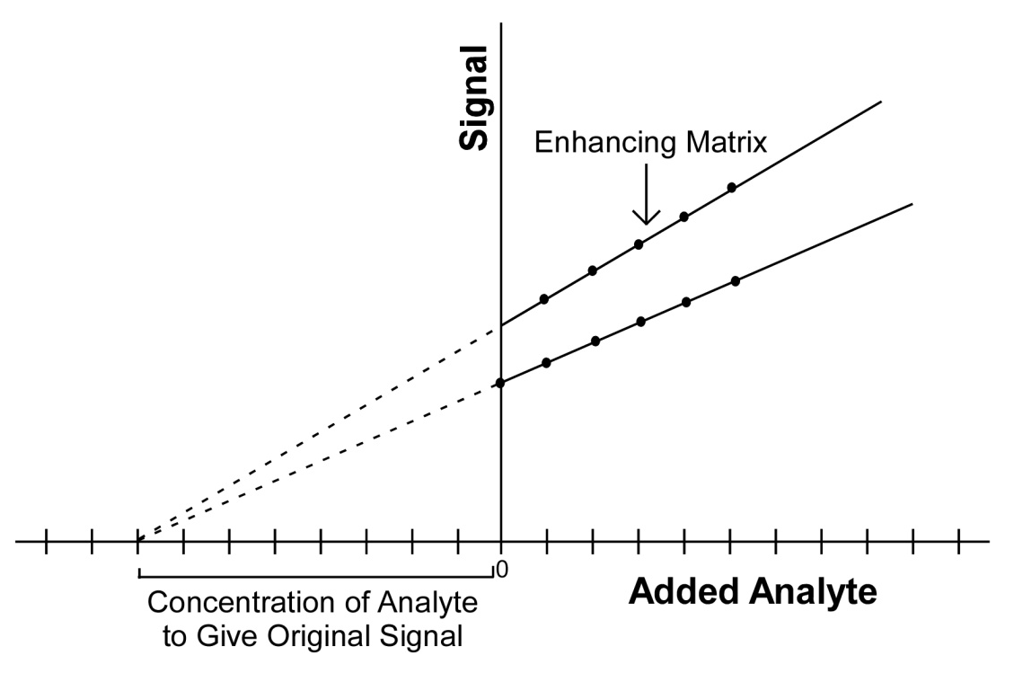
Figure 6.14. Standard addition plot for two samples with the same concentration. The sample with the higher slope has a matrix that enhances the signal.

The experimental steps involved in conducting a standard addition are more complex than those involving the use of a standard curve. If someone is testing a series of samples with similar properties that have similar matrices, it is desirable to use the standard addition procedure on one or a few samples and compare the concentration to that obtained using a standard curve. If the two results are similar, then it says that the matrix effects are minimal and the use of a standard curve is justified.

