CAPILLARY ELECTROPHORESIS

The design of a capillary electrophoresis (CE) instrument is shown in Figure 80. The separation is performed in a fused silica capillary column that is about 50 cm long with an internal diameter of 25-75 um. We have previously discussed the use of fused silica capillary columns for gas chromatographic separations. Two important distinctions for the capillary used in CE is that (1) it is much shorter than those used in GC-MS, which are typically 30-60 meters, and (2) the inside in CE is usually not covered with a stationary phase and is typically the bare surface of the fused silica glass. Note that there are times when the capillary walls are coated with a substance or derivatized to change the elution behavior. The development in this unit will only consider CE separations using bare silica surfaces. As with the GC capillary, the outside is coated with a polyimide polymer to protect the column from degradation caused by handling.

By removing the end of the capillary in the inlet buffer, placing it in a sample vial and applying pressure to the vial, a small plug of sample can be introduced into the capillary. The end of the capillary with the sample plug is then put back into the inlet buffer. Migration and separation is achieved by applying an electric field across the capillary as indicated in Figure 80 (Note the (+) and (-) potentials at the different ends of the capillary column). Understanding the mechanism for how species migrate in the capillary and are separated will require a consideration of several factors.

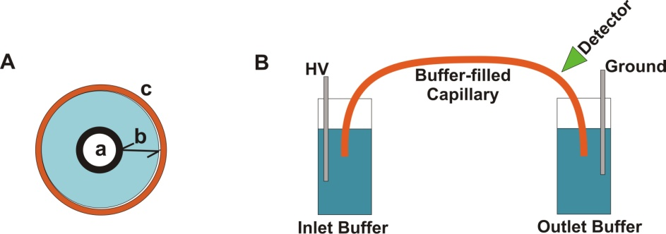
(+)
(–)
Figure 80. Diagram of a capillary electrophoresis instrument.

Detection is often accomplished using UV absorbance or fluorescence. The section of the capillary shown in the detector in Figure 81 has the polyimide coating removed to allow UV/Visible radiation to pass through the capillary.
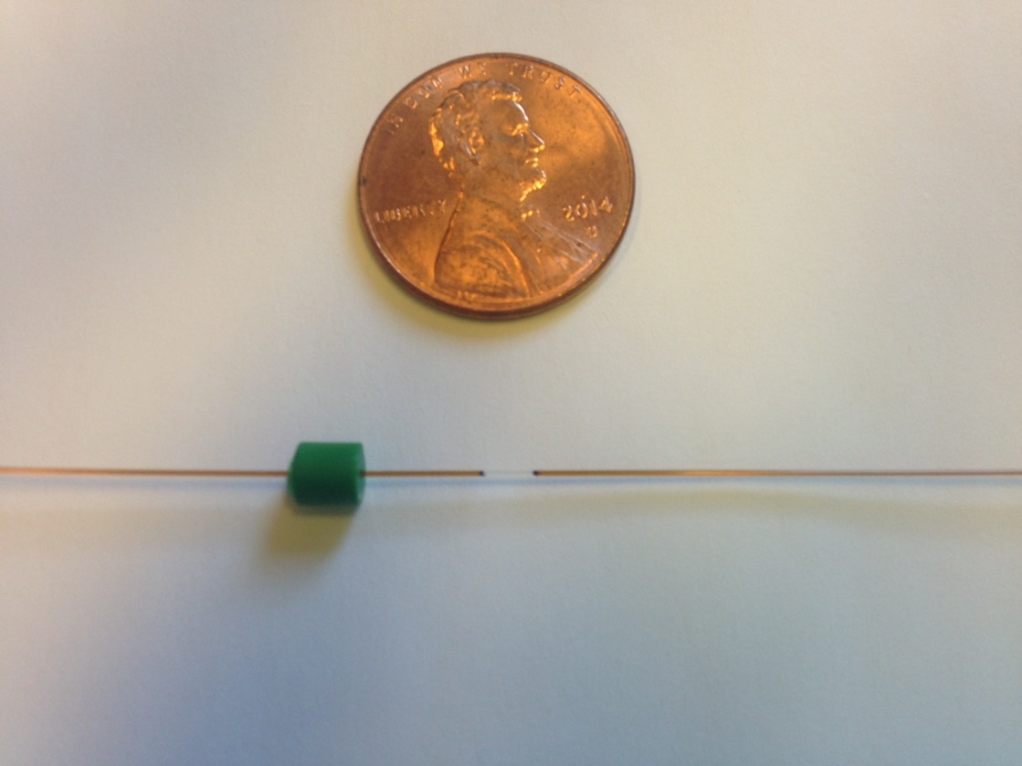
detection window

Figure 81. A fused silica capillary with an inner diameter of 50 μm. The polyimide coating is removed at the detection window.

What is the functional group on the surface of a fused silica capillary column? Fused silica is a silicon dioxide (SiO₂) polymeric material.
While fused silica is very different in physical appearance from the silica gel that is used for liquid chromatographic bonded phases, as a form of silicon dioxide it contains the same functionalities. Therefore, the surface would consist of many silanol (-Si-OH) groups.

Would the nature of the interior surface of the capillary be different if the background electrolyte was at pH 2 versus pH 9?
Silanol groups are mildly acidic and therefore can be deprotonated. At pH 2, most of the silanols would be protonated and therefore neutral. At pH 9, many of the silanol groups would be deprotonated resulting in anionic silanate groups on the surface of the glass.

As seen in Figure 79, CE separations are performed using a background electrolyte. The background electrolyte is an appropriate buffer and therefore contains positive and negative ions.

Assuming the silanol groups are deprotonated to anionic silanate groups, what do you think will happen in the portion of the solution in immediate contact with the surface of the fused silica?
Because of the negative charge of the surface, an excess of cations from the mobile phase buffer will congregate near the walls of the capillary. Figure 82 shows a representation of the inside of the capillary. Some of the cations are tightly associated with the silanate ions forming what is known as the fixed layer. Note that the fixed layer represented in Figure 82 has a net negative charge as there are more silanate ions than tightly associated cations. Adjacent to the fixed layer is something known as the diffuse layer. Note that the diffuse layer in Figure 82 has a net positive charge as there is a higher concentration of buffer cations than anions. To convince you of this, count the number of cations (10) and anions (6) in the diffuse layers in Figure 82 and compare it to the number of cations (12) and anions (12) in the bulk solution. Together the fixed and diffuse layers are known as the double layer. It is important to note that the concentration of ions in the buffer is large compared to the concentration of silanate ions in the fixed layer (The cartoon in Figure 82 does not properly represent how much higher the concentration of buffer is relative to silanate ions). This means that in CE done using the capillary dimensions referred to at the beginning of this unit, the formation of the diffuse layer will not deplete the bulk solution of cations. As a result, the bulk solution in the center of the capillary has equivalent concentrations of cations and anions.

Figure 82 also indicates the electric field that has been applied across the capillary with a resulting cathode (-) and anode (+).
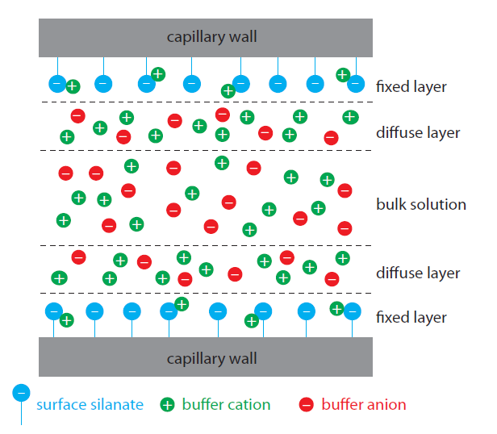
(+)
Anode
(–)
Cathode
Figure 82. Schematic diagram showing the origin of the double layer within a capillary tube. Although the net charge within the capillary is zero, the distribution of charge is not. The walls of the capillary have an excess negative charge, which decreases across the fixed layer, reaching a value of zero in the bulk solution. (Figure from Analytical Chemistry 2.0, David Harvey, http://community.asdlib.org/activelearningmaterials/analytical-chemistry-2-0-online-textbook/).

What happens in the diffuse layer in the presence of this applied electric field?
The net positive charge in the diffuse layer means that the cations will be drawn toward the cathode. Because these cations are solvated, they drag along solvent molecules and the rest of the solution with them. Because the internal diameter of the capillary is so small, the net result is that both the diffuse layer and bulk solution flow toward the cathode in what is known as the electroosmosis.

Figure 83 shows the profile for electroosmotic and hydrodynamic flow in a capillary tube. Hydrodynamic flow occurs in a capillary when pressure is used to push the liquid through the tube. Hydrodynamic flow has a parabolic cross-section because friction at the surface means that molecules at the capillary walls travel more slowly than molecules in the center of the capillary. Note that the flow velocity in electroosmosis is nearly constant across the capillary and is very different from the profile in hydrodynamic flow. This occurs because in electroosmosis the flow originates at the surface with cations in the diffuse layer.

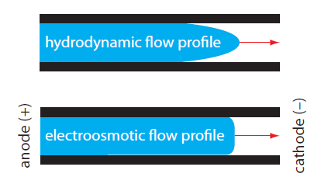

Figure 83. Comparison of hydrodynamic flow and electroosmotic flow. The nearly uniform electroosmotic flow profile means that the electroosmotic flow velocity is nearly constant across the capillary. (Figure from Analytical Chemistry 2.0, David Harvey, http://community.asdlib.org/activelearningmaterials/analytical-chemistry-2-0-online-textbook/).

Which flow profile, hydrodynamic or electroosmotic, results in greater peak broadening?
Hydrodynamic flow causes greater broadening because there is a larger difference in velocity between molecules at the center of the tube and those at the walls of the capillary tube when compared to electroosmotic flow.

As previously discussed, broadening in chromatographic columns results from eddy diffusion, longitudinal diffusion, and mass transport broadening in the stationary and mobile phases. Which of these processes contribute to peak broadening in capillary electrophoresis?
Since this is an open tubular capillary column without packing, there is no eddy diffusion. Since there is also no stationary phase, there cannot be any mass transport broadening in the stationary phase. Mobile phase mass transport broadening occurred because of the time it took for the analytes to encounter the stationary phase. With no stationary phase, there is also no mobile phase mass transport broadening. Therefore, the only contribution to peak broadening occurs from longitudinal diffusion. Even under the influence of electrophoretic and electroosmotic flow, analyte molecules still have random diffusion in all directions that causes the peaks to broaden. Because of the limited contributions to broadening in CE, peaks tend to be quite sharp and separations have high numbers of theoretical plates.

What would happen to the electroosmotic flow rate at pH 2.5 versus pH 10?
At pH 2.5, very few of the silanols are deprotonated to silanates so the diffuse layer only has a small net positive charge. At pH 10, almost all of the silanols are deprotonated to silanates and the diffuse layer has a much greater net positive charge. Because of the higher positive charge at pH 10, the electroosmotic flow rate will increase.

Suppose the compounds being analyzed have a charge. Is there any other process that will result in analyte ions moving in the capillary column?
Because there is an applied electric field, analytes with a positive charge will migrate toward the negatively charged cathode and those with a negative charge will migrate toward the positively charged anode. This movement is known as electrophoresis.

What variables influence the electrophoretic migration rate of a charged analyte?
The electrophoretic migration rate of a substance depends on its charge and size. A species with a higher charge has a greater electrostatic attraction for either the cathode or anode and will migrate faster than a species with a lower charge. Similarly, an ion with a smaller size will migrate faster than an ion with a larger size.

Imagine that four ions start in the middle of the capillary as shown in Figure 84.

Cathode (-)
Anode (+)
+1
+1
-1
-1

Figure 84. Representation of four ions in the middle of a capillary prior to the beginning of migration.

Assuming that the ions only move as a result of electrophoresis, draw the position of the ions after 30 kV has been applied for a short time.
With only electrophoresis, the negative ions would move toward the positively charged anode and the positive ions would move toward the negatively charged cathode. Also, the ions with the smaller size would move faster and therefore further than the larger ions. The result after applying the voltage for a short period of time is shown in Figure 85.

Cathode
(-)
Anode (+)
+1
+1
-1
-1

Figure 85. Representation of four ions in the capillary a brief period of time after applying an electric field. Remember, the ions in this picture only experience electrophoretic migration.

Now consider the separation of a sample that has anionic, cationic and neutral analytes and has both electroosmotic and electrophoretic flow. The detector is placed on the end of the capillary near the cathode as shown in Figure 86. Anions, cations and neutrals are all detected. Explain.
Cathode
(-)
Anode (+)
Detector

Figure 86. Representation of capillary showing the placement of the anode, cathode and detector.

To explain this observation, the total velocity (v_{tot}), which is the sum of the electrophoretic migration (v_{ep}) and electroosmotic flow (v_{eo}), must be considered (v_{tot} = v_{ep} + v_{eo}).
- For cations, the electrophoretic migration and electroosmotic flow both are in the direction of the cathode.
- For anions, the electrophoretic flow is toward the anode but the electroosmotic flow is toward the cathode. In order for anions to pass through the detector, the electroosmotic flow must be greater than the electrophoretic migration.
- Neutral compounds only experience electroosmotic flow. Therefore, they will flow toward the cathode and pass through the detector.

Figure 87 shows arrows representing the different flow contributions for cations, neutrals and anions.
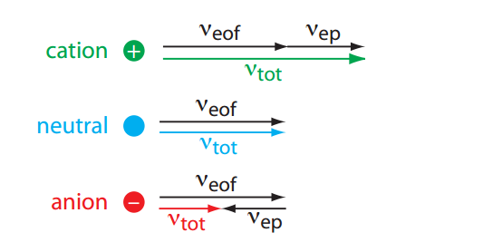
Figure 87. Visual explanation for the general elution order in capillary electrophoresis. Each species has the same electroosmotic flow. Neutrals have no electrophoretic velocity. The electrophoretic velocity of cations and anions are in opposite directions. (Figure from Analytical Chemistry 2.0, David Harvey, http://community.asdlib.org/activelearningmaterials/analytical-chemistry-2-0-online-textbook/).

What is the predicted elution order of the following five substances?
In addition, draw an electropherogram of the results and explain your reasoning.
Substance A: neutral
Substance B: ̶ 1 charge
Substance C: +1 charge
Substance D: neutral
Substance E: ̶ 2 charge
Substances A, B, C, and E are all the same size. Substance D is twice as large as the others.

Figure 88 shows the electropherogram for the analysis of A-E. Substance C, which is the only species with a positive charge, elutes first as its velocity is a combination of the electroosmotic and electrophoretic flow. The two anions B and E elute last because they have an electrophoretic flow in the opposite direction from electroosmotic flow. Substance E with a –2 charge is the last because it has a larger electrophoretic migration than Substance B with a –1 charge. Neutral species A and D only move because of electroosmosis. Unlike electrophoresis, electroosmotic flow is independent of size so A and D will coelute.
C
A,D
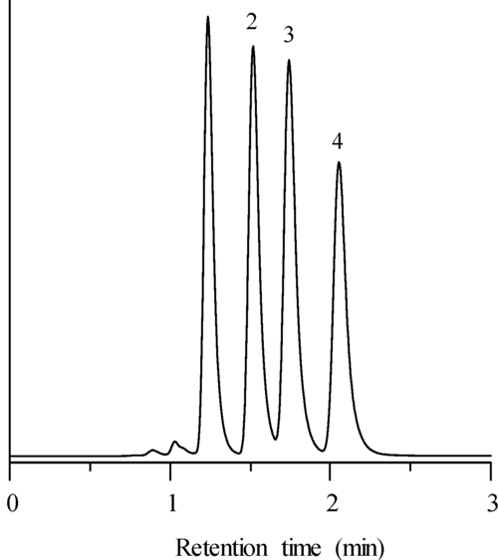
B
E

Figure 88. Electropherogram for substances A-E.

The structural formulas and relevant pK_{a} values for the four components of an Exedrin tablet are shown in Figure 89. (The protonated form of the boxed group is shown.) Predict the elution order in CE with a 20 mM borate buffer at pH = 9.3.
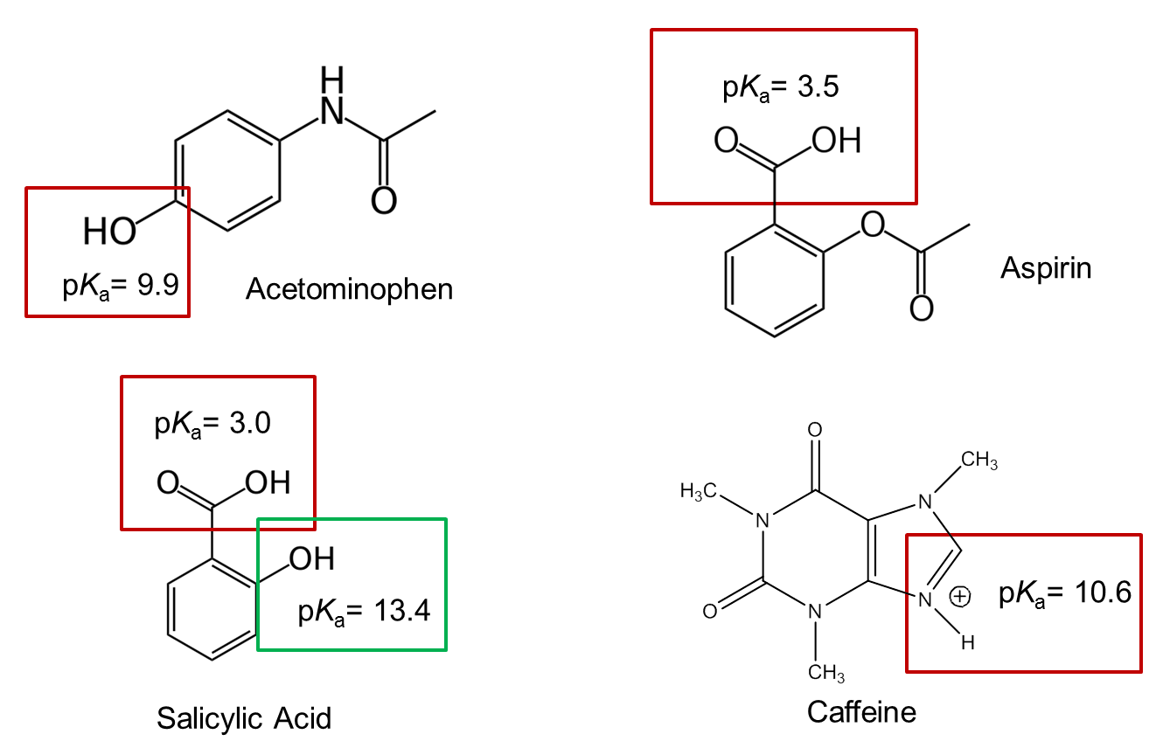

Figure 89. Structures and pKa values of the four primary constituents of Excedrin

The important thing to consider is whether the acidic or basic functional groups are protonated or deprotonated at pH 9.3 to determine the overall charge of the species.
- For aspirin, the carboxylic acid group with a pKa of 3.5 will be “fully deprotonated” so will have a –l charge. The words “fully deprotonated” are put in quotes because a very small amount must be protonated to satisfy the Ka expression, but it is so small that it can be ignored.
- For caffeine, the nitrogen atom with a pKa of 10.6 will be “fully protonated” so will have a charge of +1.
- For acetaminophen, the hydroxyl (phenol) group with a pKa of 9.9 is only 0.6 units from the pH of the buffer. In this case, only a portion of the acetaminophen will be deprotonated at any given moment and there will be a rapid exchange between protonated (neutral) and deprotonated (anionic) forms. Therefore, it will have a charge that can be considered as between 0 and –1.
- For salicylic acid, the carboxylic acid group with a pKa of 3.5 will be “fully deprotonated” whereas the hydroxyl group with a pKa of 13.4 will be “fully protonated”. The overall charge will be –1.

To summarize, at pH 9.3, the species would have the following charges:
Aspirin: –1 charge
Caffeine: +1 charge
Acetaminophen: Average charge between 0 to –1
Salicylic acid: –1 charge

The system is set up such that cations elute first, followed by neutrals and finally followed by anions. Therefore, caffeine elutes first. Acetaminophen elutes second because it has the smallest negative charge of the three anionic species. Aspirin and salicylic acid have identical charges but differ slightly in size with aspirin being slightly larger than salicylic acid. Because aspirin is larger its electrophoretic migration is less than that of salicylic acid and since the electrophoresis of anions is opposite of the direction of electroosmotic flow needed for elution, aspirin elutes before salicylic acid.

What could you do experimentally to confirm your predicted elution order?
You would need to make up solutions with one each of the four compounds and carry out the analysis to determine their retention time.

An actual electropherogram of this sample at pH 9.3 is shown in Figure 90.

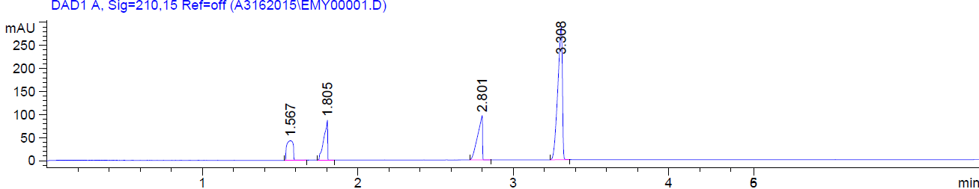

Figure 90. Electropherogram of the four constituents of Excedrin at pH 9.3: caffeine (1.567 min), acetaminophen (1.805 min), aspirin (2.801 min) and salicylic acid (3.308 min).

