BROADENING OF CHROMATOGRAPHIC PEAKS

One of the most important occurrences in chromatographic systems is the broadening of peaks as compounds move through the chromatographic column. For example, if we examine Figure 18 in which both sets of peaks have the same retention times but different extents of broadening, we see that the set of conditions that produce the narrower set of peaks (Figure 18b) resulted in “better” or more efficient chromatography. What we observe in the chromatogram with less peak broadening is that the peaks are fully resolved and that we could fit more peaks into a similar window of time in the chromatogram. An ideal chromatographic system would therefore produce peaks that were straight line spikes in which no broadening occurred (Figure 18a).

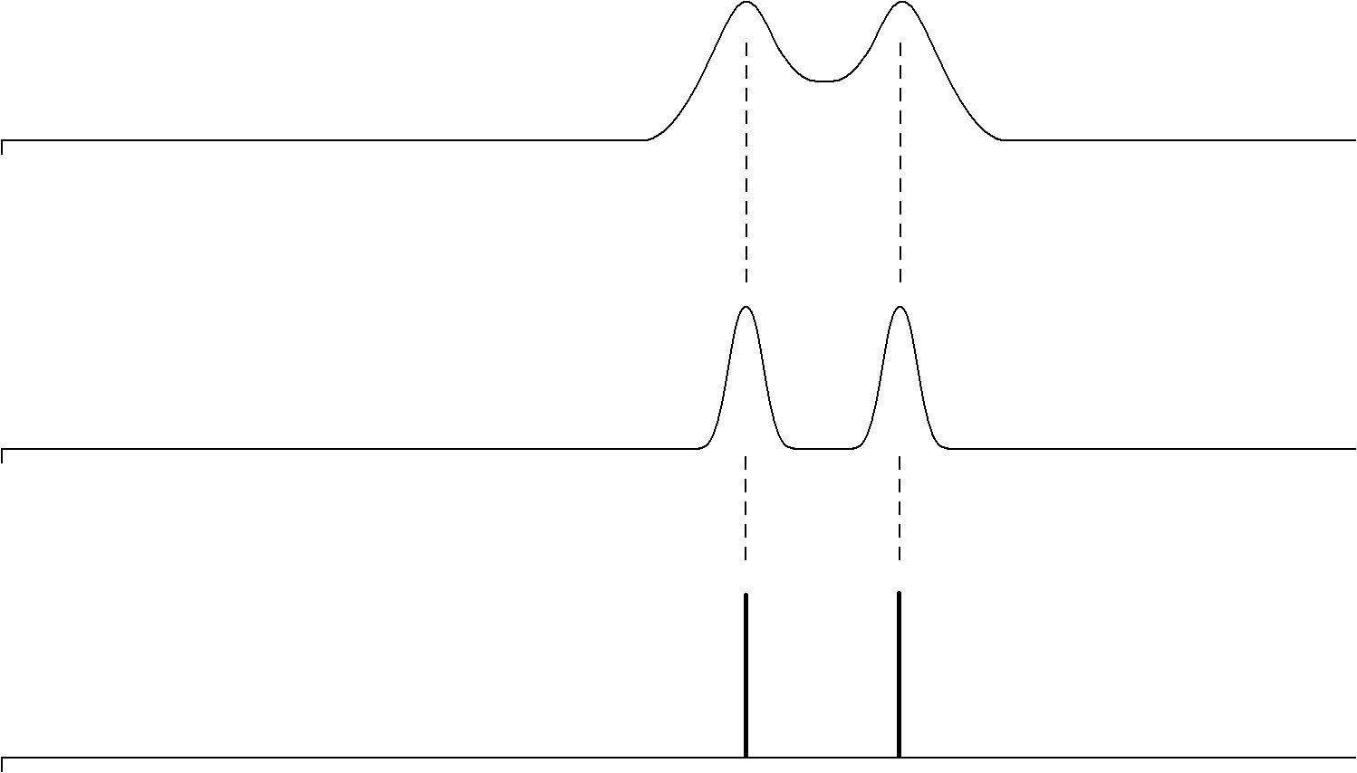
(a)
(b)
(c)
INJ
INJ
INJ

Figure 18. Representation of chromatographic peaks in which the broadening increases going from (a) to (c).

There are specific processes that occur in chromatographic systems that cause peaks to broaden. It also turns out that these processes are often influenced by experimental variables that we may have some control over. Contributions to broadening in chromatographic systems can be divided into two broad areas of concern. One is the contribution from what is known as dead volume. Dead volume refers to all the volume in a chromatographic system from the injector to the detector other than the column. Remember, the separation only occurs in the column. All other volumes (tubing used to connect components, volume within the detector cell, etc.) have the ability to contribute to peak broadening but not to the separation. One general goal then is to try to reduce the total dead volume to as small a quantity as possible. In liquid chromatography this involves using very narrow internal diameter tubing and short lengths of tubing to connect the components, using small-volume detector cells, etc. The fittings that are used to connect pieces of tubing together or components to each other have been designed specifically to reduce the dead volume to minimal levels and in ways that do not promote mixing and broadening.

The other source of broadening is within the column. If you were to examine state-of-the-art columns that are used today in gas and liquid chromatography, it turns out that there are several features of their design that lead to significant reductions in peak broadening. In other words, these columns represent the best we can do today to reduce the broadening of peaks, and therefore represent the most efficient column technology. It is worth taking the time to understand the various contributions to peak broadening that occur within the chromatographic column and to examine the ways in which current gas and liquid chromatographic columns have been designed to minimize these effects.

There are four general contributions to broadening within chromatographic columns. These are known as:

- longitudinal diffusion

- eddy diffusion

- mass transport broadening in the stationary phase

- mass transport broadening in the mobile phase

Before moving on, it is worth remembering back to two fundamental criteria we talked about with regards to chromatographic columns, the number of theoretical plates (N) and the reduced plate height (h). Remember that a column with more plates, or better yet a column with a small reduced plate height, was more efficient and provided better separations. We can therefore use the reduced plate height as a determining measure of the efficiency of a chromatographic column. The smaller the value of h, the more efficient the column. What we will develop as we analyze the four contributions to broadening above is an equation, which was first known as the van Deemter equation (J. J. van Deemter described the first treatment of this for chromatographic systems in 1956), that relates these four terms to the reduced plate height.

Longitudinal Diffusion Broadening in Chromatography

Consider a band of a compound in a chromatographic column. The band has the concentration profile shown in Figure 19.
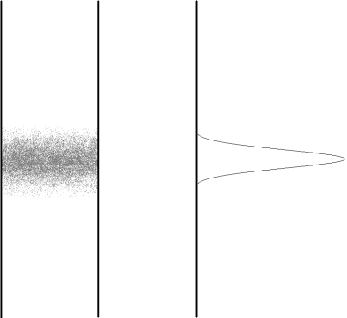

Figure 19. The representation on the left shows a band of a compound on a chromatographic column. The representation on the right shows the concentration profile of the band. The concentration is greatest at the center of the band.

The first thing to consider is what would happen to this profile if the flow of the column was stopped and the column was allowed to sit. We know from the random process of diffusion that there is a statistical preference in which more molecules diffuse away from regions of high concentration to regions of low concentration. If we were to allow this band to sit stopped in the column, it would slowly diffuse out from its central region and lead to a broadening of the concentration profile as shown in Figure 20.

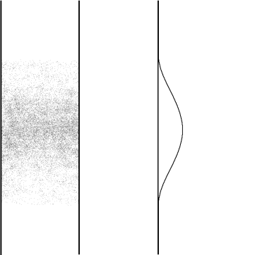

Figure 20. Representation of band or peak broadening that results from longitudinal diffusion. Compare to the concentration profile in Figure 19.

This observation of diffusion from a region of high concentration to one of low concentration will occur whether the band of material is sitting stationary in a column or is flowing through the column. A molecule flowing through a column has two means of movement. One is the physical flow that is taking place. But the other is still its ability to diffuse in a random manner from one point to another. All compounds moving through a chromatographic column must exhibit some degree of longitudinal diffusion broadening. Therefore, we can never get the idealized chromatogram shown in Figure 18a.

An important thing to consider is whether this phenomenon is more significant (i.e., happens faster and therefore causes more broadening, everything else being equal) in gas or liquid chromatography. To consider this, we would need to know something about the relative rates of diffusion of gases and liquids. A substance with a faster rate of diffusion will broaden more in a certain amount of time than something with a slower rate of diffusion. So the relevant question is, which diffuses faster, gases or liquids? I suspect we all know that gases diffuse appreciably faster than liquids. Just imagine yourself standing on the opposite side of a room from someone who opens a bottle of a chemical with the odor of a skunk. How fast do you smell this odor? Compare that with having the room full of water, and someone adds a drop of a colored dye to the water at one side of the room. How fast would that color make its way across the water to the other side of the room? In fact, gases have diffusion rates that are approximately 100,000 times faster than that of liquids. The potential contribution of longitudinal diffusion broadening to chromatographic peaks is much more serious in gas chromatography than in liquid chromatography. In liquid chromatography, the contribution of longitudinal diffusion broadening is so low that it’s really never a significant contribution to peak broadening.

Finally, we could ask ourselves whether this phenomenon contributes more to band broadening at higher or lower flow rates. What we need to recognize is that longitudinal broadening occurs at some set rate that is only determined by the mobile phase (gas or liquid) and the particular molecule undergoing diffusion. In the gas or liquid phase, it would be reasonable to expect that a small molecule would have a faster rate of diffusion than a large molecule. If we are doing conventional gas or liquid chromatography using organic compounds with molecular weights from about 100 to 300, the differences in diffusion rates are not sufficient enough to make large differences here. If we were comparing those molecules to proteins with molecular weights of 50,000, there might be a significant difference in the rate of diffusion in the liquid phase. If the longitudinal diffusion occurs at a set, fixed rate, then the longer a compound (solute) is in the column, the more time it has to undergo longitudinal diffusion. The compound would be in the column a longer time at a slower flow rate. This allows us to say that the contribution of longitudinal diffusion to overall peak broadening will be greater the slower the flow rate. If we use the term B to represent longitudinal diffusion broadening and v to represent flow rate, and want to relate this to h, we would write the following expression:
$$\text{h = }\frac{\text{B}}{\text{v}}$$

Remember that the smaller the reduced plate height the better. At high flow rates, B/v gets smaller, h is smaller, and the contribution of longitudinal diffusion to peak broadening is smaller.

We can also write the following expression for B: B = 2ϕD_{M}

In this case, D_{M} refers to the diffusivity (diffusion coefficient) of the solute in the solvent. Notice that this is a direct relationship: the faster the rate of diffusion of the solute, the greater the extent of longitudinal diffusion. ϕ is known as the obstruction factor, and occurs in a packed chromatographic column. In solution, a molecule has an equal probability of diffusion in any direction. In a packed column, the solid packing material may restrict the ability of the solute to diffuse in a particular direction, thereby hindering longitudinal diffusion. This term takes this effect into account.

Eddy Diffusion (Multipath) Broadening in Chromatography

Consider a group of molecules flowing through a packed bed of particles (Figure 21). Another way to think of this is to imagine you and a group of friends following a river downstream in a set of inner tubes. The river has a number of rocks in the way and a variety of different flow paths through the rocks. Different people go in different channels either because they paddle over to them or get caught in different flows of the current as they bounce off of obstacles.

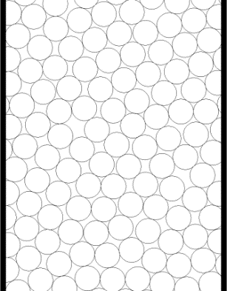

Figure 21. Representation of a chromatographic column packed with particles.

The question we need to consider is whether different molecules would have different path lengths as they passed through the bed. Would each person traveling down the river travel a slightly different distance, or would everyone travel the exact same distance? I suspect we can see that different molecules would end up traveling paths with different lengths as shown in Figure 22. One molecule (Molecule 1) might find a relatively straight shot through the packed bed, whereas another might encounter more particles that needed to be circumvented (Molecules 2 and 3). If we watched a group of molecules pass through a packed bed, and then mapped out each path with a length of string, we would see if we then stretched out all the strings, that there was a distribution of path lengths with some being shorter and some being longer. If that were the case, the molecule with the shortest path length would move through the column more quickly (Molecule 1). The molecule with the longest path length would move through the column more slowly (Molecule 3). If we have a distinction between the time it takes a set of molecules to move through the column based only on different path lengths, we have broadened the peak. This is known as eddy diffusion.

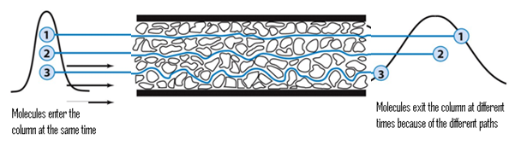
Figure 22. Representation of the different paths of three different molecules traveling through a packed bed of particles.
A key factor to consider when examining eddy diffusion is to ask whether the difference in length between the shortest and longest path depends at all on the diameter of the particles.
If it is, we could then ask which particles (smaller or larger) would lead to a greater difference in path length?

Almost everyone who is asked the first question seems to intuitively realize that the size of the particles must somehow make a difference. It just seems too coincidental to think that the difference between the shortest and longest path would be identical if the particle sizes are different. But interestingly enough, almost everyone, when they first consider this, seems to select the wrong answer when figuring out which particle (small or large) would lead to a greater difference in path length between the shortest and longest path. Remember, the important distinction is the size of the difference between the shortest and longest path, not whether one column would uniformly have longer path lengths than the other.

To help with this assessment, two columns are pictured in Figure 23, one with small particles, the other with larger particles.

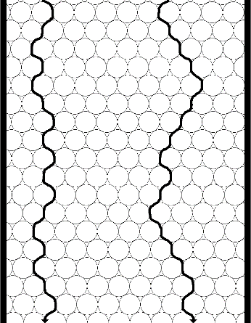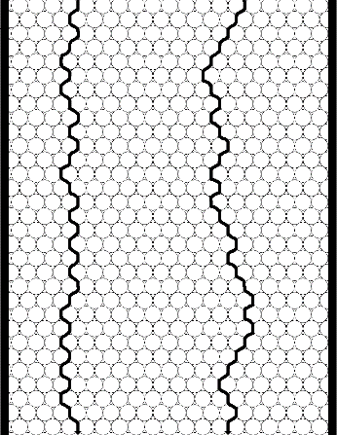

Figure 23. Representation of two columns with different size particles.

Note that the greatest distinction will occur between two molecules, one of which has found a relatively straight shot through the column, the other of which has encountered a lot of particles and so has to travel around them. Also note that the distance a molecule needs to travel around a larger particle is larger. Now you might be inclined to say that if we have to travel around lots of small particles, wouldn’t that eventually add up to the larger distance of travelling around one larger particle? Turns out that it doesn’t! The conclusion is that smaller particles will reduce the contribution of eddy diffusion to peak broadening (although we will add a proviso in just a bit). In other words, the distribution of path lengths of a set of molecules travelling through a packed bed is more uniform for a bed containing smaller particles than it is for a bed made up of larger particles. Thus, regarding eddy diffusion, there is a theoretical advantage to using smaller particles. That is the reason we use the reduced plate height (h = H/d_{p}) instead of the plate height for an overall assessment of column efficiency. If we had two people pack a column with the idea of seeing who packed a better one, if one person used smaller particles they would have a competitive advantage if we only compared the plate height (H).

It is also worth realizing that the flow profile shown in Figure 24 for a molecule would not occur (okay, there’s probably some infinitesimally small possibility that this could occur, but it’s so small that we could ignore it) in a chromatographic column. There is a physical flow pushing the material through the column and when a molecule reaches a flowing area, it will generally be swept downstream.
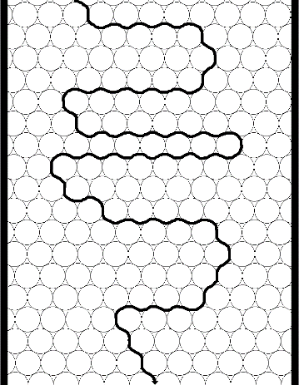

Figure 24. Unrealistic representation of the flow profile for a molecule through a packed chromatographic column.

Some packed columns exhibit channeling, and channeling leads to a significant and undesirable amount of eddy diffusion. The illustration in Figure 25 shows a column with a channel and compares two flow paths, one of which goes through the channel.

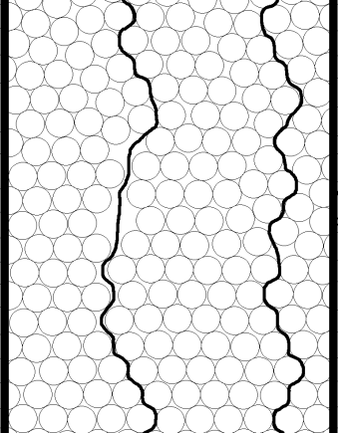
Channel

Figure 25. Representation of a packed chromatographic column with a channel.

Channels provide a straight path through a portion of the column and molecules in a channel avoid any need to move around any particles. A molecule moving through a channel will have a much more streamlined or shorter path than a molecule in an adjacent part of the column that has to move through the packed bed. Channels occur when the particles stick together in some way and separate from each other, instead of nesting together in a packing arrangement with every particle closest together. A liquid chromatographic column that has dried out (all of the mobile phase is allowed to evaporate) will likely develop channels during the drying process that will never close back up if it is rewetted. Channels in chromatographic columns are undesirable and introduce a lot of broadening into the system.
Another key thing to ask then is whether channeling is more likely to occur with smaller or larger particles. Channeling will occur if a column is poorly packed. There are very specific procedures that have been developed for packing gas and liquid chromatographic columns that are designed to minimize the chance that channeling will occur. One key to packing a good column is to slowly lay down a bed of particles so that they nest into each other as well as possible. In packing a gas chromatographic column, this will usually involve slowly adding the particles to the column while vibrating it so that the particles settle in together. Liquid chromatographic columns are usually packed slowly under high pressure. A column is packed efficiently when the particles are in a uniform bed with the minimum amount of voids. Given a particular particle size, the goal is to fit as many of them as possible into the column. We can then ask which is more difficult to pack efficiently, larger or smaller particles.

One way to think about this is if you were asked to fill a large box (say a refrigerator box) with basketballs or tennis balls. The goal is to fit as many of either one in as possible. You could imagine readily taking the time to carefully lay down each basketball into the refrigerator box, layer by layer, and fitting in as many basketballs as possible. You might also be able to imagine that you would start slowly with the tennis balls, laying in one in a time, and quickly lose patience at how long this would take to fill the entire box. If you then sped up, say by slowing dumping in balls from a pail while a helper shook the box, you would probably create more voids in the box. Also, because the interstitial volumes between the tennis balls will be smaller than that with the basketballs, any channels become more significant. The result is that it is more difficult to avoid the formation of channels with smaller particles. Recapping, smaller particles have a theoretical advantage over larger particles, but more care must be exercised when packing smaller particles if this theoretical advantage in column efficiency is to be realized.

Do open tubular capillary columns exhibit eddy diffusion? Capillary columns do not have packing material. Instead, they are long, narrow diameter tubes that have a coating of a liquid stationary phase on the internal walls of the column. A representation of a capillary column with a uniform coating of a liquid on the walls is shown in Figure 26.


Liquid
Coating
Flow

Figure 26. Representation of a coated capillary column.

Because there is no packing material to move around, there would not be any eddy diffusion in such a column. The absence of eddy diffusion broadening is one advantage that capillary columns have when compared to packed columns.

Finally, we could ask whether eddy diffusion exhibits any dependence on the flow rate. This actually turns out to be a difficult question to answer with conflicting opinions and data about whether there is a flow dependence, and if so, exactly what the dependency is. If we go back to van Deemter’s initial development of peak broadening in chromatography in 1956, we would see that van Deemter believed that the contribution of eddy diffusion to peak broadening did not depend in any way on the flow rate. This is a reasonable argument if we thought that we could draw a variety of different flow paths through a packed bed, and the difference in length between the shortest and longest flow path would be fixed irrespective of how fast the molecules were moving through the path.

But let’s return to our river analogy to see how the flow rate might get involved in this. Suppose the river had a relatively fast flow rate, such that different people in different inner tubes got locked into particular flow channels and stayed in those all the way down the river. Under that situation, each path would have a preset length and even if we slowed down the flow, so long as you were locked into a particular path, the difference in distance would be invariant. But suppose now we slowed down the flow so much that there were opportunities to drift around at points and sample a variety of flow paths down the river. This might lead to some averaging and the amount of sampling of different flow paths would be greater the slower the flow. This same thing can happen in a chromatographic column and leads to conflicting data and opinions about the nature of any flow rate dependence on eddy diffusion. Also, the exact point at which there is a crossover between a rapid flow that locks in a flow path versus a slow one that allows each molecule to sample many different flow paths is impossible to determine. This point is still not fully resolved, and literature on band broadening show different terms for eddy diffusion. We usually denote eddy diffusion by the term A. If you look at van Deemter’s initial treatment of peak broadening, you would see (note, van Deemter also did not use the reduced plate height, but we could write h = A as well):

H = A
(where A = 2λd_{p})

Note how the particle diameter (d_{p}) is included in this equation for A, so that the smaller the particle diameter, the smaller the contribution of eddy diffusion to the reduced plate height.

Another common conclusion today is that the contribution of eddy diffusion broadening does exhibit a slight dependence on flow rate. The usual form of this is that the dependence is v^{1/3}, and you might often see books or articles that include the following term in the overall band broadening equation.
h = A v^{1/3}

Still other people throw up their hands at all the confusion regarding eddy diffusion and show overall band broadening equations that do not have any A-term in them. We will develop another broadening term that has to do with processes going on in the mobile phase (and note that eddy diffusion only involves the mobile phase - none of what we talked about even requires the presence of a liquid stationary phase), so some people lump the eddy diffusion term into this other mobile phase term.

Stationary Phase Mass Transport Broadening

Consider a compound that has distributed between the mobile and stationary phase within a plate in a chromatographic column. Figure 27 might represent the concentration distribution profiles in the two phases (note that the compound, as depicted, has a slight preference for the mobile phase).
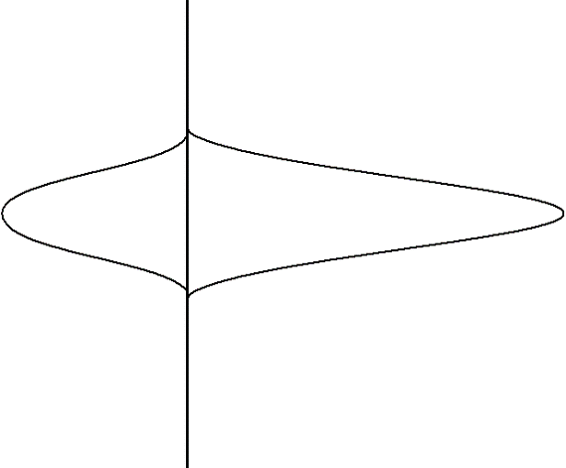
Concentration
Concentration
Mobile Phase
Stationary Phase
Flow

Figure 27. Representation of the concentration profiles for a compound distributed between the stationary (left) and mobile (right) phases of a chromatographic column. Note that the compound has a preference for the mobile phase.

What we want to do is consider what would happen to these two concentration profiles a brief instant of time later. Since the mobile phase is mobile and the solute molecules in it are moving, we could anticipate that the profile for the mobile phase would move ahead a small amount. Figure 28 illustrates this.

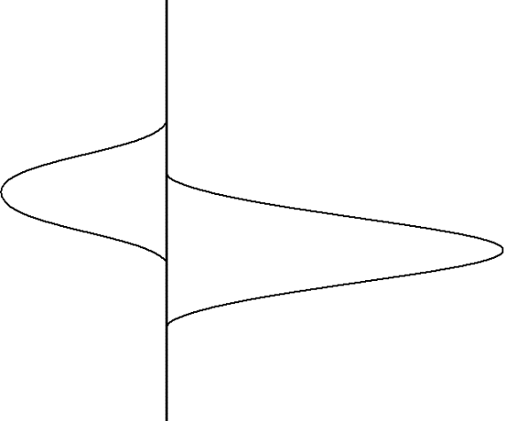
Concentration
Concentration
Mobile Phase
Stationary Phase
Flow

Figure 28. Representation of the two concentrations profiles in Figure 27 a brief instant of time later. Note that the mobile phase profile has moved ahead of the stationary phase profile.

What about the concentration profile for the solute molecules in the stationary phase? Consider the picture in Figure 29 for two solute molecules dissolved in the stationary phase of a capillary column and let’s assume that these are at the trailing edge of the stationary phase distribution.

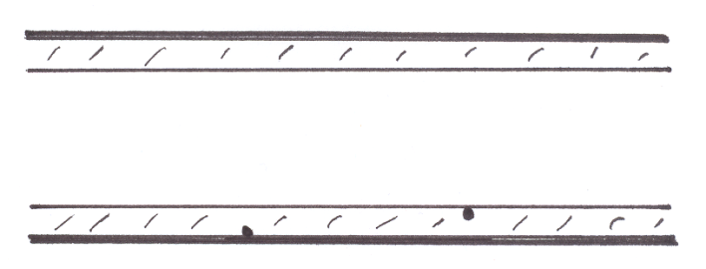
#1
Liquid Coating
#2
Figure 29. Two molecules dissolved in the liquid stationary phase of a capillary column.

What we observe is that the molecule labeled 1 is right at the interface between the stationary and mobile phase and provided it is diffusing in the right direction, it can transfer out into the mobile phase and move along. The molecule labeled 2, however, is “trapped” in the stationary phase. It cannot get out into the mobile phase until it first diffuses up to the interface. We refer to this process as mass transport. The solute molecules in the stationary phase must be transported up to the interface before they can switch phases. What we observe is that the solute molecules must spend a finite amount of time in the stationary phase. Since the mobile phase solute molecules are moving away, molecules stuck in the stationary phase lag behind and introduce a degree of broadening.

If we then consider the leading edge of the mobile phase distribution, we would observe that the molecules are encountering fresh stationary phase with no dissolved solute molecules and so these start to diffuse into the stationary phase when they encounter the surface. We can illustrate this in Figure 30 with arrows showing the direction of migration of solute molecules out of the stationary phase at the trailing edge and into the stationary phase at the leading edge.
Mobile Phase
Stationary Phase
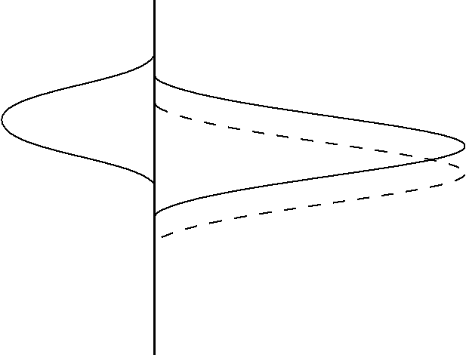
Concentration
Concentration
Flow

Figure 30. Representation of the movement of analyte molecules at the leading and trailing edge of the concentration distribution.

Hopefully it is obvious from Figure 30 that the finite time required for the molecules to move out of the stationary phase leads to an overall broadening of the concentration distribution and overall broadening of the peak.
A critical question to ask is whether the contribution of stationary phase mass transport broadening exhibits a dependence on the flow rate. Suppose we go back to the small amount of time in the first part above, but now double the flow rate. Comparing the first situation (solid line in the figure above) to that with double the flow rate (dashed line) leads to the two profiles. Hopefully it is apparent that the higher flow rate leads to a greater discrepancy between the mobile and stationary phase concentration distributions, which would lead to more broadening.

The term used to express mass transport broadening in the stationary phase is C_{S} (not to be confused with the C_{S} that we have been using earlier to denote the concentration of solute in the stationary phase). If we wanted to incorporate this into our overall band broadening equation, recognizing that higher flow rates lead to more mass transport broadening and reduced column efficiency (higher values of h), it would take the following form:

h = C_{S} v

Something we might ask is whether the flow rate dependency of the stationary phase mass transport term has any troublesome aspects. An alternative way to phrase this question is to ask whether we would like to use slow or fast flow rates when performing chromatographic separations. The advantage of fast flow rates is that the chromatographic separation will take place in a shorter time. Since “time is money”, shorter analysis times are preferred (unless you like to read long novels, and so prefer to inject a sample and then have an hour of reading time while the compounds wend their way through the column). If you work for Wenzel Analytical, we’re going to try to perform analyses as fast as possible and maximize our throughput. The problem with speeding up the flow rate too high is that we begin to introduce large amounts of stationary phase mass transport broadening. The shortening of the analysis time begins to be offset by broad peaks that are not fully separated. Ultimately, stationary phase mass transport broadening forces us to make a compromise between adequate efficiency and analysis time. You cannot optimize both at the same time.

Another thing we need to think about is what effect the thickness of the stationary phase has on the magnitude of stationary phase mass transport broadening. The pictures in Figure 31 for one wall of a coated capillary column serve to illustrate this point.

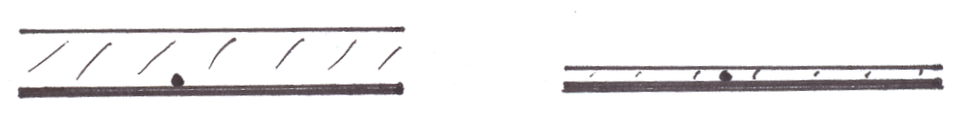

Figure 31. Representation for one wall of a coated capillary column with a thicker (left) and thinner (right) stationary phase coating.

Remember that the key point is that solute molecules spend a finite amount of time in the stationary phase, and since solute molecules in the mobile phase are moving away, the longer this finite time the worse. Therefore the thicker the phase, the more broadening will occur from stationary phase mass transport processes. This says that the ideal stationary phase coating ought to be microscopically thin, so that molecules rapidly diffuse into and out of the stationary phase, thereby reducing how far ahead mobile phase molecules can move in this finite amount of time. We should also be able to realize that the optimal coated phase ought to have a uniform thickness. If we have thin and thick regions as shown in Figure 32, we see that the time spent in the stationary phase by solute molecules will vary considerably, an undesirable situation. Compound 1 will likely spend less time in the stationary phase than compound 2.

#2
#1
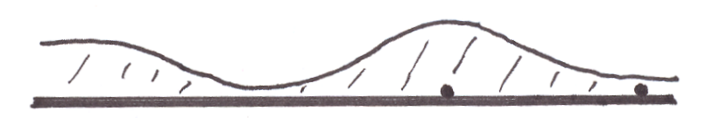

Figure 32. Representation of one wall of a coated capillary column with non-uniform thickness of the coating.

While microscopically thin coatings reduce stationary phase mass transport broadening, there are two problems with microscopically thin coated phases. If we consider the picture in Figure 31, where we have two capillary columns with different thickness coatings, the capillary column with the thinner coating will have much lower capacity than the one with the thicker coating. This means that there is much less weight of stationary phase over a theoretical plate for the column with the thinner coating and much less analyte dissolves into the stationary phase. Increasing the thickness of the coating or capacity of the column has several advantages. One is that it helps in the separation of the mixture (something we will learn more about later in the course). The other is that it is easy to overload or saturate a column that has a very low capacity.

This raises the question of whether you could design a column that has a thin stationary phase coating but high capacity. For coated capillary columns, this is not possible. A thinner coating in a capillary column means less capacity. For a coated packed column; however, it is possible to retain a high capacity while thinning the coating. Accomplishing this involves using smaller particles but the same weight of coating. Imagine taking large solid support particles and crushing them into a bunch of smaller particles. What you should realize is that the smaller particles have a much larger surface area. If we then coated the same amount of stationary phase (e.g., 5% by weight) relative to the weight of solid support, because of the larger surface area a thinner coating results. What we see is that the use of smaller particles has a theoretical advantage over the use of larger particles for coated stationary phases.

Another problem with coating microscopically thin phases is the risk of leaving some of the surface of the underlying solid support uncoated. These exposed solid surfaces (Figure 33) provide highly active sites for adsorption of solute molecules, and we have already seen how adsorption is an inefficient process that leads to peak tailing. While thin coatings have an advantage, great care must be taken in coating these phases to insure a complete coverage with uniform thickness of the surface.

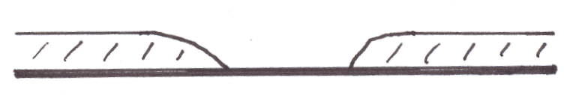
Exposed Solid
Surface
Figure 33. Representation of the wall of a coated capillary column showing an exposed solid surface.

Open tubular capillary columns are common in gas chromatography because it is possible to coat their inside walls with an exceptionally thin, uniform stationary phase. Today, it is also possible to chemically bond the liquid phase onto the interior surface of the capillary column. In the early days of capillary gas chromatographic columns, these were made of glass tubing that was approximately the same diameter as a melting point capillary that you are familiar with from organic chemistry. These columns were stretched from thick-walled glass tubes that were heated in an oven. As the capillary tube was stretched out, it was coiled in a coiling oven. It was common to use 30-meter lengths, essentially a 30-meter long glass slinky. The most common process for coating a capillary column involves what is known as the “moving plug” technique. As illustrated in Figure 34, the liquid stationary phase is dissolved in a plug of solvent that is pushed through the column using pressure from an inert gas. As the plug moves, it coats a very thin layer of liquid onto the inside walls of the column. As the solvent evaporates, a very thin layer of liquid stationary phase remains on the walls of the column. A systematic process is used to treat the inside walls of the column prior to coating to ensure that the liquid wets the surface well and is deposited uniformly over all of the interior surfaces.

Stationary Phase
in Solvent

Flow

Figure 34. Moving plug technique for coating a capillary column.

One problem with these glass columns was their fragility. Many frustrated workers broke the columns trying to mount them into a gas chromatograph with leak-proof fittings. The fittings used with these glass columns are usually made of graphite, a soft substance that often can be molded around the tube without breaking it (but if you’re not careful, it’s easy to break it). Another problem is caused by the chemical nature of glass. We think of glass as a silicate material (SiO₂), but it actually turns out that most silicate glasses contain other metal ions as constituents (aluminum, magnesium, calcium, and iron oxides are some of the other metals present). In some glasses, these other metals can be as much as 50% of the glass. These metals are positively charged centers, and if some of the surfaces are not coated by the liquid phase (an inevitable occurrence), these metal ions provide active sites for adsorption that cause tailing of compounds (especially oxygen- and nitrogen-containing compounds that have dipoles).

The capillary columns used in gas chromatography today are known as fused silica columns. Fused silica is pure silicon dioxide (SiO₂) and lacks the metal ions in regular glass. The surface of fused silica is considerably less active than the surface of regular glass. Fused silica is widely used in the production of devices known as fiber optics. Fiber optics are thin, solid glass fibers. Light is shined into one end of the fiber at an angle that causes complete internal reflection of the light as shown in Figure 35.

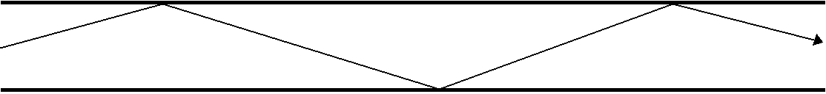

Figure 35. Complete internal reflection of a light beam inside a fiber optic.

Light going in one end (e.g., New York City) exits out the other end (e.g., Los Angeles, CA). The light can be pulsed (sent in small bursts) and the speed of light allows for very rapid communication. It turns out to be easy to make fiber optic-like devices with a hole in the center (in fact, it took people a while to learn how to make glass fibers without the hole since the fibers tend to cool from the outside to the inside, leading to contraction and a hole in the center). The hole in the center of fused silica capillary columns is so small you cannot see it with the naked eye (we will see later that this very small opening has advantages in chromatographic applications). Also, these capillary columns are incredibly flexible. They can be tied into knots, and more importantly for chromatographic applications, leak-tight fittings can be attached without breaking the columns. The deactivated surface, flexible nature making them easy to install and use, and chromatographic efficiency (partly because of the deactivated surface, partly because of how well they can be coated with thin phases, and partly because of the small diameter) make them the column of choice for most gas chromatographic applications today. The only drawback to these columns is that they have very small capacities. Gas chromatographs built to use fused silica capillary columns usually have what are known as split injection systems. A typical injection size for a gas chromatographic sample is 1 µL. Even this amount is too much for a fused silica capillary column, but reproducibly injecting smaller volumes is very difficult. Instead, the flow from the injector is split, and only a small part (often 1 in 50 to 1 in 100) is actually sent into the capillary column. The rest is vented away and never enters the column.

Another thing we need to examine under the topic of stationary phase mass transport broadening is the nature of the stationary phase used today in liquid chromatography. In 1963, Calvin Giddings published a significant paper titled “Liquid Chromatography with Operating Conditions Analogous to Those of Gas Chromatography” (Analytical Chemistry, 1963, 25, 2215). At this point in time, gas chromatography was the method of choice when performing analyses because existing gas chromatographic columns were far more efficient than the liquid chromatographic columns that were available. In fact, gas chromatography was so preferable to liquid chromatography that many publications of the 1960s and 1970s described ways of preparing volatile derivatives of non-volatile compounds so that they could be analyzed by gas chromatography. The extra steps involved in the derivatization were worthwhile since liquid chromatographic methods were not good enough to separate most compounds in complex mixtures.

What Giddings did in this paper was show that it was theoretically possible to perform liquid chromatography at the efficiency of gas chromatography. The key feature, which we have not yet fully developed because we have one more contribution to broadening to examine, was to use exceptionally small particles with exceptionally thin coatings in liquid chromatographic columns. Of course, these exceptionally thin coatings cause several problems. One is how to coat them so that none of the surface of the solid support is exposed. If you can coat them uniformly, another problem in a liquid chromatographic system is that there might be locations in the column where the flowing liquid mobile phase can physically wash away regions of the coated phase thereby exposing the underlying solid surface. Finally, there is no such thing as two liquids that are completely immiscible in each other. It’s true that oil and water don’t mix, but it’s also true that a little bit of oil will dissolve in water. Over time, the coated stationary phase will gradually dissolve away in the mobile phase, eventually exposing the underlying solid surface. Even though Giddings showed in 1963 how to perform liquid chromatography at the efficiency of gas chromatography, the phases that were needed could not be coated in a way that it was a widely practical method.

It was not until the late 1970s, when bonded liquid chromatographic stationary phases were introduced, that it was finally practical to do liquid chromatography with the same efficiency as gas chromatography. Bonded phases relied on silica gel, something we already encountered when we first talked about solid phase, adsorption chromatography. Silica gel is an excellent support for liquid chromatographic phases. It is physically robust, stable at pH values from about 2 to 8, and can be synthesized in a range of particle sizes including the very small particle sizes needed for liquid chromatography. The chemistry used in preparing bonded phases is shown in Figure 36. Basically this involves the surface derivatization of the silanol groups on the surface of the silica gel with chlorodimethyloctadecylsilane. The C₁₈ or octadecylsilane (ODS) phase shown in the scheme are the most common ones used. The pyridine is added to remove the HCl produced in the reaction.
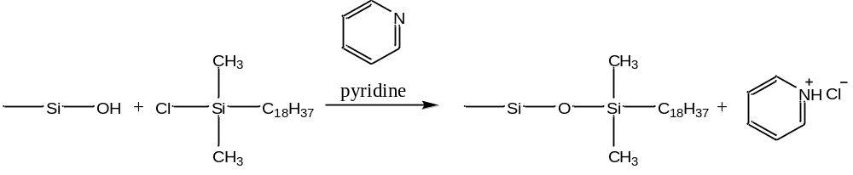
Figure 36. Scheme for bonding C₁₈ groups to the surface of silica gel.

Other common bonded phases use C₈ or C₁ surface groups. You can also purchase bonded phases with phenyl groups, C₃H₆NH₂ (aminopropyl) groups, and C₃H₆CN groups. But the C₁₈ phases are so common, and so versatile, that we will examine these in more detail.

The first thing to realize is that attaching the C₁₈ groups converts a highly polar surface (the silanol groups can form hydrogen bonds) into a non-polar surface. In effect, this is like attaching a one-molecule thick, oily skin to the surface of silica gel. There is some question about the exact conformation of the attached C₁₈ groups. Figure 37 shows two forms, one with the C₁₈ groups extended, the other with the C₁₈ groups collapsed. There is substantial evidence to support the idea that if the non-polar C₁₈ phase is in contact with a mobile phase that is very polar (e.g., water), that the C₁₈ groups are in the collapsed form. Putting the C₁₈ phase in contact with a less polar mobile phase (e.g, methanol) leads to more extension of the C₁₈ groups.

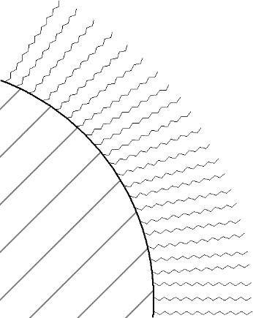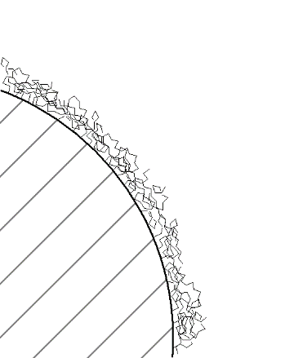
Collapsed Form
Extended Form

Figure 37. Extended and collapsed forms of C₁₈ groups bonded to the surface of silica gel.

If we examine the extended form of the C₁₈ phase, it is interesting to consider the nature of this material at the outer regions. Even though the C₁₈ groups are attached to a solid, are they long enough such that the outer edges are “fluid” enough to behave more like a liquid than a solid? If so, then molecules might distribute into these phases by a partitioning mechanism. If not, then molecules adsorb to the surface. We previously learned that adsorption was undesirable when compared to partitioning, but that was adsorption on a polar surface. The non-polar, deactivated nature of the C₁₈ surface does not provide strong adsorption sites so peak tailing is quite minimal with C₁₈ bonded phases.

If you look at most liquid chromatograms, though, you will see that the peaks tail more than in gas chromatography. The likely reason for this is that some of the surface silanol groups remain underivatized. Crowding of the C₁₈ groups during the derivatization process makes it unlikely that all of the silanols can be reached and deactivated. In an effort to minimize the number of unreacted silanol groups, some commercially available C₁₈ phases are end-capped. End capping involves exhaustively reacting the C₁₈ phase with a much smaller silane such as chlorotrimethylsilane (ClSi(CH₃)₃).

Because of the covalent bonds, the C₁₈ groups cannot wash or dissolve off of the solid support. With regards to mass transport in the stationary phase, we said that we want the stationary phase as thin as possible. C₁₈ bonded phases are essentially one-molecule thick. We could never coat a one-molecule thick chromatographic phase that was uniform and had no exposed solid surfaces. Therefore, we could never really make a liquid chromatographic phase with faster stationary phase mass transport properties than the bonded silica phases.

Until recently, the common particle sizes to find in commercially available C₁₈ columns had diameters of 3, 5, and 10 µm. Columns using particles of these sizes are commonly referred to as high performance liquid chromatography (HPLC). Recently columns with 1.7 or 1.8 um particles have become commercially available and there use is referred to as ultra-high pressure liquid chromatography (UPLC). Smaller particles will require higher pressures to force a liquid through the column and UPLC columns can run at pressures up to 15,000 psi. In gas chromatography, we observe that smaller particles usually have thinner coatings because they have more surface area. Note that for these bonded phases the thickness of the stationary phase with the 1.7, 3, 5, and 10 µm particles is always identical. What does change is the surface area. A column packed with 3 µm particles will have more surface area than a column of the same length packed with 5 or 10 µm particles. This increased surface area leads to an increase in the column’s capacity. If the columns are the same length, the increased capacity will lead to increased separation of compounds and lengthen the retention times. The usual approach is to use shorter columns with the smaller particles. The shorter column reduces the analysis time because there is less volume of mobile phase in the column. Typically C₁₈ columns packed with 10 µm particles are 25 cm long; 5 µm particles are used in columns that are 15 cm long; and 3 µm particles are used in columns that are 3 cm long. These $\text{3×3}$ columns can have very short analysis times. A negative aspect is that they are more susceptible to fouling by contaminants in the sample. Also, a difficulty with ultra-small particles involves packing the columns so that there are no channels. Because of the small particles, liquid chromatographic columns require highly specialized packing procedures. Finally, the particles need to have uniform sizes (the smaller the particle, the smaller the tolerance on the range of particle sizes that can be used). A mixture of particles of different sizes is known as an aggregate. Concrete is an excellent example of an aggregate. The problem with an aggregate is that the smaller particles fill in the voids between the larger particles, making it very difficult to get a liquid to flow through the bed.

One last thing we can consider is whether stationary phase mass transport broadening is more significant in gas or liquid chromatography. We have to be careful here, because it’s a somewhat subtle distinction. What we need to consider is the diffusion rate of the solute in the stationary phase. In gas chromatography, we have a gaseous molecule dissolved in a liquid coating. The important thing is that it is a dense liquid with a molecule dissolved in it. The diffusion rate is therefore rather comparable in this stationary phase to that of a liquid. Of course, a liquid chromatographic column is usually at room temperature whereas a gas chromatographic column is usually at some elevated temperature that is often higher than 100ºC. We know that diffusion rates are temperature dependent, so that the rate ought to be faster in gas chromatography, and mass transport broadening in the stationary phase ought to be more significant in liquid chromatography, assuming everything else is equal. Just realize that this is not a 100,000-fold difference, because the stationary phase in gas chromatography is not a gas, but a heated liquid. It is also possible to operate liquid chromatographic columns at higher temperatures to speed up the rate of diffusion and improve the mass-transport broadening.

Mobile Phase Mass Transport Broadening

It’s going to turn out that a similar mass transfer effect occurs within the mobile phase. The thing to consider here is that we want solute molecules to encounter the surface of the stationary phase as quickly as possible so that they can immediately undergo a distribution between the two phases.

For example, if we reconsider the picture for mass transport broadening in the stationary phase (Figure 38), we realize that we want the molecules at the leading edge of the mobile phase profile to quickly encounter and enter the stationary phase, otherwise they will move further ahead and broaden the distribution.
Mobile Phase
Stationary Phase
Flow
Concentration
Concentration

Figure 38. Representation of the movement of analyte molecules at the leading and trailing edge of the concentration distribution.

Another way to examine mobile phase mass transport broadening is to consider a capillary column as shown in Figure 39.

Flow
Stationary Phase

Figure 39. Capillary column showing a molecule (black dot) that has just left the stationary phase.

The dot represents a molecule that has just left the stationary phase and is about to diffuse across the mobile phase and re-encounter stationary phase on the other side of the column.
It is helpful to draw a line representing the path of the molecule, and then draw a second line for the path of the molecule if the flow rate were doubled (Figure 40). We could also imagine a situation in which the flow was so fast that the molecule never re-encountered the stationary phase. This would be a problem since it’s important for the molecule to encounter the stationary phase if we are to ever have a distribution occurring that leads to a separation of two compounds.

Flow
Stationary Phase

Figure 40. Representation of the movement of a molecule as it diffuses through the mobile phase. The longer the arrow, the higher the flow rate.

If we are using capillary columns in a chromatographic system, what does this observation above suggest about the desirable diameter for such a column? Hopefully it would be apparent that a much smaller column diameter would lead to much faster encounters with the stationary phase. So we want capillary columns of very small diameter. That is one of the reasons why the fused silica columns used today in gas chromatography are so efficient. We can not even see the opening in these columns with the naked eye. They really approach the limit of how narrow we are able to make chromatographic capillary columns.

Next we need to ask whether this effect occurs in a packed column. If we think about a packed column, we should realize that there are voids, or interstitial volume, between the particles that make up the packing (Figure 41). Solute molecules need to diffuse across these voids to encounter the stationary phase. The larger the void, the more time it takes to diffuse across, and the more significant the mobile phase mass transport broadening. How can we reduce the voids? If we use smaller particles, they will pack closer together and reduce the interstitial volume between the particles. Once again, we see how small particles offer a theoretical advantage when compared to large particles. Note that this has happened in every instance when particle size made a difference. Using a packing material with smaller particles is better, provided we pack a good column with minimal to no channeling.

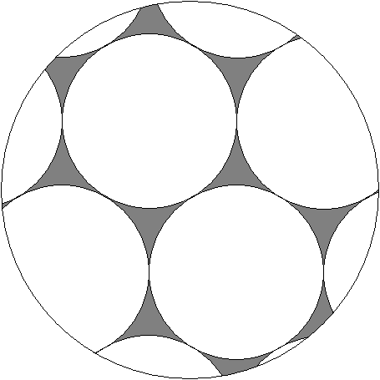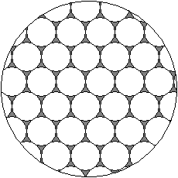
Interstitial
Volume

Figure 41. Representation of a packed column showing the interstitial regions.

Another critical question to consider is whether mobile phase mass transport broadening is more significant in gas or liquid chromatography. To answer this, we need to realize that we want the solute compound to diffuse across regions of mobile phase as fast as possible. If we remember that gases diffuse about 100,000 times faster than liquids, we realize that the impact of mobile phase mass transport broadening is significantly lower for gases than it is for liquids. In fact, mobile phase mass transport broadening is the most important distinction between gas and liquid chromatography. Gases diffuse far more quickly across regions of mobile phase than do liquids. That means in liquid chromatography we need far smaller mobile phase voids to reduce the magnitude of this term. When Giddings published his important paper in 1963 on doing liquid chromatography with the efficiency of gas chromatography, this was a critical realization put forward in this paper.

What does this mean for practical applications of liquid chromatography? If we were to try to perform capillary liquid chromatography, it would mean that we ought to have columns with much smaller internal diameters than we use for gas chromatography. But gas chromatography already uses fused silica columns, which essentially reach the limit of practical internal diameters (remember, if we reduced this diameter even smaller, we introduce a problem of not having enough sample capacity in the column and would have a very difficult time actually introducing sample into the column), so capillary liquid chromatography is not a practical method and does not offer the same advantages of capillary gas chromatography. There are researchers who investigate aspects of capillary liquid chromatography, but it is not a commercial method and is not used widely by practitioners in the field. As far as packed column liquid chromatography, we have already seen how we end up using very small particles (1.7, 3, 5, and 10 µm). The real value of these small particles is that they reduce the interstitial volume of mobile phase between the particles, thereby reducing the time required for mobile phase mass transport. Gas chromatography can be done with much larger particles because of the much faster mobile phase mass transport.

Another aspect of the particles used in most liquid chromatographic phases is that they are totally porous. In many ways, they resemble a sponge with pores going throughout the structure. With such a highly porous structure, it is reasonable to expect that there could be some “dead-end” pores. Such pores would fill with mobile phase and essentially provide regions within the particle of “immobile” mobile phase. Solute diffusion through these regions would represent a similar mass transport problems as solute diffusion within the stationary phase. So mass transport within these stagnant regions of mobile phase is a significant problem. A way to improve the broadening is to use something called a core-shell particle (Figure 42). In these particles, the inner part is a solid material without any pores. Only a small outer shell is porous and has the bonded C₁₈ groups. Core-shell particles have much faster mass transport than totally porous particles and therefore much smaller plate heights and narrower peaks. Core-shell particles also lead to improvements in the Eddy Diffusion term as well. Core-shell particles will have less stationary phase than totally porous particles, meaning they have lower capacity and the columns can be more easily overloaded.

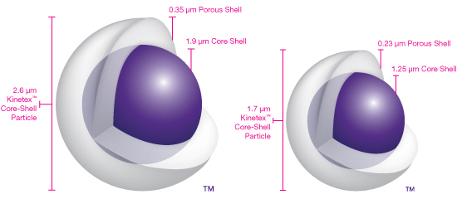

Figure 42. Representation of core-shell liquid chromatographic phases.

The last thing we could consider about mobile phase mass transport broadening is whether its overall contribution to band broadening depends on flow rate. If we go back to our initial picture of the capillary column, we know that we want the solute molecules to encounter stationary phase as often as possible. The faster the flow, the fewer encounters, so a faster flow makes this contribution worse (this is analogous to the leading edge of the mobile phase distribution moving ahead more per unit time, thereby causing more broadening of the overall distribution). If we needed to write a term to go into our equation for h, and we represent mobile phase mass transport broadening as C_{M} (be careful not to confuse this with C_{M} the concentration of solute in the mobile phase that we have used earlier), the term would take the following form:

h = C_{M} v

Notice how the relationship is analogous to what we saw with mass transport broadening in the stationary phase.

Concluding Comments – Peak broadening in Chromatographic Systems
Can you now draw a generalized plot of h versus flow rate?

We have now developed all four contributions to peak broadening in chromatographic systems, compared their significance in gas and liquid chromatography, and seen how current state-of-the-art columns have been designed to minimize band broadening effects. We can now pull together all four of the contributions into one equation that reflects overall contributions to peak broadening. It is shown below, using one common way of expressing the eddy diffusion term:

h = Av^{1/3} + B/v + C_{S} v + C_{M} v

It is worthwhile examining the overall form of this expression. First note how the longitudinal diffusion term (B/v) will become very large at very low flow rates. Note how the mass transport terms (C_{S} v and C_{M} v) will become very large at very high flow rates. This implies that this equation will have a minimum at some intermediate flow rate. A generalized plot of this equation for a gas chromatographic packed column is shown in Figure 43. The general contributions of the longitudinal diffusion and mass transport terms to the equation are also represented. The optimal flow rate for a gas chromatographic packed column is around 15 to 20 mL/minute. A lot of times people actually run these at higher flow rates of about 30 mL/minute. The reason for this is to shorten the analysis time. Some column efficiency is sacrificed, but the entire separation process is a balance between chromatographic efficiency and analysis time, where there is a desirability to shorten this if possible.

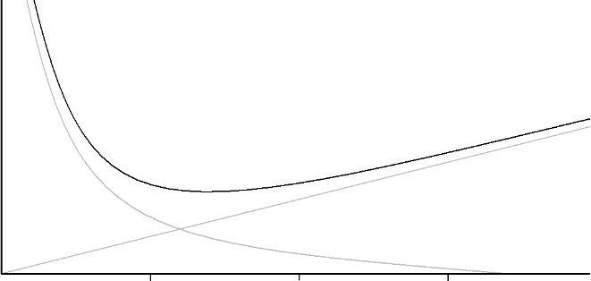
B/v
10
30
20
(C_{S} + C_{M}) v
h
Flow Rate (v) (mL per minute)

Figure 43. Generalized van Deemter plot for a packed gas chromatographic column.

A similar plot is shown in Figure 44 for liquid chromatography. Notice in this case that extremely low flow rates must be used before longitudinal diffusion becomes a significant contribution to broadening. This means that the optimal flow rate for liquid chromatographic separations is very slow, which is undesirable because of the long analysis times this would create. Instead, a common flow rate for a packed C₁₈ liquid chromatographic column is in the 1.0 to 1.5 mL/minute range.

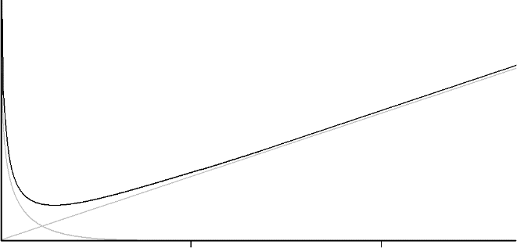
B/v
1.0.5
2.0
(C_{S} + C_{M}) v
h
Flow Rate (v) (mL per minute)

Figure 44. Generalized van Deemter plot for a packed liquid chromatographic column.

Earlier we learned that smaller particles are preferable and provide more efficient liquid chromatographic columns by virtue of reducing the contributions of eddy diffusion and mobile phase mass transport to peak broadening. Figure 45 shows a van Deemter plot for liquid chromatographic columns three porous silica particles with diameters of 5, 3.5 and 1.8 um and fused-core particles with a diameter of 2.7 um. The enhanced efficiency, as evidenced by reductions in the plate height, for smaller particles and the fused-core particles are apparent.

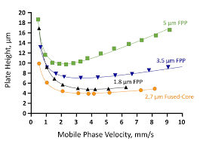
Figure 45. van Deemter plot for a packed liquid chromatographic column containing porous silica particles with diameters of 5, 3.5 and 1.8 um and fused-core particles with a diameter of 2.7 um.

For capillary GC columns, which are more commonly used today than packed GC columns, instead of setting a column flow rate you often set the column head pressure to a value recommended by the instrument manufacturer. By adjusting the pressure of the carrier gas (usually helium) at the beginning of the column, this insures an adequate flow of gas through the column. The desired head pressure depends on the length and internal diameter of the capillary column. Longer or narrower columns will require higher pressures to maintain adequate flow. One observation is that the pressure of the gas drops from the beginning to the end of the column, such that the flow rate changes over the column as well. Instead of measuring a flow rate for a fused silica capillary column in mL/min, it is more common to measure the carrier gas velocity (u) in cm/sec. Since this value changes as well over the column, an average value is obtained by dividing the column length in cm by the retention time in seconds of an unretained compound.

u (cm/sec) = | ___column length (cm)___
u (cm/sec) = | RT of unretained peak (sec)

A plot of the plate height versus carrier gas velocity for a column that is 25 m long and has a 0.25 mm internal diameter is shown in Figure 46. The characteristic observation of an optimum velocity as which to minimize peak broadening is observed.

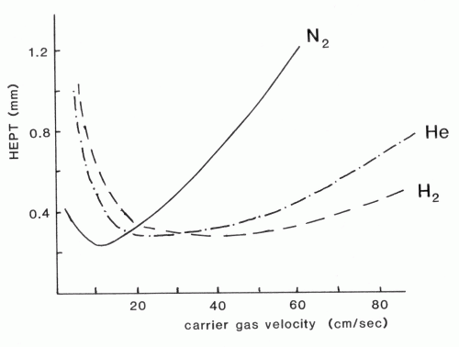

Figure 46. van Deemter plots for a capillary gas chromatographic column.

Why is the plot different for nitrogen versus helium as the carrier gas? The key difference between nitrogen and helium is the viscosity of the two gases. Nitrogen, as a heavier molecule, will have a higher viscosity than helium. The higher viscosity of nitrogen slows down the diffusion rates and increases the contribution of mobile phase mass transport broadening. Using helium as the carrier gas leads to improved efficiency because of the reduction in mobile phase mass transport broadening relative to nitrogen. Also, the u_{opt} for helium is at a higher flow rate meaning that the analysis time can be shortened. This plot shows that hydrogen would actually be a better carrier gas than helium. Hydrogen is rarely used as a carrier gas because of its explosion risk.

