CHROMATOGRAPHY – BACKGROUND

Chromatography refers to a group of methods that are used as a way of separating mixtures of compounds into their individual components. The basic set up of a chromatographic system is to have two phases, one stationary and one mobile. A compound, which we will usually call the solute, is introduced into the system, and essentially has a choice. If it is attracted to the mobile phase (has van der Waal attractions to the mobile phase), it will move through the system with the mobile phase. If it is attracted to the stationary phase, it will lag behind. It’s easy to imagine some solute compounds with some degree of attraction for both phases, such that these move through the system with some intermediate rate of travel.

The first report of a chromatographic application was by Mikhail Tswett, a chemist from Estonia, in 1903. (A list of important literature articles is provided at the end). Undoubtedly other people had observed chromatography taking place, but no one until Tswett recognized its applicability for the separation of mixtures in chemistry. Tswett was interested in separating the pigments in plants. He packed a glass column that might have been comparable to a buret with starch, mashed up the plant and extracted the pigments into a solvent, loaded the solution onto the top of the starch column, and ran a mobile phase through the starch. Eventually he saw different color bands separate on the column, hence the term chromatography. Rather than eluting the colored bands off of the column, he stopped it, used a rod to push out the starch filling, divided up the bands of color, and extracted the individual pigments off the starch using an appropriate solvent. Twsett used a solid stationary phase (starch) and a liquid mobile phase.

Chromatographic systems can use either a gas or liquid as the mobile phase. Chromatographic systems can use either a solid or liquid as the stationary phase. A solid stationary phase is easy to imagine, as we have already seen for Tswett’s work. Another common example is to use paper as the solid (actually, paper is made from a compound called cellulose). The sample is spotted onto the paper as shown in Figure 1a, and the bottom of the piece of paper is dipped into an appropriate liquid (note that the spot is above the liquid – Figure 1b). The liquid mobile phase moves up the paper by capillary action, and components of the mixture can separate into different spots depending on their relative attraction to the cellulose or chemicals that make up the liquid (Figure 1c).
(c)
(a)
(b)

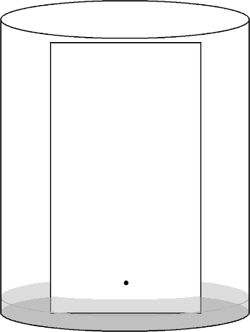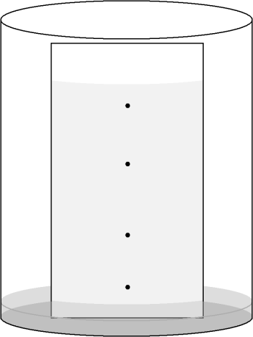
Solvent Front
Sample Spot

Figure 1. Paper chromatography

Another type of chromatography that you may be familiar with is thin layer chromatography (TLC). This is very similar to paper chromatography, although the stationary phase is usually a coating of small particles of a material known as silica gel (silica gel is a polymer with the formula SiO₂, although a bit later we will talk in more detail about the exact chemical nature of this material) on a glass or plastic plate. Similarly, we could take these silica gel particles and pack them into a glass column, and then flow a liquid through the column. If we used some gas pressure to force the liquid through the silica gel column more quickly, we would have a common technique known as flash chromatography that synthetic chemists use to separate relatively large amounts of materials they have prepared. Another common solid to use in column chromatography is alumina (Al₂O₃ is the general formula, although we will say more later about its exact chemical nature).

These methods we have just been talking about are examples of liquid-solid chromatography. If we used gas as the mobile phase, injected either a gaseous sample or liquid sample into a high temperature zone that flash volatilized it, with some solid as the stationary phase (there are a range of possible materials we could use here), we could perform gas-solid chromatography. If we thought about how a solute compound would interact with such a solid stationary phase, we would realize that it must essentially “stick” to the surface by some intermolecular (van der Waal) forces. This sticking process in chromatography is known as adsorption.

Earlier I said that it is also possible to use a liquid as the stationary phase. This might seem odd at first, because it would seem as if the flowing mobile phase would somehow push along a liquid stationary phase. The way to use a liquid as the stationary phase is to coat a very thin layer of it onto a solid support, as illustrated in Figure 2.
Solid Support
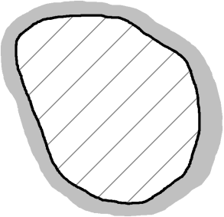
Liquid Coating

Figure 2. Liquid phase coated onto a solid support.

Alternatively, it is possible to coat a liquid phase onto the inside walls of a small-diameter, open-tubular column (known as a capillary column) as shown in Figure 3.

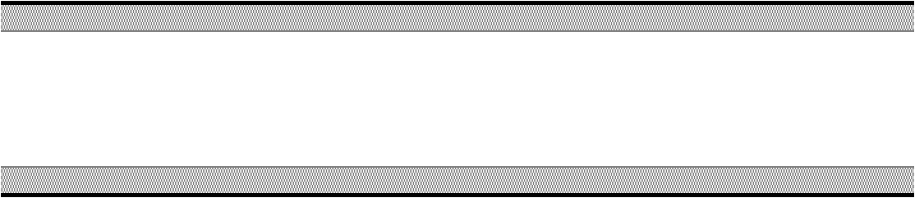
Liquid
Coating
Flow

Figure 3. Liquid phase coated onto the inside walls of a capillary column.
The liquid coating has some attractive forces for the underlying solid surface, such that it sticks to the surface and stays in place. We could probably see how we could easily have a gas flowing around a packed bed of such particles and, so long as the liquid coating did not evaporate, it would stay in place on the particles. Flowing a liquid around it might be a bit more problematic, and we will examine that in length later in this unit. Suffice it to say, though, that it can be done. This would lead to gas-liquid and liquid-liquid chromatographic methods. The interaction of a solute compound with a liquid stationary phase is different than with the solid stationary phases discussed above. It will still depend on having attractive intermolecular forces, but instead of sticking to the solid surface by adsorption, the solute molecule will now dissolve into the liquid stationary phase. If a solute molecule dissolves into a liquid stationary phase in a chromatographic system, we say that the molecule partitions between the two phases.

These two terms are so important in chromatographic systems that it is worth summarizing them again:

Adsorption – describes the process of a solute molecule adhering to a solid surface

Partition – describes the process of a solute molecule dissolving into a liquid stationary phase

There are two terms we can describe in chromatography that are analogous to those we already described for liquid-liquid extraction. One of these is the distribution constant (K_{C}) that is the ratio of the concentration of the solute in the stationary phase (C_{S}) to that in the mobile phase (C_{M}).

$${\text{K}}_{\text{C}} \text{= }\frac{{\text{C}}_{\text{S}}}{{\text{C}}_{\text{M}}}\text{ = }\frac{{{\text{mol}}_{\text{S}}}/{{\text{V}}_{\text{S}}}}{{{\text{mol}}_{\text{M}}}/{{\text{V}}_{\text{M}}}}\text{ = }\frac{{\text{mol}}_{\text{S}} \text{×} {\text{V}}_{\text{M}}}{{\text{mol}}_{\text{M}}\text{ × }{\text{V}}_{\text{S}}}$$

But just like in liquid-liquid extraction, a problem with this ratio is that the volumes of the stationary and mobile phases might be significantly different from each other. With a solid stationary phase, V_{S} is comparable to the surface area of the particles. With a liquid stationary phase, the coating is usually so thin that V_{M} would be much larger than V_{S}. In many cases, a more useful term is the partition coefficient (K_{X}), which is the ratio of the moles of solute in each of the two phases.
$${\text{K}}_{\text{X}}\text{ = }\frac{{\text{mol}}_{\text{S}}}{{\text{mol}}_{\text{M}}}$$

Notice that we can relate K_{C} to K_{X} because the mole ratio shows up in both. That allows us to write the following:
$${\text{K}}_{\text{C}}\text{ = }{\text{K}}_{\text{X}}\left(\frac{{\text{V}}_{\text{M}}}{{\text{V}}_{\text{S}}}\right)$$

There are also some other fundamental figures of merit that we often use when discussing chromatographic separations. The first is known as the selectivity factor (α). In order to separate two components of a mixture, it is essential that the two have different distribution or partition coefficients (note, it does not matter which one you use since the volume terms will cancel if K_{C} is used). The separation factor is the ratio of these two coefficients, and is always written so that it is greater than or equal to one. K₂ represents the distribution coefficient for the later eluting of the two components.
$$\text{α = }\frac{{\text{K}}_{\text{2}}}{{\text{K}}_{\text{1}}}$$

If α = 1, then there will be no separation of the two components. The larger the value of α, the greater the separation. One thing to realize is that there is some limit as to how large we want an
α -value to be. For example, the chromatogram in Figure 4b has a much greater α value than that in Figure 4a. But the two components are fully separated so that the extra time we would need to wait for the chromatogram in Figure 4b is undesirable. In most chromatographic separations, the goal is to get just enough separation, so that we can keep the analysis time as short as possible.

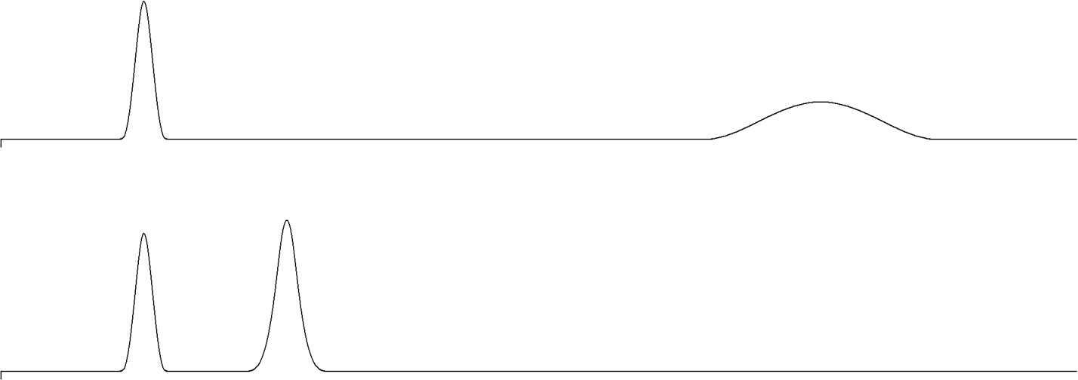
(a)
(b)
INJ
INJ

Figure 4. Elution of compounds where the α-value in (b) is much greater than the α-value in (a).

Another important figure of merit in chromatographic separations is known as the retention factor (k), which is a measure of the retention of a solute, or how much attraction the solute has for the stationary phase. The k term was formerly known as the capacity factor. The retention factor is actually identical to the partition coefficient.

$$\text{k = }\frac{{\text{mol}}_{\text{S}}}{{\text{mol}}_{\text{M}}}\text{ = }\frac{{\text{C}}_{\text{S}}{\text{V}}_{\text{S}}}{{\text{C}}_{\text{M}}{\text{V}}_{\text{M}}}\text{ = }{\text{K}}_{\text{C}}\left(\frac{{\text{V}}_{\text{S}}}{{\text{V}}_{\text{M}}}\right)$$

We can determine k values from a chromatogram using the following equation:

$$\text{k = }\frac{{\text{t}}_{\text{R}}- {\text{t}}_{\text{0}}}{{\text{t}}_{\text{0}}}$$
t_{R}
t₀

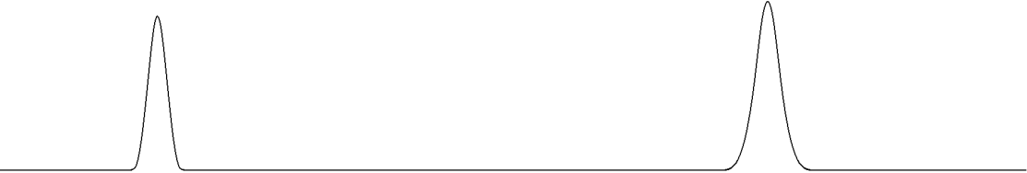

Figure 5. Chromatographic information used to calculate the k value for a peak.

As seen in Figure 5, the term t_{R} is the retention time of the compound of interest, whereas t₀ refers to the retention time of an unretained compound (the time it takes a compound with no ability to partition into or adsorb onto the stationary phase to move through the column). Since t₀ will vary from column to column, the form of this equation represents a normalization of the retention times to t₀.

Another important figure of merit for a chromatographic column is known as the number of theoretical plates (N). It turns out that one helpful way to think of a chromatographic column is as a series of microscopically thin plates as shown in Figure 6. Using the picture in Figure 6, we

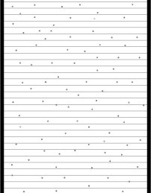

Figure 6. Representation of a chromatographic column as a series of microscopically thin plates.

could imagine a compound moving down the column as a series of steps, one plate at a time. The compound enters a plate, distributes according to its distribution coefficient between the stationary and mobile phase, and then moves on to the next plate. Now it turns out that chromatographic systems never really reach equilibrium, and in fact are not steady state systems, but things like the distribution and partition coefficients, which are equilibrium expressions, are useful ways to examine the distribution in chromatographic systems. A compound with less favorable solubility in the stationary phase would then move through the series of plates faster. The only way to separate two compounds is to have enough plates, or enough equilibrations, to exploit the difference in partition coefficients between the two compounds. A column with more theoretical plates is more likely to separate two compounds than one with fewer.

We can determine the number of plates for a compound as shown in Figure 7.

$$\text{N = 16}{\left(\frac{{\text{t}}_{\text{R}}}{\text{W}}\right)}^{\text{2}}$$
t_{R}

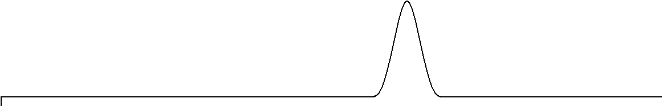
W
INJ

Figure 7. Chromatographic information used to determine N for a column.

W is the width of the peak where it intersects with the baseline. The important thing to remember is to use the same units when measuring W and t_{R} (e.g., distance in cm on a plot, time in seconds, elution volume in mL – which is common in liquid chromatography). It should be pointed out that a column will have a set number of plates that will not vary much from compound to compound. The reason for this is that a compound with a longer retention time will exhibit a larger peak width, such that the ratio term is correcting for these two effects.
If we determine the number of plates for a column, dividing the column length (L) by the number of plates leads to the height equivalent to a theoretical plate (H). Note that the smaller the value of H the better. It actually turns out the H is the important figure of merit for a column.

$$\text{H = }\frac{\text{L}}{\text{N}}$$

The chromatograms in Figure 8 show the distinction between a column with a smaller value of H (Figure 8a) and one with a much larger value of H (Figure 8b).

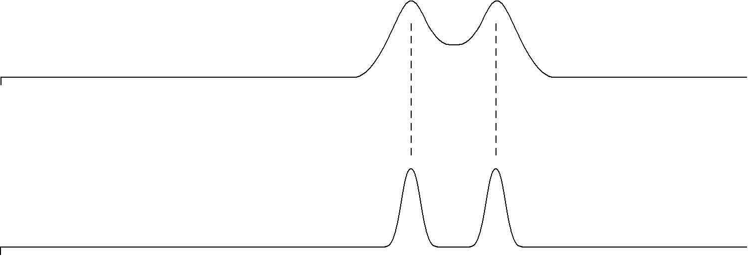
(b)
(a)
INJ
INJ

Figure 8. Chromatograms for a column with (a) a smaller value of H and (b) a larger value of H.

Usually today, though, people refer to something called the reduced plate height (h) for a column. The reduced plate height is defined as shown below, in which d_{p} is the particle diameter of the packing material used in the column (or the internal tube diameter if an open tubular capillary column is used).
$$\text{h = }\frac{\text{H}}{{\text{d}}_{\text{p}}}$$

You will also come across a term known as the reduced velocity (ν) in the chromatographic literature. The reduced velocity is defined as follows, in which v is the mobile phase velocity, and D_{M} the diffusion coefficient of the solute in the mobile phase.

$$\text{v}\text{ = }\frac{{\text{d}}_{\text{p}} \text{×} \text{v}}{{\text{D}}_{\text{M}}}$$

Finally, we can define an equation for the resolution (R_{S}) of two compounds. This will be a measure of how much two compounds in a chromatogram are separated from each other.

$${\text{R}}_{\text{S}}\text{ = }\frac{\text{2(}{\text{t}}_{\text{2}}- {\text{t}}_{\text{1}}\text{)}}{{\text{W}}_{\text{1}}\text{ + }{\text{W}}_{\text{2}}}$$

The terms t₂ and t₁ refer to the retention time of the two compounds, and W₁ and W₂ to the width of each peak at baseline.

Figure 9 shows the separation of two peaks at resolution values of 0.75 (Figure 9a), 1.0 (Figure 9b) and 1.5 (Figure 9c). The better separation of A and B that occurs with increasing resolution is obvious. It is also worth noting that the analysis time is longer the higher the resolution. Chromatographic analyses are always a compromise between the degree of separation of the peaks and how long it takes to perform the analysis. In many cases, the goal is to get just enough separation in the shortest period of time.

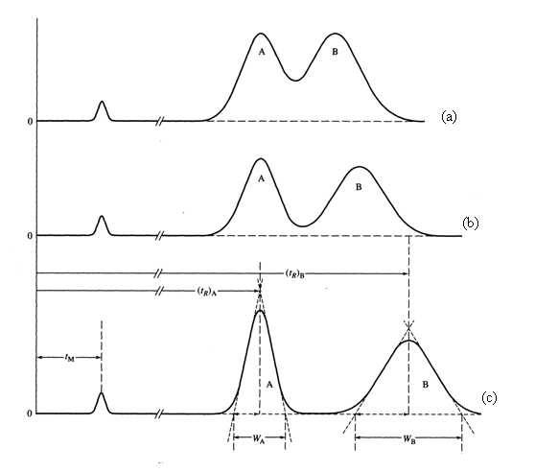

Figure 9. Separation of two peaks with resolution values of (a) 0.75, (b) 1.0 and (c) 1.5.

Distribution Isotherms (Isotherm means constant temperature):

We have used the distribution and partition coefficients as ways to express the distribution of a molecule between the mobile and stationary phase. Note that these equations take the form of equilibrium expressions, and that K_{C} is a constant for the distribution of a solute compound between two particular phases. (K_{X} depends on the relative volumes of the two phases.)

Suppose that we plotted C_{S} versus C_{M}, as shown on the coordinate system in Figure 10.

C_{S}

C_{M}

Figure 10. Coordinate system with the concentration of analyte in the stationary phase (C_{S}) shown on the y-axis and the concentration of analyte in the mobile phase (C_{M}) shown on the x-axis.

Notice that C_{M} plus C_{S} would give the total amount of the solute injected. So as you move to the right on the C_{M} axis, it means that more sample is being injected into the chromatograph. If we have the expression for the distribution coefficient:

$${\text{K}}_{\text{C}}\text{ =} \frac{{\text{C}}_{\text{S}}}{{\text{C}}_{\text{M}}}\text{ = constant}$$

The idealized form of the plot of the distribution isotherm is shown in Figure 11. If we inject more sample into the column, it distributes according to a set ratio of the distribution coefficient. The result would be a straight line, with the slope being the distribution coefficient.

Slope = K_{C}

Ideal Behavior
C_{S}

C_{M}

Figure 11. Idealized plot of the distribution isotherm.

If we examine this in more detail, though, we will realize that the volume of stationary phase is some fixed quantity, and is usually substantially less than the volume of the mobile phase. It is possible to saturate the stationary phase with solute, such that no more can dissolve. In that case, the curve would show the behavior shown in Figure 12, a result known as the Langmuir isotherm (Langmuir was a renowned surface scientist and a journal of the American Chemical Society on surface science is named in his honor). If we get a region of Langmuir behavior, we have saturated the stationary phase or overloaded the capacity of the column.

C_{S}
Langmuir Isotherm

C_{M}

Figure 12. Plot of the Langmuir isotherm.

We might also ask whether you could ever get the following plot, which is called anti-Langmuir behavior (Figure 13).
C_{S}

Anti-Langmuir Isotherm

C_{M}

Figure 13. Plot of the anti-Langmuir isotherm.

There are actually two ways this could happen. One is if the solute dissolves in the stationary phase, creating a mixed phase that then allows a higher solubility of the solute. This behavior is not commonly observed. Another way that this can occur is in gas chromatography if too large or concentrated a sample of solute is injected. At a fixed temperature, a volatile compound has a specific vapor pressure. This vapor pressure can never be exceeded. If the vapor pressure is not exceeded, all of the compound can evaporate. If too high a concentration of compound is injected such that it would exceed the vapor pressure if all evaporates, some evaporates into the gas phase but the rest remains condensed as a liquid. If this happens, it is an example of anti-Langmuir behavior because it appears as if more is in the stationary phase (the condensed droplets of sample would seem to be in the stationary phase because they are not moving).

The last question we need to consider is what these forms of non-ideal behavior would do to the shape of a chromatographic peak. From laws of diffusion, it is possible to derive that an “ideal” chromatographic peak will have a symmetrical (Gaussian) shape. Either form of overloading will lead to asymmetry in the peaks. This can cause either fronting or tailing as shown in Figure 14.

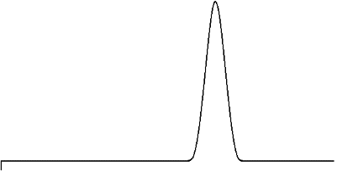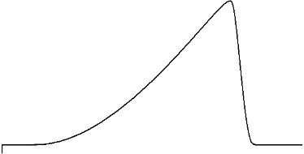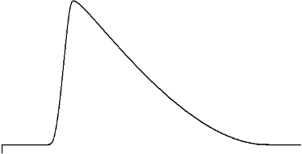
Ideal
INJ
INJ
Fronting
Tailing
INJ

Figure 14. Representation of a chromatographic peak exhibiting ideal peak shape, fronting, and tailing.

Adsorption Compared to Partition as a Separation Mechanism

If we go back now and consider Tswett’s first separation, we see that he used solid starch as the stationary phase, and so solutes exhibited an adsorption to the surface of the starch. A useful thing to consider is the nature of the chemical groups on the surface of starch. Starch is a carbohydrate comprised of glucose units. The glucose functionality of starch is shown below, and we see that the surface is comprised of highly polar hydroxyl groups.

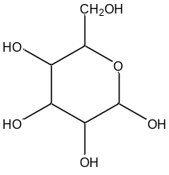
Glucose

Silica gel (SiO₂) and alumina (Al₂O₃) were mentioned previously as two other common solid phases. If we examine the structure of silica gel, in which each silicon atom is attached to four oxygen atoms in a tetrahedral arrangement (this corresponds to two silicon atoms sharing each of the oxygen atoms), we run into a problem when you try to create a surface for this material. If we have an oxygen atom out on the edge, we would then need to attach a silicon atom, which necessitates more oxygen atoms. We end up with a dilemma in which we can never wrap all of these around on each other and only make something with the formula SiO₂. Some of these groups are able to do this and some of the surface of silica gel consists of what are known as siloxane (Si–O–Si) groups. But many of the outer oxygen atoms cannot attach to another silicon atom and are actually hydroxyl or silanol (Si–OH) groups.

–Si–O–Si– –Si–OH

Siloxane units Silanol units

What we notice is that the surface of silica gel consists of very polar hydroxyl groups. It turns out that the same thing will occur for the surface of alumina.

If we consider a solute molecule (S), and have it adsorb to the surface of silica gel, we could write the following equation to represent the process of adsorption.

Si–OH + S  Si–OH - - - S

With any reaction we can talk about its enthalpy and entropy. So in this case, we could talk about the enthalpy of adsorption (ΔH_{ADS}). Suppose now we took one solute molecule and millions of surface silanols, and went through one by one and measured ΔH_{ADS} for this one solute molecule with each of these millions of surface silanols. The question is whether we would get one single ΔH_{ADS} value for each of the measurements. Hopefully it might seem intuitive to you that we would not get an identical value for each of these individual processes.
Instead, it seems like what we would really get is a distribution of values. There would be one value that is most common with other less frequent values clustered around it. For some reason, some silanol sites might be a bit more active because of differences in their surrounding microenvironment, whereas others might be a bit less active. Suppose we entered all these measurements in a spreadsheet and then plotted them as a histogram with number of measurements of a particular value versus ΔH_{ADS}. But another important question involves the nature of this distribution of ΔH_{ADS} values. Would it be symmetrical as shown in Figure 15, or would it have some asymmetry?

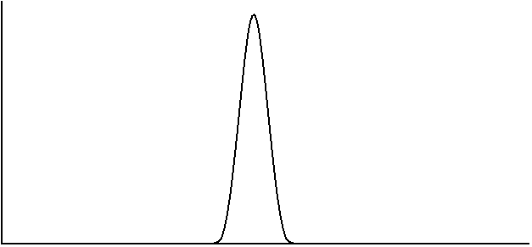
High
Energy
ΔH_{ADS}
Low
Energy
Frequency of
Occurrence

Figure 15. Representation of a symmetrical distribution for ΔH_{ADS}

The easiest way to think of this is to examine the nature of the silanol groups on the surface of silica gel. One thing we could ask is whether there are different types of silanols, as shown below (are there also disilanols and trisilanols?).

–Si–OH –Si–(OH)₂ –Si(OH)₃

It turns out that we will get some di- and trisilanols, although these are far fewer in number than the monosilanols. It should make sense that even if the distribution about a monosilanol were symmetrical, that the di- and trisilanols will have different distributions of ΔH_{ADS}. Assuming that ΔH_{ADS} is larger for the di- and trisilanols, that might lead to the plot shown in Figure 16 for each of the individual distributions and then the composite drawing for the overall distribution.
Overall
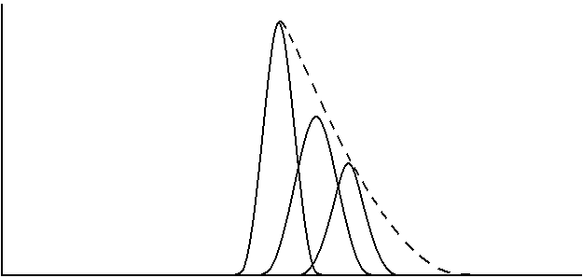
Trisilanol
Disilanol
Silanol
High
Energy
ΔH_{ADS}
Low
Energy
Frequency of
Occurrence

Figure 16. Representation of the distribution of ΔH_{ADS} values for a surface that contains silanol, disilanol and trisilanol groups.

Notice the asymmetry in the plot in Figure 16 with a smaller number of highly active sites. Something to realize is that even if we had only monosilanols, there is still experimental data that shows a small proportion of highly active sites that produced an asymmetric distribution. It is important to realize that not everything in nature occurs in a symmetrical manner.

The key question for us to ask is what a chromatographic peak would look like for a solute traveling through this stationary phase. Hopefully it seems reasonable to predict that the peak for the solute would also be asymmetric. Those solute molecules adsorbed at the highly active sites would essentially get stuck on the column and take much longer to elute. The asymmetric peak observed in Figure 17 exhibits tailing. Note that tailed peaks are undesirable in chromatographic separations because they are more likely to overlap with each other and interfere with the separation. Unless the solid surface is highly deactivated, all chromatographic separations based on adsorption will exhibit peak tailing. This causes an inherent inefficiency in adsorption methods.

INJ

Figure 17. Tailed peak shape in adsorption chromatography

One last thing before we move on is to understand that strong adsorption by molecules on active solid surfaces has a profound implication in environmental chemistry. Consider a leaking, underground tank of gasoline at a service station. The soil around the tank gets contaminated by the leaking gas and it is desirable to clean it up. One way is to remove all the contaminated soil, heat it in a very high temperature oven that combusts all the hydrocarbon components of the gasoline, and recycle the soil. This is a common remediation procedure. But suppose the soil exists over a very large area (say the soil surrounding an old hazardous waste dump). This may be too large a volume of soil to use the removal and combustion method. The chemicals may have leached far away from the original site, contaminating nearby drinking wells.

Based on our knowledge of chromatography, and essentially using the ground as something similar to a chromatographic column, we could imagine pumping lots of clean water in from wells outside the contaminated area, and removing contaminated water from wells internal to the contaminated region. After some time of pumping, all the contaminants ought to migrate by a chromatographic-like process from the outside to the inside and be removed. If you do this, you eventually see that the level of contaminants in the water coming out of the inner wells drop considerably (maybe even to acceptable levels). But if you allow the system to sit for quite a while, you start to discover elevated levels of contaminants in the water again. What has happened is that some of the contaminants adsorbed quite strongly to the solid surfaces in the ground and were unavailable to the water. As the system sat, these slowly began to come off the surface into the water, raising the concentration. This kind of treatment process has generally proven ineffective as a way of completely treating such ground water contamination. It does get rid of a lot of the contaminants, but the strong adsorption requires enormous lengths of time before the levels would drop low enough.

Chromatographic methods languished under these inefficient methods for many years until Martin and Synge reported the first application of a partition separation in chromatography in 1941. Recognizing that WWII was taking place in 1941, there was a considerable need for wool clothing for soldiers from England fighting in the war. Wool is rather unique as a fabric since it retains much of its warmth even if wet. In fact, so much wool was needed that England did not have enough sheep to provide the volume of wool clothing that was necessary. Martin and Synge were interested in seeing whether it was possible to make artificial wool, and sought to examine the amino acid content of the proteins that make up wool fibers as a first step in understanding the chemical nature of wool. What they also realized, though, was that separating amino acids using adsorption chromatographic methods available at that time was going to be a difficult process. They therefore investigated whether it would be possible to take a solid particle and coat it with a liquid stationary phase, and perform the separation based on partitioning. What they found was that it was possible, and that the chromatographic efficiency was improved considerably when compared to methods based on adsorption.

The important thing to realize here is that we no longer have an adsorption process, but the dissolution of the solute into another liquid solvent. The relevant enthalpy to consider here is the enthalpy of solvation (ΔH_{SOLV}). It turns out that ΔH_{SOLV} of a particular solute in a particular solvent will also show a distribution of values; however, in this case, the distribution is a symmetrical one. Therefore, a chromatographic peak for a solute being separated entirely by a partitioning mechanism between the mobile and stationary phases ought to be symmetrical as well. This will greatly enhance the efficiency of the chromatography. This work was so important that it was recognized with the Nobel Prize in 1952. The only problem was that there were still other important issues with liquid chromatography such that it really could not flourish as an analytical method (we will examine these other issues later in our unit on chromatography).

One intriguing aspect of Martin and Synge’s 1941 paper is the last sentence, which predicted that it should be possible to use gas as the mobile phase (i.e., gas chromatography), and that some of the limitations that restrict the efficiency of liquid chromatography should not occur in gas chromatography. What was also interesting is that it was not until 1951, that James and Martin published the first report in which gas chromatography was described as an analysis method. Much of the delay was because of WWII and the need for scientists to devote their research to areas of immediate national concern related to the war effort.

The introduction of gas chromatography revolutionized the entire field of chemical analysis. One thing, as we will develop in the next substantial portion of this unit, is that gas chromatographic methods had certain fundamental advantages over liquid chromatographic methods when it came to column efficiency. It was possible, using gas chromatography, to separate very complex mixtures of volatile chemicals in very short periods of time. Before gas chromatography, no one even considered that it might be possible to separate as many as 50 to 100 constituents of a sample in only an hour. The other thing that prompted an explosion of interest in gas chromatography as an analysis method was the development of some highly sensitive methods of detection in the 1950s and 1960s. People were now able to sense levels of molecules that were not detectable in other, conventional solution-phase systems. Part of the problem with solution-phase analysis is the overwhelming volume of solvent that can interfere with the technique used to perform the measurement. Gas phase measurements, where the overall density of molecules is very low, do not have as much potential for interference from gases other than those being measured.

What we now need to do is develop an understanding of what created the inherent advantage in efficiency of gas chromatographic columns, and then understand what took place to improve the efficiency of liquid chromatographic columns. When we talk about the efficiency of a chromatographic column, what we really refer to is the width of the chromatographic bands of solutes as they migrate through the column.

