IN-CLASS PROBLEM SET #4

1. Calculate the concentration of free calcium(II) ions in a solution prepared with initial concentrations of calcium of 0.020 M and EDTA^{4–} of 0.10 M.

This is our first example involving a water-soluble metal complex. The general form of these equations is that a metal ion (M) reacts with a ligand (L) to form a water-soluble complex.

M(aq) + L(aq)  ML(aq) K_{f}

Usually we appreciate that these are all water-soluble species and omit the (aq) notation from the equations. The general form of the equation is referred to as a formation constant, hence the notation K_{f} for the equilibrium constant. If you examine the values of K_{f} in the table, you will see that many of these are reasonably large values. In fact, because they are large, it is common for tables to report the logK_{f} value rather than the K_{f} value. It makes sense that many of these in the table would have large values because people would be interested in metal complexes that had relatively high formation constants if they wanted to use them for analytical purposes. Another thing to realize is that many ligands can form a series of stepwise complexes with a metal, as illustrated below.

M + L  ML K_{f1}

ML + L  ML₂ K_{f2}

ML₂ + L  ML₃ K_{f3}

ML₃ + L  ML₄ K_{f4}

It is also worth examining what types of species function as ligands. First, it’s worth realizing that the metal in these reactions is almost always a cation. Therefore, anions are one group of compounds that have to be examined as possible ligands. The way to see if complexation occurs is to determine all of the anions and metal ions that exist in a particular solution, and then see if any possible combination of a metal ion with an anion has a value or values in the table of formation constants. If any do, then that process needs to be incorporated into any calculations of equilibrium concentrations. One thing to note is that every aqueous solution has some amount of hydroxide ion, and many metal ions form water-soluble complexes with hydroxide. The presence of hydroxide ion therefore provides an additional complication when assessing the distribution of most metal species in solution.

Another thing to realize is that anions are always the conjugate bases of acids. In other words, any anion has the potential to be protonated with a hydrogen ion. If the anion is the conjugate base of a strong acid (halide, nitrate, perchlorate), then its concentration will not vary as a function of pH because it will not be protonated in water. If the anion is the conjugate base of a weak acid, which is actually far more common, then the concentration of the anion in water is a function of the pH. This means that the complexation of the metal by the anion will depend on the pH as well. What you might begin to realize now is that metal complexation in water is a complicated process that is influenced by the pH and the availability of different ligands. We will see that there are a series of systematic ways to address metal complexation and handle all of the simultaneous equilibria that occur.

The other large group of ligands are the nitrogen bases. These are neutral ligands that have the ability to form donor-acceptor complexes with the metal ion. The ligand acts as an electron-pair donor, something we refer to as a Lewis base. The positive metal ion acts as an electron-pair acceptor, something we refer to as a Lewis acid. (Actually, the Lewis acid-Lewis base interaction also occurs for anions when they bond to metals). For example, ammonia is a ligand that forms water-soluble complexes with many metal ions. Ethylenediamine is another important nitrogen-containing ligand that forms water-soluble complexes with many metal ions. In this case, what is particularly interesting is that both nitrogen atoms bond to the metal ion at the same time, forming what is called a chelate complex.
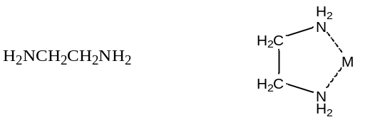
Ethylenediamine Chelate Bonding

Anions can bond to metal ions in a chelate manner as well. For example, the carboxylate ion actually bonds to metal ions through a chelate arrangement of the two oxygen atoms.

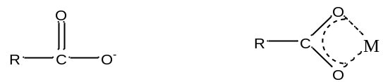
Carboxylate ion Chelate Bonding

Another very important ligand is the species ethylenediaminetetraacetic acid (H₄EDTA or H₄E). EDTA is a tetraprotic acid that can act as a ligand and form very stable chelate complexes with metal ions. We have a table of K_{f} values for different EDTA complexes and note that these are very large numbers. An interesting thing to realize is that we always think of the fully deprotonated ligand (E^{4–}) as the species that actually forms the complex. The other forms (H₄E, H₃E–, H₂E^{2–}, HE^{3–}) are not involved in the complexation. Note that this is a general observation. For example, in the phosphoric acid system, the species $\text{P}{\text{O}}_{\text{4}}^{\text{3}-}$ would be the ligand, not the partially protonated $\text{HP}{\text{O}}_{\text{4}}^{\text{2}-}$ and ${\text{H}}_{\text{2}}\text{P}{\text{O}}_{\text{4}}^{\text{2}-}$ species.
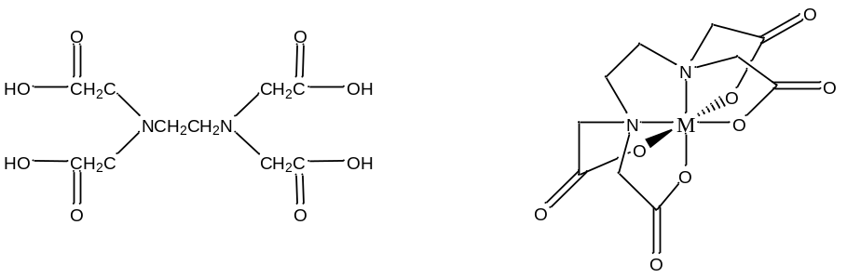
H₄EDTA Chelate bonding to a metal
Note that one E^{4–} ligand has the ability to completely surround a metal ion and fill all of the coordination sites simultaneously. It might be tempting to think that this ability to fill all the sites at one time accounts for the exceptionally large formation constants. In actuality, the large formation constants are driven more by entropy changes. If we think about the nature of a metal cation in water, we realize that the positive metal ion is surrounded by negative ends of water molecules as shown below. In this picture, the oxygen atoms of the water molecules are said to be in the first coordination sphere of the metal ion. This is typically what occurs with many metal salts in water. The cation and anion separate from each other and are solvated by water.

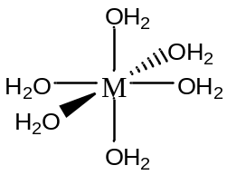

The reaction that we can now write to represent the bonding of E^{4–} to a metal ion (M⁺) is shown below:
M${\text{(}{\text{H}}_{\text{2}}\text{O)}}_{\text{6}}^{\text{+}}$ + E^{4–}  ME^{3–} + 6 H₂O

Note that the reaction side of the equation has two species, the product side has seven species. There is considerably larger entropy associated with the seven species on the product side, and this huge gain in favorable entropy is what primarily accounts for the large formation constants of metal complexes with EDTA. We will rarely write the metal ion as $\text{M}{\text{(}{\text{H}}_{\text{2}}\text{O)}}_{\text{6}}^{\text{+}}$ and instead simplify it to M⁺. But it’s sometimes worth remembering that it is surrounded by some number of water molecules. Also note that the ME^{3–} species has a net charge of –3. Many of these water-soluble complexes have a net charge, which in part is responsible for their water solubility.

One last thing about EDTA. If you look in the structures shown in our table, you will see that EDTA is actually a zwitterion in solution (See below a neutral and zwitterionic form of EDTA). What’s important to realize is that it really does not matter what form you write it in. Both forms below have four dissociable protons. Both forms have a net neutral charge. Both can be expressed as H₄EDTA.

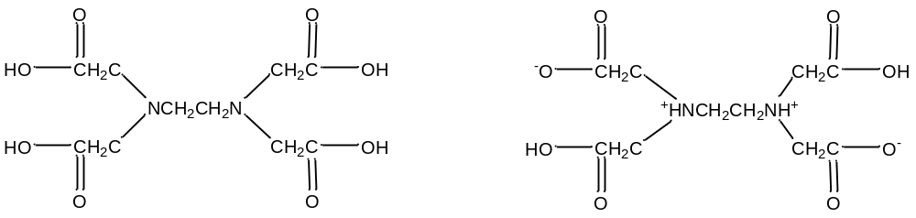
H₄EDTA H₄EDTA
(neutral) (zwitterion)

In theory, it might actually be possible to protonate both nitrogen atoms of EDTA, producing a species of the form H₆EDTA²⁺.
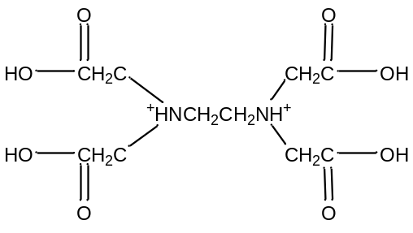
H₆EDTA²⁺

This species does not occur because the first two protons are so acidic that, even if we dissolved EDTA in a strong acid such as concentrated hydrochloric acid, it is doubtful that these sites would be protonated. In water, at pH values of 1 or higher, we will never be able to put more than four protons onto the EDTA.

Now we are ready to calculate the answer to the first problem.

Calculate the concentration of free calcium(II) ion in a solution prepared with initial concentrations of calcium of 0.020 M and EDTA⁴⁻ of 0.10 M.

In solving this problem, we will start under very naïve circumstances. We will not consider any other complexation of the calcium ion (for example, by something like hydroxide), and we have been given a concentration of E^{4–} and do not need to worry about the pH of this solution, how we got a concentration of 0.10 M, or whether protonation occurs.

The first thing to do is to write the reaction and look up the relevant formation constant.

Ca²⁺ + E^{4–}  CaE^{2–} K_{f} = 5.0$\text{×}$10¹⁰

What we see is that has a very large formation constant. That means that this reaction will go to completion. The approach to solving this problem is to allow it to go to completion, realizing that one of the reagents will limit the amount of product that forms. Then we need to allow a small amount of back reaction to occur. We can construct the following chart.

Ca²⁺ + E^{4–}  CaE^{2–}

Initial 0.020 M 0.10 M 0
Complete Reaction 0 0.08 0.02
Back Reaction x 0.08 + x 0.02 – x
Assumption 0.08 >> x 0.02 >> x

The approximation that 0.08 >> x and 0.02 >> x is reasonable since the K_{f} value is so large, therefore the amount of back reaction will be excessively small.

$${\text{K}}_{\text{f}}\text{ = }\frac{\left[{\text{CaE}}^{2-}\right]}{\left[{\text{Ca}}^{\text{2+}}\right]\left[{\text{E}}^{4-}\right]}\text{ = }\frac{\text{0.02}}{\text{(x)(0.08)}}\text{ = 5.0×}{\text{10}}^{\text{10}}$$

x = [Ca²⁺] = 5$\text{×}$10⁻¹²

The amount of unreacted calcium ion is incredibly small. Obviously the approximations we made were justified and we see how far these reactions can go toward completion.

2. Calculate the concentration of free calcium(II) ions in a solution prepared with initial concentrations of calcium of 0.020 M and total EDTA of 0.10 M. The solution is buffered at a pH of 2.

Now we have added a complicating factor. We will incorporate the fact that the EDTA has several protonated forms, and that these forms depend on the pH of the solution. Since only the E^{4–} form bonds to the metal ion, protonated forms of EDTA reduce the concentration of E^{4–} available for complexation. If very little E^{4–} is available for complexation, very little of the calcium ion will be complexed.

It is also worth realizing that, in most cases, we do know the pH of a solution. One reason is because we want a particular pH so we have prepared the solution in a buffer. The other is that it is very easy to measure the pH of a solution using a pH meter, so if pH is a relevant issue, we simply measure it.

The set of reactions below show what we now know will occur in this solution (note, we are ignoring the possibility that the calcium can complex with hydroxide ion – more on that later).

Ca²⁺ + E^{4–}  CaE^{2–}

HE^{3–}

H₂E^{2–}

H₃E–

H₄E

The problem we face here is that the reaction we want to examine is the K_{f} reaction for CaE^{2–}. If we want to use our established way of doing that calculation, we need to know the initial amounts of Ca²⁺ and E^{4–} that we have in solution, but some of the E^{4–} has been protonated and we do not know how much we have. Also, we have one other problem. Suppose, in a solution with a total amount of EDTA of 0.10 M, we could calculate how much of the EDTA was in the E^{4–} form. We could conceivably allow this to complex with the Ca²⁺, but we have an additional source of EDTA (the HE^{3–}, H₂E^{2–}, H₃E–, and H₄E forms) that will redistribute to some extent and provide additional amounts of E^{4–}.

There is a very interesting observation about acid-base systems. It turns out that if we know the pH of the solution, the fraction of the total that exists in any one form is fixed. In other words, the fraction of total EDTA that exists in the H₄E, H₃E–, H₂E^{2–}, HE^{3–}, and E^{4–} forms is only a function of the pH of the solution. It does not depend on the total amount of EDTA in solution. We refer to these fractions as α−values. We are usually interested in the α-value for the fully deprotonated anion, since that is the form that complexes with the metal. It’s important to realize that we can calculate α-values for any of the species involved in a series of reactions for a polyprotic acid.
It is worth showing that the fraction of EDTA that exists in solution as E^{4–} is only a function of pH. This will also demonstrate the general procedure that we can use to calculate α−values.

First, write an expression for the fraction of EDTA that exists in solution as E^{4–}.

$${\text{α}}_{{\text{E}}^{4-}} \text{=} \frac{\left[{\text{E}}^{4-}\right]}{\left[{\text{H}}_{\text{4}}\text{E}\right]\text{ + }\left[{\text{H}}_{\text{3}}{\text{E}}^{-}\right]\text{ + }\left[{\text{H}}_{\text{2}}{\text{E}}^{2-}\right] \text{+} \left[\text{H}{\text{E}}^{3-}\right] \text{+ }\left[{\text{E}}^{4-}\right]}$$

Note that this is just the concentration of E^{4–} over the total EDTA in solution. The next step is to take the reciprocal of this expression. Doing so will allow you to divide the equation into a set of separate terms.
$$\frac{\text{1}}{{\text{α}}_{{\text{E}}^{4-}}} \text{= }\frac{\left[{\text{H}}_{\text{4}}\text{E}\right]}{\left[{\text{E}}^{4-}\right]} + \frac{\left[{\text{H}}_{\text{3}}{\text{E}}^{-}\right]}{\left[{\text{E}}^{4-}\right]} + \frac{\left[{\text{H}}_{\text{2}}{\text{E}}^{2-}\right]}{\left[{\text{E}}^{4-}\right]} + \frac{\left[\text{H}{\text{E}}^{3-}\right]}{\left[{\text{E}}^{4-}\right]} + \frac{\left[{\text{E}}^{4-}\right]}{\left[{\text{E}}^{4-}\right]}$$

The next step is to use the K_{a} values for EDTA to substitute in for each of the ratio terms. The first one to examine is the ratio of [HE^{3–}]/[E^{4–}], which we can obtain using only the K_{a4} expression. Rearranging K_{a4} as shown below gives the following term to substitute in.

HE^{3–} + H₂O  E^{4–} + H₃O⁺ K_{a4}

$${\text{K}}_{\text{a4}}\text{ = }\frac{\left[{\text{E}}^{4-}\right]\left[{{\text{H}}_{\text{3}}\text{O}}^{\text{+}}\right]}{\left[\text{H}{\text{E}}^{3-}\right] } \frac{\left[\text{H}{\text{E}}^{3-}\right]}{\left[{\text{E}}^{4-}\right]}\text{ = }\frac{\left[{{\text{H}}_{\text{3}}\text{O}}^{\text{+}}\right]}{{\text{K}}_{\text{a4}}}$$

Next we can evaluate an expression to substitute in for [H₂E^{2–}]/[E^{4–}]. This will involve using the K_{a3} and K_{a4} expression for EDTA. The easiest way to see this is to add up the K_{a3} and K_{a4} reactions. Remember, the equilibrium constant for the resulting reaction is the product of the equilibrium constants for those added together.

H₂E^{2–} + H₂O  HE^{3–} + H₃O⁺ K_{a3}

HE^{3–} + H₂O  E^{4–} + H₃O⁺ K_{a4}
––––––––––––––––––––––––––––
H₂E^{2–} + 2H₂O  E^{4–} + 2H₃O⁺ K = K_{a3} K_{a4}

$${\text{K}}_{\text{a3}} {\text{K}}_{\text{a4}}\text{ = }\frac{\left[{\text{E}}^{4-}\right]{\left[{{\text{H}}_{\text{3}}\text{O}}^{\text{+}}\right]}^{\text{2}}}{\left[{\text{H}}_{\text{2}}{\text{E}}^{2-}\right]} \frac{\left[{\text{H}}_{\text{2}}{\text{E}}^{2-}\right]}{\left[{\text{E}}^{4-}\right]} = \frac{{\left[{{\text{H}}_{\text{3}}\text{O}}^{\text{+}}\right]}^{\text{2}}}{{\text{K}}_{\text{a3}} {\text{K}}_{\text{a4}}}$$

Perhaps by this point we see a pattern developing. Evaluating the [H₃E–]/[E^{4–}] term will require the use of K_{a2}, K_{a3}, and K_{a4} and yield the following term:

$$\frac{\left[{\text{H}}_{\text{3}}{\text{E}}^{-}\right]}{\left[{\text{E}}^{4-}\right]} = \frac{{\left[{{\text{H}}_{\text{3}}\text{O}}^{\text{+}}\right]}^{\text{3}}}{{\text{K}}_{\text{a2}} {\text{K}}_{\text{a3}} {\text{K}}_{\text{a4}}}$$

Similarly, evaluating the [H₄E]/[E^{4–}] term will, which requires using K_{a1}, K_{a2}, K_{a3}, and K_{a4}, will yield the following term:

$$\frac{\left[{\text{H}}_{\text{4}}\text{E}\right]}{\left[{\text{E}}^{4-}\right]} =\frac{{\left[{{\text{H}}_{\text{3}}\text{O}}^{\text{+}}\right]}^{\text{4}}}{{\text{K}}_{\text{a1}} {\text{K}}_{\text{a2}} {\text{K}}_{\text{a3}} {\text{K}}_{\text{a4}}}$$

The final result is shown below.

$$\frac{\text{1}}{{\text{α}}_{{\text{E}}^{4-}}} \text{= }\frac{{\left[{{\text{H}}_{\text{3}}\text{O}}^{\text{+}}\right]}^{\text{4}}}{{\text{K}}_{\text{a1}} {\text{K}}_{\text{a2}} {\text{K}}_{\text{a3}} {\text{K}}_{\text{a4}}} + \frac{{\left[{{\text{H}}_{\text{3}}\text{O}}^{\text{+}}\right]}^{\text{3}}}{{\text{K}}_{\text{a2}} {\text{K}}_{\text{a3}} {\text{K}}_{\text{a4}}} + \frac{{\left[{{\text{H}}_{\text{3}}\text{O}}^{\text{+}}\right]}^{\text{2}}}{{\text{K}}_{\text{a3}} {\text{K}}_{\text{a4}}} + \frac{\left[{{\text{H}}_{\text{3}}\text{O}}^{\text{+}}\right]}{{\text{K}}_{\text{a4}}} +\text{1}$$

What we see is that the only variable in this expression is [H₃O⁺], so the fraction of EDTA that exists in solution as E^{4–} is only a function of the pH. There is no term for the total amount of EDTA in the equation, so that does not matter. It only depends on the pH.

Similarly, we can evaluate the fraction of the other species as a function of pH. For example, let’s begin the process of evaluating the α-value of H₄E. The general procedure is the same as used for ${\text{α}}_{{\text{E}}^{4-}}$. The first step is to write the relevant equation for H₄E over the total.

$${\text{α}}_{{\text{H}}_{\text{4}}\text{E}}\text{ = }\frac{\left[{\text{H}}_{\text{4}}\text{E}\right]}{\left[{\text{H}}_{\text{4}}\text{E}\right]\text{ + }\left[{\text{H}}_{\text{3}}{\text{E}}^{-}\right]\text{ + }\left[{\text{H}}_{\text{2}}{\text{E}}^{2-}\right]\text{ + }\left[\text{H}{\text{E}}^{3-}\right]\text{ + }\left[{\text{E}}^{4-}\right]}$$

The next step is to take the reciprocal and divide the equation into separate terms.

$$\frac{\text{1}}{{\text{α}}_{{\text{H}}_{\text{4}}\text{E}}} \text{= }\frac{\left[{\text{H}}_{\text{4}}\text{E}\right]}{\left[{\text{H}}_{\text{4}}\text{E}\right]} + \frac{\left[{\text{H}}_{\text{3}}{\text{E}}^{-}\right]}{\left[{\text{H}}_{\text{4}}\text{E}\right]} + \frac{\left[{\text{H}}_{\text{2}}{\text{E}}^{2-}\right]}{\left[{\text{H}}_{\text{4}}\text{E}\right]} + \frac{\left[\text{H}{\text{E}}^{3-}\right]}{\left[{\text{H}}_{\text{4}}\text{E}\right]} + \frac{\left[{\text{E}}^{4-}\right]}{\left[{\text{H}}_{\text{4}}\text{E}\right]}$$

The next step is to use the K_{a} expressions to express each ratio in terms of [H₃O⁺] and the K_{a} values. I will not show all these rearrangements here, but doing them yields the following result for 1/${\text{α}}_{{\text{H}}_{\text{4}}\text{E}}$. You ought to try this and convince yourself that this is correct.

$$\frac{\text{1}}{{\text{α}}_{{\text{H}}_{\text{4}}\text{E}}} \text{= 1 + }\frac{{\text{K}}_{\text{a1}} }{\left[{{\text{H}}_{\text{3}}\text{O}}^{\text{+}}\right]} + \frac{{\text{K}}_{\text{a1}} {\text{K}}_{\text{a2}}}{{\left[{{\text{H}}_{\text{3}}\text{O}}^{\text{+}}\right]}^{\text{2}}} + \frac{{\text{K}}_{\text{a1}} {\text{K}}_{\text{a2}} {\text{K}}_{\text{a3}}}{{\left[{{\text{H}}_{\text{3}}\text{O}}^{\text{+}}\right]}^{\text{3}}} + \frac{{\text{K}}_{\text{a1}} {\text{K}}_{\text{a2}} {\text{K}}_{\text{a3}} {\text{K}}_{\text{a4}}}{{\left[{{\text{H}}_{\text{3}}\text{O}}^{\text{+}}\right]}^{\text{4}}}$$

Similarly, we could write expressions, take reciprocals, and evaluate the terms for α-values for H₃E–, H₂E^{2–}, and HE^{3–}. The full 1/α-value expressions that would result for all of the species involved in the EDTA system are shown below. Note the characteristic patterns that result.

$$\frac{\text{1}}{{\text{α}}_{{\text{E}}^{4-}}} \text{= }\frac{{\left[{{\text{H}}_{\text{3}}\text{O}}^{\text{+}}\right]}^{\text{4}}}{{\text{K}}_{\text{a1}} {\text{K}}_{\text{a2}} {\text{K}}_{\text{a3}} {\text{K}}_{\text{a4}}} + \frac{{\left[{{\text{H}}_{\text{3}}\text{O}}^{\text{+}}\right]}^{\text{3}}}{{\text{K}}_{\text{a2}} {\text{K}}_{\text{a3}} {\text{K}}_{\text{a4}}} + \frac{{\left[{{\text{H}}_{\text{3}}\text{O}}^{\text{+}}\right]}^{\text{2}}}{{\text{K}}_{\text{a3}} {\text{K}}_{\text{a4}}} + \frac{\left[{{\text{H}}_{\text{3}}\text{O}}^{\text{+}}\right]}{{\text{K}}_{\text{a4}}} +\text{1}$$

$$\frac{\text{1}}{{\text{α}}_{{\text{HE}}^{3-}}}\text{ =} \frac{{\left[{{\text{H}}_{\text{3}}\text{O}}^{\text{+}}\right]}^{\text{3}}}{{\text{K}}_{\text{a1}} {\text{K}}_{\text{a2}} {\text{K}}_{\text{a3}}} + \frac{{\left[{{\text{H}}_{\text{3}}\text{O}}^{\text{+}}\right]}^{\text{2}}}{{\text{K}}_{\text{a2}} {\text{K}}_{\text{a3}}} + \frac{\left[{{\text{H}}_{\text{3}}\text{O}}^{\text{+}}\right]}{{\text{K}}_{\text{a3}}} +\text{1}+ \frac{{\text{K}}_{\text{a4}}}{\left[{{\text{H}}_{\text{3}}\text{O}}^{\text{+}}\right]}$$

$$\frac{\text{1}}{{\text{α}}_{{\text{H}}_{\text{2}}{\text{E}}^{2-}}}\text{ = }\frac{{\left[{{\text{H}}_{\text{3}}\text{O}}^{\text{+}}\right]}^{\text{2}}}{{\text{K}}_{\text{a1}} {\text{K}}_{\text{a2}}} + \frac{\left[{{\text{H}}_{\text{3}}\text{O}}^{\text{+}}\right] }{{\text{K}}_{\text{a2}}}\text{ +}\text{ 1} + \frac{{\text{K}}_{\text{a3}}}{\left[{{\text{H}}_{\text{3}}\text{O}}^{\text{+}}\right]} + \frac{{\text{K}}_{\text{a3}} {\text{K}}_{\text{a4}}}{{\left[{{\text{H}}_{\text{3}}\text{O}}^{\text{+}}\right]}^{\text{2}}}$$

$$\frac{\text{1}}{{\text{α}}_{{\text{H}}_{\text{3}}{\text{E}}^{-}}} \text{= }\frac{\left[{{\text{H}}_{\text{3}}\text{O}}^{\text{+}}\right] }{{\text{K}}_{\text{a1}}}\text{ +}\text{ 1}+ \frac{{\text{K}}_{\text{a2}}}{\left[{{\text{H}}_{\text{3}}\text{O}}^{\text{+}}\right]} + \frac{{\text{K}}_{\text{a2}} {\text{K}}_{\text{a3}}}{{\left[{{\text{H}}_{\text{3}}\text{O}}^{\text{+}}\right]}^{\text{2}}} + \frac{{\text{K}}_{\text{a2}} {\text{K}}_{\text{a3}} {\text{K}}_{\text{a4}}}{{\left[{{\text{H}}_{\text{3}}\text{O}}^{\text{+}}\right]}^{\text{3}}}$$

$$\frac{\text{1}}{{\text{α}}_{{\text{H}}_{\text{4}}\text{E}}}\text{ = 1 + }\frac{{\text{K}}_{\text{a1}} }{\left[{{\text{H}}_{\text{3}}\text{O}}^{\text{+}}\right]} + \frac{{\text{K}}_{\text{a1}} {\text{K}}_{\text{a2}}}{{\left[{{\text{H}}_{\text{3}}\text{O}}^{\text{+}}\right]}^{\text{2}}} + \frac{{\text{K}}_{\text{a1}} {\text{K}}_{\text{a2}} {\text{K}}_{\text{a3}}}{{\left[{{\text{H}}_{\text{3}}\text{O}}^{\text{+}}\right]}^{\text{3}}} + \frac{{\text{K}}_{\text{a1}} {\text{K}}_{\text{a2}} {\text{K}}_{\text{a3}} {\text{K}}_{\text{a4}}}{{\left[{{\text{H}}_{\text{3}}\text{O}}^{\text{+}}\right]}^{\text{4}}}$$

The other important thing to do with α-values is examine a plot of α-values versus pH for a series of compounds. Examples are shown in Figure 5 for carbonic acid, phosphoric acid, and citric acid.

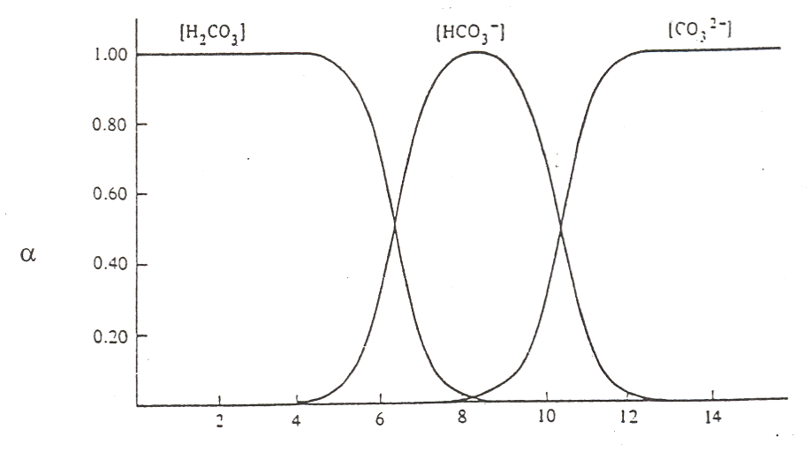
Carbonic Acid (pK_{a} values of 6.4 and 10.4)

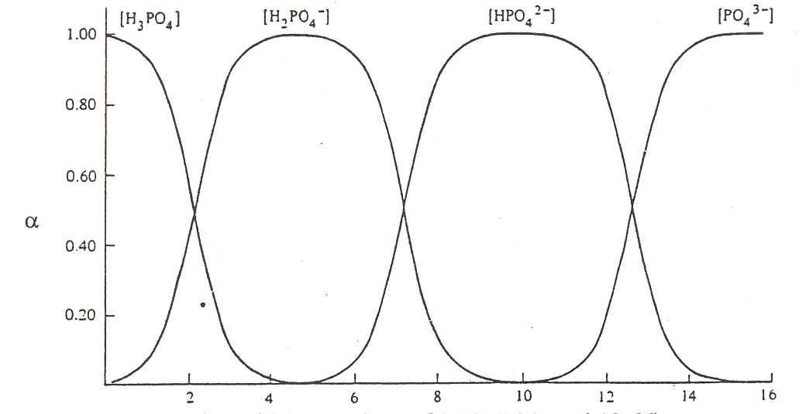
Phosphoric Acid (pK_{a} values of 2.12, 7.21, and 12.66)

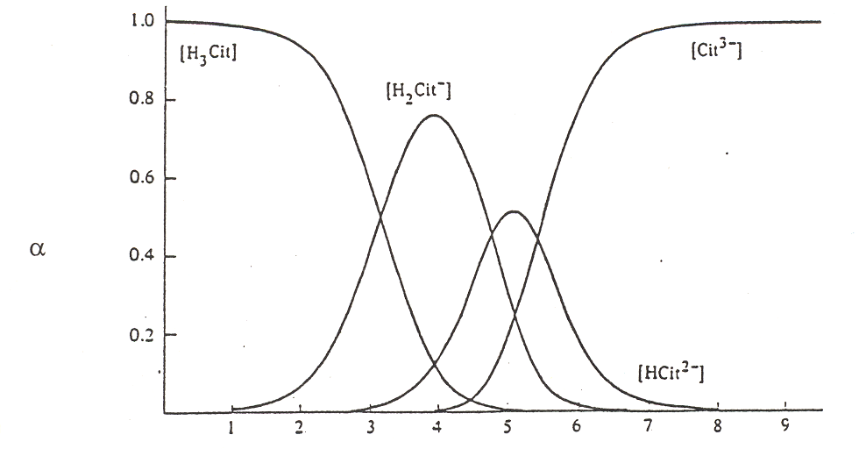
Citric Acid (pK_{a} values of 3.13, 4.76, and 5.41)

Figure 5. Plots of a-values as a function of pH for carbonic, phosphoric and citric acid.
There are several important items to note about these figures on the previous page. At very low pH, meaning highly acidic conditions, the fully protonated forms predominate. At very high pH, meaning highly basic conditions, the fully deprotonated forms predominate. Since the deprotonated forms are the ones that will bond to metal ions, complexation of metal ions by ligands is favored at more basic pH values. (Note, we could do a similar plot of α-values for the different forms of ethylenediamine, H₂En²⁺, HEn⁺, and En. Remembering that the neutral form, En, is the one that complexes with metals, we would see that this form is favored at more basic pH values). At intermediate pH values, different intermediate forms increase and then diminish as the pH is raised from acidic to basic conditions. At the crossing points of two of the α-value plots, we typically have a 50:50 mixture of a conjugate pair. In other words, these crossing points are the excellent buffer regions for these reagents.

Observe that the forms of the carbonic and phosphoric acid systems are very regularized. There is some pH where only one species of the series predominates and the concentrations of all others are minimal. This is not the case with citric acid. We see a somewhat unusual situation in which at a pH of around 4 and 5, we see that the H₂cit– and Hcit^{2–} forms respectively do not reach 99%. At these points we find appreciable amounts of the neighboring species. Also note that the amounts of H₂cit– and cit^{3–} present at the point at which Hcit^{2–} is maximized are exactly equal to each other. The same thing occurs for the two neighboring species at pH 4. This is a rather rare occasion of having appreciable quantities of three species from an acid-base system present at the same time. The reason for this unusual behavior is that the pK_{a} values are very close to each other. (Note: pK_{a3} in this chart is reportedly 5.41, which is different than the value of 6.396 in our table of K values!) We have already examined citric acid when it was titrated with sodium hydroxide and introduced its somewhat unusual behavior. The plot of α-values really points out the effects of having close pK_{a} values and how this influences the concentrations of species in solution.

We are now in a position to finally see how to incorporate an α-value into the calculation involving complexation of Ca²⁺ by E^{4–} at a pH of 2. Write the formation constant expression and recognize that we can substitute in for the [E^{4–}] term.

Ca²⁺ + E^{4–}  CaE^{2–} K_{f}

$${\text{K}}_{\text{f}}\text{ = }\frac{\left[\text{Ca}{\text{E}}^{2-}\right]}{\left[{\text{Ca}}^{\text{2+}}\right]\left[{\text{E}}^{4-}\right]}$$

[E^{4–}] = ${\text{α}}_{{\text{E}}^{4-}}$[E]_{TOT}

Substituting the [E^{4–}] expression into the K_{f} equation gives the following:

$${\text{K}}_{\text{f}}\text{ = }\frac{\left[\text{Ca}{\text{E}}^{2-}\right]}{\left[{\text{Ca}}^{\text{2+}}\right]{\text{α}}_{{\text{E}}^{4-}}{\left[\text{E}\right]}_{\text{TOT}}}$$

The ${\text{α}}_{{\text{E}}^{4-}}$ term is a constant, since the pH is known, and we can rearrange the expression into the following:
$$({\text{K}}_{\text{f}}\text{)(}{\text{α}}_{{\text{E}}^{4-}}\text{) }\text{= }\frac{\left[\text{Ca}{\text{E}}^{2-}\right]}{\left[{\text{Ca}}^{\text{2+}}\right]{\left[\text{E}\right]}_{\text{TOT}}}$$

$({\text{K}}_{\text{f}}\text{)(}{\text{α}}_{{\text{E}}^{4-}}\text{)}$ is something we call a conditional constant (K_{COND}). Why a conditional constant? It turns out that the pH is a “condition” in this solution that influences the concentration and availability of E^{4–}. Incorporating the α-value into the conditional constant will allow us to assess whether it is likely that the Ca²⁺ will complex with the E^{4–}. The conditional constants for the complexation of Ca²⁺ with E^{4–} are shown in Table 6 as a function of pH. What we need to do is calculate the conditional constant, and then examine its magnitude. If the conditional constant is large, the reaction goes to completion. If the conditional constant is small, the reaction does not go to completion.

Table 6. Conditional constants for the complexation of Ca²⁺ with E⁴⁻.

pH ${\text{α}}_{{\text{E}}^{4-}}$ $({\text{K}}_{\text{f}}\text{)(}{\text{α}}_{{\text{E}}^{4-}}\text{)}$ Extent of reaction

1 3.66$\text{×}$10⁻¹⁸ 1.83$\text{×}$10⁻⁷ Very small
2 2.00$\text{×}$10⁻¹⁴ 1.00$\text{×}$10⁻³ Fairly small
3 1.61$\text{×}$10⁻¹¹ 0.805 Intermediate
4 2.48$\text{×}$10⁻⁹ 1.24$\text{×}$10² Intermediate
5 2.47$\text{×}$10⁻⁷ 1.24$\text{×}$10⁴ Close to completion
6 1.67$\text{×}$10⁻⁵ 8.35$\text{×}$10⁵ Completion
7 3.89$\text{×}$10⁻⁴ 1.95$\text{×}$10⁷ Completion
8 4.47$\text{×}$10⁻³ 2.24$\text{×}$10⁸ Completion
9 4.36$\text{×}$10⁻² 2.18$\text{×}$10⁹ Completion
10 0.314 1.57$\text{×}$10¹⁰ Completion
11 0.820 4.10$\text{×}$10¹⁰ Completion
12 0.979 4.90$\text{×}$10¹⁰ Completion
13 0.998 4.99$\text{×}$10¹⁰ Completion

Note how the reaction, based on the magnitude of the conditional constant, goes further to completion as the pH is made more basic. At very acidic pH values, very little reaction occurs. Also note that the conditional constant is large by a pH of 6, even though the α-value for the E^{4–} is still fairly small (1.67$\text{×}$10⁻⁵). This shows how the very large formation constant (5$\text{×}$10¹⁰) leads to formation of the complex (as the E^{4–} is used up, we have a source of additional E^{4–} from the protonated E species HE^{3–}, H₂E^{2–}, H₃E–, and H₄E). But also note, the α-values for the E species do not change as long as the pH remains fixed. If E^{4–} is removed by complexation, some new E^{4–} will form to maintain the same distribution of α-values for all of the E species.

If we have the expression:

$$({\text{K}}_{\text{f}}\text{)(}{\text{α}}_{{\text{E}}^{4-}}\text{) }\text{= }\frac{\left[\text{Ca}{\text{E}}^{2-}\right]}{\left[{\text{Ca}}^{\text{2+}}\right]{\left[\text{E}\right]}_{\text{TOT}}}$$

We could write this as belonging to the following reaction. Note that the procedure we use assumes that only a small amount of reaction occurs since the conditional constant is only
1$\text{×}$10⁻³.

Ca²⁺ + E_{TOT}  CaE^{2–} K_{COND} = $({\text{K}}_{\text{f}}\text{)(}{\text{α}}_{{\text{E}}^{4-}}\text{)}$ = 1$\text{×}$10⁻³

Initial 0.02 0.10 0
Equilibrium 0.02 – x 0.10 – x x
Approximation 0.02 0.10 x

Substitute these in to calculate the value of [CaE^{2–}]:

$${\text{K}}_{\text{COND}} \text{= }\frac{\left[\text{Ca}{\text{E}}^{2-}\right]}{\left[{\text{Ca}}^{\text{2+}}\right]{\left[\text{E}\right]}_{\text{TOT}}}\text{ = }\frac{\text{x}}{\text{(0.02)(0.1)}}\text{ = 1×}{\text{10}}^{\text{-3}}$$

x = [CaE^{2–}] = 2$\text{×}$10⁻⁶

Checking the approximation shows that it was valid to assume that very little of the Ca²⁺ and E^{4–} complexes.
$$\frac{\text{2×}{\text{10}}^{\text{-6}}}{\text{0.02}}\text{ × 100 = 0.01\%}$$

Let’s also consider how we would handle this if we had a pH with a large conditional constant. For example, consider the situation at pH 6. In this case, we treat it assuming that the reaction goes to completion and that some back reaction then occurs.

Ca²⁺ + E_{TOT}  CaE^{2–} K_{COND} = 8.35$\text{×}$10⁵

Initial 0.02 0.10 0
Completion 0 0.08 0.02
Back reaction x 0.08 + x 0.02 – x
Approximation x 0.08 0.02

Substituting this in gives the following concentration of free calcium ion. This concentration is very low such that we know the approximations were valid.

$${\text{K}}_{\text{COND}} \text{= }\frac{\left[\text{Ca}{\text{E}}^{2-}\right]}{\left[{\text{Ca}}^{\text{2+}}\right]{\left[\text{E}\right]}_{\text{TOT}}}\text{ = }\frac{\text{0.02}}{\text{(x)(0.08)}}\text{ = 8.35×}{10}^{5}$$

x = [Ca²⁺] = 2.99$\text{×}$10⁻⁷

An important thing to notice is that the total concentration of EDTA drops in this process because some of it reacts with the Ca²⁺ to form the complex. Remember that [E]_{TOT} refers only to those forms of EDTA that are not complexed with Ca²⁺ and does not include the complexed form (CaE^{2–}).

There is one other aspect to this problem we have not yet considered. That is whether calcium can complex with the hydroxide ion and whether this complexation is significant enough to alter any of the results we have seen before regarding complexation of Ca²⁺ by E⁴⁻. Looking in the table of formation constants indicates that calcium ions can complex with hydroxide according to the following equation. Since only one K_{f} value is listed, it is only a one-step process. We might also notice that it’s a fairly small association constant, so that we might anticipate that this reaction would never represent that much of an interference in the complexation of Ca²⁺ with E⁴⁻.

Ca²⁺ + ${\text{OH}}^{-}$  Ca(OH)⁺ K_{f} = 1.99$\text{×}$10

We can couple this process into the overall scheme as shown below:

Ca²⁺ + E^{4–}  CaE^{2–}
${\text{OH}}^{-}$    
Ca(OH)⁺ HE^{3–}

H₂E^{2–}

H₃E–

H₄E

The approach we will use is analogous to that employed with the protonation of E^{4–}. If we know the concentration of ligand, it is possible to calculate α−values for the uncomplexed metal ion and the metal-ligand species. In this case of hydroxide ion, the concentration is known and fixed provided the pH is known and fixed. With other ligands, we may need to assess whether the initial ligand concentration we are provided remains fixed. In some cases, the ligand will complex with the metal and this causes the concentration to drop from its initial value, changing the α-values that were calculated.

For the situation in this problem, we need to calculate ${\text{α}}_{{\text{Ca}}^{\text{2+}}}$. We do this by setting up a ratio of Ca²⁺ to the total of other calcium species. There is one important thing to realize in setting up this ratio. We only want to look at the distribution of calcium species in the set of reactions involving complexation with hydroxide ion. We therefore do not include CaE^{2–} as a term in the ratio.
$${\text{α}}_{{\text{Ca}}^{\text{2+}}} = \frac{\left[{\text{Ca}}^{\text{2+}}\right]}{\left[\text{Ca}{\text{(OH)}}^{\text{+}}\right]\text{ + }\left[{\text{Ca}}^{\text{2+}}\right]}$$

The next step is to take the reciprocal, and divide the equation into a series of separate terms.

$$\frac{\text{1}}{{\text{α}}_{{\text{Ca}}^{\text{2+}}}} = \frac{\left[\text{Ca}{\text{(OH)}}^{\text{+}}\right]}{\left[{\text{Ca}}^{\text{2+}}\right]} + \frac{\left[{\text{Ca}}^{\text{2+}}\right]}{\left[{\text{Ca}}^{\text{2+}}\right]}$$

We can now use the K_{f} expression to substitute in for the first term in this equation. Using K_{f} for complexation of Ca²⁺ with hydroxide, we get as follows:

Ca²⁺ + ${\text{OH}}^{-}$  Ca(OH)⁺ K_{f} = 1.99$\text{×}$10

$${\text{K}}_{\text{f}}\text{ =} \frac{\left[\text{Ca}{\text{(OH)}}^{\text{+}}\right]}{\left[{\text{Ca}}^{\text{2+}}\right]\left[{\text{OH}}^{-}\right]}$$

Rearrange the K_{f} expression as follows:

$$\frac{\left[\text{Ca}{\text{(OH)}}^{\text{+}}\right]}{\left[{\text{Ca}}^{\text{2+}}\right]} ={\text{K}}_{\text{f}}\left[{\text{OH}}^{-}\right]$$

Substitute this into the 1/${\text{α}}_{{\text{Ca}}^{\text{2+}}}$ expression to get:

$$\frac{\text{1}}{{\text{α}}_{{\text{Ca}}^{\text{2+}}}} ={\text{K}}_{\text{f}}\left[{\text{OH}}^{-}\right] + \text{1}$$

What we see is that the fraction of calcium that exists as Ca²⁺ only depends on the K_{f} value and the concentration of ligand (hydroxide in this case). We could also write the following expression:

[Ca²⁺] = ${\text{α}}_{{\text{Ca}}^{\text{2+}}}$[Ca]_{TOT}

Remember, [Ca]_{TOT} = [Ca²⁺] + [Ca(OH)⁺] in this expression.

We can substitute this into our original K_{f} expression for the complexation of Ca²⁺ with E^{4–}, just as we did previously to account for the protonation of EDTA as a function of pH.

Ca²⁺ + E^{4–}  CaE²⁻

$${\text{K}}_{\text{f}}\text{ = }\frac{\left[\text{Ca}{\text{E}}^{2-}\right]}{\left[{\text{Ca}}^{\text{2+}}\right]\left[{\text{E}}^{4-}\right]}$$

$${\text{K}}_{\text{f}}\text{ = }\frac{\left[\text{Ca}{\text{E}}^{2-}\right]}{{\text{(α}}_{{\text{Ca}}^{\text{2+}}}{\left[\text{Ca}\right]}_{\text{TOT}}{\text{)(α}}_{{\text{E}}^{4-}}{\left[\text{E}\right]}_{\text{TOT}})}$$

$${\text{(K}}_{\text{f}}\text{)(}{\text{α}}_{{\text{Ca}}^{\text{2+}}}{\text{)(α}}_{{\text{E}}^{4-}}\text{) = }\frac{\left[\text{Ca}{\text{E}}^{2-}\right]}{{\left[\text{Ca}\right]}_{\text{TOT}}{\left[\text{E}\right]}_{\text{TOT}}}$$

This provides a conditional constant ${\text{(K}}_{\text{f}}\text{)(}{\text{α}}_{{\text{Ca}}^{\text{2+}}}{\text{)(α}}_{{\text{E}}^{4-}}\text{)}$ that incorporates both conditions that are present: protonation of the E^{4–} and complexation of Ca²⁺ by hydroxide ion. This conditional constant is essentially the equilibrium constant for the following reaction:

[Ca]_{TOT} + [E]_{TOT}  CaE^{2–}

What we then need to do is examine the magnitude of this conditional constant to assess whether the complexation of calcium with EDTA will occur.

Table 7 is a compilation of ${\text{α}}_{{\text{E}}^{4-}}$, ${\text{α}}_{{\text{Ca}}^{\text{2+}}}$, conditional constants, and extent of reaction for this entire process as a function of pH.

Table 7. Conditional constants for the complexation of Ca²⁺ with E⁴⁻.

pH ${\text{α}}_{{\text{E}}^{4-}}$ ${\text{α}}_{{\text{Ca}}^{\text{2+}}}$ $({\text{K}}_{\text{f}}\text{)(}{\text{α}}_{{\text{E}}^{4-}}\text{)(}{\text{α}}_{{\text{Ca}}^{\text{2+}}})$ Extent of reaction

1 3.66$\text{×}$10⁻¹⁸ 1 1.83$\text{×}$10⁻⁷ Very small
2 2.00$\text{×}$10⁻¹⁴ 1 1.00$\text{×}$10⁻³ Fairly small
3 1.61$\text{×}$10⁻¹¹ 1 0.805 Intermediate
4 2.48$\text{×}$10⁻⁹ 1 1.24$\text{×}$10² Intermediate
5 2.47$\text{×}$10⁻⁷ 1 1.24$\text{×}$10⁴ Close to completion
6 1.67$\text{×}$10⁻⁵ 1 8.35$\text{×}$10⁵ Completion
7 3.89$\text{×}$10⁻⁴ 1 1.95$\text{×}$10⁷ Completion
8 4.47$\text{×}$10⁻³ 1 2.24$\text{×}$10⁸ Completion
9 4.36$\text{×}$10⁻² 1 2.18$\text{×}$10⁹ Completion
10 0.314 0.998 1.57$\text{×}$10¹⁰ Completion
11 0.820 0.980 4.02$\text{×}$10¹⁰ Completion
12 0.979 0.834 4.09$\text{×}$10¹⁰ Completion
13 0.998 0.334 1.67$\text{×}$10¹⁰ Completion

First, let’s consider the situation at pH 2. The ${\text{α}}_{{\text{Ca}}^{\text{2+}}}$ value is 1, which means that essentially none of the Ca²⁺ is complexed with the hydroxide ion. This makes sense since there is a very low level of hydroxide ion at pH 2 ([${\text{OH}}^{-}$] = 10⁻¹²) and because the K_{f} value for calcium complexation with hydroxide is not that large. The complexation of calcium by hydroxide has no significant effect on the system at this pH. As the pH becomes more basic, notice how ${\text{α}}_{{\text{Ca}}^{\text{2+}}}$ eventually falls below 1. This means that some of the calcium ion will complex with hydroxide. But if we examine the overall conditional constant, we also see that there is so much E^{4–} available at the more basic pH values, that complexation with hydroxide is never sufficient enough to overcome the complexation of Ca²⁺ with the E^{4–}. It would take a much larger K_{f} value for complexation of Ca²⁺ with hydroxide for this reaction to compete with the reaction with E^{4–}.

Calcium ion in tap water forms an insoluble precipitate with soap molecules and prevents the formation of lots of suds. Because it’s hard to get suds when a high concentration of calcium ion is present, the water is referred to as “hard water”. The classic procedure for analyzing the calcium concentration in hard water is to perform a titration with EDTA. The solution is buffered at a pH of 10 to ensure that there is complete complexation of the calcium with the EDTA. The conditional constants in the table above show the reason why a pH of 10 is used.

One last thing we need to consider is how we would handle a metal complex in which there were multiple formation constants. For example, if we look up the complexation of Cd²⁺ with hydroxide, we see that there are four steps in the process and that the K_{f} values are larger than the one with Ca²⁺. If we had substituted Cd²⁺ for Ca²⁺ in the problem above, the competing complexation of Cd²⁺ with hydroxide might have had more of an influence on the complexation of Cd²⁺ with E^{4–}. Of course, we also need to examine the complexation of Cd²⁺ with E^{4–}, which has a K_{f} value of 3.16$\text{×}$10¹⁶ from the table.

The relevant equilibria for Cd²⁺ in this case are as follows:

Cd²⁺ + ${\text{OH}}^{-}$  Cd(OH)⁺ K_{f1}

Cd(OH)⁺ + ${\text{OH}}^{-}$  Cd(OH)₂ K_{f2}

Cd(OH)₂ + ${\text{OH}}^{-}$  $\text{Cd}{\text{(OH)}}_{\text{3}}^{-}$ K_{f3}

$\text{Cd}{\text{(OH)}}_{\text{3}}^{-}$ + ${\text{OH}}^{-}$  $\text{Cd}{\text{(OH)}}_{\text{4}}^{2-}$ K_{f4}

The evaluation of ${\text{α}}_{{\text{Cd}}^{\text{2+}}}$ would involve the initial equation shown below:

$${\text{α}}_{{\text{Cd}}^{\text{2+}}} \text{= }\frac{\left[{\text{Cd}}^{\text{2+}}\right]}{\left[\text{Cd}{\text{(OH)}}_{\text{4}}^{2-}\right]\text{ + }\left[\text{Cd}{\text{(OH)}}_{\text{3}}^{-}\right]\text{ + }\left[\text{Cd}{\text{(OH)}}_{\text{2}}\right]\text{ + }\left[\text{Cd}{\text{(OH)}}^{\text{+}}\right]\text{ + }\left[{\text{Cd}}^{\text{2+}}\right]}$$

Taking the reciprocal leads to the following terms:

$$\frac{\text{1}}{{\text{α}}_{{\text{Cd}}^{\text{2+}}}} \text{= }\frac{\left[\text{Cd}{\text{(OH)}}_{\text{4}}^{2-}\right]}{\left[{\text{Cd}}^{\text{2+}}\right]} + \frac{\left[\text{Cd}{\text{(OH)}}_{\text{3}}^{-}\right]}{\left[{\text{Cd}}^{\text{2+}}\right]} + \frac{\left[\text{Cd}{\text{(OH)}}_{\text{2}}\right]}{\left[{\text{Cd}}^{\text{2+}}\right]} + \frac{\left[\text{Cd}{\text{(OH)}}^{\text{+}}\right]}{\left[{\text{Cd}}^{\text{2+}}\right]} + \frac{\left[{\text{Cd}}^{\text{2+}}\right]}{\left[{\text{Cd}}^{\text{2+}}\right]}$$

Using the K_{f} expressions for the complexation of Cd²⁺ with hydroxide, each ratio can be evaluated in terms of K_{f} values and [${\text{OH}}^{-}$], leading to the following equation.

$$\frac{\text{1}}{{\text{α}}_{{\text{Cd}}^{\text{2+}}}} = {\text{K}}_{\text{f1}} {\text{K}}_{\text{f2}} {\text{K}}_{\text{f3}} {\text{K}}_{\text{f4}}{\left[{\text{OH}}^{-}\right]}^{\text{4}}\text{ + }{\text{K}}_{\text{f1}} {\text{K}}_{\text{f2}} {\text{K}}_{\text{f3}}{\left[{\text{OH}}^{-}\right]}^{\text{3}}\text{ + }{\text{K}}_{\text{f1}} {\text{K}}_{\text{f2}}{\left[{\text{OH}}^{-}\right]}^{\text{2}}\text{ + }{\text{K}}_{\text{f1}}\left[{\text{OH}}^{-}\right]\text{ + 1}$$
$${\text{(K}}_{\text{f}}\text{)(}{\text{α}}_{{\text{Cd}}^{\text{2+}}}{\text{)(α}}_{{\text{E}}^{4-}}\text{) = }\frac{\left[\text{Cd}{\text{E}}^{2-}\right]}{{\left[\text{Cd}\right]}_{\text{TOT}}{\left[\text{E}\right]}_{\text{TOT}}}$$

Evaluation of a similar set of conditional constants over the entire pH range for the complexation of Cd²⁺ with E⁴⁻ leads to the set of data in Table 8.

Table 8. Conditional constants for the complexation of Cd²⁺ with E⁴⁻.

pH ${\text{α}}_{{\text{E}}^{4-}}$ ${\text{α}}_{{\text{Cd}}^{\text{2+}}}$ ${\text{(K}}_{\text{f}}\text{)(}{\text{α}}_{{\text{Cd}}^{\text{2+}}}{\text{)(α}}_{{\text{E}}^{4-}}\text{)}$ Extent of reaction

1 3.66$\text{×}$10⁻¹⁸ 1 1.20$\text{×}$10⁻¹ Intermediate
2 2.00$\text{×}$10⁻¹⁴ 1 6.32$\text{×}$10² Intermediate
3 1.61$\text{×}$10⁻¹¹ 1 5.09$\text{×}$10⁵ Close to completion
4 2.48$\text{×}$10⁻⁹ 1 7.84$\text{×}$10⁷ Completion
5 2.47$\text{×}$10⁻⁷ 1 7.81$\text{×}$10⁹ Completion
6 1.67$\text{×}$10⁻⁵ 1 5.28$\text{×}$10¹¹ Completion
7 3.89$\text{×}$10⁻⁴ 0.998 1.23$\text{×}$10¹³ Completion
8 4.47$\text{×}$10⁻³ 0.980 1.38$\text{×}$10¹⁴ Completion
9 4.36$\text{×}$10⁻² 0.830 1.14$\text{×}$10¹⁵ Completion
10 0.314 0.284 2.81$\text{×}$10¹⁵ Completion
11 0.820 1.09$\text{×}$10⁻² 2.82$\text{×}$10¹⁴ Completion
12 0.979 2.84$\text{×}$10⁻⁵ 8.79$\text{×}$10¹¹ Completion
13 0.998 8.30$\text{×}$10⁻⁹ 2.62$\text{×}$10⁸ Completion

If we compare this data to that for Ca²⁺, we see that a much higher proportion of the Cd²⁺ is complexed with hydroxide ion at the more basic pH values. The complexation with hydroxide is sufficient enough at pH 12 and 13 to significantly lower the conditional constant compared to the maximum at pH 10. Nevertheless, the complexation of Cd²⁺ by the EDTA is still complete at pH 12 and 13 because of such a high formation constant.

What we see for a species like Cd²⁺ is some optimum pH for complexation with EDTA. At low pH, protonation of the EDTA reduces the extent of complexation. At high pH, complexation of the Cd²⁺ with hydroxide competes with the EDTA to some extent. If we wanted to perform an analysis of Cd²⁺ using EDTA, we would buffer the solution at the pH that produces the maximum conditional constant, which is at a pH of 10.

