7. Electrochemical Analytical Methods
There are a wide variety of analytical methods that are based on the use of electrochemical reactions or processes. Only a subset of all the electrochemical methods will be discussed herein. The simplest electrochemical cell has two electrodes. One of them is sensitive toward the analyte and is referred to as either the working or indicator electrode. The second electrode is referred to as the counter or reference electrode, with the potential of the working electrode measured relative to it. The most common reference electrode is comprised of a
silver-silver chloride (Ag/AgCl) half-cell, with a fill solution that is saturated with KCl and AgCl (Figure 8).

AgCl (s) + e⁻ Ag(s) + Cl⁻(sat) E = +0.197 V

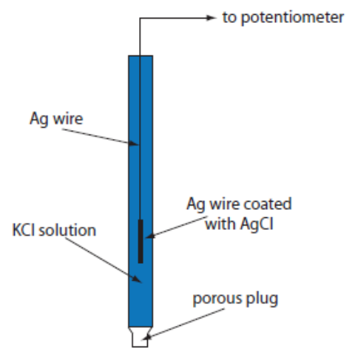

Figure 8. Diagram of a silver-silver chloride reference electrode.
(Figure from Analytical Chemistry 2.0, David Harvey, http://community.asdlib.org/activelearningmaterials/analytical-chemistry-2-0-online-textbook/).

The measurement uses a device known as a potentiostat, which is an electronic component that can run a three electrode cell. The potentiostat maintains the potential of the working electrode at a constant level with respect to the reference electrode. In some cases, it will be important that there be no current running through the reference electrode, which is achieved by having the system at a high impedance.

While a Ag/AgCl electrode is commonly used as a reference so that potentials are measured relative to it, for the purposes of the methods discussed herein, we will use the standard hydrogen electrode (SHE) as the reference electrode. Since the potential of the SHE is 0.00 Volts, this will allow us to use the numbers directly from a table of standard electrode potentials without having to correct for the potential of the reference electrode.

7.2. Electrodeposition/Electrogravimetry
Electrodeposition or electrogravimetry are two terms used to describe the same analysis method. The general procedure is to use something like a platinum electrode and apply a constant reducing potential that is sufficient to plate out a solid metal. For example, this method could be used to plate out cadmium metal from solution by the reaction shown below.

Cd²⁺(aq) + 2e– = Cd(s) Εº = – 0.403 V

The platinum is weighed before and after the plating step. The difference in weight is solid cadmium and this amount can be related back to the concentration of cadmium in the original solution.

Because it is essential that all the Cd²⁺ in solution get plated out onto the electrode, it is necessary use large surface area electrodes (on the order of 50 cm²) and to stir the solution to bring the Cd²⁺ up to the electrode. The plating step typically occurs at a potential well above the Eº value and over 30-60 minutes to insure that virtually all the Cd²⁺ has been plated onto the electrode. The plating potential must be well above the Eº value because, as the plating proceeds, the concentration of Cd²⁺ in solution will diminish, thereby raising the reducing potential needed for plating.

Will the presence of Fe²⁺ at 0.0800 M interfere with the electroplating of 99.9% of the Cd²⁺ in a solution in which the cadmium is expected to be present at a concentration of no less than 0.0500 M? Calculate potential values relative to a standard hydrogen electrode.

The first thing to consider is the two relevant half reactions for the metal ions in this problem.

Cd²⁺(aq) + 2e– = Cd(s) Εº = – 0.403 V

Fe²⁺(aq) + 2e– = Fe(s) Εº = – 0.440 V

Because the reduction potential of Cd²⁺ is less negative than that of Fe²⁺, it is easier to plate out the cadmium. This means that it may be possible to apply a reducing potential that is sufficient to plate out cadmium but not large enough to plate out any of the iron.

The next step is to focus on the plating of cadmium. We only need to consider the half reaction for cadmium for this calculation.
$$E= E^{0}- \frac{0.059}{n}log\frac{1}{[{Cd}^{2+}]}$$

In this equation, n = 2. If we substitute in the initial concentration of Cd²⁺ (0.0500 M), we get the following value for Ε.

$$E= -0.403- \frac{0.059}{2}log\frac{1}{0.0500}= -0.403-0.038= -0.441 V$$

Note, this is the potential needed to start the plating of cadmium. As the cadmium plates out, the concentration will be lower than 0.0500 M and that will impact the value of Ε. What we really need to consider is the concentration of Cd²⁺ when 99.9% of it has plated out. That would mean that only 0.1% of it is left in solution. 0.1% of 0.0500 M is 0.0000500 M (5.00 x 10⁻⁵ M). Let’s now reevaluate the potential for this solution.

$$E= -0.403- \frac{0.059}{2}log\frac{1}{0.0000500}= -0.403-0.126= -0.529 V$$

So the potential needed to plate out 99.9% of the cadmium is –0.529 V. Note that as the concentration of Cd²⁺ drops, the potential needed to plate the cadmium becomes more negative (i.e,. the plating of cadmium becomes more difficult and requires a higher potential). Hopefully it seems reasonable that it would take a higher potential to force the cadmium to plate from solution as the concentration of Cd²⁺ becomes smaller.

The question we now need to answer is whether the potential needed to plate out 99.9% of the Cd²⁺ will begin to plate out the Fe²⁺. In this case, we only need to consider the potential that would be needed to start the plating of Fe²⁺, since plating of any iron will interfere with the measurement of cadmium. This requires using the half reaction for iron:

$$E= -0.440- \frac{0.059}{2}log\frac{1}{0.0800}= -0.440-0.032= -0.472 V$$

Since the potential needed to begin plating out iron (– 0.472 V) is less negative than that needed to plate out 99.9% of the cadmium (– 0.529 V), it is not possible to selectively analyze for the cadmium in the presence of iron. The iron will plate out as well and interfere with the method.

Suppose the solution had 0.0800 M Cr³⁺ as a possible interference. Is it possible to plate out 99.9% of the cadmium without any interference from the chromium?
We first need to consider the appropriate half reaction for the reduction of Cr³⁺.

Cr³⁺(aq) + 3e– = Cr(s) Εº = – 0.744 V

Then we can solve for the potential that would just start the plating of chromium.

$$E= -0.744- \frac{0.059}{3}log\frac{1}{0.0800}= -0.744-0.022= -0.766 V$$

Since the potential needed to begin plating out the chromium (– 0.766 V) is more negative than that needed to plate out 99.9% of the cadmium (– 0.529 V), it is possible to selectively plate out the cadmium. Setting the potential somewhere in the window between – 0.529 V and – 0.766 V relative to a standard hydrogen electrode would be necessary for the analysis.
7.3. Coulometry
Coulometry is similar to electrogravimetry in that a constant potential is applied that is sufficient to carry out a particular electrochemical reaction. In this case, instead of plating out a metal and measuring its weight, the current generated through the electrochemical reaction is measured as a function of time. As with electrogravimetry, it is essential that all of the species in solution undergo the electrochemical reaction. To accomplish this, the potential is typically applied to the solution for 30-60 minutes, an electrode with a large area is used and the solution is stirred. The charge (Q) can be related to the number of electrons using Faraday’s Constant, which can then be related to the moles of substance being measured. We can use the reduction of Cd²⁺ to cadmium metal to examine the technique of coulometry.

Draw the plot you would obtain for current (y-axis) versus time (x-axis) if you applied a constant potential high enough to carry out the reduction of Cd²⁺ to cadmium metal.
Just like in electrogravimetry, the concentration of Cd²⁺ is high at the beginning of the analysis and diminishes as it is reduced to cadmium metal. This means that the current starts out high and will diminish with time. That leads to the plot in Figure 11.

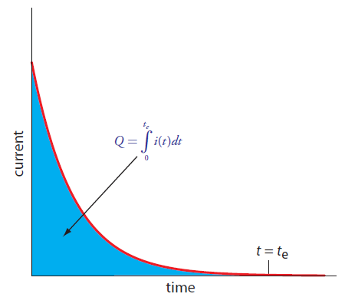
Figure 11. Plot of current versus time in a coulometric analysis.
(Figure from Analytical Chemistry 2.0, David Harvey, http://community.asdlib.org/activelearningmaterials/analytical-chemistry-2-0-online-textbook/).

How would you relate the outcome of the plot in Figure 11 to the concentration of Cd²⁺ in the sample?
What is important to determine here is the total amount of charge that flowed as that can be related using Faraday’s constant to the total number of electrons that were used in reducing Cd²⁺. The total number of electrons can be related to the total moles of cadmium in solution. Determining the total charge would involve integrating the area under the curve in Figure 11.

What advantages does coulometry have over electrogravimetry?
There are several advantages that coulometry has over electrogravimetry.

Since coulometry measures the charge needed to complete the electrochemical reaction instead of the weight of the substance plated out, reactions in which both species are water soluble can be examined (e.g., the half reaction Fe³⁺(aq) + e– = Fe²⁺(aq)).

Electrogravimetry is only useful for reduction processes involving the plating of a metal. Coulometry can be used in either a reduction or oxidation mode, increasing its versatility. The direction in which the electrons flow will be different depending on whether the reaction involves a reduction or oxidation, but that is not a hindrance to measuring the current and obtaining a plot like that in Figure 11.

One last advantage is that coulometry is more sensitive than electrogravimetry. The sensitivity and detection limits in electrogravimetry are limited by the minimum weight that can be measured on a balance – analytical balances typically measure down to 0.0001 gram but a much higher weight is needed for suitable accuracy and precision. We have the ability to measure very small quanities of current and can accurately measure time.

7.4. Titrimetic Methods of Analysis
7.4.1. “Classical” Redox Titration
A “classical” redox titration is one in which a titrant of a known concentration is prepared and standardized versus some appropriate primary standard. Then an accurate volume of an analyte solution with an unknown concentration is measured out. To be suitable for a titration, the analyte and titrant must undergo a rapid redox reaction that has a very large equilibrium constant so that formation of products is highly favored. The titrant is added from a burette and the volume needed to reach the endpoint is determined. The endpoint is identified through the use of an appropriate color-changing indicator. Besides an obvious color change, the criteria for selection of a suitable indicator is that it undergoes a redox reaction with the titrant that is less favored (has a lower equilibrium constant) than that of the analyte so that it only reacts after all of the analyte has reacted away. If the reaction between the titrant (TITR) and analyte (AN) is one-to-one, the following equation can be used to calculate the concentration (C) of the analyte.

C_{TITR} x V_{TITR} = C_{AN} x V_{AN}

If the titrant and analyte react in something other than a one-to-one equivalency, then the above equation needs to be modified to reflect the proper stoichiometry.

7.4.2. Coulometric Titration (Controlled Current Coulometry)
A coulometric titration is an interesting variation on a classical redox titration. Consider the reaction below in which Fe²⁺ is the analyte and Ce⁴⁺ is the titrant. An examination of the two standard potentials for the two half reactions confirms that in this pair cerium will proceed as the reduction and iron as the oxidation.

Fe²⁺(aq) + Ce⁴⁺(aq) = Fe³⁺(aq) + Ce³⁺(aq)

Ce⁴⁺(aq) + e– = Ce³⁺(aq) Εº = 1.61 V

Fe³⁺(aq) + e– = Fe²⁺(aq) Εº = 0.77 V

Rather than performing the titration by adding the Ce⁴⁺ from a burette, an excess of Ce³⁺ is added to an accurately measured volume of the unknown analyte solution. A constant electrochemical potential suitable to convert Ce³⁺ to Ce⁴⁺ is applied to the solution. As Ce⁴⁺ is produced, it immediately reacts with Fe²⁺ and is converted back to Ce³⁺. The result is that the concentration of Ce³⁺ is constant. A plot of the current measured by the generation of Ce⁴⁺ versus time would look like that in Figure 12.
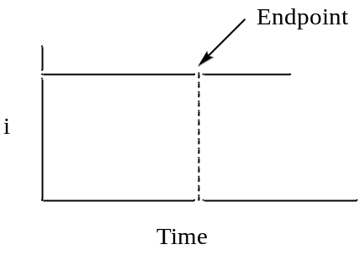

Figure 12. Plot of the current versus time in a coulometric titration.

There is more than one way to determine the endpoint of a coulometric titration. One is to add an indicator that reacts only when all the analyte is used up. In this case, you would measure the time until the color change and integrate the current versus time plot to determine the number of electrons and moles of analyte in the sample. Another possibility is that after the equivalence point, the “titrant” that is electrochemically generated no longer reacts away and there are other ways to measure that both members of the redox couple (Ce³⁺ and Ce⁴⁺ in the example above) are present.

What are some advantages of using a coulometric titration?
There are a number of advantages of a coulometric titration when compared to a classical redox titration.
- A coulometric titration has no burette.
- There is no need to standardize the titrant in a coulometric titration. All one has to do is add sufficient amounts of the titrant to the analyte solution (remember, we don’t actually add the titrant but add the appropriate species that will be converted into the titrant). Faraday’s constant is essentially the standard as it relates charge to the number of electrons and we know Faraday’s constant to a high degree of precision.
- Since we can accurately and precisely measure current and time, coulometric titrations are highly accurate and precise.
- Coulometric titrations are much more sensitive and can often measure lower concentrations than conventional titrations.
- Finally, because the titrant immediately reacts with the analyte after it is produced, it is possible to use an unstable titrant in a coulometric titration. Note that the species added to the solution that is converted into the titrant must be stable.

7.4.3. Amperometric Titration
An amperometric titration is done analogously to a classical titration in which a known volume of an analyte is measured out and a standardized titrant is added using a burette. The difference is that instead of using a color-changing indicator to determine the end point, the ability of the solution to generate a current is measured. It should be pointed out that you do not generate a large amount of current in an amperometric titration so the current generation does not deplete the solution of significant levels of the chemical species. Instead, you merely measure whether and how much current is produced at any given point during the titration.

Analyte + Titrant = Products

A stipulation for monitoring a particular titration reaction amperometrically is that the products can never generate a current at the potential being applied to the system. What is also necessary is that the analyte and/or titrant are able to generate a current. This means that there are the three possible scenarios to consider for an amperometric titration.

Draw the plot of current (y-axis) versus ml of titrant (x-axis) if only the analyte generates a current.
In this case, at the beginning before any titrant is added there is a high concentration of analyte and therefore the current would be high. As titrant is added, it reduces the concentration of analyte leading to the formation of products and the current would drop. Since every similar increment of titrant reacts with the same amount of analyte, the current should decay in a linear manner and go to zero at the endpoint. The result is the plot seen in Figure 13.

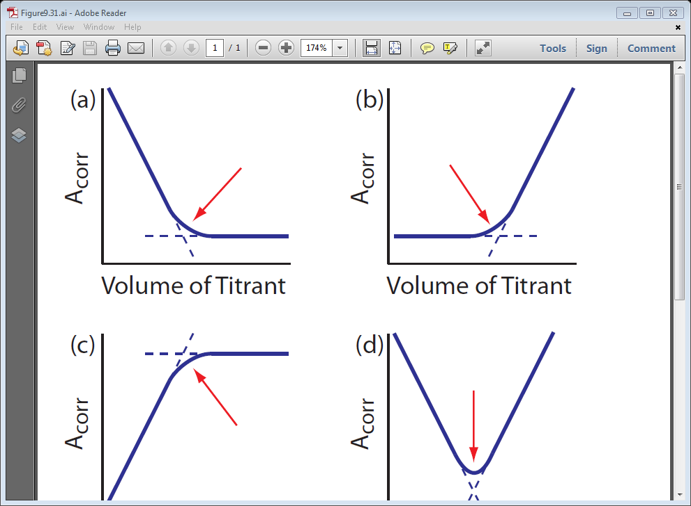
i

Figure 13. Plot of current versis ml of titrant in an amperometric titration when only the analyte produces a current.

Draw the plot of current (y-axis) versus ml of titrant (x-axis) if only the titrant generates a current.
In this case, there is no current at the beginning because the analyte does not generate one. As small amounts of titrant are added, all of the titrant reacts with the analyte to form products so there is still no measureable current. In fact, up until the equivalence point, any added titrant reacts away. Only after the equivalence point and all of the analyte is used up is there extra unreacted titrant in the solution that produces a current. The result is the plot seen in Figure 14.
i

Figure 14. Plot of current versis ml of titrant in an amperometric titration when only the titrant produces a current.

Draw the plot of current (y-axis) versus ml of titrant (x-axis) if both the analyte and titrant generate a current.
The plot in this case is the combination of those in Figures 13 and 14. Prior to the equivalence point, there is analyte and a current is observed but diminishes as more titrant is added. After the equivalence point the concentration of unreacted titrant goes up so the current gets larger. The only point where there is no species in solution capable of generating a current is at the equivalence point. The result is the plot seen in Figure 15.

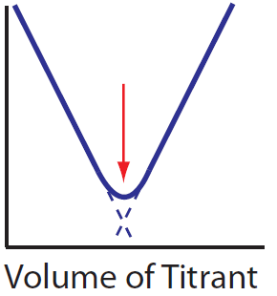
i

Figure 15. Plot of current versis ml of titrant in an amperometric titration when both the analyte and titrant produce a current.

7.4.4. Potentiometric Titration
The final titrimetric method we will examine is known as a potentiometric titration. This is similar to a classical titration as titrant is added from a burette. Instead of determining the endpoint using a color-changing indicator, a junction potential is continuously monitored during the titration. An example of a potentiometric titration that you are likely familiar with is a pH titration. In this case, a pH electrode is placed in the solution and the pH (determined by a membrane potential at the external glass membrane as described earlier in this unit) is measured continuously as titrant is added. The pH is plotted versus the ml of titrant added and there is a characteristic “break” or sharp rise in the plot that occurs at the equivalence point as seen in Figure 16. The plot has an inflection point that occurs at the equivalence point, although it is easier to identify the location of the inflection point by taking either the first or second derivative of the plot shown in Figure 16.

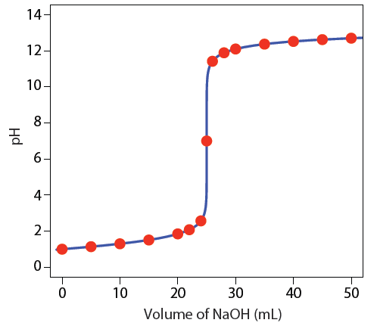
Figure 16. Plot of pH of a strong acid versus ml NaOH in a pH titration. (Figure from Analytical Chemistry 2.0, David Harvey, http://community.asdlib.org/activelearningmaterials/analytical-chemistry-2-0-online-textbook/).

It is also possible to measure the progress of other redox reactions potentiometrically. For example, we could monitor the progress of the titration of a solution of Fe²⁺ using Ce⁴⁺ as the titrant. The products of the reaction are Fe³⁺ and Ce³⁺.

Fe²⁺(aq) + Ce⁴⁺(aq) = Fe³⁺(aq) + Ce³⁺(aq)

The two relevant half reactions are shown below and indicate that the cerium reaction is the cathode and iron reaction is the anode.

Ce⁴⁺(aq) + e– = Ce³⁺(aq) Εº = 1.61 V

Fe³⁺(aq) + e– = Fe²⁺(aq) Εº = 0.77 V

Note that the Εº for the complete reaction is 0.84 V. Using the equation on p. 10 that relates Εº to K, the equilibrium constant for the reaction is greater than 10¹⁴. As with other electrochemical devices, a reference and working electrode is needed to perform the measurement. In this case, a platinum working electrode could be used. Let’s consider the following example to examine what will happen during the course of the titration and how one goes about calculating the potential during the titration.

20 ml of an 0.10 M solution of Fe²⁺ is titrated with 0.10 M Ce⁴⁺. Calculate the potential that would be measured when 5 ml, 10 ml, 20 ml, 30 ml and 40 ml of titrant have been added.

The following steps will allow us to work through the calculation of the junction potentials.

Write an expression for the total electrochemical potential of the titration reaction (this is the Nernst equation for the complete reaction).

$$E_{TOTAL}= E_{TOTAL}^{0}- \frac{0.059}{1}log\frac{\left[{Fe}^{3+}\right][{Ce}^{3+}]}{\left[{Fe}^{2+}\right][{Ce}^{4+}]}$$

Note, the reaction has one electron transferred between the cerium and iron so n = 1.

What is the total electrochemical potential of the titration reaction at any point during a titration? Think carefully about this because your first intuition may not be correct.
One of the criteria for any reaction to be useful in a titration is that the system must rapidly achieve equilibrium. What that means is that the titration above is always at equilibrium. In other words, when a drop of the cerium titrant is added, it immediately reacts with the iron and the system achieves equilibrium. Once past the equivalence point, there is some continuing distribution of species that occurs to establish equilibrium after each increment of titrant is added, but the system is always at equilibrium during all phases of the titration. That means that the total electrochemical potential of the reaction between Fe²⁺ and Ce⁴⁺ is zero at all points of the titration.

If we consider the other way we developed for determining the total electrochemical potential of a system.
Ε_{TOTAL} = Ε_{CATHODE} – Ε_{ANODE}

Remember that when using this form of the equation, both the cathode and anode values are evaluated as reductions. Since we determined that Ε_{Total} = 0 at all steps for the titration reaction, the following relationship is valid throughout the titration:

Ε_{CATHODE} = Ε_{ANODE}

However, there are two reactions to consider. One is the titration reaction and the other is the overall cell reaction. The overall cell reaction includes species in the reference electrode. Whereas the titration reaction goes to completion, the extent of the overall cell reaction is negligible because the voltmeter has high impedance that prevents current flow. The result is that the potential difference measured between the platinum and reference electrode during the titration is either the value Ε_{CATHODE} or Ε_{ANODE} developed above. Since these will both be equal, in theory either one of them could be used to calculate the potential at any point in the titration. However, there are advantages to using one of the half reactions over the other at certain points of the titration.

Which half reaction is easier to use to calculate the junction potential before the equivalence point? Which half reaction is easier to use after the equivalence point?
A way to consider this is to examine the amounts of the different species present at different points in the titration. The chart below shows the amounts of the different species in moles as the titration progresses.

Titrant (ml) Fe²⁺ Ce⁴⁺ Fe³⁺ Ce³⁺
0 0.0020 m 0 m 0 m 0 m
5 ml 0.0015 m 0 m 0.0005 m 0.0005 m
10 ml 0.0010 m 0 m 0.0010 m 0.0010 m
20 ml 0 m 0 m 0.0020 m 0.0020 m
30 ml 0 m 0.0010 m 0.0020 m 0.0020 m
40 ml 0 m 0.0020 m 0.0020 m 0.0020 m

It is important to note that except for the first line when no titrant has been added, the concentrations listed as “0 m” are not actually zero. Because the equilibrium constant for the reaction has a finite value, the concentration of each species must be a finite value. However, the equilibrium constant for this reaction is large (>10¹⁴), so the redistribution or back reaction of species that occurs involves only a small amount. As an example, let’s consider the values at 5 ml.

5 ml Titrant Fe²⁺ Ce⁴⁺ Fe³⁺ Ce³⁺
Initial 0.0015 m 0 m 0.0005 m 0.0005 m
Back reaction 0.0015 + X m X m 0.0005 – X m 0.0005 – X m
Approximation 0.0015 X m 0.0005 0.0005 m

For the line labeled “back reaction”, a small amount (X) of the Fe³⁺ and Ce³⁺ are removed to generate some Ce⁴⁺ and Fe²⁺. However, the value of X is so small relative to 0.00050 and 0.0015 moles (again because K is so large) that it is insignificant and can be ignored. Therefore, the amounts shown in the line labeled “approximation” can be used for any calculations.

An important outcome that arises by examining the amounts in the chart above is that prior to the equivalence point (5 and 10 ml of titrant) there are appreciable amounts of both Fe²⁺ and Fe³⁺. That means it will be preferable to use the iron half reaction in calculating the junction potential before the equivalence point.

Also note that after the equivalence point (30 and 40 ml of titrant) there are appreciable amounts of both Ce³⁺ and Ce⁴⁺. That means it will be preferable to use the cerium half reaction in calculating the junction potential after the equivalence point.

We can now calculate the values before and after the equivalence point.

5 ml
$$E_{Fe}= E_{Fe}^{0}- \frac{0.059}{1}log\frac{[{Fe}^{2+}]}{[{Fe}^{3+}]}$$

$$E_{Fe}=0.77- \frac{0.059}{1}log\frac{\left[0.0015 m\right]}{\left[0.0005 m\right]}=0.74 V$$

There is one other important thing to note in this calculation. Because we have a ratio of [Fe²⁺] to [Fe³⁺] in the log term, the volumes associated with the two concentrations cancel each other out. So using the number of moles of the two species when there are appreciable amounts of both gives the same value as using the concentration.

10 ml
$$E_{Fe}= E_{Fe}^{0}- \frac{0.059}{1}log\frac{[{Fe}^{2+}]}{[{Fe}^{3+}]}$$

$$E_{Fe}=0.77- \frac{0.059}{1}log\frac{\left[0.0010 m\right]}{\left[0.0010 m\right]}=0.77 V$$

Note that in this case, with the concentrations of Fe²⁺ and Fe³⁺ being equal, the log of 1 is zero and the potential is equal to Εº_{Fe}.

30 ml
$$E_{Ce}= E_{Ce}^{0}- \frac{0.059}{1}log\frac{[{Ce}^{3+}]}{[{Ce}^{4+}]}$$

$$E_{Fe}=1.61- \frac{0.059}{1}log\frac{\left[0.0010 m\right]}{\left[0.0020 m\right]}=1.59 V$$

40 ml
$$E_{Ce}= E_{Ce}^{0}- \frac{0.059}{1}log\frac{[{Ce}^{3+}]}{[{Ce}^{4+}]}$$

$$E_{Fe}=1.61- \frac{0.059}{1}log\frac{\left[0.0020 m\right]}{\left[0.0020 m\right]}=1.61 V$$

Note that in this case, with the concentrations of Ce³⁺ and Ce⁴⁺ being equal, the log of 1 is zero and the potential is equal to Εº_{Ce}.

The only item remaining potential to be calculated is at the equivalence point where we cannot easily use either of the two half reactions to calculate the potential. Using the two half reactions and knowledge of the stoichiometric equivalence of the different species at the equivalence point, It is possible to derive the following generalizable equation for the potential that will be measured at the equivalence point. A and B refer to the two half reactions and n_{A} and n_{B} are the number of electrons in each of the half reactions, respectively.

$$E_{Eq.Pt.}= \frac{(n_{A}E_{A}^{0}+ n_{B}E_{B}^{0})}{(n_{A}+ n_{B})}$$

For the reaction in our problem, n_{A} and n_{B} are both 1 so the result is that the equivalence point potential is the average of the two Εº values.

$$E_{Eq.Pt.}= \frac{(0.77+ 1.61)}{(2)}=1.19 V$$

The chart below summarizes the potential measured at different points in the titration.

Titrant (ml) Fe²⁺ Ce⁴⁺ Fe³⁺ Ce³⁺ Potential
5 ml 0.0015 m 0 m 0.0005 m 0.0005 m 0.74 V
10 ml 0.0010 m 0 m 0.0010 m 0.0010 m 0.77 V (Εº_{Fe})
20 ml 0 m 0 m 0.0020 m 0.0020 m 1.19 V
30 ml 0 m 0.0010 m 0.0020 m 0.0020 m 1.59 V
40 ml 0 m 0.0020 m 0.0020 m 0.0020 m 1.61 V (Εº_{Ce})

A plot of the potential (y-axis) versus the ml of titrant (x-axis) is shown in Figure 17.

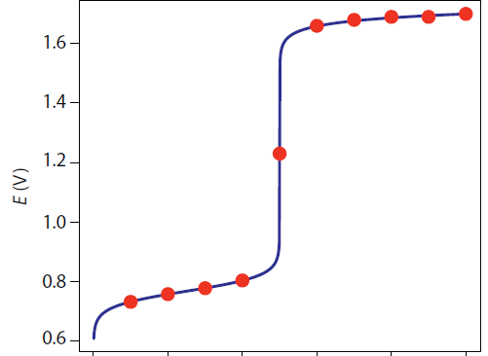
Εº_{Ce}

Εº_{Fe}
Eq.Pt
0 10 20 30 40 ml Titrant

Figure 17. Plot of potential versus ml titrant for the potentiometric titration of Fe²⁺ with Ce⁴⁺. (Figure from Analytical Chemistry 2.0, David Harvey, http://community.asdlib.org/activelearningmaterials/analytical-chemistry-2-0-online-textbook/).

The break in potential that occurs at the equivalence point is apparent in this plot. Note how the general form of this plot is similar to what is observed in a pH titration. This is not surprising since a pH titration is also a potentiometric titration.

One last thing worth examine is the equivalence point potential for a redox reaction where the number of electrons is different in each of the half reactions. For example, suppose Sn²⁺ was titrated with Ce⁴⁺. The two relevant half reactions are shown below.

Ce⁴⁺(aq) + e– = Ce³⁺(aq) Εº = 1.61 V

Sn⁴⁺(aq) + 2e– = Sn²⁺(aq) Εº = 0.154 V

In this case, the balanced reaction needs two equivalents of Ce⁴⁺ for each Sn²⁺ to balance out the electrons being transferred.

Sn²⁺(aq) + 2Ce⁴⁺(aq) = Sn⁴⁺(aq) + 2Ce³⁺(aq)

The equivalence point potential is calculated as follows:

$$E_{Eq.Pt.}= \frac{(n_{A}E_{A}^{0}+ n_{B}E_{B}^{0})}{(n_{A}+ n_{B})}$$

$$E_{Eq.Pt.}= \frac{(E_{Ce}^{0}+ 2E_{Sn}^{0})}{(1+2)}$$

$$E_{Eq.Pt.}= \frac{(1.61+ 2(0.154)}{(3)}=0.639 V$$

The plot of potential versus ml titrant that would be obtained for this titration is shown in Figure 18.
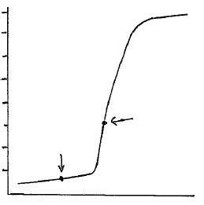
Ε (V)
Equiv.
Point
1.6

1.2

0.8

0.4
Εº_{Sn}
ml Titrant

Figure 18. Plot of potential versus ml titrant for the potentiometric titration of Sn²⁺ with Ce⁴⁺.

It is important to note that the equivalence point in Figure 18 is not symmetrically placed between the two potential plateaus surrounding the Εº value of tin and Εº value of cerium as it was in the reaction of cerium and iron we examined earlier. Instead, the equivalence point potential is weighted toward the Εº value of tin because the tin half reaction requires two electrons whereas the cerium half reaction only requires one.

