GAS CHROMATOGRAPHIC SEPARATION METHODS

A gas chromatograph typically has a carrier gas (it is common to refer to the mobile phase in gas chromatography as the carrier gas since the mobile phase has no influence at all over the separation – its only purpose is to carry the solutes through the column), heated injection port, column in a heated oven, and detector.

The carrier gas must be inert and helium or nitrogen is used for most gas chromatographic applications. Sample injection is most commonly accomplished through the use of a small-volume syringe (1 μL is a typical injection volume). The liquid sample is injected into a hot zone that is sealed with a polymer septum. The syringe pierces the septum, and on injection the liquid sample is flash-volatilized in the heated injection port and flushed into the column by the carrier gas. With fused silica capillary columns, 1 μL of liquid sample will overload the column so the injector is designed with a splitter. Adjusting the flow of the splitter gas allows you to calibrate the split ratio. Ratios of 50:1 to 100:1 (only the one part is injected) are common. Most injection ports of this type have glass liners. Different glass liners are inserted under the septum depending on whether you are doing split or splitless injections.

Another gas chromatographic injection technique that is used in certain applications involves thermal desorption from a polymer trap. The technique is illustrated in Figure 74 for the analysis of organic chemicals in air. Assume that we have a small piece of tubing filled with a polymer. The polymer is a material that organic chemicals will adsorb to. Water in the air will pass through unretained. A polymer that is used quite frequently for this application is Tenax. Tenax is a p-polyphenylene oxide polymer that is stable at very high temperatures. In the adsorption step, we use a pump to draw some large volume of air (this might be as high as 15 liters of air) through the Tenax trap, which is held at room temperature. The organic chemicals from the air will adsorb onto the polymer.

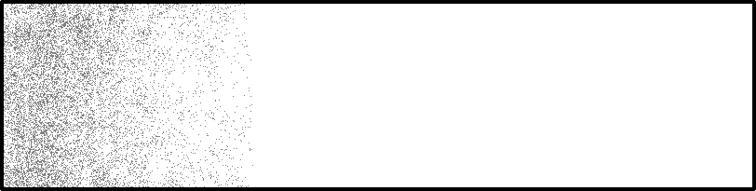
Pump
Water
Air (organics, water)

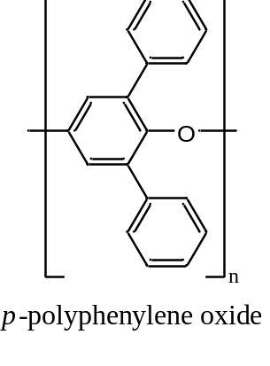

Figure 74. Use of a sorbent trap to remove organic compounds from an air sample.
The organic chemicals can be desorbed from the Tenax trap by heating the gas under a flow of helium. The illustration in Figure 75 shows how the Tenax trap is desorbed in a backflush mode (the end that had the higher concentrations of organic chemicals is put closer to the gas chromatograph). Switching valves comparable to liquid chromatographic injection valves make it easy to redirect the flow of gases through these Tenax traps between the adsorption and backflushing orientation.


Δ
Helium

Figure 75. Desorption of a sorbent trap in a backflush mode.

Desorption might typically be done at a temperature of 225ºC over a period of five minutes. One thing to realize is that we would never be able to tolerate a five-minute injection of a sample, since this would mean that all of the peaks might be as long as five minutes. It is essential to maintain a “plug” injection, which is achieved by thermal focussing. Thermal focussing is accomplished by cooling a region in the injector (or in older gas chromatographs, the entire oven) to a temperature of –50ºC. This cooling is accomplished using either liquid carbon dioxide or liquid nitrogen. At –50ºC, the organic compounds that desorb from the Tenax trap freeze in a small band at the head of the column. Rapid heating of this frozen band injects the sample at a comparable rate to a normal syringe injection.

Sorbent traps are frequently used for the analysis of trace levels of volatile organic chemicals in water as well. In this case, the method is known as a purge and trap technique and is shown in Figure 76. A sample of water is taken (usually 5 mL – too large to ever inject into a gas chromatograph) and purged with helium gas. After exiting the water, the helium gas flows through a Tenax trap. The helium gas bubbling through the water displaces the dissolved volatile organic chemicals, which adsorb onto the Tenax trap. The Tenax trap is desorbed as described above for the analysis of volatile organic chemicals in air.
He

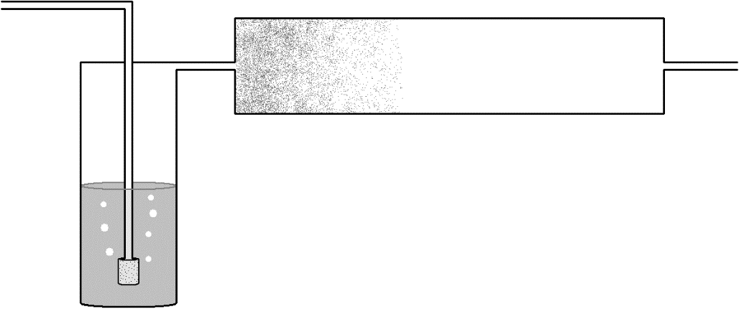

Figure 76. Purge and trap device used to analyze volatile organic compounds in water.
Another adsorption technique analogous to the sorbent traps discussed above involves the use of solid phase microextraction (SPME). SPME employs a specially designed syringe in which the metal barrel that is inserted through the septum of the injection port is wider in diameter than a usual GC syringe. Inside this wider barrel is a small fiber and a suitable solid adsorbent is coated onto the fiber. A common SPME procedure would involve the analysis of volatile organic compounds dissolved in water. A known volume of the water is put into a special vial that has a cap with a septum. The vial is not filled completely but has a layer of air between the solution and cap (this is known as the headspace). The syringe needle is inserted through the septum and a device on the syringe is used to push the fiber out of the syringe barrel. Depending on the particulars of the analysis, the fiber can be either in the headspace or in the liquid sample. After a specific adsorption time, the fiber is drawn back into the barrel of the syringe. The sample is injected into the GC by inserting the syringe through the septum on the injection port and pushing the fiber out to allow desorption to occur.

Information on a variety of commercially available gas chromatographic stationary phases is provided in Table 3. The distinction between different stationary phases is based on a comparison of their polarity. Five different compounds are typically used to represent different types of functional groups. Individual indices for these five compounds are measured, and a composite value (P) is determined as well. These polarity indices are referred to as Rohrschneider constants. The higher the number the more polar the phase. In reality, a sampling of four or five stationary phases would be good enough to span the range of polarities that is needed for gas chromatographic separations.

Table 3. Rohrschneider constants for gas chromatographic liquid phases

Liquid phase Max T ºC X' Y' Z' U' S' P
Squalane 100 0 0 0 0 0 0
Apiezon L 250 32 22 15 32 42 29
SE-30 300 15 53 44 64 41 43
OV-1, methyl gum 350 16 55 44 65 42 44
OV-3, 10% phenyl 350 44 86 81 124 88 85
OV-7, 20% phenyl 350 69 113 111 171 128 118
Dioctyl sebacate 125 72 168 108 180 123 130
Dilauryl phthalate - 79 158 120 192 158 141
Dinonyl phthalate 150 83 183 147 231 159 161
OV-17, 50% phenyl 375 119 158 162 243 202 177
Versamid 930 150 109 313 144 211 209 197
Trimer acid 150 94 271 163 182 328 218
OV-25, 75% phenyl 350 178 204 208 305 280 235
Polyphenylether 225 182 233 228 313 293 250
Triton X-305 200 262 467 314 488 430 392
Carbowax 20M 225 322 536 368 572 510 462
Carbowax 1540 175 371 639 453 666 641 554
Diglycerol 100 371 826 560 676 854 657
Ethylene glycol phthalate 200 453 697 602 816 872 688
Diethylene glycol succinate 200 496 746 590 837 835 701
Tetrahydroxyethylenediamine 150 463 942 626 - 893 731
Hexakis(2-cyanoethoxycyclohexane) 150 567 825 713 978 901 797
N,N-bis(2-cyanoethyl)formamide 125 690 991 853 1110 1000 929

X' = benzene; Y' = butanol; Z' = 2-pentanone; U' = nitropropane; S' = pyridine, P = (X' + Y' + Z' + U' + S')/5
If we consider what governs retention order in gas chromatography, there are two important parameters. One is the volatility of the compound, with the observation that more volatile compounds (those with a higher vapor pressure or lower boiling point) elute first. The other is the attractive forces between the compound and the stationary phase. If we consider the homologous series of alcohols listed in Table 4, it’s interesting to note that the boiling point goes up by approximately 20ºC for each additional methylene group (CH₂) in the chain. The increase in boiling point with each additional methylene group is a little higher for the series of alkanes. The alcohols have higher boiling points than the corresponding alkanes because they can hydrogen bond with each other.

Table 4. Boiling points for homologous series of alkanes and primary alcohols.

Hydrocarbon Boiling Point (ºC) Alcohol Boiling Point (ºC)

Pentane 36 1-Pentanol 137
Hexane 69 1-Hexanol 157
Heptane 98 1-Heptanol 176
Octane 126 1-Octanol 196
Nonane 151 1-Nonanol 215
Decane 174 1-Decanol 231

If we consider a homologous series, it turns out that the boiling points are actually determined by the molar volumes of the molecules. Just as we observed with the size of molecules in steric exclusion chromatography, the molar volume of a molecule is the volume swept out by the molecule as it tumbles. Molecules with larger molar volumes have higher boiling points, provided the molecules being compared have identical intermolecular forces (you cannot compare hydrocarbons to alcohols). An interesting comparison is observed by looking at the boiling point of n-octane and iso-octane (2,2,4-trimethylpentane).

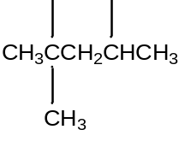

n-octane (bp = 126ºC) iso-octane (bp = 98ºC)

The branched iso-octane would have a smaller molar volume than the linear n-octane, and this is clearly reflected in the boiling points of the two compounds.

When predicting retention order in gas chromatography, the overriding factor is a comparison of the boiling points. The compound with the lowest boiling point elutes first. Only when two compounds have very close boiling points (within 5ºC or less) does it become important to consider the polarity of the compounds and the polarity of the stationary phase. Remember that like dissolves like, so a polar stationary phase will show more retention of a polar compound. The Rohrschneider values are used to determine the polarity of the stationary phase.
Detection Methods

As mentioned previously, highly sensitive detection methods were developed for gas chromatography in the 1950s and 1960s that facilitated its use as an analytical method.

One of the most useful detection methods is known as the flame ionization detector (FID). The flame ionization detector is highly sensitive and involves burning the sample in an air-hydrogen flame. Molecules with a CH bond will form CH⁺ ions in the flame, and these are measured using a negatively charged collector above the flame. When these positive ions strike the negatively charged collector, a current proportional to the amount of ions is measured. This detector is essentially universal, as it is able to measure all organic compounds. It is not sensitive toward compounds like water and carbon dioxide, which is advantageous.

Another important detector in the development of gas chromatography is the thermal conductivity detector. This is a universal detector, but not nearly as sensitive as the FID. A resistance circuit called a Wheatstone bridge is used. The bridge has two halves, and the resistance of these halves is compared. Instruments with a thermal conductivity detector need two matched columns. One column has only carrier gas flowing through it. The other has carrier gas and sample. Changes in the thermal conductivity of the gas change the resistance reading over the Wheatstone bridge. Some representative values for thermal conductivities of gases are listed below. The value for butane is representative of most organic compounds. Since we need to measure a difference in thermal conductivity, we need a carrier gas with as different a thermal conductivity as possible from most organic compounds. This would suggest the use of hydrogen gas as a carrier gas, however hydrogen is too much of an explosion risk for this purpose. Helium is therefore the carrier gas of choice. Thermal conductivity detectors tend to be used on less expensive pieces of equipment like the gas chromatographs used for the analysis of the purity of compounds prepared in organic chemistry instructional labs.

Thermal conductivity values: Hydrogen 471
Helium 376
Nitrogen 66
n-Butane 43

One of the most important gas chromatographic detectors ever developed was the electron capture detector. This device, which is illustrated in Figure 77, was invented by James Lovelock. The device has a radioactive foil (usually containing tritium or radioactive nickel) that emits beta particles. Beta particles are high-energy electrons emitted by a nuclear decay process (a neutron decays into a beta particle and a proton). The opposite side of the device is positively charged so the beta particles stream across the tube. As the high-energy beta particles strike carrier gas molecules (usually either nitrogen or an argon/methane mixture), they create a cascade of lower energy electrons, which generate a current that can be measured. If we had a compound coming out of the gas chromatograph that could capture some of these low-energy electrons, the current would drop. The drop in current can be related to the concentration of electron capturing compound in the sample. What is especially impressive about this detector is the level of sensitivity that can be achieved for certain classes of compounds.

Eluent

Beta Emitter
(–)
Collector
(+)

Figure 77. Representation of an electron capture detector.

What types of compounds ought to have the ability to capture electrons? Remembering back to your knowledge of periodic properties, you should predict that halogen-containing compounds (compounds with a chlorine, fluorine, or bromine atom) ought to be very effective at capturing electrons. What are especially significant are the classes of compounds that contain halogens. These include the following (with their respective application or concern):

- Chlorofluorocarbons (or freons) – ozone layer destruction
- Chloroform – potential carcinogen formed in drinking water from water chlorination
- Dioxin – by-product of combustion and certain industrial processes
- Chlorinated pesticides such as DDT
- Polychlorinated biphenyls – used in electronic devices (transformers)

These are only some examples, but they form an extensive array of compounds of environmental significance. The invention of the electron capture detector facilitated the discovery that freons were making their way to the stratosphere and leading to the destruction of the ozone layer. Without this detector, this discovery would have been delayed by many years.

Mass spectrometric detection is especially important because it provides information that can be used for compound identification. Most gas chromatograph-mass spectrometers (GC-MS) use fused silica capillary columns, and the column effluent can go straight into the mass spectrometer. What happens in the mass spectrometer is that the column effluent is bombarded with a high-energy beam of electrons. As these electrons strike the sample, they generate ions. These can be anions or cations, but most mass spectrometers are designed to draw off only the cations for analysis. Usually almost all the cations have a +1 charge. If we consider the molecule acetophenone, we can illustrate what will take place (three functional groups within the molecule are labeled A, B, and C).

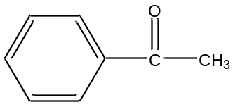
A B C
Acetophenone

If an electron struck this molecule and knocked out one other electron, we would have the entire molecule with a +1 charge. This ion is referred to as the molecular ion, and we would show this as ABC⁺. It’s usually very desirable to have a molecular ion in the spectrum. The other valuable observation in mass spectrometry when you use an electron beam for ionization is that you get fragment ions as well. Possible fragments we could get from acetophenone are listed in Table 5, along with their masses. Actually, what is really measured is the mass-to-charge ratio, denoted as m/e. If all of the ions have a charge of +1, the mass equals the mass-to-charge ratio.

Table 5. Possible fragment ions from acetophenone using A, B and C to denote pieces of the molecule.

Ion m/e
ABC⁺ 120
AB⁺ 105
AC⁺ 92
A⁺ 77
BC⁺ 43
B⁺ 28
C⁺ 15

A good question to ask is whether we would ever get AC⁺ as a fragment? This would require an intramolecular reaction to take place. This does happen with some molecules, but not the one we are using as an example. Similarly, it might be very unlikely to get a B⁺ ion, which would require the loss of two groups. If you were to examine a book on reaction mechanisms that occur in a mass spectrometer, you would notice that it would look very similar to an organic chemistry textbook. The two things we observe is that different fragments have different weights, but they also have different intensities. For example, if a molecule has a good leaving group, it will tend to leave in the mass spectrometer. Depending on which fragment is more stable as a positive ion, the relative intensity of the two ions will vary. The most intense ion is given a value of 100 and the intensity of each other ion is reported relative to it. The mass spectrum for acetophenone obtained through the National Institute of Standards and Technology (NIST) is provided in Figure 78. It is worth noting that there will be many more ions in the spectrum than these. For one thing, isotope effects show up. It turns out that 1% of all carbon is carbon-13 so one out of every hundred molecules weighs one more (meaning that we will see a small peak at m/e = 121). Note that the mass spectrometer does not measure an average molecular weight based on isotopic abundance, but the exact weight of each ion.

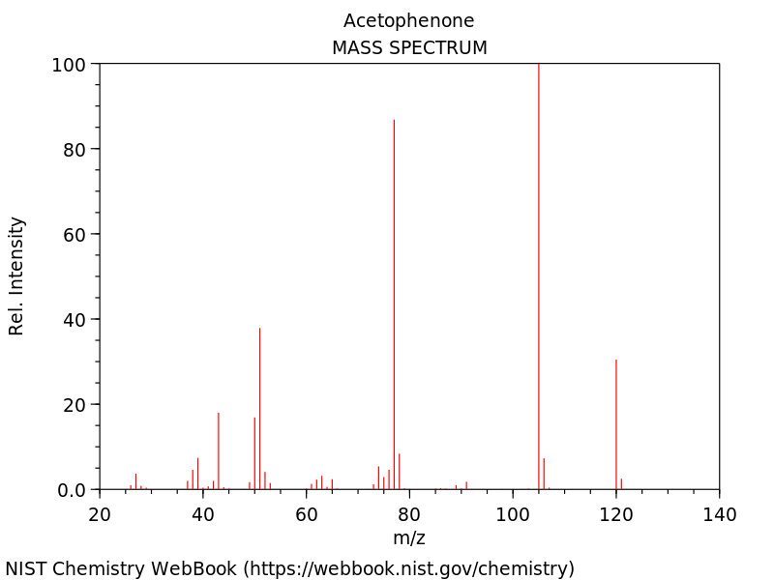

Figure 78. Mass spectrum of acetophenone.

Notice how we could use these masses to determine a possible molecular formula for the compound, and the masses of fragments to determine possible groups that are found in the molecule. The compound below (benzeneacetaldehyde) has the exact same molecular weight (120) as acetophenone, but you might appreciate that it would probably have a different mass spectrum because it would form fragments of different weights than those from acetophenone. Figure 79 shows the mass spectrum of benzeneacetaldehyde, which you will not is quite different from that of acetophenone.
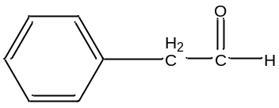

benzeneacetaldehyde

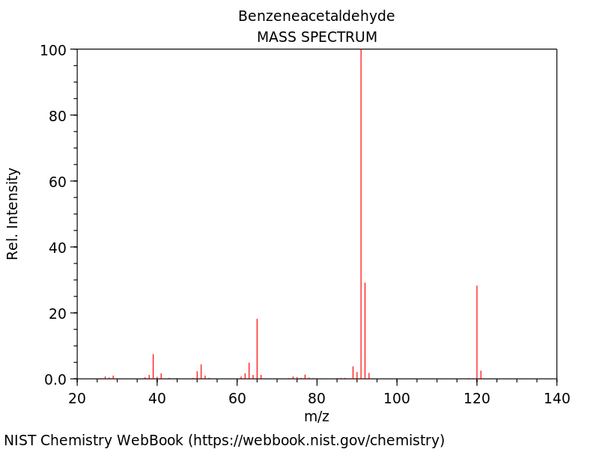

Figure 79. Mass spectrum of benzeneacetaldehyde.
Mass spectra are relatively difficult to interpret and to assign an unequivocal structure to. What is usually done instead is that the mass spectrometers with a GC-MS come with a library of spectra of known compounds. The computer will compare your measured mass spectrum to those in the library and report the ten best matches. The top match does not confirm the assignment. To do that, you would need an authentic sample of that compound and would have to show that it has the same retention time and mass spectrum on your instrument. With those two matches, you can be assured that you have identified the compound. GC-MS is commonly used for drug testing at sports events like the Olympics.

