MASS SPECTROMETRY

- Introductory Concepts

Mass spectrometry is a useful technique for compound identification. As the name implies, it is a method that allows you to determine the mass of a species. Mass spectrometric techniques require the formation of gas-phase ions, and most involve the formation and analysis of cations.

Why do you think it is necessary to have ions instead of neutral species?
The benefit of having ions is that an electric field can be used to draw them out of a gas-phase mixture and move them around in a mass spectrometer. Most mass spectrometers operate at high vacuum conditions.

Why do you think mass spectrometers operate under high vacuum conditions?
It will be important to have the ion exist for a long enough time to be able to perform the measurement. High vacuum conditions will reduce collisions with other gas-phase species and prolong ion lifetime.

One component of a mass spectrometer is known as an ion source. There are a number of different methods that are used to generate ions in mass spectrometry. A common one when analyzing relatively small molecules (e.g., most of the organic chemicals you studied in a sophomore-level organic chemistry course) is to bombard compounds in the gas phase with a high-energy beam of electrons – this is known as electron ionization (EI).

Figure 1 shows a mass analyzer system known as a sector instrument. Even though this mass analyzer is not commonly used today, the way it works is helpful in understanding some basic factors that allow a mass spectrometer to distinguish ions. In addition to the magnetic sector, the figure shows the location of the ion source and detector.

In the sector analyzer, a magnetic field (B) is applied that deflects the path of the ions. Figure 1 also shows the paths of several ions moving through the curved path. Note how one makes it all the way through to the detector. Others strike the walls of the channel. When ions strike the walls of the analyzer, they will gain an electron and no longer be capable of being analyzed.
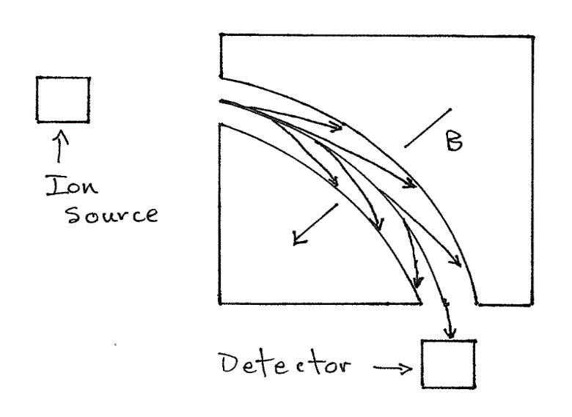
Figure 1. Magnetic sector mass analyzer
An EI source will have a gas-phase mixture that contains neutral, cationic and anionic species.

What would be needed between the ion source and magnetic sector if the goal is to analyze cations?
It would be necessary to introduce a negatively charged electric field between the ion source and mass analyzer that is capable of pulling the cations out of the gas-phase mixture. This electric field serves several purposes. One is to draw out only the cations. A second is to create a focused beam of the cations to introduce into the mass analyzer. A third is to accelerate the beam of cations before it enters the mass analyzer.

What aspects of (a) the chemical species and (b) operating parameters of the mass spectrometer would influence the angle of deflection? For each variable you identify, indicate what would make the deflection of an ion smaller or larger.
There are four parameters that influence the angle of deflection, two of which relate to the chemical species; two of which relate to operating parameters of the mass spectrometer.

- The mass of the chemical species. The heavier the species, the less the angle of deflection. Hopefully, it makes intuitive sense that the heavier a species, all else being equal, the more difficult it would be to deflect it off its path.

- The charge of the chemical species. The larger the charge, the more the species interacts with the magnetic field and the larger the angle of deflection.

- The acceleration voltage used in creating the focused beam of cations. This voltage will influence the speed at which the ions enter the mass analyzer. The higher the voltage, the faster the speed, and the less the angle of deflection.

- The size of the applied magnetic field. The larger the applied magnetic field, the larger the angle of deflection.

Note that at any specific group of the four settings (acceleration voltage, magnetic field, mass of the ion, charge of the ion provided all have +1 charges), only one particular species will make its way through the open channel of the sector device to the detector. Because of the influence of mass and charge in determining which species makes it through the device, a mass spectrometer actually measures the mass-to-charge ratio (m/z) for the species. Fortunately, it is exceedingly rare in an EI source to produce ions that have anything other than a +1 charge, which simplifies the analysis of a mass spectrum.

What could you vary to obtain a mass spectrum for a chemical compound using an EI source and sector mass analyzer? A mass spectrum is a plot of isotopic abundance (Y-axis) versus m/z (X-axis).
Since the m/z value is set for a particular species, the two things that can be varied are either the acceleration voltage or the applied magnetic field. (1) Systematically scanning from high to low acceleration voltages with a constant applied magnetic field or (2) scanning from low to high magnetic field with a constant acceleration voltage would allow you to obtain a mass spectrum from low to high m/z values.

- Fragmentation in Mass Spectrometry

An important aspect of electron ionization is that it can generate fragment ions for a molecule. As the name implies, fragments are smaller portions of the molecule. Almost all the cations created in a conventional mass spectrometer have a +1 charge. Consider the molecule acetophenone, consisting of three parts labeled A, B, and C. The dotted lines represent the division of the different parts.

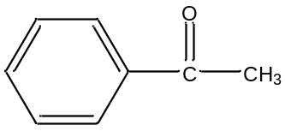
A B C
Acetophenone

List all cationic fragments that are hypothetically possible, along with their respective masses.
We would consider all of the following ions as hypothetical possibilities:

ABC⁺ – 120
AB⁺ – 105
BC⁺ – 43
AC⁺ – 92
A⁺ – 77
B⁺ – 28
C⁺ – 15

Which of these fragments do you think are likely to form? Are there any fragments that are unlikely to form? Explain why.
An important consideration with mass spectrometry involves the extent to which the different fragments form. In many ways, the processes that occur within an EI source mirror the reactivity properties of the molecules. For example, you are likely familiar with the concept of a leaving group in organic molecules. In a mass spectrometer, a leaving group is likely to “leave” the compound meaning either its cationic species or the cation of the remaining species will be a very likely fragment.

If we consider acetophenone, we might expect that the AC⁺ fragment would be highly unlikely. Formation of AC⁺ would require an intramolecular rearrangement where the CH₃ group would form a bond to the phenyl ring and the carbonyl group (C=O) would split out. In acetophenone, the methyl group isn’t close enough to the ring to undergo such an intramolecular reaction. An interesting observation occurs if the ketone functional group had a longer carbon chain (-CH₂CH₂CH₃). In this case, the substituent group is now long enough that the methyl group can participate in the corresponding intramolecular rearrangement in an EI source and the resulting fragment is actually quite favorable.

The other fragment we might expect to be highly unlikely is B⁺. This ion would require the simultaneous breaking of two bonds, which is less likely to occur in an EI source.

All of the other fragments are reasonable to expect in the mass spectrum of acetophenone. The ABC⁺ ion, which is the molecular ion, is very useful when trying to interpret mass spectra. However, some compounds fragment too easily and do not product a molecular ion in EI source.

The mass spectrum of acetophenone is shown in Figure 2.

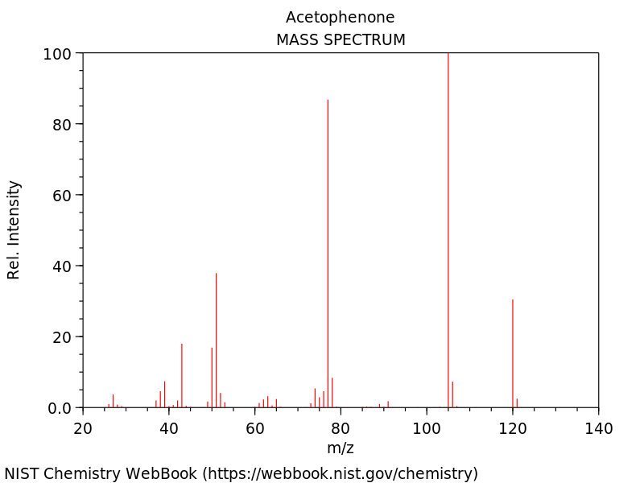

Figure 2. Mass spectrum of acetophenone.

There are several things in this spectrum worth commenting on. In a mass spectrum, the most intense ion is given a value of 100 and the intensity of each other ion is reported relative to it. Note that the m/z = 105 peak is the largest peak in the spectrum (what we called AB⁺). That means that this is the most common fragment ion of acetophenone. Note that there is a fairly intense molecular ion for acetophenone (ABC⁺ = 120). Peaks for the other fragments we identified as being reasonable (BC⁺ = 43; A⁺ = 77) are observed in the spectrum. Peaks for fragments we thought were unlikely (AC⁺ = 92; B⁺ = 28) are not observed in the spectrum. Also note that the spectrum only goes down to m/z = 20, meaning we would not know whether the peak for C⁺ with a mass of 15 is in the spectrum. It is common to cut off the low m/z region of the spectrum because fragments with masses below m/z = 20 are not that useful in interpreting mass spectra.

An important aspect of mass spectrometry is that two compounds with the same molecular weight often have very different mass spectra because of differences in their fragmentation patterns. As example would be to consider the compound benzeneacetaldehyde

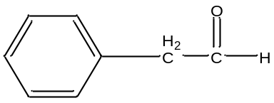
A B C

benzeneacetaldehyde

What would be the masses of the major fragments of benzeneacetaldehyde?
The chart below shows the masses of similar fragments for acetophenone and benzeneacetaldehyde.

Acetophenone Benzeneacetaldehyde
ABC⁺ – 120 ABC⁺ – 120
AB⁺ – 105 AB⁺ – 91
BC⁺ – 43 BC⁺ – 43
A⁺ – 77 A⁺ – 77
C⁺ – 15 C⁺ – 29

Note that the AB⁺ fragment shows a significant difference in acetophenone (AB⁺ = 105) and benzeneacetaldehyde (AB⁺ = 91). Since the 105 fragment was the most intense peak in acetophenone, this fragment alone should distinguish the two compounds. The mass spectrum for benzeneacetaldehyde is shown in Figure 3.

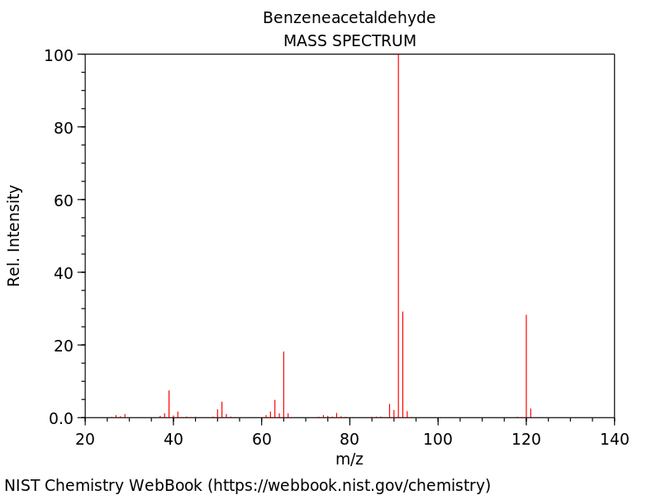

Figure 3. Mass spectrum of benzeneacetaldehyde.

A comparison of this spectrum to that of acetophenone in Figure 2 shows clear differences that would allow you to distinguish these two compounds from each other. Interpretation of mass spectra is not a trivial matter, though, so the most common approach when using mass spectra for compound identification is to have a library of spectra. The library developed by the National Institute of Standards and Technology (NIST) has mass spectra of approximately 180,000 compounds. Computer algorithms can search the library and compare the mass spectrum of an unknown compound to those in the library and identify and rank the best matches.

In examining the spectra in Figures 2 and 3, you will note that there are fragments with masses that differ from those we identified above. For most compounds, there are lots of fragment pathways and therefore lots of fragments that you might not initially expect to find in the spectrum.

- Isotopes in Mass Spectrometry

Figure 4 shows an enlargement of the most intense peak in the mass spectrum of acetophenone.

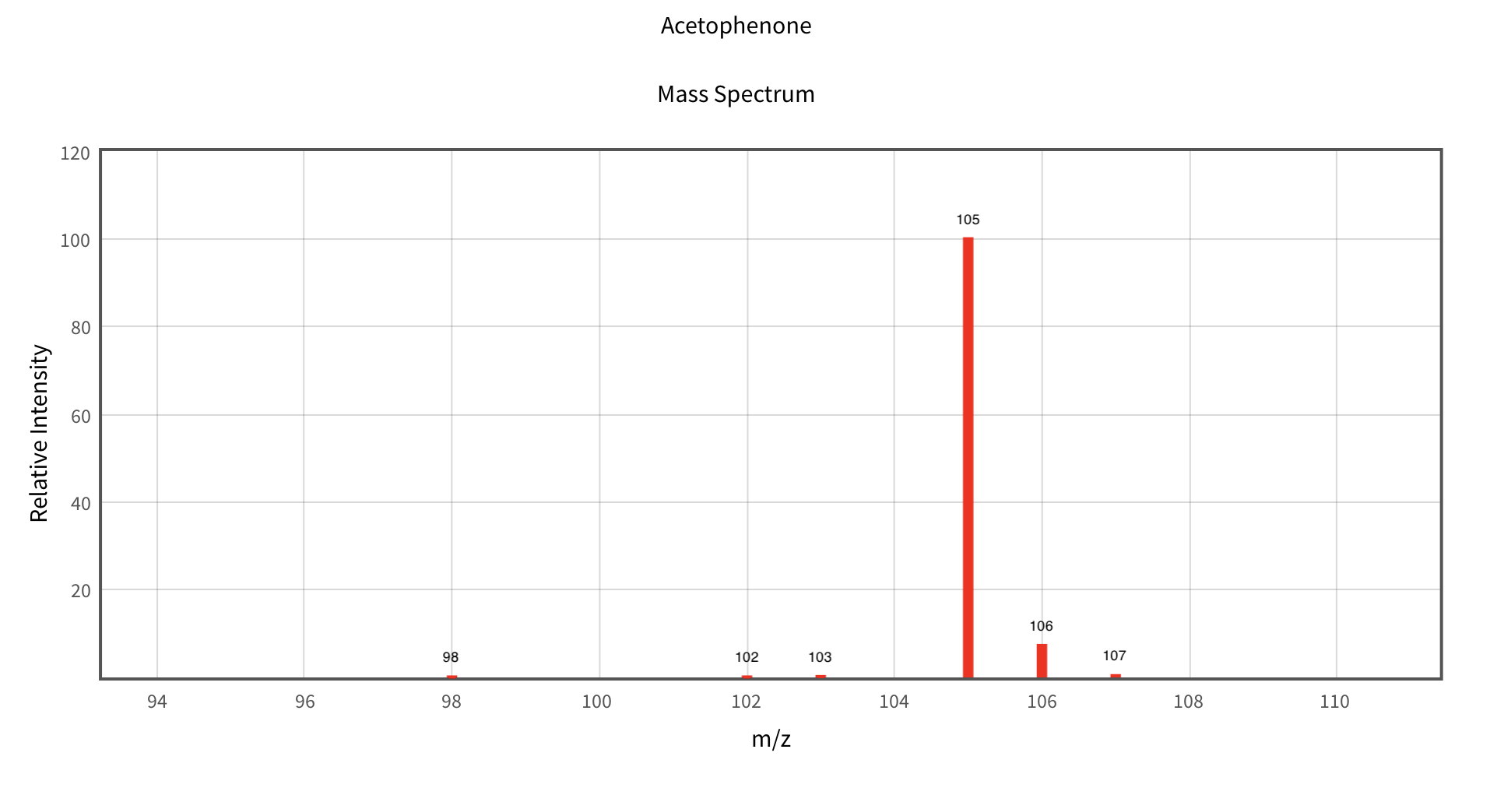
Figure 4. Enlargement of the m/z = 105 peak in the spectrum of acetophenone.

What accounts for the peaks at m/z = 106 and 107?
It is important to recognize that carbon has two isotopes: ¹²C and ¹³C. About 99% of carbon is ¹²C and about 1% is ¹³C. This means that only 1 out of every 100 carbon atoms is ¹³C. The formula for the 105 fragment is C₇H₅O. This means that most of the C₇H₅O fragments will only have ¹²C atoms and will weigh 105 – this is referred to as the base peak. However, some of the C₇H₅O fragments will have a ¹³C atom. Those C₇H₅O fragments that do have a ¹³C atom will weigh 106 (denoted as the m+1 peak). In some cases, the presence of isotope peaks in mass spectra can be highly useful in interpreting the spectrum.

Why is the peak at 107 so much smaller than the peak at 106?
The peak at 107 (m+2) would require a C₇H₅O fragment with two ¹³C atoms. With 1 out of every 100 carbon atoms being a ¹³C, there is some very slight probability of getting a C₇H₅O fragment with two ¹³C atoms. So a 107 peak is observed, but it is very low intensity.

One use of the carbon isotope peak at m+1 is that its relative intensity can be used to determine the number of carbon atoms in the fragment.

If a carbon-based fragment of mass m has an intensity of 100 and a fragment with the same formula but a mass of m+1 has an intensity of 10, how many carbon atoms are in that fragment?
The approach is to consider 100 carbon atoms. If the relative intensity of the m+1 peak is 10% of the base peak, then that suggests that 1 in every 10 of the species has a ¹³C atom. That would occur if the cluster consists of a fragment with 10 carbon atoms.

Let’s reconsider the relative intensities of the 105 and 106 peaks for acetophenone shown in Figure 4. This fragment has 7 carbon atoms. Consider 100 total carbon atoms. With 7 carbon atoms in each fragment, dividing 100 by 7 produces approximately 14 fragment ions (7 x 14 = 98). Only one of these would have a ¹³C atom. So 1 in 14 fragments has a ¹³C atom: 1/14 = 0.07. Converting this to a percentage by multiplying by 100 means that 7% of the fragments have a ¹³C atom. A careful inspection of the relative intensity of the 106 peak in Figure 4 shows that it is 7% of the base peak at 105. A general rule is that the relative intensity of the m+1 ¹³C isotope peak to the base peak tells you how many carbon atoms are in the fragment (e.g, 5% means there are five carbon atoms in the fragment; 12% means that there are 12 carbon atoms in the fragment.

Chlorine is another atom that has an interesting isotope effect that can be very helpful in spectral interpretation.

About one in every four Cl atoms has a mass of 37 amu rather than the typical 35. (Note: this explains the somewhat unusual atomic weight of chlorine of 35.453). Draw the approximate relative intensities of the m and m+2 peaks of CH₃Cl?
The one in four abundance means that one of every four fragments would have a ³⁷Cl atom. Three of every four fragments would have a ³⁵Cl atom. Therefore, the ratio of the m to m+2 peaks is 3:1. The mass spectrum of chloromethane (CH₃Cl) is shown in Figure 5. Careful inspection of the intensity of the m+2 peak at 52 to the peak at 50 shows it to be about 33%.

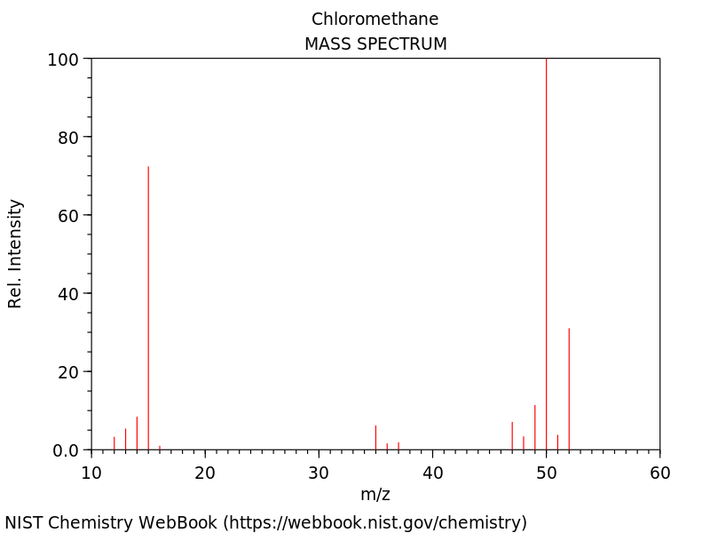

Figure 5. Mass spectrum of chloromethane (CH₃Cl).

- Isotopes and Delta Values in Mass Spectrometry

The atomic weight reported in the periodic table for an element (e.g., chlorine = 35.453 g/m) is a weighted average based on the abundance and specific weights of each of the isotopes of that element. An implication of these atomic weights is that the abundance of each specific isotope of an element is identical in every sample of that element. However, the actual situation is that isotopic abundances for a particular element can vary slightly from sample to sample.

These variations in abundances are expressed in what are known as δ-values (e.g., δ¹³C for carbon-13). These values are calculated using the following equation:

$$∂X=\frac{\left(R_{sample}-R_{Standard}\right) }{R_{Standard}} × 1000$$

Where X is the isotope and R is the ratio of heavy-to-light isotope.

Table 1. Standard ratio values for different elements. Reproduced from O’Brien, D. M., Stable isotope ratios as biomarkers of diet for health research, Annual Reviews of Nutrition, 2015, 35, 565-594.

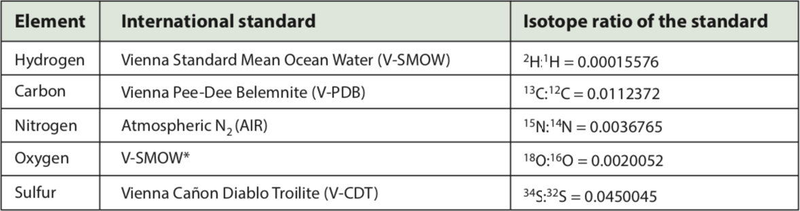

Plants exhibit differences in their ¹³C-¹²C ratios compared to the international standard. Plants get their carbon from carbon dioxide in the atmosphere – a process referred to as fixing. Plants use an enzyme known as rubisco to fix carbon dioxide from the atmosphere. Rubisco is better at fixing ¹²CO₂ than ¹³CO₂ – the slight mass difference between ¹²C and ¹³C causes ¹²CO₂ to have a slightly faster diffusion rate and therefore faster rate constant than ¹³CO₂.

Based on the properties of rubisco, will the δ¹³C values for plants be positive or negative?
The R value for the sample will have less ¹³C than the R value for the standard because rubisco is more effective at fixing ¹²CO₂. That means that the sign of the δ¹³C will be negative. The more negative the value, the lower the percentage of ¹³C in the sample.

R values are measured for a sample of corn (R = 0.0110911) and wheat (R = 0.0109338). Calculate the δ¹³C values for corn and wheat.
Using the equation above, the δ¹³C for corn is 13%_{o}. The δ¹³C value for wheat is 27%_{o}.

Which plant has a higher amount of ¹³C?
Corn has a higher amount of ¹³C.
Corn, sugarcane and sorghum are known as C4 plants. Wheat, rice, beans and most fruits and vegetables are known as C3 plants. During photosynthesis, C3 plants incorporate carbon into a 3-carbon sugar whereas C4 plants incorporate carbon into a 4-carbon sugar. Also, C4 plants have a second enzyme involved in the fixation of carbon dioxide that is not as selective for δ¹²C as rubisco. Figure 6 shows the results of approximately 1000 measurements of δ¹³C values for C3 and C4 plants.
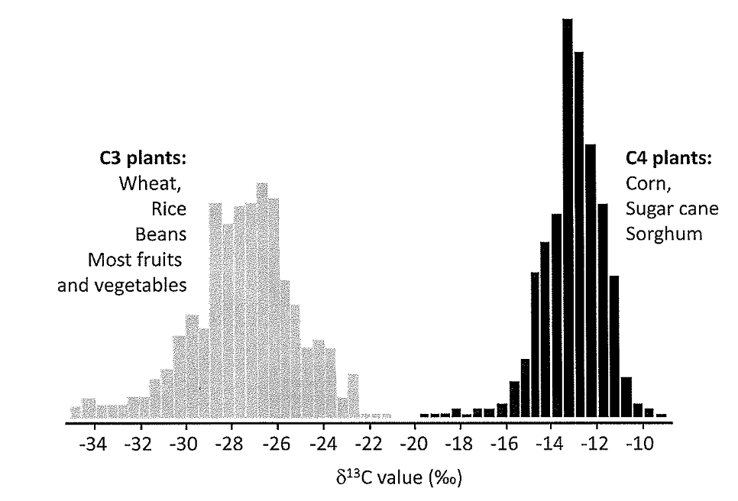
Figure 6. Measurements of δ¹³C values for C3 and C4 plants. Reproduced from O’Leary, M. H., Carbon isotopes in photosynthesis, Bio Science, 1988, 38, 328-336.

The R value of a sample of blood plasma collected from a college student in the United States is measured and found to be 0.0110038. What does this say about the diet of this student?
The δ¹³C value for the student is 20.8%_{o}. If the average δ¹³C value for corn is 13% and wheat is 27%_{o}, that suggests that the student’s diet is about 50% from C4 plants.

Does this value surprise you? You might wish to think about sources of corn in a typical American diet.
It would be unusual to have a diet containing about 50% of direct corn and corn-based products. However, corn products are used in many other ways. One is the use of high fructose com syrup as a sweetener in many processed foods. Another is that corn is used as a primary feed source for many animals including beef, pork and poultry. An analysis of the δ¹³C values in human blood plasma or hair can be used to determine the contribution of corn-based products in one’s diet.

