3. MOLECULAR LUMINESCENCE

3.1. Introduction

Luminescent methods refer to a family of techniques in which excited state species emit electromagnetic radiation. Among luminescent methods are various sub-categories that include the processes of fluorescence, phosphorescence, chemiluminescence, bioluminescence and triboluminescence. Among these different sub-categories, fluorescence spectroscopy is by far the most common technique used for analysis purposes. You are no doubt familiar with fluorescent lights. This unit will allow you to understand how such a light works.

3.2. Energy States and Transitions

Fluorescence only occurs after a chemical species has first been excited by electromagnetic radiation. The emission of radiation by a solid object heated in a flame (e.g., a piece of iron) is not fluorescence because the excitation has occurred thermally rather than through the absorption of electromagnetic radiation. Fluorescence can occur from species that have been excited by UV/VIS radiation. To consider what happens in the process of fluorescence, we need to think of the possible energy states for a ground and excited state system.

Draw an energy level diagram for a typical organic compound with π and π * orbitals.

Figure 3.1 represents the energy levels for a typical organic compound in which the π orbitals are full and the π* orbitals are empty.

Figure 3.1. Energy level diagram for π- and π*-orbitals of a typical organic compound.

Now consider the electron spin possibilities for the ground and excited state. Are there different possible ways to orient the spins (if so, these represent different spin states).

The ground state, which is shown on the left in Figure 3.1, has two electrons in the π-orbital. These two electrons must have opposite spins or else they would have the same four quantum numbers. Therefore, there is only one possible way to align the spins of the two electrons in the π-orbital.

The excited state has one electron in the π-orbital and one electron in the π*-orbital as shown in Figure 3.1. In this case, there are two possible ways we might align the spins. In one case, the electron in the π*-orbital could have the opposite spin of the electron in the π-orbital (e.g., the electrons have paired spins, even though they are in different orbitals – see Figure 3.2, middle diagram). In the other case, the electron in the π*-orbital could have a spin that is parallel with the electron in the π-orbital (see Figure 3.2 – far right diagram). In both cases, it does not matter which electron has spin-up and which has spin-down, the only important point is that in one case the two spins are opposite and in the other they are parallel. The energy level diagram in Figure 3.2 shows representations for the two possibilities.

Figure 3.2. Representations of possible spin states for ground and excited state systems.

Do you think these different spin states have different energies?

Since they are different from each other (i.e., spins parallel versus spins paired), it makes sense that they would have different energies.

Which one do you expect to be lower in energy?

To answer this question, we have to think back to a rule we established with placing electrons into atomic or molecular orbitals that have the same energy (i.e., are degenerate). We learned that electrons go into degenerate orbitals with parallel spins and only pair up their spins when forced to do so (e.g., an atomic p³ configuration has three unpaired electrons with parallel spins; only when we added a fourth electron to make a p⁴ configuration do two of the electrons have paired spins). The rationale we gave for this observation is that configurations with parallel spins in degenerate orbitals are lower in energy than configurations with paired spins (i.e., it took energy to pair up electron spins). Applying this general concept to the situation above, we can reason that the configuration in which the electrons in the π- and π*-orbitals have parallel spins is lower in energy than the configuration in which the two electrons have paired spins. The energy level diagrams in Figure 3.3 show the lower energy of the configuration where the electrons have parallel spins.

Figure 3.3. Relative energies of excited state systems with paired and unpaired spins.

If the spin state is defined as (2S + 1) where S represents the total electronic spin for the system, try to come up with names for the ground and possible excited states for the system that are based on their spin state.

Remember that spin quantum numbers are either +½ or –½. S, the total electronic spin for the system, is the sum of the individual spin quantum numbers for all of the electrons.

In the case of the ground state, for every electron with a spin of +½ there is an electron with a spin of –½. Therefore, the value of S is zero. The spin state, which is 2S + 1, would have a value of 1.

In the case of the excited state in which the electrons have paired spins (+½ and –½), the value of S is also zero. Therefore, the spin state, which is 2S + 1, would have a value of 1.

In the case of the excited state in which the electrons have parallel spins (+½ and +½; by convention, we use the positive value of the spin for parallel spins when determining the spin state), the value of S is now one. Therefore, the spin state, which is 2S + 1, would have a value of 3.

The name we use to signify a system with a spin state of one is a singlet state. The name we use to signify a system with a spin state of three is a triplet state. Note that the ground state is a singlet state and that one of the excited states is a singlet state as well. We differentiate these by denoting the energy level with a number subscript. So the ground singlet state is denoted as S₀ whereas the first excited state is denoted as S₁. It is possible to excite a molecular species to higher electronic states so that higher energy S₂, S₃, etc. singlet states exist as well. The triplet state would be denoted as T₁. There are also T₂, T₃, etc. as well. Now we can draw a more complex energy diagram for the molecule that shows different singlet and triplet levels (Figure 3.4).

Draw a diagram of the energy levels for such a molecule. Draw arrows for the possible transitions that could occur for the molecule.

Figure 3.4. Energy level diagram for a molecular species.

Note in Figure 3.4 how a triplet state is slightly lower in energy than the corresponding singlet state. Note as well that there are vibrational and rotational levels superimposed within the electronic states as we observed before when considering UV/VIS spectroscopy. The energy level diagram in Figure 3.4 shows the transitions that can occur within this manifold of energy states for an organic molecule. The transitions are numbered to facilitate our discussion of them.

Transition 1 (Absorption)
The transitions labeled with the number (1) in Figure 3.4 represent the process of absorption of incident radiation that promotes the molecule to an excited electronic state. The diagram shows the absorption process to the S₁ and S₂ states. It is also possible to excite the molecule to higher vibrational and rotational levels within the excited electronic states, so there are many possible absorption transitions. The following are equations that show the absorption of different frequencies of radiation needed to excite the molecule to S₁ and S₂.

S₀ + hν = S₁
S₀ + hν’ = S₂

It is reasonable at first to think that there is an absorption transition that goes directly from the S₀ to the T₁ state. This is a transition that involves a spin-flip and it turns out that transitions that involve a spin-flip or change in spin state are forbidden, meaning that they do not happen (although, as we will soon see, sometimes transitions that are forbidden do happen). What is important here is that you will not get direct excitation from the S₀ level to a higher energy triplet state. These transitions are truly forbidden and do not happen.

Transition 2 (Internal Conversion)
Internal conversion is the process in which an electron crosses over to another electronic state of the same spin multiplicity (e.g., singlet-to-singlet, triplet-to-triplet). The internal conversion in Figure 3.4 is from S₂ to S₁ and involves a crossover into a higher energy vibrational state of S₁. It is also possible to have internal conversion from S₁ to a higher vibrational level of S₀.

Transition 3 (Radiationless decay – loss of energy as heat)
The transitions labeled with the number (3) in Figure 3.4 are known as radiationless decay or external conversion. These generally correspond to the loss of energy as heat to surrounding solvent or other solute molecules.

S₁ = S₀ + heat
T₁ = S₀ + heat

Note that systems in S₁ and T₁ can lose their extra energy as heat. Also, systems excited to higher energy vibrational and rotational states also lose their extra energy as heat. The energy diagram level in Figure 3.4 shows systems excited to higher vibrational levels of S₁ and all of these will rapidly lose some of the extra energy as heat and drop down to the S₁ level that is only electronically excited.

An important consideration that effects the various processes that take place for excited state systems is the lifetimes of the different excited states. The lifetime of a particular excited state (e.g. the S₁ state) depends to some degree of the specific molecular species being considered and the orbitals involved, but measurements of excited state lifetimes for many different compounds allows us to provide ballpark numbers of the lifetimes of different excited states.

The lifetime of an electron in an S₂ state is typically on the order of 10⁻¹⁵ second.

The lifetime of an electron in an S₁ state depends on the energy levels involved. For a π-π* system, the lifetimes range from 10⁻⁷ to 10⁻⁹ second. For a n-π* system, the lifetimes range from 10⁻⁵ to 10⁻⁷ second. Since π-π* molecules are more commonly studied by fluorescence spectroscopy, S₁ lifetimes are typically on the order of 10⁻⁸ second. While this is a small number on an absolute scale of numbers, note that it is a large number compared to the lifetimes of the S₂ state.

The lifetime of a vibrational state is typically on the order of 10⁻¹² second. Note that the lifetime of an electron in the S₁ state is significantly longer than the lifetime of an electron in a vibrationally excited state of S₁. That means that systems excited to vibrationally excited states of S₁ rapidly lose heat (in 10⁻¹² second) until reaching S₁, where they then “pause” for 10⁻⁸ second.

Transition 4 (Fluorescence)
The transition labeled (4) in Figure 3.4 denotes the loss of energy from S₁ as radiation. This process is known as fluorescence.

S₁ = S₀ + hν

Therefore, molecular fluorescence is a term used to describe a singlet-to-singlet transition in a system where the chemical species was first excited by absorption of electromagnetic radiation. Note that the diagram in Figure 3.4 does not show molecular fluorescence occurring from the S₂ level. Fluorescence from the S₂ state is extremely rare in molecules and there are only a few known systems where it occurs. Instead, what happens is that most molecules excited to energy states higher than S₁ quickly (10⁻¹⁵ second) undergo an internal conversion to a high energy vibrational state of S₁. They then rapidly lose the extra vibrational energy as heat and “pause” in the S₁ state. From S₁, they can either undergo fluorescence or undergo another internal conversion to a high energy vibrational state of S₀ and then lose the energy as heat. The extent to which fluorescence or loss of heat occurs from S₁ depends on particular features of the molecule and solution that we will discuss in more detail later in this unit.

An important aspect of fluorescence from the S₁ state is that the molecule can end up in vibrationally excited states of S₀, as shown in the diagram above. Therefore, fluorescence emission from an excited state molecule can occur at a variety of different wavelengths. Just like we talked about with absorbance and the probability of different transitions (reflected in the magnitude of the molar absorptivity), fluorescent transitions have different probabilities as well. In some molecules, the S₁-to-S₀ fluorescent transition is the most probable, whereas in other molecules the most probable fluorescent transition may involve a higher vibrational level of S₁. A molecule ending up in a higher vibrational level of S₁ after a fluorescent emission will quickly lose the extra energy as heat and drop down to S₀.

So how do fluorescent light bulbs work? Inside the tube that makes up the bulb is a gas comprised of argon and a small amount of mercury. An electrical current that flows through the gas excites the mercury atoms causing them to emit light. This light is not fluorescence because the gaseous species was excited by an electrical current rather than radiation. The light emitted by the mercury strikes the white powdery coating on the inside of the glass tube and excites it. This coating then emits light. Since the coating was excited by light and emits light, it is a fluorescence emission.

Transition 5 (Intersystem crossing)
The transition labeled (5) in Figure 3.4 is referred to as intersystem crossing. Intersystem crossing involves a spin-flip of the excited state electron. Remember that the electron has “paused” in S₁ for about 10⁻⁸ second. While there, it is possible for the species to interact with things in the matrix (e.g. collide with a solvent molecule) that can cause the electron in the ground and/or excited state to flip its spin. If the spin flip occurs, the molecule is now in a vibrationally excited level of T₁ and it rapidly loses the extra vibrational energy as heat to drop down to the T₁ electronic level.

What do you expect for the lifetime of an electron in the T₁ state?

Earlier we had mentioned that transitions that involve a change in spin state are forbidden. Theoretically that means that an electron in the T₁ state ought to be trapped there, because the only place for it to go on losing energy is to the S₀ state. The effect of this is that electrons in the T₁ state have a long lifetime, which can be on the order of 10⁻⁴ to 100 seconds.

There are two possible routes for an electron in the T₁ state. One is that another spin flip can occur for one of the two electrons causing the spins to be paired. If this happens, the system is now in a high-energy vibrational state of S₀ and the extra energy is lost rapidly as radiationless decay (transition 3) or heat to the surroundings.

Transition 6 (Phosphorescence)
The other possibility that can occur for a system in T₁ is to emit a photon of radiation. Although, theoretically a forbidden process, it does happen for some molecules. This emission, which is labeled (6) in Figure 3.4, is known as phosphorescence. There are two common occasions where you have likely seen phosphorescence emission. One is from glow-in-the-dark stickers. The other is if you have ever turned off your television in a dark room and observed that the screen has a glow that takes a few seconds to die down. Phosphorescence is usually a weak emission from most substances.

Why is phosphorescence emission weak in most substances?

One reason why phosphorescence is usually weak is that it requires intersystem crossing and population of the T₁ state. In many compounds, radiationless decay and/or fluorescence from the S₁ state is preferable to intersystem crossing and not many of the species ever make it to the T₁ state. Systems that happen to have a close match between the energy of the S₁ state and a higher vibrational level of the T₁ state may have relatively high rates of intersystem crossing. Compounds with non-bonding electrons often have higher degrees of intersystem crossing because the energy difference between the S₁ and T₁ states in these molecules is less. Paramagnetic substances such as oxygen gas (O₂) promote intersystem crossing because the magnetic dipole of the unpaired electrons of oxygen can interact with the magnetic spin dipole of the electrons in the species under study, although the paramagnetism also diminishes phosphorescence from T₁ as well. Heavy atoms such as Br and I in a molecule also tend to promote intersystem crossing.

A second reason why phosphorescence is often weak has to do with the long lifetime of the T₁ state. The longer the species is in the excited state, the more collisions it has with surrounding molecules. Collisions tend to promote the loss of excess energy as radiationless decay. Such collisions are said to quench fluorescence or phosphorescence. Observable levels of phosphorescent emission will require that collisions in the sample be reduced to a minimum. Hence, phosphorescence is usually measured on solid substances. Glow-in-the-dark stickers are a solid material. Chemical substances dissolved in solution are usually cooled to the point that the sample is frozen into a solid glass to reduce collisions before recording the phosphorescence spectrum. This requires a solvent that freezes to a clear glass, something that can be difficult to achieve with water as it tends to expand and crack when frozen.

Which transition (π*-π or π*-n) would have a higher fluorescent intensity? Justify your answer.

There are two reasons why you would expect the π*-n transition to have a lower fluorescent intensity. The first is that the molar absorptivity of n-π* transitions is less than that of π-π* transitions. Fewer molecules are excited for the n-π* case, so fewer are available to fluoresce. The second is that the excited state lifetime of the n-π* state (10⁻⁵-10⁻⁷ second) is longer than that of the π-π* state (10⁻⁷-10⁻⁹ second). The longer lifetime means that more collisions and more collisional deactivation will occur for the n-π* system than the π-π* system.

Now that we understand the transitions that can occur in a system to produce fluorescence and phosphorescence occurs, we can examine the instrumental setup of a fluorescence spectrophotometer.

3.3. Instrumentation

What would constitute the basic instrumental design of a fluorescence spectrophotometer?

In many ways the design of a fluorescence spectrophotometer is similar to an UV/VIS absorption spectrophotometer. We need a source of radiation and a monochromator to select out the desired wavelength of light. The device needs a sample holder and a detector to measure the intensity of the radiation.

Just like UV/VIS absorption spectroscopy, radiation is used to excite the sample. Unlike absorption spectroscopy, a fluorescent sample emits radiation, and the emission goes from the S₁ level to either the S₀ level or higher vibrational states of the S₀ level. Since fluorescence involves an excitation and emission process, and the wavelengths that these two processes occur at will almost always be different, a fluorescence spectrophotometer requires an excitation and emission monochromator. Also, since the emitted radiation leaves the sample in all directions, the detector does not need to be at 180º relative to the source as in an absorption instrument. Usually the detector is set at 90º to the incident beam and mirrors are placed around the sample cell 180º to the source and 180º to the detector to reflect the source beam back through the sample and to reflect emitted radiation toward the detector. A diagram of the components of a fluorescence spectrophotometer is shown in Figure 3.5.

Figure 3.5. Diagram of the components of a fluorescence spectrophotometer.

3.4. Excitation and Emission Spectra

What would be the difference between an excitation and emission spectrum in fluorescence spectroscopy?

In an excitation spectrum, the emission monochromator is set to some wavelength where the sample is known to emit radiation and the excitation monochromator is scanned through the different wavelengths. The excitation spectrum will look similar if not identical to the absorption spectrum obtained in UV/VIS spectroscopy.

In an emission spectrum, the excitation monochromator is set to some wavelength known to excite the sample and the emission monochromator is scanned through the different wavelengths.

Draw representative examples of the excitation and emission spectrum for a molecule.

The important point to realize is that the only peak that overlaps between the excitation and emission spectrum is the S₀-S₁ transition. Otherwise, all the excitation peaks occur at higher frequencies or shorter wavelengths and all of the emission peaks occur at lower frequencies or longer wavelengths. The spectra in Figure 3.6 show the excitation and emission spectra of anthracene. Note that the only overlap occurs at 380 nm, which corresponds to the S₀-S₁ transition.
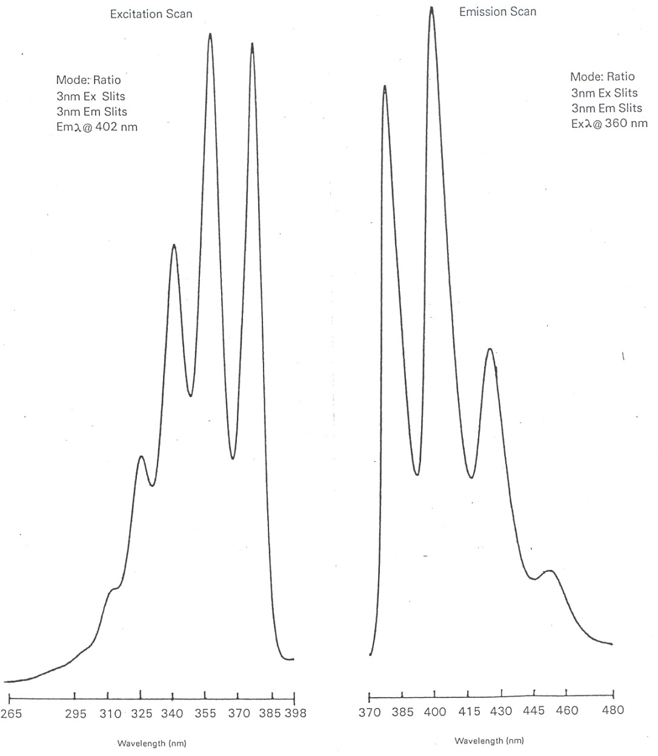
Figure 3.6. Fluorescence excitation (left) and emission (right) spectra of anthracene.

Describe a way to measure the phosphorescence spectrum of a species that is not compromised by the presence of any fluorescence emission.

The important thing to consider in addressing this question is that the lifetime of the S₁ state from which fluorescence occurs is approximately 10⁻⁸ second whereas the lifetime of the T₁ state from which phosphorescence occurs is on the order of 10⁻⁴ to 100 seconds. Because of these different lifetimes, fluorescence emission will decay away rather quickly while phosphorescence emission will decay away more slowly. The diagram in Figure 3.7 shows representations for the decay of fluorescence versus phosphorescence as a function of time if the radiation source was turned off. The two can be distinguished by using a pulsed source. A pulsed source is turned on for a brief instant and then turned off. Many fluorescent spectrophotometers use a pulsed source. The electronics on the detector can be coordinated with the source pulsing. When measuring fluorescence, the detector reads signal when the pulse is on. When measuring phosphorescence, a delay time during which the detector is turned off occurs after the pulse ends. Then the detector is turned on for some period of time, which is referred to as the gate time. Figure 3.7 also shows where the delay and gate times might be set for the sample represented in the decay curves. The proper gate time depends in part on how slow the phosphorescence decays. You want a reasonable length of time to measure enough signal, but if the gate time is too long and weak to no phosphorescence occurs at the end, the detector is mostly measuring noise and the signal-to-noise ratio will be reduced.

Figure 3.7. Fluorescence and phosphorescence decay profiles after a pulse of radiation.

If performing quantitative analysis in fluorescence spectroscopy, which wavelengths would you select from the spectra you drew in the problem above?

The two best wavelengths would be those that produced the maximum signal on the excitation and emission spectra. That will lead to the most sensitivity and lowest detection limits in the analysis. For the spectra of anthracene drawn in Figure 3.6, that would correspond to an excitation wavelength of 360 nm and emission wavelength of 402 nm. The one exception is if the S₀-S₁ transition is the maximum on both spectra, which would mean having the excitation and emission monochromators set to the same wavelength. The problem that occurs here is that the excitation beam of radiation will always exhibit some scatter as it passes through the sample. Scattered radiation appears in all directions and the detector has no way to distinguish this from fluorescence. Usually the excitation and emission wavelengths must be offset by some suitable value (often 30 nm) to keep the scatter to acceptable levels.

3.5. Quantum Yield of Fluorescence (ϕ_{F})

The quantum yield (ϕ_{F}) is a ratio that expresses the number of species that fluoresce relative to the total number of species that were excited. Earlier we said that anything that reduces the number of excited state species that undergo fluorescence is said to quench the fluorescence. The expression for the quantum yield will depend on the rate constants for the different processes that can occur for excited state species. Referring back to our original drawing of the different processes that can occur, we can write the following expression for the quantum yield, where k_{F} is the rate constant for fluorescence, k_{IC} is the rate constant for internal conversion, k_{EC} is the rage constant for external conversion, k_{ISC} is the rate constant for intersystem crossing and k_{C} is the rate constant for any other competing processes and includes photodecomposition of the sample. Excited state species sometimes have sufficient energy to decompose through processes of dissociation or predissociation. In dissociation, the electron is excited to a high enough vibrational level that the bond ruptures. In predissociation, the molecule undergoes internal conversion from a higher electronic state to an upper vibrational level of a lower electronic state prior to bond rupture. When putting a sample into a fluorescence spectrophotometer, it is usually desirable to block the excitation beam until just before making the measurement to minimize photodecomposition.

ϕ_{F} = (k_{F})/(k_{F} + k_{IC} + k_{EC} +k_{ISC} + k_{C})

Since this is a ratio, the limits of ϕ_{F} are from 0 to 1. Species with quantum yields of 0.01 or higher (1 out of 100 excited species actually undergo fluorescence) are useful for analysis purposes.

Which method is more sensitive, absorption or fluorescence spectroscopy?

On first consideration it might seem reasonable to think that absorption spectroscopy is more sensitive than fluorescence spectroscopy. As stated above, for some compounds that we measure by fluorescence, only one of the 100 species that is excited undergoes fluorescence emission. In this case, 100 photons are absorbed but only one is emitted. The answer though requires a different consideration.

The measurement of absorption involves a comparison of P to P_{o}. At low concentrations, these two values are large and similar in magnitude. Therefore, at low concentrations, absorption involves the measurement of a small difference between two large signals. Fluorescence, on the other hand, is measured at 90º to the source. In the absence of fluorescence, as in a blank solution, there ought to be no signal reaching the detector (however, there is still some scattered and stray light that may reach the detector as noise). At low concentrations, fluorescence involves the measurement of a small signal over no background. For comparison, suppose you tried to use your eyes to distinguish the difference between a 100 and 99 Watt light bulb and the difference between complete darkness and a 1 Watt light bulb. Your eyes would have a much better ability to determine the small 1 Watt signal over darkness than the difference between two large 100 and 99 Watt signals. The same occurs for the electronic measurements in a spectrophotometer. Therefore, because emission involves the measurement of a small signal over no background, any type of emission spectroscopy has an inherent sensitivity advantage of one to three orders of magnitude over measurements of absorption. Fluorescence spectroscopy is an especially sensitive analysis method for those compounds that have suitable quantum yields.

3.6. Variables that Influence Fluorescence Measurements

What variables influence fluorescence measurements? For each variable, describe its relationship to the intensity of fluorescence emission.

There are a variety of variables that influence the signal observed in fluorescence spectroscopy. As seen in the original diagram showing the various energy levels and transitions that can occur, anything that can quench the fluorescent transition will affect the intensity of the fluorescence.

When discussing absorption spectroscopy, an important consideration is Beer’s Law. A similar relationship exists for fluorescence spectroscopy, as shown below, in which I is the fluorescence intensity, ε is the molar absorptivity, b is the path length, c is the concentration, and P_{o} is the source power.

I = 2.303K’εbcP_{o}

Not surprisingly, fluorescence intensity varies linearly with the path length and with the concentration. K’ is a constant that is dependent on the geometry and other factors and includes the fluorescence quantum yield. Since ϕ_{F} is a constant for a given system, K’ is defined as K”ϕ_{F}. Of particular interest is that the fluorescence intensity relates directly to the source power. It stands to reason that the higher the source power, the more species that absorb photons and become excited, and therefore the more that eventually emit fluorescence radiation. This suggests that high-powered lasers, provided they emit at the proper wavelength of radiation to excite a system, have the potential to be excellent sources for fluorescence spectroscopy.

The equation above predicts a linear relationship between fluorescence intensity and concentration. However, the utility of this equation breaks down at absorbance values of 0.05 or higher leading to a negative deviation of the standard curve.

Something else that can possibly occur with fluorescence or other emission processes is that emitted photons can be reabsorbed by ground state molecules. This is a particular problem if the S₁-S₀ emission transition is the one being monitored. In this situation, at high concentrations of analyte, the fluorescence intensity measured at the detector may actually start to drop as shown in the standard curve in Figure 3.8.

Figure 3.8. Standard curve for fluorescence showing re-absorption of emitted photons at higher concentrations.

Any changes in the system that will affect the number and force of collisions taking place in the solution will influence the magnitude of the fluorescence emission. Collisions promote radiationless decay and loss of extra energy as heat, so more collisions or more forceful collisions will promote radiationless decay and reduce fluorescence emission. Therefore, fluorescent intensity is dependent on the temperature of the solution. Higher temperatures will speed up the movement of the molecules (i.e., higher translational energy) leading to more collisions and more forceful collisions, thereby reducing the fluorescent intensity. Insuring that all the measurements are done at the same temperature is important. Reducing the temperature of the sample will also increase the signal-to-noise ratio.

Another factor that will affect the number of collisions is the solvent viscosity. More viscous solutions will have fewer collisions, less collisional deactivation, and higher fluorescent intensity.

The solvent can have other effects as well, similar to what we previously discussed in the section on UV/VIS absorption spectroscopy. For example, a hydrogen-bonding solvent can influence the value of λ_{max} in the excitation and emission spectra by altering the energy levels of non-bonding electrons and electrons in π* orbitals. Other species in the solution (e.g., metal ions) may also associate with the analyte and change the λ_{max} values.

Many metal ions and dissolved oxygen are paramagnetic. We already mentioned that paramagnetic species promote intersystem crossing, thereby quenching the fluorescence. Removal of paramagnetic metal ions from a sample is not necessarily a trivial matter. Removing dissolved oxygen gas is easily done by purging the sample with a diamagnetic, inert gas such as nitrogen, argon or helium. All solution-phase samples should be purged of oxygen gas prior to the analysis.

Another concern that can distinguish sample solutions from the blank and standards is the possibility that the unknown solutions have impurities that can absorb the fluorescent emission from the analyte. Comparing the fluorescent excitation and emission spectra of the unknown samples to the standards may provide an indication of whether the unknown has impurities that are interfering with the analysis.

The pH will also have a pronounced effect on the fluorescence spectrum for organic acids and bases. An interesting example is to consider the fluorescence emission spectrum for the compound 2-naphthol. The hydroxyl hydrogen atom is acidic and the compound has a pKa of 9.5. At a pH of 1, the compound exists almost exclusively as the protonated 2-naphthol. At a pH of 13, the compound exists almost exclusively as the deprotonated 2-naphtholate ion. At a pH equal to the pKa value, the solution would consist of a 50-50 mixture of the protonated and deprotonated form.

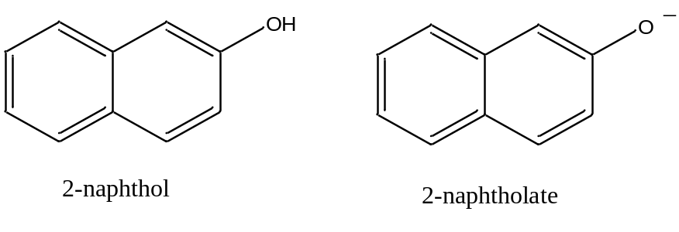

The emission spectra of an aqueous solution of 2-naphthol at pH 2 and 13 are shown in Figure 3.9.

Figure 3.9. Fluorescence emission spectra of 2-naphthol at pH 2 and pH 13.

The most obvious thing to note is the large difference in the _{max} value for the neutral 2-naphthol (355 nm) and the anionic 2-naphtholate ion (415 nm). The considerable difference between the two emission spectra occurs because the presence of more resonance forms leads to stabilization (i.e., lower energy) of the excited state. As shown in Figure 3.10, the 2-naphtholate species has multiple resonance forms involving the oxygen atom whereas the neutral 2-naphthol species only has a single resonance form. Therefore, the emission spectrum of the 2-naphtholate ion is red-shifted relative to that of the 2-naphthol species.

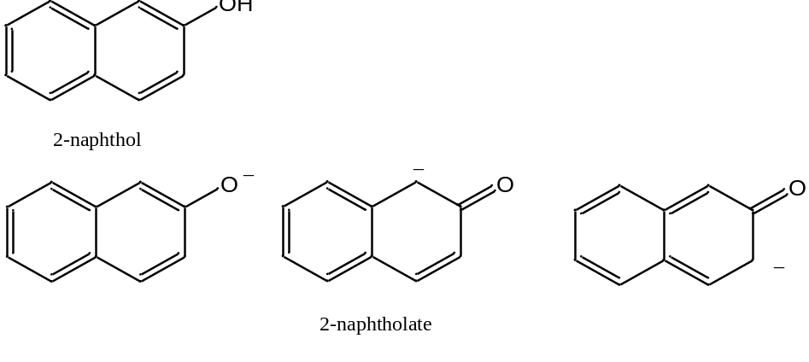

Figure 3.10. Resonance forms involving the oxygen atom of 2-naphthol and 2-naphtholate.

Consider the reaction shown below for the dissociation of 2-naphthol. This reaction may be either slow (slow exchange) or fast (fast exchange) on the time scale of fluorescence spectroscopy. Draw the series of spectra that would result for an initial concentration of 2-naphthol of 10⁻⁶ M if the pH was adjusted to 2, 8.5, 9.5, 10.5, and 13 and slow exchange occurred. Draw the spectra at the same pH when the exchange rate is fast.

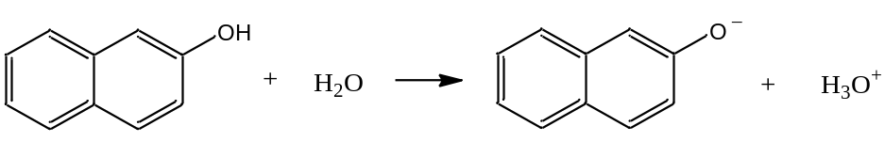

If slow exchange occurs, an individual 2-naphthol or 2-naphtholate species stays in its protonated or deprotonated form during the entire excitation-emission process and emits its characteristic spectrum. Therefore, when both species are present in appreciable concentrations, two peaks occur in the spectrum for each of the individual species. On the left side of Figure 3.11, at pH 2, all of the species is in the neutral 2-naphthol form, whereas at pH 13 it is all in the anionic 2-naphtholate form. At pH 9.5, which equals the pKa value, there is a 50-50 mixture of the two and the peaks for both species are equal in intensity. At pH 8.5 and 10.5, one of the forms predominates. The intensity of each species is proportional to the concentration.

Figure 3.11. Representation of fluorescent emission spectrum of 2-naphthol as a function of pH under the conditions of slow (left) and fast (right) exchange.

If fast exchange occurs, as seen on the right side of Figure 3.11, a particular species rapidly changes between its protonated and deprotonated form during the excitation and emission process. Now the emission is a weighted time average of the two forms. If the pH is such that more neutral 2-naphthol is present in solution, the maximum is closer to 355 nm (pH = 8.5). If the pH is such that more anionic 2-naphtholate is present in solution, the maximum is closer to 415 nm (pH = 10.5). At the pKa value (9.5), the peak appears in the middle of the two extremes.

What actually happens – is the exchange fast or slow? The observation is that the exchange of protons that occurs in the acid-base reaction is slow on the time scale of fluorescence spectroscopy. Remember that the lifetime of an excited state is about 10⁻⁸ second. This means that the exchange rate of protons among the species in solution is slower than 10⁻⁸ second and the fluorescence emission spectrum has peaks for both the 2-naphthol and 2-naphtholate species.

Devise a procedure that might allow you to determine the pKa of a weak acid such as 2-naphthol.

The pKa value of an acid is incorporated into an expression called the Henderson-Hasselbalch equation, which is shown below where HA represents the protonated form of any weak acid and A– is its conjugate base.

pH = pKa + log ([A–]/[HA])

If a standard curve was prepared for 2-naphthol at a highly acidic pH and 2-naphtholate at a highly basic pH, the concentration of each species at different intermediate pH values when both are present could be determined. These concentrations, along with the known pH, can be substituted into the Henderson-Hasselbach equation to calculate pKa. As described earlier, this same process is used quite often in UV/VIS spectroscopy to determine the pKa of acids, so long as the acid and base forms of the conjugate pair have substantially different absorption spectra.

If you do this with the fluorescence spectra of 2-naphthol; however, you get a rather perplexing set of results in that slightly different pKa values are calculated at different pH values where appreciable amounts of the neutral and anionic form are present. This occurs because the pKa of excited state 2-naphthol is different from the pKa of the ground state. Since the fluorescence emission occurs from the excited state, this difference will influence the calculated pKa values. A more complicated set of calculations can be done to determine the excited state pKa values. UV/VIS spectroscopy is therefore often an easier way to measure the pKa of a species than fluorescence spectroscopy.

Because many compounds are weak acids or bases, and therefore the fluorescence spectra of the conjugate pairs might vary considerably, it is important to adjust the pH to insure all of either the protonated or deprotonated form.

Which compound will have a higher quantum yield: anthracene or diphenylmethane?

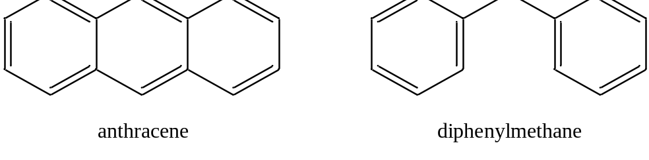

Answering this question involves a consideration of the effect that collisions of the molecules will have in causing radiationless decay. Note that anthracene is quite a rigid molecule. Diphenylmethane is rather floppy because of the methylene bridge between the two phenyl rings. Hopefully it is reasonable to see that collisions of the floppy diphenylmethane are more likely to lead to radiationless decay than collisions of the rigid anthracene molecules. Another way to think of this is the consequences of a crash between a Greyhound bus (i.e., anthracene) and a car towing a boat (i.e., diphenylmethane). It might be reasonable to believe that under most circumstances, the car would suffer more damage in the collision.

Molecules that are suitable for analysis by fluorescence spectroscopy are therefore rigid species, often with conjugated π systems, that undergo less collisional deactivation. As such, fluorescence spectroscopy is a much more selective method than UV/VIS absorption spectroscopy. In many cases, a suitable fluorescent chromophore is first attached to the compound under study. For example, a fluorescent derivatization agent is commonly used to analyze amino acids that have been separated by high performance liquid chromatography. The advantage of performing such a derivatization step is because of the high sensitivity of fluorescence spectroscopy. Because of the high sensitivity of fluorescence spectroscopy, it makes it all the more important to control the variables described above as they will then have a more pronounced effect with the potential to cause errors in the measurement.

3.7. Other Luminescent Methods

Two other important forms of luminescence are chemiluminescence and bioluminescence. Chemiluminescence refers to a process in which a chemical reaction forms a product molecule that is in an excited state. The excited state product then emits radiation. The classic example of a chemiluminescent process involves the reaction of luminol with hydrogen peroxide (H₂O₂) in the presence of a catalyst as shown below. The reaction generates 3-aminophthalate in an excited state and it emits a bluish light. The luminal reaction is used in forensics to detect the presence of blood. In this case, the iron from the hemoglobin serves as the catalyst.

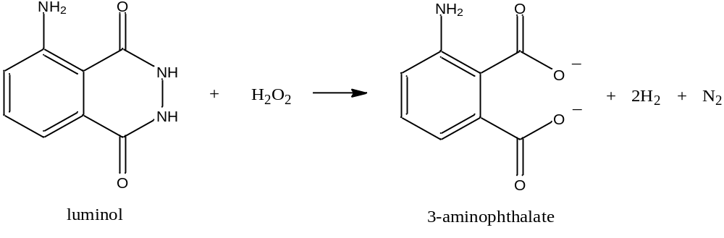

Another important example of a chemiluminescent reaction involves the reaction of nitric oxide (NO) with ozone (O₃) to produce excited state nitrogen dioxide (NO₂*) and oxygen gas. Nitric oxide is an important compound in atmospheric chemistry and, with the use of an ozone generator, it is possible to use the chemiluminescent reaction as a sensitive way of measuring NO.

NO = O₃ = NO₂* + O₂
NO₂* = NO₂ + hν

An important feature of both chemiluminescent reactions above is that peroxide and ozone, which are strong oxidants, have an unstable or energetic chemical bond. Chemiluminescence is a rare process only occurring in a limited number of chemical reactions.

Bioluminescence refers to a situation when living organisms use a chemiluminescent reaction to produce a luminescent emission. The classic example is fireflies. There are also a number of bioluminescent marine organisms.

Triboluminescence is a form of luminescence caused by friction. Breaking or crushing a wintergreen-flavored lifesaver in the dark produces triboluminescence. The friction of the crushing action excites sugar molecules that emit ultraviolet radiation, which is triboluminescence but cannot be seen by our eyes. However, the ultraviolet radiation emitted by the sugar is absorbed by fluorescent methyl salicylate molecules that account for the wintergreen flavor. The methyl salicylate molecules emit the light that can be seen by our eyes.

Finally, light sticks also rely on a fluorescent process. Bending the light stick breaks a vial that leads to the mixing of phenyl oxalate ester and hydrogen peroxide. Two subsequent decomposition reactions occur, the last of which releases energy that excites a fluorescent dye. Emission from the dye accounts for the glow from the light stick.

