2. ULTRAVIOLET/VISIBLE ABSORPTION SPECTROSCOPY

2.1. Introduction

Compare and contrast the absorption of ultraviolet (UV) and visible (VIS) radiation by an atomic substance (something like helium) with that of a molecular substance (something like ethylene).

Do you expect different absorption peaks or bands from an atomic or molecular substance to have different intensities? If so, what does this say about the transitions?

UV/VIS radiation has the proper energy to excite valence electrons of chemical species and cause electronic transitions.

For atoms, the only process we need to think about is the excitation of electrons, (i.e., electronic transitions), from one atomic orbital to another. Since the atomic orbitals have discrete or specific energies, transitions among them have discrete or specific energies. Therefore, atomic absorption spectra consist of a series of “lines” at the wavelengths of radiation (or frequency of radiation) that correspond in energy to each allowable electronic transition. The diagram in Figure 2.1 represents the energy level diagram of any multielectron atom.

Figure 2.1. Energy level diagram of a multielectron atom.

The different lines in the spectrum will have different intensities. As we have already discussed, different transitions have different probabilities or different molar absorptivities, which accounts for the different intensities. The process of absorption for helium is shown in Figure 2.2 in which one electron is excited to a higher energy orbital. Several possible absorption transitions are illustrated in the diagram.

Figure 2.2. Absorption transitions of helium.

The illustration in Figure 2.3 represents the atomic emission spectrum of helium and clearly shows the “line” nature of an atomic spectrum.

Figure 2.3. Atomic emission spectrum of helium.

For molecules, there are two other important processes to consider besides the excitation of electrons from one molecular orbital to another. The first is that molecules vibrate. Molecular vibrations or vibrational transitions occur in the infrared portion of the spectrum and are therefore lower in energy than electronic transitions. The second is that molecules can rotate. Molecular rotations or rotational transitions occur in the microwave portion of the spectrum and are therefore lower in energy than electronic and vibrational transitions. The diagram in Figure 2.4 represents the energy level diagram for a molecule. The arrows in the diagram represent possible transitions from the ground to excited states.

Figure 2.4. Energy level diagram for a molecule showing electronic, vibrational and rotational states. Arrows represent possible absorption transitions.

Note that the vibrational and rotational energy levels in a molecule are superimposed over the electronic transitions. An important question to consider is whether an electron in the ground state (lowest energy electronic, vibrational and rotational state) can only be excited to the first excited electronic state (no extra vibrational or rotational energy), or whether it can also be excited to vibrationally and/or rotationally excited states in the first excited electronic state. It turns out that molecules can be excited to vibrationally and/or rotationally excited levels of the first excited electronic state, as shown by arrows in Figure 2.4. Molecules can also be excited to the second and higher excited electronic states. Therefore, we can speak of a molecule as existing in the second excited rotational state of the third excited vibrational state of the first excited electronic state.

One consequence in the comparison of atomic and molecule absorption spectra is that molecular absorption spectra ought to have many more transitions or lines in them than atomic spectra because of all the vibrational and rotational excited states that exist.

Compare a molecular absorption spectrum of a dilute species dissolved in a solvent at room temperature versus the same sample at 10K.

The difference to consider here is that the sample at 10K will be frozen into a solid whereas the sample at room temperature will be a liquid. In the liquid state, the solute and solvent molecules move about via diffusion and undergo frequent collisions with each other. In the solid state, collisions are reduced considerably.

What is the effect of collisions of solvent and solute molecules? Collisions between molecules cause distortions of the electrons. Since molecules in a mixture move with a distribution of different speeds, the collisions occur with different degrees of distortion of the electrons. Since the energy of electrons depends on their locations in space, distortion of the electrons causes slight changes in the energy of the electrons. Slight changes in the energy of an electron means there will be a slight change in the energy of its transition to a higher energy state. The net effect of collisions is to cause a broadening of the lines in the spectrum. The spectrum at room temperature will show significant collisional broadening whereas the spectrum at 10K will have minimal collisional broadening. The collisional broadening at room temperature in a solvent such as water is significant enough to cause a blurring together of the energy differences between the different rotational and vibrational states, such that the spectrum consists of broad absorption bands instead of discrete lines. By contrast, the spectrum at 10K will consist of numerous discrete lines that distinguish between the different rotationally and vibrationally excited levels of the excited electronic states. The diagrams in Figure 2.5 show the difference between the spectrum at room temperature and 10K, although the one at 10K does not contain nearly the number of lines that would be observed in the actual spectrum.

Figure 2.5. Comparison of the absorption spectrum of a molecule in a solvent at room temperature and at 10 K.

Are there any other general processes that contribute to broadening in an absorption spectrum?

The other general contribution to broadening comes from something known as the Doppler Effect. The Doppler Effect occurs because the species absorbing or emitting radiation is moving relative to the detector. Perhaps the easiest way to think about this is to consider a species moving away from the detector that emits a specific frequency of radiation heading toward the detector. The frequency of radiation corresponds to that of the energy of the transition, so the emitted radiation has a specific, fixed frequency. The picture in Figure 2.6 shows two species emitting waves of radiation toward a detector. It is worth focusing on the highest amplitude portion of each wave. Also, in Figure 2.6, assume that the detector is on the right side of the diagram and the right side of the two emitting spheres. The emission process to produce the wave of radiation requires some finite amount of time. If the species is moving away from the detector, even though the frequency is fixed, to the detector it will appear as if each of the highest amplitude regions of the wave is lagging behind where they would be if the species is stationary (see the upper sphere in Figure 2.6). The result is that the wavelength of the radiation appears longer, meaning that the frequency appears lower. For visible radiation, we say that the radiation from the emitting species is red-shifted. The lower sphere in Figure 2.6 is moving towards the detector. Now the highest amplitude regions of the wave are appearing at the detector faster than expected. This radiation is blue-shifted. In a solution, different species are moving in different directions relative to the detector. Some exhibit no Doppler shift. Others would be blue-shifted whereas others would be red-shifted and the degree of red- and blue-shift varies among different species. The net effect would be that the emission peak is broadened. The same process occurs with the absorption of radiation as well.

Figure 2.6. Representation of the Doppler effect on the wavelength of radiation measured by a detector.

The emission spectrum in Figure 2.7 represents the Doppler broadening that would occur for a gas phase atomic species where the atoms are not moving (top) and then moving with random motion (bottom).

Figure 2.7. Effect of Doppler broadening on the emission from a gas phase atomic substance.

A practical application of the Doppler Effect is the measurement of the distance of galaxies from the earth. The universe is expanding away from a central point. Hubble’s Law and the Hubble effect is an observation that the further a galaxy is from the center of the universe, the faster it moves. There is also a precise formula that predicts the speed of movement relative to the distance from the center of the universe. Galaxies further from the center of the universe therefore show a larger red shift in their radiation due to the Doppler Effect than galaxies closer to the center of the universe. Measurements of the red-shift are used to determine the placement of galaxies in the universe.

2.2. Effect of Conjugation

Compare the UV absorption spectrum of 1-butene to 1,3-butadiene.

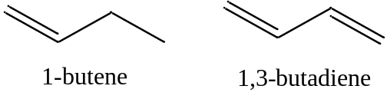
A comparison of the two spectra involves a consideration of the molecular orbitals involved in the compounds and energy transitions. Organic compounds have a network of σ-bonds and then a set of associated σ* anti-bonding orbitals. 1-Butene has one double bond so therefore has a single π and π* orbital. The representations in Figure 2.8 show the sign of the p-orbital wave functions (dark is positive, white is negative) used in creating the π and π* orbitals. In the π-orbital, the two wave functions have the same sign and therefore positive overlap. In the π*-orbital, the two wave functions have the opposite sign and therefore negative overlap.

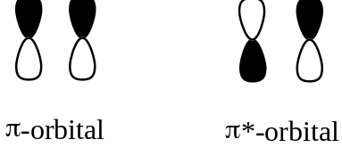

Figure 2.8. Representation of overlap of p-orbitals of a double bond.

In organic compounds, the bonding orbitals are almost always filled and the anti-bonding orbitals are almost always empty. The important consideration becomes the ordering of the molecular orbitals in an energy level diagram. Figure 2.9 shows the typical ordering that would occur for an organic compound with π orbitals.

Figure 2.9. Energy level diagram for a compound with a π- and π*-orbital.

The most important energy transition to consider in Figure 2.9 is the one from the highest occupied molecular orbital (HOMO) to the lowest unoccupied molecular orbital (LUMO). This will be the lowest energy transition. In the case of 1-butene, the lowest energy transition would be the π-π* transition. The UV/VIS absorption spectrum for 1-butene is shown in Figure 2.10. The λ_{max} value has a value of about 176 nm, which is in the vacuum ultraviolet portion of the spectrum.
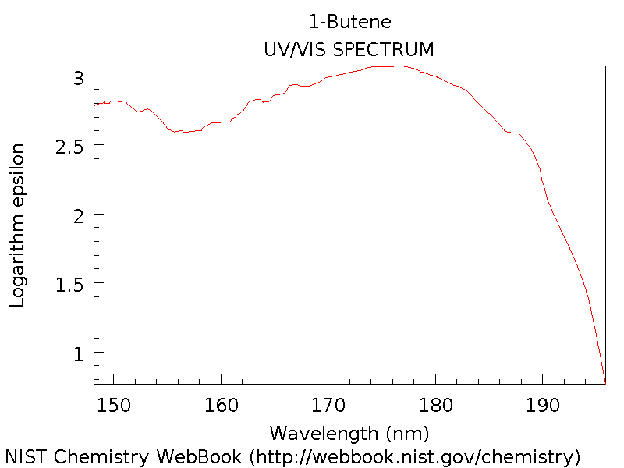

Figure 2.10. Ultraviolet absorption spectrum of 1-butene.

1,3-Butadiene has two double bonds and is said to be a conjugated system. There are two ways we could consider what happens in butadiene. The first, shown Figure 2.11, is to consider each double bond separately showing how the p-orbitals overlap to form the π and π* orbitals (Figure 2.11a). Each of these double bonds and energy level diagrams is comparable to the double bond in 1-butene. However, because of the conjugation in 1,3-butadiene, you can think of the π and π* orbitals from each double bond as further overlapping to create the energy level diagram in the bottom picture (Figure 2.11b).

Figure 2.11 Energy level diagram for (a) two adjacent π-bonds in 1,3-butadiene and (b) the orbitals when the two adjacent π- and π*-orbitals are conjugated.

Because of the additional overlap, the lowest energy transition in butadiene is lower than that in 1-butene. Therefore, the spectrum is expected to shift toward the red.

A better way to consider the situation is to examine all the possible orientations of the p-orbitals in 1,3-butadiene. The picture in Figure 2.12 provides a representation of 1.3-butadiene showing how the four p-orbitals are all positioned side-by-side to overlap with each other.

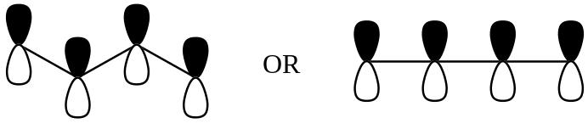

Figure 2.12. Representation of the four p-orbitals in 1,3-butadiene.

Using representations of the p-orbitals in which the dark color indicates the positive region of the wave function and a light color indicates the negative region of the wave function, draw all of the possible ways in which the wave functions of the four p-orbitals can overlap with each other.

The four pictures in Figure 2.13 represent the possible alignments of the signs of the wave functions in 1,3-butadiene. In Figure 2.13a, all four p-orbitals constructively overlap with each other. In Figure 2.13b, two adjacent pairs of p-orbitals constructively overlap with each other. In Figure 2.13c, only the pair of p-orbitals in the center has constructive overlap. In Figure 2.14d, there is no constructive overlap and only destructive overlap occurs.

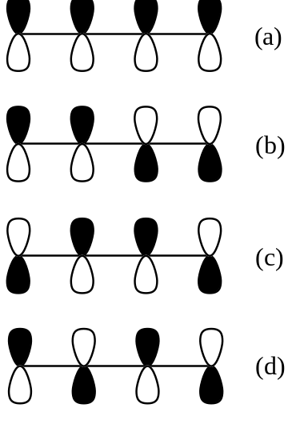

Figure 2.13. Possible alignments of the signs of the wave functions of the p-orbitals in 1,3-butadiene.

Rank these from high to low energy.

The orbital in which all four p-orbitals overlap would be the lowest in energy (Figure 2.14). The next has two regions of overlap. The third has only one region of overlap and the highest energy orbital has no regions of overlap. Because there are four electrons to put in the orbitals (one from each of the contributing p-orbitals), the bottom two orbitals are filled and the top two are empty.
Figure 2.14. Energy level diagram and representation of the π- and π*-molecular orbitals in 1,3-butadiene.

The lowest energy HOMO to LUMO transition will be lower than observed in 1-butene. The UV/VIS spectrum of 1,3-butadiene is shown in Figure 2.15. In this case, the λ_{max} value is at about 292 nm, a significant difference from the value of 176 nm in 1-butene. The effect of increasing conjugation is to shift the spectrum toward longer wavelength (lower frequency, lower energy) absorptions.
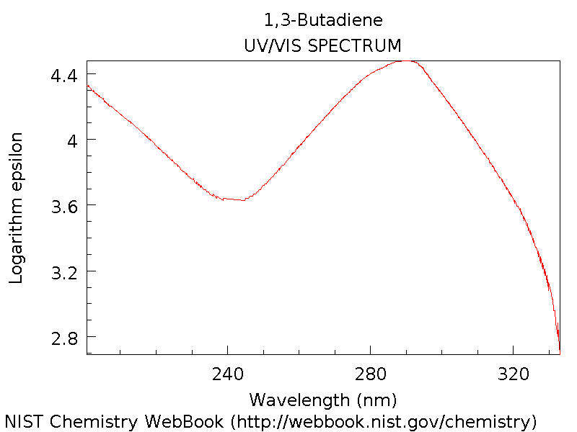

Figure 2.15. Ultraviolet absorption spectrum of 1,3-butadiene.
Another comparative set of conjugated systems occurs with fused ring polycyclic aromatic hydrocarbons such as naphthalene, anthracene and pentacene.

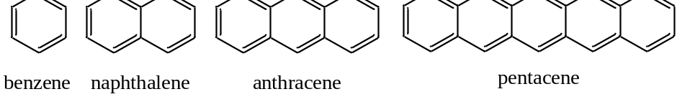

The spectra in Figure 2.16 are for benzene, naphthalene, anthracene and pentacene. Note that as more rings and more conjugation are added, the spectrum shifts further toward and into the visible region of the spectrum.

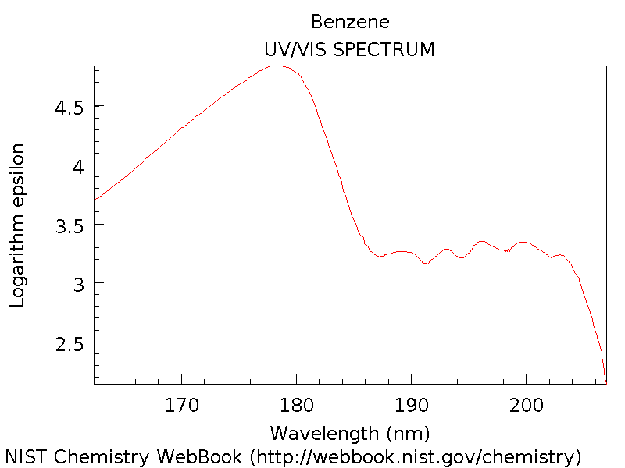

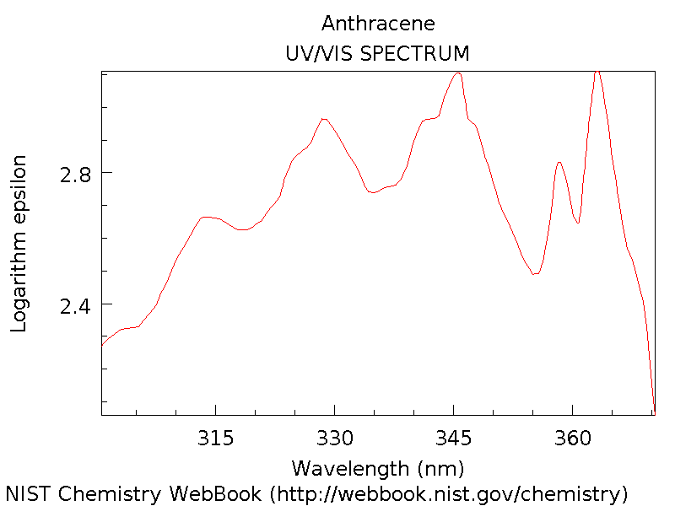
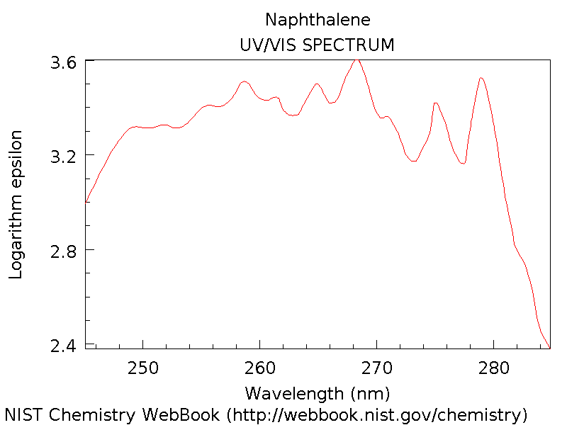

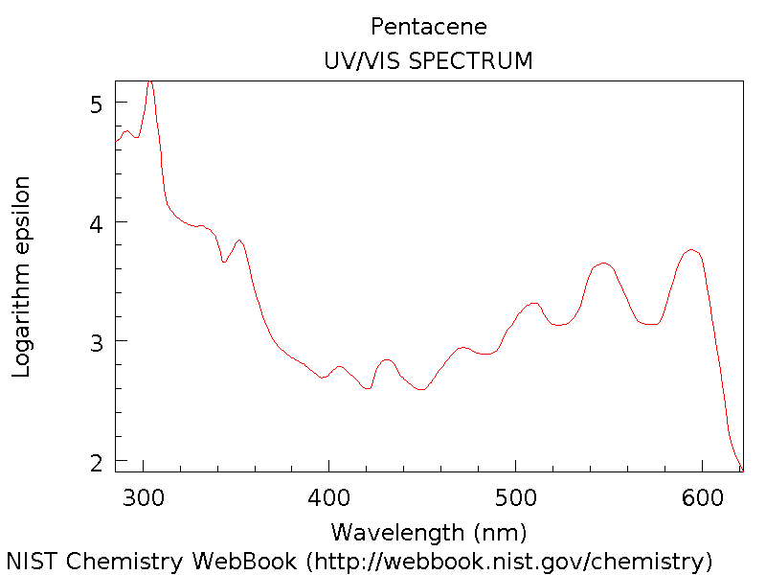

Figure 2.16. UV/VIS absorption spectra of benzene, naphthalene, anthracene and pentacene.

2.3. Effect of Non-bonding Electrons

Compare the UV absorption spectrum of benzene and pyridine.

Benzene has a set of conjugated π-bonds and the lowest energy transition would be a π-π* transition as shown in Figure 2.17.

Figure 2.17. Representation of the lowest energy transition in benzene.

The UV/VIS absorption spectrum for benzene is shown in Figure 2.18.

Figure 2.18. Ultraviolet absorption spectrum of benzene.

Benzene absorbs radiation in the vacuum ultraviolet over the range from 160-208 nm with a _{max} value of about 178 nm. Pyridine has a similar conjugation of double bonds comparable to what occurs in benzene.

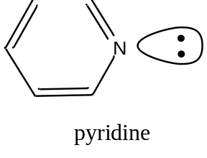

An important distinction with pyridine involves the extra lone pair of electrons on the nitrogen atom that are non-bonding electrons. As non-bonding electrons, their energy is not all that different from the value that would occur in the nitrogen atom. As such, the non-bonding electrons usually reside in orbitals that fall in between the π and π* orbitals. The generalized diagram in Figure 2.19 shows filled bonding molecular orbitals (BMOs), empty anti-bonding molecular orbitals (ABMOs) and the location of non-bonding electrons.

Figure 2.19. Representation of the relative energies of bonding molecular orbitals (BMOs), anti-bonding molecular orbitals (ABMOs) and non-bonding electrons.

For pyridine, the lowest energy transition involves the n-π* orbitals and this will be much lower in energy than the π-π* transition in pyridine or benzene. The UV/VIS absorption spectrum of pyridine is shown in Figure 2.20.

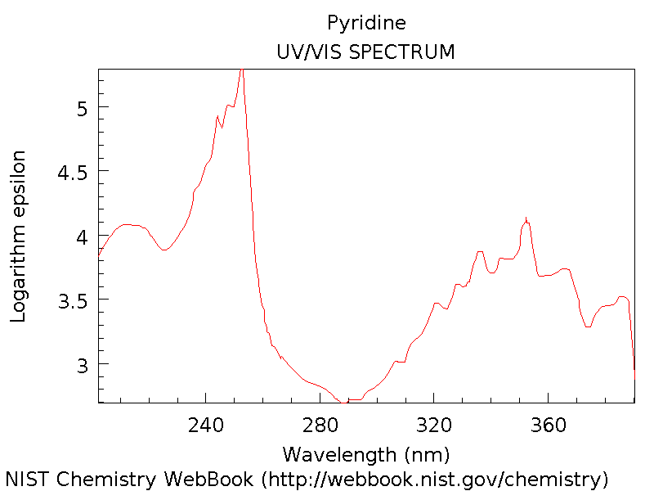

Figure 2.20. UV/VIS absorption spectrum of pyridine.

The shift toward higher wavelengths when compared to benzene is quite noticeable in the spectrum of pyridine, where the peaks from 320-380 nm represent the n-π* transition and the peak at about 240 nm is a π-π* transition. Note that intensity and therefore the molar absorptivity of the n-π* transition is lower than that of the π-π* transition. This is usually the case with organic compounds.

Dye molecules absorb in the visible portion of the spectrum. They absorb wavelengths complementary to the color of the dye. Most π-π* transitions in organic molecules are in the ultraviolet portion of the spectrum unless the system is highly conjugated. Visible absorption is achieved in dye molecules by having a combination of conjugation and non-bonding electrons. Azo dyes with the N=N group are quite common, one example of which is shown in Figure 2.21.

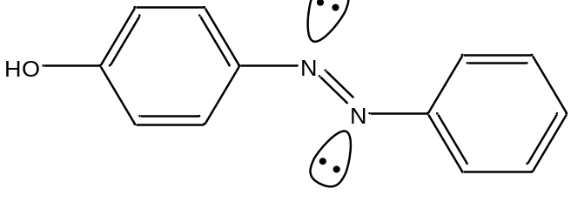

Figure 2.21. Structure of yellow azo dye.

2.4. Effect of Solvent

The peaks in the 320-380 nm portion of the UV absorption spectrum of pyridine shift noticeably toward the blue (high energy) portion of the spectrum on changing the solvent from hexane to methanol. Account for this change.

These are the lowest energy peaks in the spectrum and correspond to the n-π* transition in pyridine. Hexane (C₆H₁₄) is a non-polar hydrocarbon. Methanol (CH₃OH) is a polar solvent with the ability to form hydrogen bonds. For pyridine, the hydrogen atom of the hydroxyl group of methanol will form hydrogen bonds with the lone pair on the nitrogen atoms, as shown in Figure 2.22. Hexane cannot form such hydrogen bonds.

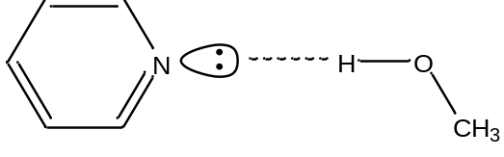

Figure 2.22. Hydrogen bond between methanol and pyridine.

In order to account for the blue-shift in the spectrum, we need to consider what, if anything, will happen to the energies of the n, π, and π* orbitals. Bonding between two atomic orbitals leads to the formation of a bonding and anti-bonding molecular orbital, one of which drops in energy and the other of which rises in energy. The electrostatic attraction between a positively charged hydrogen atom and negatively charged lone pair of electrons in a hydrogen-bond (as illustrated in Figure 2.22 for methanol and pyridine) is a stabilizing interaction. Therefore, the energy of the non-bonding electrons will be lowered.

The picture in Figure 2.23 shows representations of a π- and π*-orbital.

Figure 2.23. Representations of the π- and π*-molecular orbitals.

Electrons in a π-orbital may be able to form a weak dipole-dipole interaction with the hydroxyl hydrogen atom of methanol. This weak interaction may cause a very slight drop in energy of the π-orbital, but it will not be nearly as pronounced as that of the non-bonding electrons. Similarly, if an electron has been excited to the π*-orbital, it has the ability to form a weak dipole-dipole interaction with the hydroxyl hydrogen atom of methanol. This weak interaction will cause a drop in energy of the π*-orbital, but it will not be nearly as pronounced as that of the non-bonding electrons. However, the drop in energy of the π*-orbital will be larger than that of the π-orbital because the π*-orbital points out from the C=C bond and is more accessible to interact with the hydroxyl hydrogen atom of methanol than the π-orbital. The diagram in Figure 2.24 shows the relative changes in the energies of the n, π, and π* orbitals that would occur on changing the solvent from hexane to methanol with stabilization occurring in the order n > π* > π.

Figure 2.24. Relative changes in energies of the n, π, and π* orbitals that occurs on changing the solvent from hexane to methanol.

An examination of the relative energies between hexane and methanol shows that both the n and π* levels drop in energy, but the drop of the n level is greater than the drop of the π* level. Therefore, the n-π* transition moves to higher energy, hence a blue-shift is observed in the peaks in the spectrum in the 320-380 nm range of pyridine. The blue-shift that is observed is referred to as a hypsochromic shift.

The peaks in the UV spectrum of benzene shift slightly toward the red (low energy) portion of the spectrum on changing the solvent from hexane to methanol. Account for this change.

The absorption in benzene corresponds to the π-π* transition. Using the diagram in Figure 2.24, the drop in energy of the π*-orbital is more than that of the π-orbital. Therefore, the π-π* transition is slightly lower in energy and the peaks shift toward the red. The red-shift is referred to as a bathochromic shift.

Note as well that the change in the position of the peak for the π-π* transition of benzene would be less than that for the n-π* transition of pyridine because the stabilization of the non-bonding electrons is greater than the stabilization of the electrons in the π*-orbital.

2.5. Applications

Is UV/VIS spectroscopy useful as a qualitative tool?

The answer depends in part of what type of system you are examining. Ultraviolet-absorbing organic molecules usually involve n-π* and π-π* transitions. Since UV/VIS absorption spectra are usually recorded at room temperature in solution, collisional broadening leads to a blurring together of all of the individual lines that would correspond to excitations to the different vibrational and rotational states of a given electronic state. As such, UV/VIS absorption spectra of organic compounds are not all that different and distinct from each other. Whereas we can reliably assign unique structures to molecules using the spectra that are obtained in NMR spectroscopy, the spectra in UV/VIS spectroscopy do not possess enough detail for such an analysis. Therefore, UV/VIS spectroscopy is not that useful a tool for qualitative analysis of organic compounds.

However, a particular organic compound does have a specific UV/VIS absorption spectrum as seen in the various examples provided above. If the spectrum of an unknown compound exactly matches that of a known compound (provided both have been recorded under the same conditions – in the same solvent, at the same pH, etc.), it is strong evidence that the compounds are the same. However, because of the featureless nature of many UV/VIS spectra, such a conclusion must be reached with caution. The use of a UV-diode array detector as a liquid chromatographic detection method is quite common. In this case, the match of identical spectra with the match in retention time between a known and unknown can be used to confirm an assignment of the identity of the compound.

Many transition metal ions have distinct UV/VIS absorption spectra that involve d-d electron transitions. The position of peaks in the spectra can vary significantly depending on the ligand, and there is something known as the spectrochemical series that can be used to predict certain changes that will be observed as the ligands are varied. UV/VIS spectroscopy can oftentimes be used to reliably confirm the presence of a particular metal species in solution. Some metal species also have absorption processes that result from a charge transfer process. In a charge transfer process, the electron goes from the HOMO on one species to the LUMO on the other. In metal complexes, this can involve a ligand-to-metal transition or metal-to-ligand transition. The ligand-to-metal transition is more common and the process effectively represents an internal electron transfer or redox reaction. Certain pairs of organic compounds also associate in solution and exhibit charge-transfer transitions. An important aspect of charge transfer transitions is that they tend to have very high molar absorptivities.

Is UV/VIS spectroscopy useful as a quantitative tool?

We have the ability to sensitively measure UV/VIS radiation using devices like photomultiplier tubes or array detectors. Provided the molar absorptivity is high enough, UV/VIS absorption is a highly sensitive detection method and is a useful tool for quantitative analysis. Since many substances absorb broad regions of the spectrum, it is prone to possible interferences from other components of the matrix. Therefore, UV/VIS absorption spectroscopy is not that selective a method. The compound under study must often be separated from other constituents of the sample prior to analysis. The coupling of liquid chromatography with ultraviolet detection is one of the more common analysis techniques. In addition to the high sensitivity, the use of UV/VIS absorption for quantitative analysis has wide applicability, is accurate, and is easy to use.

If you were using UV spectroscopy for quantitative analysis, what criteria would you use in selecting a wavelength for the analysis?

The best wavelength to use is the one with the highest molar absorptivity (λ_{max}), provided there are no interfering substances that absorb at the same wavelength. If so, then there either needs to be a separation step or it may be possible to use a different wavelength that has a high enough molar absorptivity but no interference from components of the matrix.

What variables influence the recording of UV/VIS absorption spectra and need to be accounted for when performing qualitative and quantitative analyses?

We have discussed several of these already in the unit. The solvent can have an effect and cause bathochromic and hypsochromic shifts. Species in the matrix that may form dipole-dipole interactions including hydrogen bonds can alter the spectra as well. Metal ions that can form donor-acceptor complexes can have the same effect. Temperature can have an effect on the spectrum. The electrolyte concentration can have an effect as well. As discussed above, the possibility that the sample has interferences that absorb the same radiation must always be considered.

Finally, pH can have a pronounced effect because the spectrum of protonated and deprotonated acids and bases can be markedly different from each other. In fact, UV/VIS spectroscopy is commonly used to measure the pKa of new substances. The reaction below shows a generalized dissociation of a weak acid (HA) into its conjugate base.

HA + H₂O = A– + H₃O⁺

Provided the UV/VIS absorption spectra of HA and A– differ from each other, describe a method that you could use to measure the pKa of the acid.

This rate of dissociation represented above is slow on the time scale of absorption (the absorption of a photon occurs over the time scale of 10⁻¹⁴ to 10⁻¹⁵ seconds). Because the reaction rate is slow, this means that during the absorption of a photon, the species is only in one of the two forms (either HA or A–). Therefore, if the solution is at a pH where both species are present, peaks for both will show up in the spectrum. To measure the pKa, standards must first be analyzed in a strongly acidic solution, such that all of the species is in the HA form, and a standard curve for HA can be generated. Then standards must be analyzed in a strongly basic solution, such that all of the species is in the A– form, to generate a standard curve for A–. At intermediate pH values close to the pKa, both HA and A– will be present and the two standard curves can be used to calculate the concentration of each species. The pH and two concentrations can then be substituted into the Henderson-Hasselbalch equation to determine the pKa value.

pH = pKa + log([A–]/[HA])

2.6. Evaporative Light Scattering Detection

Evaporative light scattering detection is a specialized technique in which UV radiation is used to detect non-UV-absorbing compounds separated by liquid chromatography. The column effluent is passed through a heated chamber that evaporates the mobile phase solvent. Non-volatile analyte compounds, which is usually the case for compounds separated by liquid chromatography, form solid particulates when the solvent is evaporated. The solid particulates scatter UV radiation, which will lead to a reduction in the UV power at the detector (i.e., photomultiplier tube) when a compound elutes from the chromatographic column. The method is more commonly used to determine the presence and retention time of non-UV-absorbing species in a chromatographic analysis rather than their concentration. It is common in liquid chromatographic separations to employ a buffer to control the pH of the mobile phase. Many buffers will form particulates on evaporation of the solvent and interfere with evaporative light scattering detection.

Evaporative light scattering detection is encompassed more broadly within a technique known as turbidimetry. In turbidometric measurements, the detector is placed in line with the source and the decrease in power from scattering by particulate matter is measured. Nephelometry is another technique based on scattering, except now the detector is placed at 90º to the source and the power of the scattered radiation is measured. Turbidmetry can be measured using a standard UV/VIS spectrophotometer; nephelometry can be measured using a standard fluorescence spectrophotometer (discussed in Chapter 3). Turbimetry is better for samples that have a high concentration of scattering particles where the power reaching the detector will be significantly less than the power of the course. Nephelometry is preferable for samples with only low concentration of scattering particles. Turbidimetry and nephelometry are widely used to determine the clarity of solutions such as water, beverages, and food products.

