Cyclic voltammetry (CV) exercises using an Excel spreadsheet simulator

Jay H. Brown
Science Department, Southwest Minnesota State University, 1501 State Street, Marshall, MN 56258, United States

Keywords: Undergraduate, Hands-on activities, Electrochemistry, and Cyclic Voltammetry.

Introduction

The following cyclic voltammetry (CV) exercises involve using an updated version of a simple spreadsheet simulator that was written in Microsoft Excel.¹⁻² To prepare the simulator for the exercises, select and delete the Experimental data that is found on the Import data page when you first open the spreadsheet. Next, click on the Species 1 tab in the spreadsheet. The simulator is now ready for the exercises. The simulations increase in complexity as you work through the examples. The following instructions assume that you are working through the exercises in the order that is outlined below.

1. Single electrochemically reversible electron transfer

The first example involves a single electrochemically reversible electron transfer.³ One characteristic of this system is that the peak potential (E_{p}) values are independent of the scan rate (v). Another characteristic is that the difference in peak potential between the forward and return scans (ΔE_{p}) is roughly equal the theoretical value of 59 mV/n (were n is the number of electrons transferred; often 1 or 2). The measured value for ΔE_{p} is often larger (60–80 mV/n) because of experimental conditions, including the switching potential and the diffusion coefficients of the involved species.

Make the following changes to the Species 1 parameters:
Redox 1: E^{oˊ}_{(1,2)} = -1.72 V, kº_{(1,2)} = 10 cm/s, α_{(1,2)} = 0.5
Subspecies 2: k_{R2} = 0
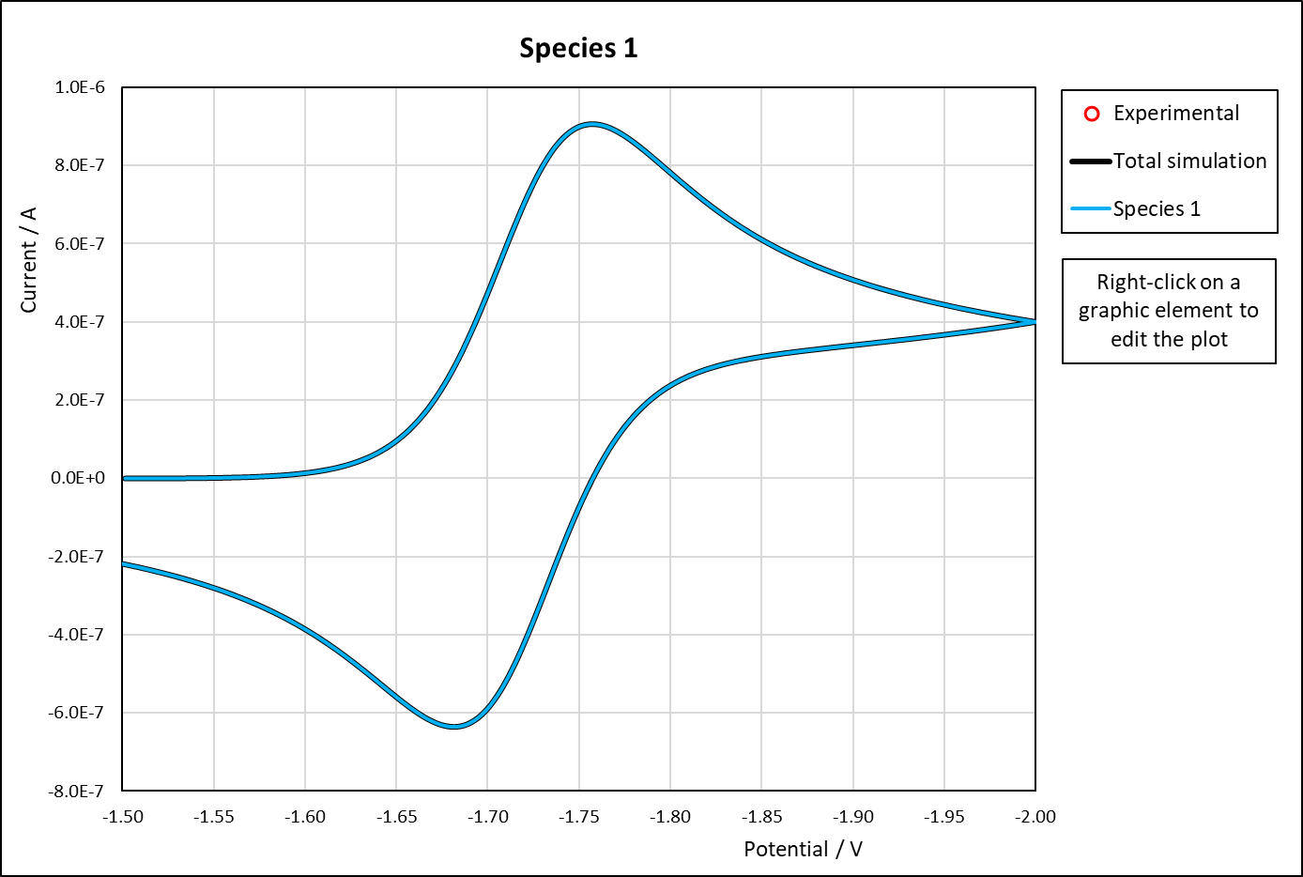
Species 1

(1)

Forward scan

Return scan

(2)

ΔEp ≈ 59 mV/n

Figure 1. A simulated CV of an electrochemically reversible redox couple.

Point to the top of the reduction peak (Figure 1; peak 1) with the computer mouse. Excel will show the potential and current values at that location. Write down the first number, which is the peak potential. Next, obtain the peak potential for the upside-down oxidation peak (peak 2). Calculate the difference in peak potential (ΔE_{p} = E_{p (2)} - E_{p (1)}). Multiply your difference by 1000 to convert from V to mV. Your ΔE_{p} value should be similar (but not identical) to the theoretical value of 59 mV.

Now, increase the scan rate from v = 0.1 V/s to 1, 10, and then 100 V/s. Determine ΔE_{p} for the scan rate of v = 100 V/s using the above procedure. It should be similar to the ΔE_{p} value that you obtained for the scan rate of v = 0.1 V/s.

2. Single electrochemically irreversible electron transfer

The next example involves the simulation of an electrochemically irreversible system.⁴ This is done by setting the heterogeneous rate constant for the electron transfer (kº_{(1,2)}) to a relatively small value. The slow electron transfer rate will not be able keep up with an increasing scan rate. The peak potentials (and the difference in peak potential) will depend on the scan rate.

Make the following changes to the Species 1 parameters:
Redox 1: E^{oˊ}_{(1,2)} = -1.72 V, kº_{(1,2)} = 0.05 cm/s, α_{(1,2)} = 0.5
Simulation parameters: v = 0.1 V/s
Subspecies 2: k_{R2} = 0

Now, increase the scan rate from v = 0.1 V/s to 1, 10, and then 100 V/s. The two peaks move further apart (Figure 2; peaks 1 and 2). Determine ΔE_{p} at a scan rate of v = 100 V/s. The value should be larger than the one obtained for the above reversible example. Electrochemical reversibility is a relative term. For example, the slowest scan rate that was used in this example (0.1 V/s) gave a result that was similar as the above reversible system. Electrochemists often use a range of scan rates to determine the extent of electrochemical reversibility.

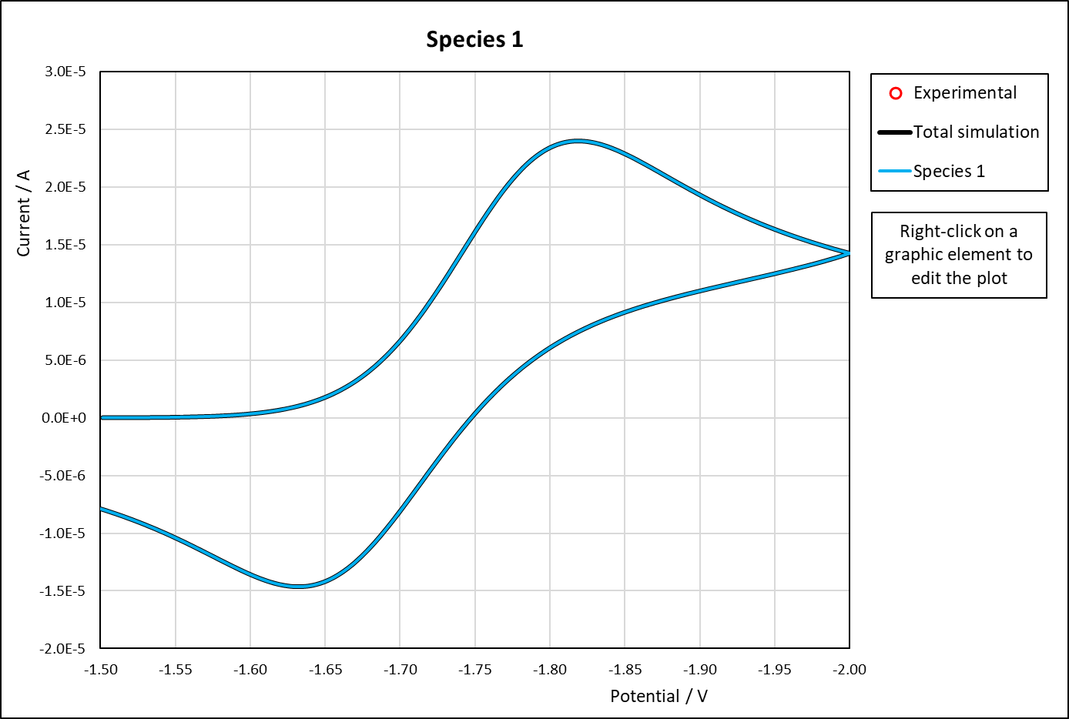
Species 1

(1)

Return scan

Forward scan

ΔEp > 59 mV/n

(2)

Figure 2. An electrochemically irreversible redox couple using a scan rate of 100 V/s.

3. Electrochemically reversible electron transfer with a coupled irreversible chemical reaction

Homogeneous chemical reactions that are coupled to the electron transfer may remove reactant from the electron transfer cycle.³⁻⁴ Coupled reactions include the first-order elimination of a group and the second-order dimerization of radicals formed during an electron transfer. This example involves an electrochemically reversible electron transfer with a coupled irreversible first-order chemical reaction. The coupled reaction will remove some of the reactant from the electron transfer cycle and lower the current intensity of the return peak.

Make the following changes to the Species 1 parameters:
Redox 1: E^{oˊ}_{(1,2)} = -1.72 V, kº_{(1,2)} = 10 cm/s, α_{(1,2)} = 0.5
Simulation parameters: v = 0.1 V/s
Subspecies 2: k_{R1} = 10, k_{R2} = 0
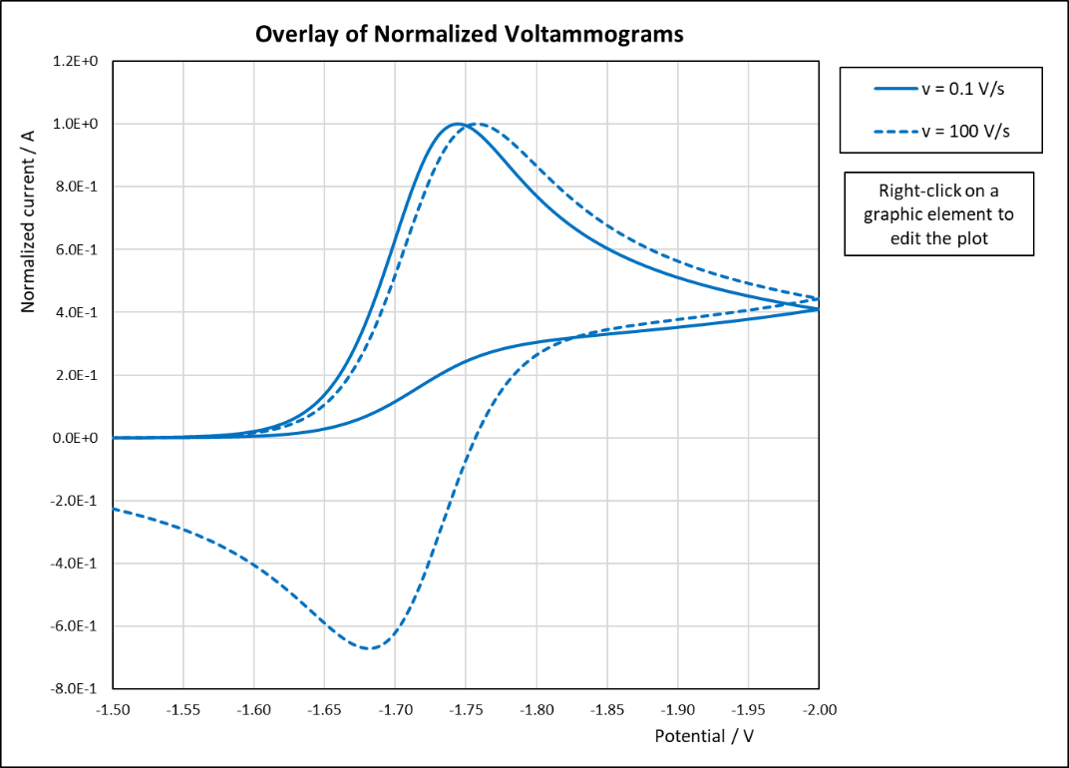
(1)

Return scan

Forward scan

Overlay of Normalized Voltammograms

(2)

Figure 3. Electrochemically reversible electron transfer with a coupled irreversible reaction.

You can sometimes outrun a slow coupled chemical reaction by using a faster scan rate. Increase your scan rate from v = 0.1 V/s to 1, 10, and then 100 V/s. The peak current during the return scan increased (Figure 3; peak 2) because you outran the coupled chemical reaction and more reactant became available for the electron transfer process. The increasing concentration of the reduction product at the working electrode surface causes negative shifts in the potential values.

4. Electrochemically reversible electron transfer with a coupled reversible chemical reaction

This example involves an electrochemically reversible electron transfer that is coupled to a reversible first-order homogeneous chemical reaction.³⁻⁴ The peak current during the return scan will be roughly 50% of the forward peak because about half of the reactant at the working electrode surface is removed by the homogeneous chemical reaction. The equilibrium constant for this reversible chemical reaction will be K = k_{R1}/k_{A1} = 1.

Make the following changes to the Species 1 parameters:
Redox 1: E^{oˊ}_{(1,2)} = -1.72 V, kº_{(1,2)} = 10 cm/s, α_{(1,2)} = 0.5
Simulation parameters: v = 0.1 V/s
Subspecies 2: k_{R1} = 10, k_{A1} = 10, k_{R2} = 0

Now, increase the scan rate from v = 0.1 V/s to 1, 10, and then 100 V/s. The peak current on the return scan increased (Figure 4; peak 2) because you outran the coupled chemical reaction and more reactant is now available for the electron transfer process. The increasing concentration of the reduction product at the working electrode surface causes negative shifts in the potential values.

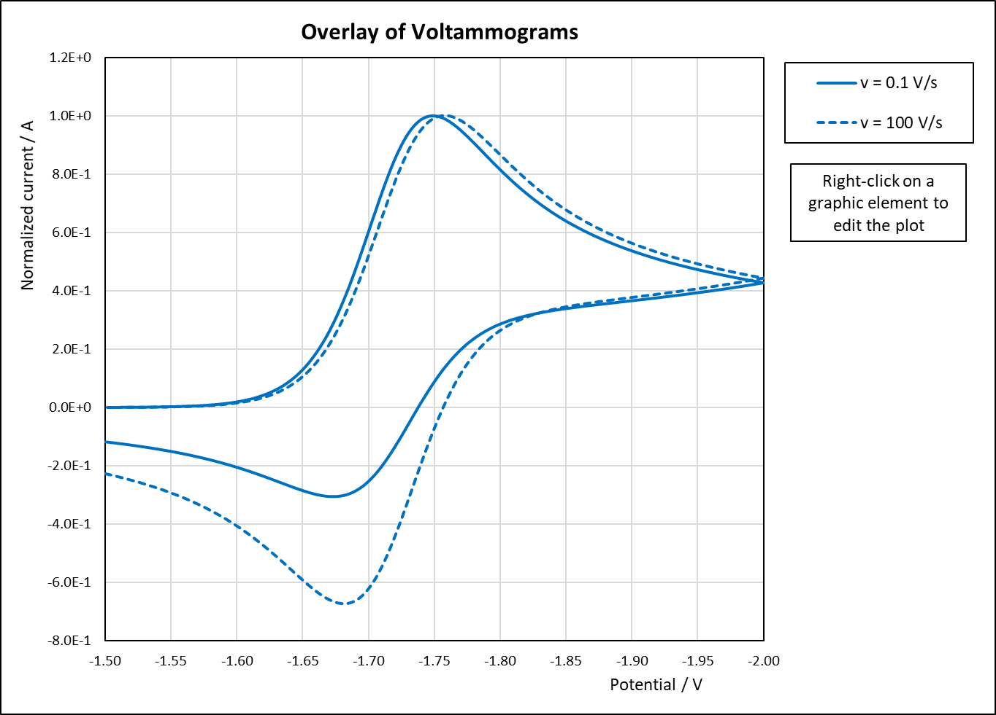
(1)

Forward scan

Overlay of Normalized Voltammograms

Return scan

(2)

Figure 4. Electrochemically reversible electron transfer with a coupled reversible reaction.

Note: The next two examples require a wider potential range. Double-click on the x-axis of the Species 1 voltammogram. Set the axis minimum to -3.5 and the maximum to -1.0. Close the Format axis panel by clicking the panel X. The simulator is now ready for the two examples below.

5. An irreversible electron transfer with a coupled chemical reaction followed by a second electron transfer

Electrostatic repulsion between two negative changes can result in a second reduction peak that is located about 0.5–0.8 V negative of the first peak.⁵ This is sometimes called normal ordering. One example is the repulsion of two electrons that were added to a conjugated system. Sometimes a coupled chemical reaction occurs with the first electron transfer. For example, the dimerization of two radicals that were formed by the first electron transfer. Because dimerization is a second-order process, we will use a second-order homogeneous rate constant to simulate this reaction.

Make the following changes to the Species 1 parameters:
Redox 1: E^{oˊ}_{(1,2)} = -2.0 V, kº_{(1,2)} = 0.01 cm/s, α_{(1,2)} = 0.5
Redox 2: E^{oˊ}_{(3,4)} = -2.5 V, kº_{(3,4)} = 0.01 cm/s, α_{(3,4)} = 0.5
Simulation parameters: E₁ = -1.0 V, E₂ = -3.5 V, v = 0.1 V/s
Subspecies 2: k_{R1} = 0, k_{A1} = 0, k_{R2} = 0
Subspecies 3: k_{R1} = 0, k_{A1} = 0, k_{R2} = 2E6 (Excel format for 2 x 10⁶)
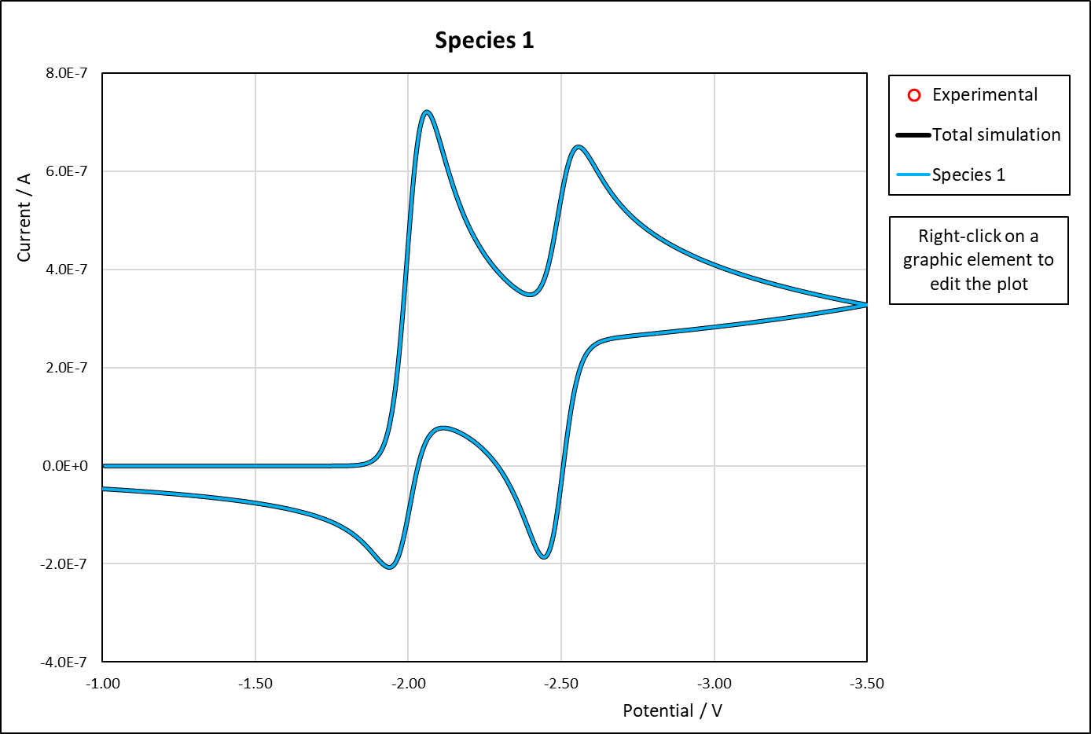
Species 1

(3)

(1)

Return scan

Forward scan

(4)

(2)

Figure 5. Electron transfer with coupled reaction followed by a second electron transfer.

The peak 3 current (Figure 5) is smaller than the peak 1 current because the coupled chemical reaction removed some of the reactant before the second electron transfer occurred. The intensities of peaks 4 and 2 decreased as well because removing a portion of the reactant lowers the concentration of all subsequent subspecies in the electron transfer sequence.

Now, increase the scan rate from v = 0.1 V/s to 1, 10, and then 100 V/s. The difference in the peak potentials (ΔE_{p}) for the two redox couples increased because of the relatively small rate constants for the electron transfers. Also, the current intensities for peaks 3, 4, and 2 increased relative to peak 1 as you outran the coupled chemical reaction that removed some of the reactant from the electron transfer sequence.

6. Two electrochemically irreversible electron transfers with inverted potential

Sometimes a second redox process has a formal potential that is more positive than the first redox process of a sequence.⁵ This is sometimes called an inverted potential. One example of this system is the placement of two electrons into two separate groups followed by an increase in stability through solvation. This last example involves the simulation of two irreversible redox couples with inverted potential.

Make the following changes to the Species 1 parameters:
Redox 1: E^{oˊ}_{(1,2)} = -2.5 V, n_{a} _{(1,2)} = 2, kº_{(1,2)} = 0.01 cm/s, α_{(1,2)} = 0.5
Redox 2: E^{oˊ}_{(3,4)} = -2.0 V, n_{a} _{(3,4)} = 2, kº_{(3,4)} = 0.01 cm/s, α_{(3,4)} = 0.5
Simulation parameters: E₁ = -1.0 V, E₂ = -3.5 V, v = 0.1 V/s
Subspecies 2: k_{R1} = 0, k_{A1} = 0, k_{R2} = 0
Subspecies 3: k_{R1} = 0, k_{A1} = 0, k_{R2} = 0
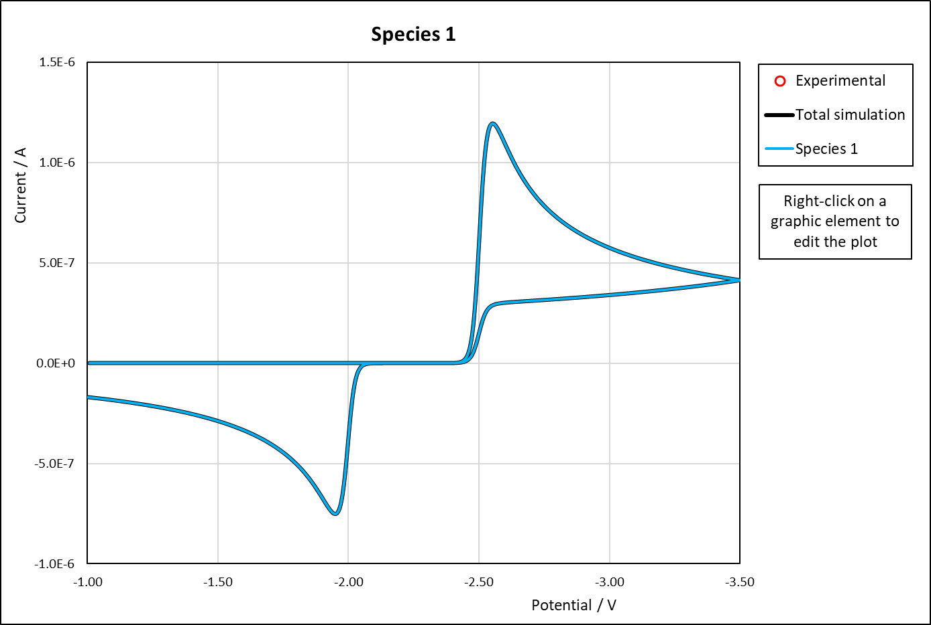
Species 1

(1,3)

Forward scan

Return scan

(2,4)

Figure 6. Two electrochemically irreversible redox couples with inverted potential.

The second electron transfer occurred immediately after the first because the scan was already negative of E^{oˊ}_{(3,4)} when the first electron transfer occurred. The two waves merged and the peak width was governed by the number of electrons transferred during the rate determining step (n_{a} _{(1,2)} = n_{a (3,4)} = 2; Figure 6).

Now, increase the scan rate from v = 0.1 V/s to 1, 10, and then 100 V/s. The forward and return traces have now crossed in two places in the simulation. This behavior is sometimes called crossover. The reactant for the second redox process was quickly reduced because the scan was already well-negative of E^{oˊ}_{(3,4)} when the reduction process could finally occur. This caused a sudden increase in the current which resulted in two crossover points during the return scan.

Additional exercises
For additional exercises, you can exchange the starting (E₁) and switching (E₂) potentials so that oxidation (rather than reduction) occurs during the forward sweep to see the effect on the simulations. You can also adjust the electron transfer coefficients (α; typical values 0.3–0.9), working electrode area (A), diffusion coefficients (D; typical value 1 x 10⁻⁵ cm²/s), number of electrons transferred (n_{a} and n) and any other parameter marked in blue on the spreadsheet. See the accompanying documentation for full descriptions of the simulation parameters.

References cited

1. a) Brown, J. J. Chem. Educ., 92 (9), 2015,1490−1496. DOI: 10.1021/acs.jchemed.5b00225. b) Brown, J. J. Chem. Educ., 93 (7), 2016, 1326–1329. DOI: 10.1021/acs.jchemed.6b00052.

2. Britz, D. in Digital Simulation in Electrochemistry 3^{ed} ed., Springer: Berlin, 2010, ISBN: 978-3-642-06307-7.

3. Bard, A.; Faulkner, L. in Electrochemical Methods: Fundamentals and Applications, Wiley: New York, 1980, ISBN: 0-471-05542-5.

4. Gosser, Jr. D. in Cyclic Voltammetry: Simulation and Analysis of Reaction Mechanisms, VCH Publishers: New York, 1993, ISBN: 1-56081-026-2.

5. a) Batchelor-McAuley, C.; Compton R. G. J. Electroanal. Chem. 669, 2012, 73–81. DOI: 10.1016/j.jelechem.2012.01.016. b) Evans, D. H. Chem. Rev. 108, 2008, 2113–2144. DOI: 10.1021/cr068066l.

