Active Learning Worksheets for Analytical Chemistry

Student Worksheets

Rebecca L. Sanders, Ph.D.
Associate Professor of Chemistry
North Central College
Naperville, Illinois

Version 1.0

2026

Open Educational Resource
Designed for use with Analytical Chemistry 2.1 by David Harvey

Table of Contents

Front Matter 3
#1 Analytical Foundations: Applying the Analytical Problem-Solving Framework 10
#2 Analytical Foundations: Evaluating Glassware Accuracy and Precision 13
#3 Analytical Foundations: Correcting Mass and Propagating Uncertainty 19
#4 Analytical Foundations: Designing a Representative Sampling Strategy 24
#5 Analytical Foundations: Analyzing and Interpreting Experimental Error 30
#6 Analytical Foundations: Solution Preparation and Error Considerations 39
#7 Equilibrium Chemistry: Solubility and Back Titration Problem Solving 46
#8 Equilibrium Chemistry: Fundamentals of Acid–Base Reactions 51
#9 Equilibrium Chemistry: Designing and Evaluating Buffer Systems 55
#10 Equilibrium Chemistry: Titration Curve Calculations for Monoprotic Acids 61
#11 Equilibrium Chemistry: Polyprotic Acid and Base Reactions and pH Calculations 66
#12 Equilibrium Chemistry: Plotting and Interpreting Polyprotic Titration Curves 70
#13 Equilibrium Chemistry: Identifying Principal Species by pH 76
#14 Equilibrium Chemistry: Titration Curve Calculations and Analysis for Diprotic Systems 80
#15 Equilibrium Chemistry: Charge Balance, Mass Balance, Ionic Strength, and Activity 90
#16 Spectroscopic Methods: Concepts and Calculations Associated with Light 94
#17 Spectroscopic Methods: Spectrophotometer Components and Comparisons 100
#18 Spectroscopic Methods: Beer's Law, Mixtures, and Deviations 111
#19 Spectroscopic Methods: Atomic Spectroscopy Part 1: Fundamentals and Flame AA Instrumentation 116
#20 Spectroscopic Methods: Atomic Spectroscopy Part 2: Interferences, Calibration, and Sensitivity 123
#21 External Calibration, Standard Addition, and Uncertainty Calculations in Standard Curves 130
#22 Electrochemical Methods: Electrochemistry Basics 135
#23 Electrochemical Methods: Exploring Ion-Selective Electrodes 140
#24 Chromatographic Methods: Chromatography Basics 149
#25 Chromatographic Methods: Comparison of GC and HPLC 157
#26 Chromatographic Methods: HPLC Simulations 167
#27 Comparing Methods: Selecting an Instrument 175

Active Learning Worksheets for Analytical Chemistry

Front Matter

This collection includes active-learning worksheets, answer keys, and instructor-facing faculty resources for a one-semester analytical chemistry course. The roadmap below summarizes the worksheets by unit, estimated completion time, recommended sequencing, technology needs, and associated sections from Harvey’s Analytical Chemistry 2.1. The worksheets are designed to be adaptable; instructors may use the full sequence, select individual activities, or reorder materials to match their own course structure.

Analytical Foundations
Worksheet | Time (mins) | Use/ Sequencing | Tech Needed | Analytical Chemistry 2.1 Sections
1. Applying the Analytical Problem-Solving Framework | 45-60 | Can be used independently; introduces core ideas | Internet | 1.2: The Analytical Perspective.  “Rapid coronavirus tests: a guide for the perplexed” (Nature, Feb 2021)
2. Evaluating Glassware Accuracy and Precision | 75 | Sequential foundation | None | 3.4 Selecting an Analytical Method  4.2 Characterizing Experiment Errors
3. Correcting Mass and Propagating Uncertainty | 90-120 | Builds on #2 | None | 16.9 Correcting Mass for the Buoyancy of Air  4.3 Propagation of Uncertainty
4. Designing a Representative Sampling Strategy | 60 | Can be used independently; introduces core ideas | None | 7.1: The Importance of Sampling  7.2: Designing a Sampling Plan  7.3: Implementing the Sampling Plan
5. Analyzing and Interpreting Experimental Error | 60-135 | Best after  #2-4; synthesis activity | Excel | 4.2 Characterizing Experiment Errors  4.4 The Distribution of Measurements and Results  4.6 Statistical Methods for Normal Distributions
6. Solution Preparation and Error Considerations | 75-90 | Builds on #2-3 | None | 2.2: Concentration  2.5: Preparing Solutions

Equilibrium Chemistry I: Solubility, Acid-Base, and Buffers
Worksheet | Time (mins) | Use/ Sequencing | Tech Needed | Analytical Chemistry 2.1 Sections
7. Solubility and Back Titration Problem Solving | 50-65 | Standalone with equilibrium prep | None | 6.4 Equilibrium Constants for Chemical Reactions  6.7 Solving Equilibrium Problems  9.2: Acid–Base Titrations
8. Fundamentals of Acid–Base Reactions | 45-60 | Acid–base foundation | None | 6.4 Equilibrium Constants for Chemical Reactions  6.7: Solving Equilibrium Problems
9. Designing and Evaluating Buffer Systems | 60-90 | Builds on #8 | None | 6.8: Buffer Solutions
10. Titration Curve Calculations for Monoprotic Acids | 75-90 | Builds on #8-9 | None | 6.4 Equilibrium Constants for Chemical Reactions  6.7: Solving Equilibrium Problems  6.8: Buffer Solutions  9.2: Acid–Base Titrations

Equilibrium Chemistry II: Polyprotic Systems and Activity
Worksheet | Time (mins) | Use/ Sequencing | Tech Needed | Analytical Chemistry 2.1 Sections
11. Polyprotic Acid and Base Reactions and pH Calculations | 60-90 | Builds on  #8-10 | None | 6.4 Equilibrium Constants for Chemical Reactions  6.7: Solving Equilibrium Problems  6.8: Buffer Solutions
12. Plotting and Interpreting Polyprotic Titration Curves | 60-75 | Synthesis of #10-11 | Excel | 6.4 Equilibrium Constants for Chemical Reactions  6.7: Solving Equilibrium Problems  9.2: Acid–Base Titrations  16.11: Acid Dissociation Constants
13. Identifying Principal Species by pH | 45-60 | Builds on  #9-11 | None | 6.6: Ladder Diagrams  6.8: Buffer Solutions
14. Titration Curve Calculations and Analysis for Diprotic Systems | 90-115 | Builds on  #10-13 | None | 6.4 Equilibrium Constants for Chemical Reactions  6.7: Solving Equilibrium Problems  6.8: Buffer Solutions  9.2: Acid–Base Titrations
15. Charge and Mass Balance, Ionic Strength, and Activity | 50-75 | Can stand alone after equilibrium review | None | 6.7: Solving Equilibrium Problems  6.9: Activity Effects

Spectroscopic Methods
Worksheet | Time (mins) | Use/ Sequencing | Tech Needed | Analytical Chemistry 2.1 Sections
16. Concepts and Calculations Associated with Light | 60-75 | Spectroscopy foundation | None | 10.1: Overview of Spectroscopy  10.2: Spectroscopy Based on Absorption  10.5: Emission Spectroscopy  10.6: Photoluminescent Spectroscopy
17. Spectrophotometer Components and Comparisons | 60-75 | Recommended after #16 | None | 10.1: Overview of Spectroscopy  10.2: Spectroscopy Based on Absorption  10.3: UV/Vis and IR Spectroscopy
18. Beer's Law, Mixtures, and Deviations | 45-60 | Builds on  #16-17 | None | 10.1: Overview of Spectroscopy  10.2: Spectroscopy Based on Absorption  10.3: UV/Vis and IR Spectroscopy
19. Atomic Spectroscopy Part 1: Fundamentals and Flame AA Instrumentation | 60-70 | Instrument-specific and modular | None | 4.7: Detection Limits  10.1: Overview of Spectroscopy  10.2: Spectroscopy Based on Absorption  10.3: UV/Vis and IR Spectroscopy  10.4: Atomic Absorption Spectroscopy
20. Atomic Spectroscopy Part 2: Interferences, Calibration, and Sensitivity | 60-90 | Builds on #19 | None | 5.2: Calibrating the Signal  5.3: Determining the Sensitivity  5.4: Linear Regression and Calibration Curves  10.4: Atomic Absorption Spectroscopy  10.5: Emission Spectroscopy  10.7: Atomic Emission Spectroscopy
21. Uncertainty Calculations in Standard Curves | 50-75 | Builds on calibration basics and #20 | Excel | 5.4: Linear Regression and Calibration Curves

Electrochemical Methods
Worksheet | Time (mins) | Use/ Sequencing | Tech Needed | Analytical Chemistry 2.1 Sections
22. Electrochemistry Basics | 60-80 | Electrochemistry foundation | None | Review General Chemistry notes from Chemistry 2e from OpenStax  17.1 Review of Redox Chemistry  17.2 Galvanic Cells  17.3 Electrode and Cell Potentials  17.4 Potential, Free Energy, and Equilibrium
23. Exploring Ion-Selective Electrodes | 55-70 | Builds on #22 | None | 11.2: Potentiometric Methods

Chromatographic Methods and Method Selection
Worksheet | Time (mins) | Use/ Sequencing | Tech Needed | Analytical Chemistry 2.1 Sections
24. Chromatography Basics | 50-65 | Chromatography foundation | None | 12.1: Overview of Analytical Separations  12.2: General Theory of Column Chromatography
25. Comparison of GC and HPLC | 50-65 | Builds on #24 | None | 12.4: Gas Chromatography  12.5: High-Performance Liquid Chromatography
26. HPLC Simulations | 75-90 | Recommended after #24-25 | Internet | 12.3: Optimizing Chromatographic Separations  12.5: High-Performance Liquid Chromatography
27. Selecting an Instrument | 55-70 | Best near end of course; synthesis activity | None | Review prior units; see Sections 11.2-11.4 as needed  11.2: Potentiometric Methods  11.3: Coulometric Methods  11.4: Voltammetric and Amperometric Methods

About This Collection
These worksheets were developed to support a flipped, activity-based approach to teaching CHEM 310: Chemical Analysis, a 300-level analytical chemistry course at North Central College in Naperville, Illinois. Since Fall 2016, I have used and refined these materials over ten semesters, continually improving the in-class learning experience through student feedback, performance data, and classroom observation.

Why These Materials Exist
Research supports the effectiveness of active learning in improving conceptual understanding, retention, and student performance in STEM disciplines, including analytical chemistry. However, when I first flipped my course, I quickly discovered that the greatest challenge wasn’t creating videos or assigning textbook readings. It was writing high-quality in-class activities that used time meaningfully. This set of worksheets grew out of that need.

Over the years, the materials have evolved through multiple course offerings and been tested in classes of 8-20 students. They are organized to support students in building both their conceptual understanding and problem-solving fluency in real analytical chemistry contexts.

Developing Analytical Intuition and Experimental Design
Beyond mastering quantitative calculations and instrumental theory, a primary objective of this collection is to put students in the "shoes of the instructor" as the experimental designer. Throughout the curriculum, students are frequently asked not just to perform a measurement, but to justify the choice of method based on real-world constraints.
- Precision vs. Speed: Students evaluate how glassware selection and multi-step vs. single-step dilutions impact both the time required for a protocol and the final propagated uncertainty (Worksheets 2, 3, 6).
- Cost and Instrument Availability: Activities require students to compare instrument specifications to determine which is appropriate for trace analysis versus routine teaching lab use based on budget and sensitivity needs (Worksheets 17, 20, 23).
- Waste Management: Students weigh the accuracy of a method against its environmental impact, specifically calculating the volume of toxic waste generated by different preparation strategies (Worksheet 6).
- Methodological Decision-Making: Capstone scenarios require students to match specific techniques (e.g., atomic spectroscopy vs. ion-selective electrodes) to diverse analytical problems, justifying their selection based on detection limits, selectivity, and portability (Worksheets 23, 27).
By focusing on these trade-offs, the curriculum aims to transform students from those who can follow procedures into analysts who can design and troubleshoot an analytical process.

How These Worksheets Are Designed to Be Used
Most worksheets are designed to take 1–2 class periods (50–100 minutes) and are aligned with key sections of Analytical Chemistry 2.1 by David Harvey. This alignment allows the collection to serve as a "plug-and-play" resource for instructors already using the Harvey text as their primary OER. While these worksheets are presented in a linear order that mirrors the textbook, they are designed to be modular and flexible. Instructors should feel empowered to reorder units to match their specific syllabus or laboratory schedule.

Ideally, students work in groups of 3–4 to check each other’s math, reasoning, and interpretation. As formative activities, these worksheets are most effective when the instructor circulates throughout the room to check for understanding and provide "just-in-time" guidance. Pre-identified "Facilitated Discussion Pauses" (detailed in the Faculty Resources for each answer key) pinpoint specific moments where the instructor should stop group work for a brief, 5-minute whole-class debrief on a threshold concept or complex calculation.

While optimized for a "flipped" classroom, these materials are flexible enough to be adapted as in-class collaborative activities to replace traditional lectures, as pre-lab assignments to prepare students for specific instrumental techniques or statistical methods, or as supplemental practice for high-stakes topics like error propagation or polyprotic titration calculations.

Pacing and Flexible Implementation
The estimated completion times for each worksheet are intended as planning guides rather than strict limits. In my own course, student groups often work through these activities at different speeds during class. When students finish early and have already completed the preparation for the next topic, they may begin the next worksheet. If the class is not ready to move ahead, early finishers can use the remaining time for related online homework, lab-data analysis, or follow-up calculations. At times, students may be asked to complete a portion of a worksheet outside of class if they do not finish during the class period. When this occurs, I typically review key points in the following class and provide answer guidance through the learning management system so students can check their understanding.

For longer worksheets, the faculty resources identify natural stopping points that can be used to divide the activity across class periods, assign part of the worksheet as follow-up work, or help instructors decide which sections to emphasize during class. These stopping points are based on conceptual transitions within the worksheet rather than a fixed time cutoff, since class periods, student preparation, and course formats vary across institutions.

Outcomes and Student Impact
Student performance on standardized assessments was higher in the flipped, worksheet-driven course offerings than in earlier traditional lecture offerings. In my traditional lecture sections (2014–2015), students averaged in the 59th percentile with a median at the 60th percentile on the American Chemical Society Analytical Chemistry standardized final exam (n = 33). In the flipped model (2016–2026), that average rose to the 66th percentile with a 73rd percentile median score (n = 122). Beyond the exam data, I have found that this structure changes the way students use class time. They talk through calculations, compare reasoning with peers, catch mistakes before they become habits, and ask more specific questions because they are actively working with the material. This format gives students more time to practice analytical thinking with support, rather than encountering the hardest parts only when they are studying alone.

What’s Included in This OER Collection
This OER collection is available in two companion versions: a student worksheet compilation and an instructor compilation containing faculty resources and suggested answers.
- Worksheets for key analytical chemistry concepts: sampling, statistics, error propagation, titration, acid–base chemistry, spectroscopy, chromatography, and electrochemistry
- Instructor-facing answer keys
- Estimated time guides
- Reading alignment with Analytical Chemistry 2.1 by Harvey
- Modular and chapter-based organization for flexible course integration
- Supporting spreadsheet templates, simulator links, and other supplemental materials for selected activities, when applicable

Using the Answer Keys
The instructor compilation includes faculty resources, pacing notes, discussion prompts, and suggested answers intended for instructor use. The suggested answers are intended to support instructors in facilitating discussion and evaluating student work. In some cases, the answers include additional explanation, examples, or context beyond what students would be expected to generate independently. These expanded responses are included as instructor support and should not necessarily be interpreted as the minimum level of detail required for a correct student response. Instructors should use their discretion in determining appropriate expectations based on course emphasis, assigned readings, and classroom discussion.

Access, Licensing, and Attribution
This collection is shared openly through Illinois OER Commons. All materials are editable and downloadable and are intended for adaptation and reuse. Instructors are encouraged to adapt, remix, and reorder these worksheets to fit their own course structure, laboratory sequence, institutional context, and student needs.

Portions of these materials, including selected figures, tables, excerpts, and adapted questions, are reproduced or adapted from David Harvey’s Analytical Chemistry 2.1, which is also licensed under CC BY-NC-SA 4.0. Individual figures, tables, excerpts, and adapted activities include source attribution and indicate when modifications were made. Instructors who revise these materials should retain existing source attributions and add appropriate attribution for any additional content they incorporate.

Suggested citation:
Sanders, Rebecca L. Active Learning Worksheets for Analytical Chemistry. Version 1.0, 2026. North Central College.

This collection includes both student-facing worksheets and instructor-facing answer keys. The answer-key files include faculty resources, pacing notes, discussion prompts, and suggested answers intended for instructor use. Instructors should remove or withhold instructor-facing notes before distributing materials to students.

Acknowledgments
The development of this worksheet collection would not have been possible without the insight, encouragement, and contributions of many members of the North Central College community. I extend deep thanks to the students in CHM 210/CHEM 310 over the past ten years, whose feedback, persistence, and thoughtful engagement helped shape and improve these materials semester after semester. I am grateful to my colleagues in the Chemistry Department for supporting a flipped-classroom model and for offering valuable conversations on pedagogy, sequencing, and assessment. I also thank the Oesterle Library faculty and staff, especially Thomas Jencks and Michelle Boule Smith, for leading the OER grant team and for their support with formatting and dissemination. Many thanks as well to Noah Cooperider, Student Disability Services Coordinator at North Central College, for reviewing these materials and providing guidance on accessibility and flexibility standards. I am also grateful to the reviewers and editors of the Analytical Sciences Digital Library (ASDL) for their thoughtful feedback and suggestions, which helped strengthen the clarity and usefulness of these materials.

Finally, this project is made possible in part by state funds from the Illinois State Library made possible by Illinois General Assembly HB5535 as administered by the Consortium of Academic and Research Libraries in Illinois. Their support of open, inclusive, and adaptable instructional resources has been instrumental in bringing this collection to life.

Use of Generative AI Tools
Generative AI tools were used as part of the revision process for this collection. ChatGPT by OpenAI and NotebookLM by Google were used to support high-level review, improve organization and consistency, refine language and formatting, brainstorm examples, organize modular content, and draft or revise portions of the instructor-facing faculty resources and front matter.

The student-facing worksheets, answer keys, and faculty resources were reviewed, revised, and edited by the author, who remains responsible for the accuracy of the chemistry, the alignment with course goals, the sequencing of activities, and the final pedagogical decisions. AI-generated suggestions were accepted, revised, rejected, or rewritten based on the author’s disciplinary expertise and classroom experience. Faculty adopting or adapting these materials should follow their institution’s policies and guidelines regarding the use, attribution, and disclosure of generative AI.

Teaching Analytical Chemistry with Purpose
This OER resource is built on the belief that students learn analytical chemistry best when they practice it: interpreting data, troubleshooting procedures, comparing methods, and applying logic to solve real problems. My goal is for these worksheets to make that kind of thinking easier to teach, easier to practice, and easier for students to see as part of analytical chemistry. If you adopt or adapt these materials, I welcome collaboration and feedback.

Dr. Rebecca L. Sanders
Associate Professor of Chemistry
North Central College
Email: rlsanders@noctrl.edu

References
- Ponikwer, F.; Patel, B. A. Implementation and Evaluation of Flipped Learning for Delivery of Analytical Chemistry Topics. Anal. Bioanal. Chem. 2018, 410, 2263–2269. https://doi.org/10.1007/s00216-018-0892-2.
- Heiss, E. M.; Oxley, S. P. Implementing a Flipped Classroom Approach in Remote Instruction. Anal. Bioanal. Chem. 2021, 413 (5), 1245-1250. https://doi.org/10.1007/s00216-020-03147-w.
- Harrison, C. R.; Stennett, E. M. S. Flipped Learning in the Analytical Chemistry Classroom. In Active Learning in the Analytical Chemistry Curriculum; ACS Symposium Series, Vol. 1409; American Chemical Society: Washington, DC, 2022; pp 37–49. https://doi.org/10.1021/bk-2022-1409.ch003.
- Esson, J. M. Flipping General and Analytical Chemistry at a Primarily Undergraduate Institution. In The Flipped Classroom, Volume 2: Results from Practice; ACS Symposium Series, Vol. 1228; American Chemical Society: Washington, DC, 2016; pp 107–125. https://doi.org/10.1021/bk-2016-1228.ch007.

Active Learning Worksheets for Analytical Chemistry

#1 Analytical Foundations: Applying the Analytical Problem-Solving Framework

Before You Begin
- Read 1.2: The Analytical Perspective.
- Read “Rapid coronavirus tests: a guide for the perplexed” (Nature, Feb 2021)

What You Should Already Know
- General familiarity with how scientists design experiments
- Introductory understanding of experimental error, validation, and iteration

What You’ll Learn
- Define and describe the key steps in the analytical problem-solving process
- Identify how these steps are used in the context of rapid COVID-19 test development
- Evaluate scientific work using performance metrics (e.g., accuracy, sensitivity)

What You’ll Practice
- Analyze how real-world analytical problems are framed and solved
- Describe the role of controls, validation, and reproducibility in method development
- Connect scientific literature to the analytical framework

Estimated Completion Time: 45-60 minutes

Author: Rebecca L. Sanders
Active Learning Worksheets for Analytical Chemistry, Version 1.0, 2026

The Analytical Approach
Many analytical chemists describe this perspective as an analytical approach to solving problems. Although there likely are as many descriptions of the analytical approach as there are analytical chemists, it is convenient to define it as the five-step process shown in Figure 1.2.1. Introductory text in this section is adapted from David Harvey, Analytical Chemistry 2.1, Section 1.2, licensed under CC BY-NC-SA 4.0.
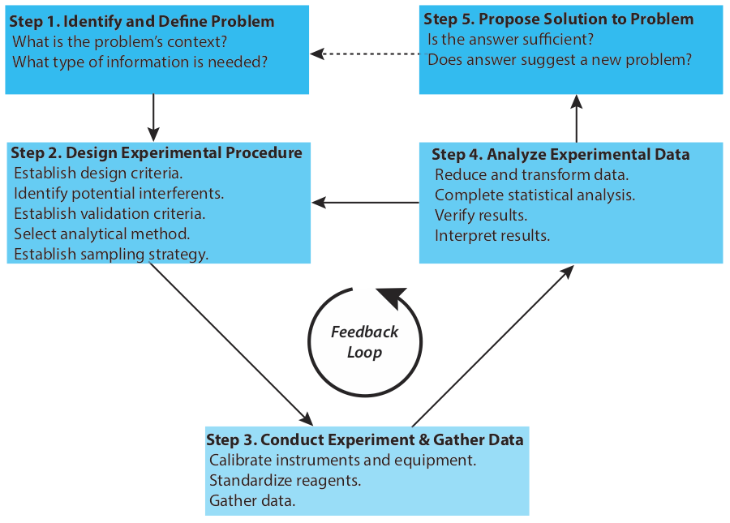
Figure 1. Flow diagram showing one view of the analytical approach to solving problems. Adapted from Figure 1.2.1 in David Harvey, Analytical Chemistry 2.1, licensed under CC BY-NC-SA 4.0. Harvey’s figure was modified after Atkinson, G. F. J. Chem. Educ. 1982, 59, 201–202.
This analytical approach can be used to solve problems that arise in everyday life. For example, when the pandemic spread rapidly in 2020, it became imperative to determine who was infected with COVID-19. Read “Rapid coronavirus tests: a guide for the perplexed” (Nature, Feb 2021). As you read the article, pay particular attention to how it emulates the analytical approach and consider the following questions, which were adapted from David Harvey, Analytical Chemistry 2.1, Section 1.2, licensed under CC BY-NC-SA 4.0.

Questions
1. What is the analytical problem, and why is it significant from both a societal and a scientific perspective?

2. What factors (e.g., accuracy, precision, sensitivity, specificity) were most important in designing the experiments? How do these relate to the key performance indicators of an analytical method?

3. What experimental controls and standards did the authors use, and how did they address potential sources of error? How might these strategies influence the reproducibility of results?

4. How did the authors validate their method? Consider both internal validation (e.g., replicates) and external validation (e.g., comparison with gold-standard methods).

5. Did the authors iterate through steps of method development (e.g., problem definition, data collection, analysis)? Identify specific examples of iteration in the article.

6. Was the analytical problem resolved effectively? Evaluate the solution based on the balance of scientific rigor, practicality, and impact.

7. If you were to design a follow-up study to improve upon this work, what would you focus on, and why?
Active Learning Worksheets for Analytical Chemistry

#2 Analytical Foundations: Evaluating Glassware Accuracy and Precision

Before You Begin
- Read 3.4 Selecting an Analytical Method
- Read 4.2 Characterizing Experiment Errors

What You Should Already Know
- Basic understanding of significant figures and measurement uncertainty.
- Conceptual familiarity with moles, solutions, and concentration (especially for volumetric work).
- Introduction to error types (systematic vs. random).
- Experience using volumetric glassware (pipets, flasks, graduated cylinders) even if not in-depth.

What You’ll Learn
- Define and distinguish between accuracy, precision, systematic error, and random error.
- Interpret volumetric glassware labels and explain their significance in quantitative analysis.
- Use manufacturer-provided tolerances to determine the expected measurement range for glassware.
- Calculate percent error, standard deviation, and relative standard deviation from experimental data.
- Compare the precision and accuracy of different types and sizes of volumetric glassware.
- Evaluate real-world student data to identify sources and types of experimental error.

What You’ll Practice
- Analyze experimental data to identify patterns in accuracy and precision.
- Apply quantitative reasoning to calculate and interpret error metrics.
- Draw conclusions about the reliability of different measurement techniques based on statistical evidence.
- Explain how procedural differences can lead to systematic or random errors.
- Rank experimental performance based on well-justified quantitative criteria.

Estimated Completion Time: 75 minutes

Author: Rebecca L. Sanders
Active Learning Worksheets for Analytical Chemistry, Version 1.0, 2026

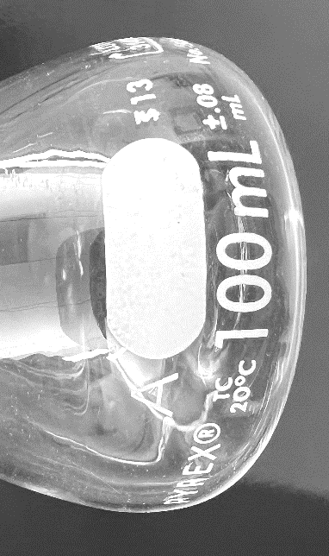
Labels on Volumetric Glassware

- Obtain from your instructor a 100 mL Class A volumetric flask. Identify what each of the following labels represents:
- A

- TC

- 20 °C

- 100 mL

- + 0.08 mL Figure 1. Image of a 100 mL volumetric flask.
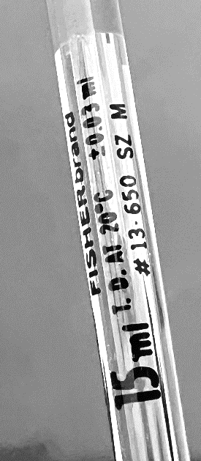
- 13

- Obtain from your instructor a 15 mL Class A volumetric pipet. Identify what each of the following labels represents:
- 15 mL

- TD

- 20 °C

- + 0.03 mL

Figure 2. Image of a 15 mL volumetric pipet.

- The manufacturers of analytical instruments and equipment, such as glassware and balances, usually provide a statement of the item’s maximum measurement error, or tolerance. For example, a 10-mL volumetric pipet has a tolerance of ±0.02 mL, which means the pipet delivers an actual volume within the range 9.98–10.02 mL at a temperature of 20 °C. Although we express this tolerance as a range, the error is determinate; that is, the pipet’s expected volume is a fixed value within this stated range. Text adapted from David Harvey, Analytical Chemistry 2.1, Section 4.2, licensed under CC BY-NC-SA 4.0.

On the following page, Table 1 shows the measurement errors associated with Class A volumetric flasks and volumetric pipets. Obtain any necessary glassware from your instructor to fill in the missing information in the table. Then, calculate percent relative tolerance for any glassware that is needed and fill out the information in table 1.
Table 1. Measurement errors for Class A volumetric glassware. Adapted from Table 4.2.1 in David Harvey, Analytical Chemistry 2.1, licensed under CC BY-NC-SA 4.0.
Volumetric Flasks |  |  | Volumetric Pipets
Capacity (mL) | Tolerance (mL) | Percent Relative Tolerance (%) | Capacity (mL) | Tolerance (mL) | Percent Relative Tolerance (%)
5 | ±0.02 | 0.4 | 1
10 |  |  | 2 | ±0.006 | 0.3
25 | ±0.03 | 0.12 | 5
50 | ±0.05 | 0.1 | 10 | ±0.02 | 0.2
100 |  |  | 15
250 | ±0.12 | 0.05 | 25 | ±0.03 | 0.12
500 | ±0.20 | 0.04 | 50 | ±0.05 | 0.1
1000 | ±0.30 | 0.03 | 100 | ±0.08 | 0.08

- What is the tolerance of the 25 mL volumetric flask? What is the expected volume range that should be contained by the volumetric flask?

- What is the tolerance of the 25 mL volumetric pipet? What is the expected volume range that should be delivered by the volumetric pipet?

Accuracy describes how closely the result of an experiment agrees with the “true” or expected result. Adapted from David Harvey, Analytical Chemistry 2.1, Section 4.2, licensed under CC BY-NC-SA 4.0. We can express accuracy as an absolute error, e
$$e = obtained result - expected result$$
or as a percentage error, %e

$$\%e= \frac{\left|obtained result-expected result\right|}{expected result} x 100$$

Precision measures the variability of the individual results of a sample that is measured multiple times. The closer the agreement between individual analyses, the more precise the results. We use standard deviations to determine the spread in a data set and percent relative standard deviation to compare standard deviations from one data set to another data set.

$$\%relative standard deviation= \frac{standard deviation}{average} x 100$$

- Based on the tolerance of the 25 mL volumetric flask and pipet listed in table 1, which would you expect to be more accurate? More precise?

- Consider the tolerance of the 15 and 25 mL volumetric pipets listed in table 1. Which would be more accurate? Why?

- If you wanted to make a solution at a known concentration as accurately as possible, would you choose to make the solution using glassware that holds larger volumes or smaller volumes? Why?

- Describe three reasons why you might not choose to measure a volume using an approach that is not the most accurate approach.

Data Collected Using Volumetric Glassware
Consider the accuracy and precision of four students using 25 mL Class A volumetric flasks and pipets to measure 25 mL of deionized water in triplicate. Their results are listed in the tables below.
Table 2. Individual and average volumes contained by a 25 mL Class A Volumetric Flask.
Student | Trial 1 | Trial 2 | Trial 3 | Average Volume (mL) | % Error | Standard Deviation (mL) | % Relative Standard Deviation
Alex | 25.02 | 25.36 | 25.08 | 25.15 | 0.61 | 0.18 | 0.7
Billy | 25.06 | 25.09 | 25.12 | 25.09 | 0.36 | 0.03 | 0.12
Charlie | 24.98 | 25.17 | 24.87 | 25.01 | 0.03 | 0.15 | 0.6
Denise | 24.89 | 24.91 | 24.93 | 24.91 | 0.36 | 0.02 | 0.08

Table 3. Individual and average volumes delivered by a 25 mL Class A Volumetric Pipet.
Student | Trial 1 | Trial 2 | Trial 3 | Average Volume (mL) | % Error | Standard Deviation (mL) | % Relative Standard Deviation
Alex | 24.76 | 24.79 | 24.64 | 24.73 | 1.1 | 0.08 | 0.3
Billy | 24.79 | 25.11 | 25.17 | 25.02 | 0.09 | 0.20 | 0.8
Charlie | 25.15 | 25.11 | 25.04 | 25.10 | 0.40 | 0.06 | 0.2
Denise | 25.50 | 25.48 | 25.35 | 25.44 | 1.8 | 0.08 | 0.3

- Based on tables 2 and 3,
  - Rank the four students from most accurate to least accurate when using the 25 mL volumetric flask. What values did you use to determine your ranking?

  - Rank the four students from most precise to least precise when using the 25 mL volumetric flask. What values did you use to determine your ranking?

  - Rank the four students from most accurate to least accurate when using the 25 mL volumetric pipet. What values did you use to determine your ranking?

  - Rank the four students from most precise to least precise when using the 25 mL volumetric pipet. What values did you use to determine your ranking?

- Did the accuracy of a student using a particular piece of glassware predict how precise the student was with that glassware? Why or why not?

- Using tables 1 and 2, did the students’ average volumes fall within the expected tolerance of the 25 mL volumetric flasks? Explain.

- Using tables 1 and 3, did the students’ measurements fall within the expected tolerance of the 25 mL volumetric pipets? Explain.

- When using the volumetric pipet, Denise was blowing out the last drop of water using her pipet bulb, yielding volumes that were higher than expected. Is this an example of systematic or random error? Why?

- If any average volumes from the student data fell outside of the expected tolerance of the glassware, list at least three reasons why that may have occurred. For each error, list if it was a systematic or random error.

- Summarize three key things you learned from this activity.

Active Learning Worksheets for Analytical Chemistry

#3 Analytical Foundations: Correcting Mass and Propagating Uncertainty

Before You Begin
- Read about buoyancy: 16.9 Correcting Mass for the Buoyancy of Air
- Read about propagation of error: 4.3 Propagation of Uncertainty

What You Should Already Know
- Molarity, dilution, and stoichiometry
- Logarithmic relationships in acid/base chemistry (pH, pOH).
- Significant figures and precision.
- Familiarity with volumetric glassware and tolerance values

What You’ll Learn
- Explain the effect of buoyancy on mass measurements and apply correction formulas
- Calculate absolute and relative uncertainties for derived quantities (e.g., $[H^{+}]$, $[{OH}^{-}]$, molarity)
- Propagate uncertainty using multiplication, division, subtraction rules
- Evaluate alternative experimental strategies based on uncertainty in final concentration
- Interpret how uncertainty accumulates through sequential measurements

What You’ll Practice
- Apply quantitative reasoning in uncertainty propagation
- Compare methods for solution preparation based on propagated uncertainty
- Assess the contribution of instruments and techniques to total uncertainty
- Communicate error and uncertainty using scientific notation and conventions

Estimated Completion Time: 90-120 minutes

Author: Rebecca L. Sanders, Active Learning Worksheets for Analytical Chemistry, Version 1.0, 2026

Useful Equations:
- $W_{v}= W_{a} * \left[1+\left(\frac{1}{D_{o}}-\frac{1}{D_{w}}\right)* 0.0012\right]$ where $W_{v}$ is the object’s true weight in vacuo, $W_{a}$ is the object’s true weight in air, $D_{o}$ is the density of the object, and $D_{w}$ is the density of the brass weights (assume 8.40 g/mL).
- $[H^{+}] = {10}^{-pH}$
- $pH= -log\left[H^{+}\right]$
- $[{OH}^{-}] = {10}^{-pOH}$
- $pOH= -log\left[{OH}^{-}\right]$
- $uncertainty in [H^{+}] = 2.303[H^{+}](uncertainty in pH)$
- $uncertainty in pH=\frac{Uncertainty in [H^{+}]}{2.303[H^{+}]}$
- $uncertainty in [{OH}^{-}] = 2.303[{OH}^{-}](uncertainty in pOH)$
- $uncertainty in pOH=\frac{Uncertainty in [{OH}^{-}]}{2.303[{OH}^{-}]}$
- ${\% relative error}_{total} = \sqrt{{\left(\%{error}_{1}\right)}^{2}+{\left(\%{error}_{2}\right)}^{2}+…}$
- ${absolute error}_{total}= \sqrt{{error}_{1}^{2}+{error}_{2}^{2}+…}$

Buoyancy Calculation
- If a 20.00 mL volumetric pipet delivered 19.9741 g of water at 21.0 °C, what is the true mass of the water? What is its true volume? The density of water at 21.0 °C is 0.9979955 $g/{mL}$.

Errors in pH Measurements
- The pH of a solution is 6.05 ± 0.03. Find $\left[H^{+}\right]$ and its absolute and percent relative uncertainties.

- A solution of KOH was standardized to have a concentration of $0.1012±0.0009 M$. What is the pOH of the solution and its absolute uncertainty?

Propagation of Error Calculations
Find the absolute uncertainty and percent relative uncertainty for each answer.
- $\left[14.12 \left(±0.07\right)÷ 3.98 \left(±0.02\right)\right]* 6.6821 (±0.0008)$

- $[2.36 \left(±0.10\right)* 7.55 (±0.04)] - 0.17 (±0.05)$

Propagation of Error When Making Solutions
You need to make a solution of 0.00111 M $Cd{Cl}_{2}$ as accurately and precisely as possible. To make the solution, you could make it in one of two ways.

Possible Method A: Two-step
- Calculate the formula mass of $Cd{Cl}_{2}$ to the correct number of significant figures. The atomic mass of Cd is 112.41 + 0.01 g/mol and the atomic mass of Cl is 35.45 + 0.01 g/mol.

- What is the absolute uncertainty in the formula mass of $Cd{Cl}_{2}$?

- A solution was made by dissolving 0.1018 ± 0.0002 grams of $Cd{Cl}_{2}$ in a 50.00 ± 0.05 mL volumetric flask with distilled water. What is the molarity? What are the absolute and percent relative uncertainties of the solution’s molarity?

- You need a 1:10 dilution of the solution from #8 to make your solution. Using a 5.00 ± 0.01 mL volumetric pipet, you dilute the solution from #8 into a new 50.00 ± 0.05 mL volumetric flask. What is the molarity of the diluted solution? What are the absolute and percent relative uncertainties of the solution’s molarity?

Possible Method B: One-step
- You could have made the solution in one step by using one tenth of the original mass of $Cd{Cl}_{2}$. This solution was made by dissolving 0.0102 ± 0.0002 grams of $Cd{Cl}_{2}$ in a 50.00 ± 0.05 mL volumetric flask with distilled water. The resulting solution would have yielded a solution with 0.00111 ± 0.00002 M $Cd{Cl}_{2}$. Calculate the percent relative standard deviation for this approach. Which method (A or B) results in a final solution concentration with less uncertainty? Why? Be sure to consider the uncertainty in each individual measurement and how it contributes to the overall uncertainty.

Active Learning Worksheets for Analytical Chemistry

#4 Analytical Foundations: Designing a Representative Sampling Strategy

Before You Begin
- Read 7.1: The Importance of Sampling
- Read 7.2: Designing a Sampling Plan
- Read 7.3: Implementing the Sampling Plan

What You Should Already Know
- Differences between population and sample
- Basics of random and representative sampling
- Sources of sampling bias
- How to calculate mean and standard deviation

What You’ll Learn

- Design a representative sampling plan for Oreo cookies
- Determine sample size and sampling locations to minimize bias
- Identify variables to control during sample preparation and measurement

What You’ll Practice

- Collaboratively plan a sampling and measurement strategy
- Evaluate the impact of sample source, preparation, and handling
- Justify sampling decisions based on analytical chemistry principles

Estimated Completion Time: 60 minutes

Author: Rebecca L. Sanders
Active Learning Worksheets for Analytical Chemistry, Version 1.0, 2026

Backstory: The Double Stuf Oreo Debate
In 2013, a high school math teacher named Dan Anderson made headlines when his students tested whether Double Stuf Oreos® really had double the crème filling of regular Oreos®. They discovered that the Double Stuf cookies only had about 1.86 times the crème. The story spread quickly, with coverage from CNN, NPR, and others, sparking a swirl of public curiosity and snack-food skepticism.
In Dan Anderson’s original study, he weighed ten full cookies of each type to find the average mass for one cookie was 11.57 grams for regular Oreos and 14.67 grams for Double Stuf Oreos. Then he weighed five wafers to find an average wafer mass was 3.98 grams. He used the average cookie mass and subtracted the average mass of two wafers to find the average mass of Oreo and Double Stuf Oreo crème. The scale used read to the nearest hundredth of a gram.
- What are the strengths of Dan Anderson’s sampling method?

- What are some limitations or possible sources of error in Anderson’s approach?

In response, Truth in Advertising conducted their own investigation in 2022 and found that while Double Stuf Oreos may not have exactly double the crème, they do consistently contain about twice as much crème as regular Oreos, supporting Nabisco’s claim. However, Nabisco still provides no published standard defining what "double" means on the packaging.
In the Truth in Advertising study, they relied on a kitchen scale that only measured to the nearest gram. The crème of a pack of each variety of cookies was measured with average crème masses of 3.1 and 6.2 grams for regular and Double Stuf Oreos, respectively.
- What are the strengths of the Truth in Advertising approach?

- What are limitations or drawbacks of the Truth in Advertising study?

Develop a Sampling Plan
As analytical chemists, you now have the tools to weigh in. Can we design a more robust sampling plan to finally settle the debate? Your team will plan how to collect data, choose how many cookies to sample (and from where), and define how to analyze your results to determine: Does a Double Stuf Oreo® from this year actually contain double the crème?
- What is your population of interest?

- How many total cookies will you sample?

- How many packages will you sample from?

- How many cookies will you sample per package?

- Where will you get the Oreos®?

Handling and Preparation
- How will you handle and store cookies to ensure consistency?

- What measurements will you make?

- What tools will you use for measurements?

Experimental Design Considerations
- What variables must be controlled to ensure accuracy?

- What qualitative observations might be helpful to record?

- Will you blind your samples or randomize order? Why?

- How will you record your data?

Data Analysis Planning
- How will you calculate and compare average crème mass?

- What statistical tests might help determine if differences are significant?

Reflection
- What’s one thing you’ll need to be especially careful about during sampling or measuring?

Optional Extension
- Would your answer change based on year, location, or package size? How could you design a broader study?

Active Learning Worksheets for Analytical Chemistry

#5 Analytical Foundations: Analyzing and Interpreting Experimental Error

Before You Begin
- Read 4.2 Characterizing Experiment Errors
- Read 4.4 The Distribution of Measurements and Results
- Read 4.6 Statistical Methods for Normal Distributions
- Reference critical values from these tables: 16.4: Critical Values for t-Test, 16.5: Critical Values for F-Test, 16.6: Critical Values for Dixon's Q-Test, and 16.7: Critical Values for Grubb's Test

What You Should Already Know
- How to calculate mean and standard deviation
- Definitions of systematic error, random error, and blunders
- Basic familiarity with confidence intervals
- The concept of a population mean vs. sample mean

What You’ll Learn
- Identify, classify, and interpret sources of error in data collection
- Calculate and interpret standard deviation and confidence intervals
- Apply statistical logic (t-test, Q-test, etc.) to evaluate data sets
- Determine whether differences in data sets are statistically significant

What You’ll Practice
- Analyze real experimental data with appropriate skepticism
- Make data-driven decisions about data quality and inclusion
- Collaborate to classify types of error and determine potential correction strategies
- Communicate statistical findings clearly and accurately

Estimated Completion Time: 60-135 minutes

Author: Rebecca L. Sanders, Active Learning Worksheets for Analytical Chemistry, Version 1.0, 2026

Useful Equations
- $µ= {\overline{X}}_{A}± \frac{ts_{A}}{\sqrt{n_{A}}}$
- $F_{exp}= \frac{s_{A}^{2}}{s_{B}^{2}}$ where $S_{A}>S_{B}$ so that $F_{exp}>1$.
- $t_{exp}= \frac{|{\overline{X}}_{A}-{\overline{X}}_{B}|}{\sqrt{\frac{s_{A}^{2}}{n_{A} } + \frac{s_{B}^{2}}{n_{B} } }}$ Degrees of freedom: $ν= \frac{{\left(\frac{s_{A}^{2}}{n_{A} } + \frac{s_{B}^{2}}{n_{B} } \right)}^{2}}{\frac{{\left(\frac{s_{A}^{2}}{n_{A} }\right)}^{2}}{n_{A}+1} + \frac{{\left(\frac{s_{B}^{2}}{n_{B} }\right)}^{2}}{n_{B}+1}}-2$
- $t_{exp}= \frac{|{\overline{X}}_{A}-{\overline{X}}_{B}|}{s_{pool}}* \sqrt{\frac{n_{A}n_{B}}{n_{A} + n_{B}}}$
where $s_{pool}=\sqrt{\frac{{(n}_{A}-1){s_{A}^{2}+(n}_{B}-1)s_{B}^{2}}{n_{A} + n_{B}-2}}$ $Degrees of freedom =n_{A}+n_{B}-2$.
- $G_{exp}=\frac{|X_{out}-\overline{X}|}{s}$
- $Q_{exp}=\frac{gap}{range}$

Errors in Data Collection
Several students and an instructor sampled Oreo cookies to determine the average mass of cream inside an Oreo cookie. Each dataset was obtained by weighing the cream from individual cookies after carefully separating it from the wafers. The purpose of this activity is to explore how data collection techniques and errors influence results and to practice identifying and categorizing these errors. Then, you will explore how to statistically analyze the data that was collected.
While identifying the cream mass may seem simple at first, there are many places where errors could occur. With your group, discuss each of the errors below. Describe how they may impact the mean and standard deviation of a dataset. Classify each error as systematic, random, or a blunder and suggest whether it could be corrected. A blunder is a human mistake or error that results in an incorrect measurement or data recording.
- Wafer crumbs are left in the cream mass due to incomplete separation.

- The masses were collected using an analytical balance with the top glass door left open.

- Environmental vibrations causing the balance to fluctuate slightly during measurements.

- When a student enters a cream mass into a spreadsheet, they switch two numbers, recording 3.9055 g instead of the measured mass of 3.0955 g.

- All cookies were selected from a single package that may not represent the larger population.

- For the first cream measurement, a student tared the balance, then recorded the mass of the cream and the weigh paper it was placed on as just the cream mass.

Now that you have evaluated a variety of possible errors in data collection, let’s explore some data collected by one instructor and four students. The data was collected as follows:
- Sampling: Nine cookies were randomly selected by each experimenter from a larger population of several Oreo packages to represent the average cream mass for regular Oreos.
- Preparation: The cream was carefully separated from the wafers using a spatula, attempting to remove all the cream without contamination.
- Measurement: The cream was weighed on an analytical balance tared with a piece of weigh paper, and the masses were recorded.
Table 1. Measured cream masses (in grams) for regular Oreos across nine trials conducted by the instructor and four students. The table includes calculated mean and standard deviation values for each dataset. Data was modified from student data collected in CHEM 310 in Fall 2023.
Trial | Instructor | Student 1 | Student 2 | Student 3 | Student 4
Trial 1 | 3.1239 | 3.2294 | 2.4386 | 2.6371 | 2.7599
Trial 2 | 2.8006 | 2.8632 | 2.6885 | 2.8363 | 2.8345
Trial 3 | 2.9186 | 3.0003 | 2.4315 | 3.5606 | 3.1014
Trial 4 | 2.9051 | 3.2717 | 3.3358 | 4.3764 | 3.3360
Trial 5 | 3.0650 | 3.2944 | 2.6176 | 3.2903 | 3.1120
Trial 6 | 2.8268 | 3.1742 | 2.9423 | 3.1744 | 2.0281
Trial 7 | 3.1425 | 3.2014 | 2.8790 | 2.7902 | 2.9948
Trial 8 | 3.2187 | 3.4146 | 2.6721 | 2.7701 | 2.7695
Trial 9 | 3.0857 | 2.9160 | 2.1463 | 2.7098 | 2.9734
Mean (g) | 3.0097 | 3.1517 | 2.6835 | 3.1272 | 2.8788
Standard Deviation (g) | 0.1498 | 0.1853 | 0.3441 | 0.5609 | 0.3686

Evaluating the Instructor’s Data
- Review the instructor’s data. The instructor’s cream masses were 3.01 + 0.15 g. What does the standard deviation represent?

- Are there any obvious sources of error? What might explain the variability in the standard deviation?

- How does the instructor’s mean and standard deviation compare to the other datasets? What do those numbers imply?

- While the actual mass of cream in regular Oreos is unknown, a 95% confidence interval of the mass can be calculated.
  - Based on the instructor’s data, calculate the 95% confidence interval of Oreo cream mass.

  - What does a 95% confidence interval represent? What does the other 5% represent?

Evaluating the Students’ Data
- Review the data collected by student 1. Are there any obvious sources of error? What might explain the variability in the standard deviation? Compared to the instructor?

- Review the data collected by student 2. How does their mean and standard deviation compare to the instructor’s data? Are there any obvious sources of error?

- Review the data collected by student 3. How does their mean and standard deviation compare to the instructor’s data? Are there any obvious sources of error?

- Review the data collected by student 4. How does their mean and standard deviation compare to the instructor’s data? Are there any obvious sources of error?

- Upon reviewing student 4’s notebook pages, the instructor finds that 2.0281 g entry was a typo that was supposed to be 3.0281 g. Based on student 4’s documentation, the instructor can fix this blunder. The instructor predicts a similar data entry error occurred with student 3’s 4.3764 g data point given that no other data point is 4 grams or more. However, student 3 only collected data digitally. What should the instructor do?

Statistical Analysis to Remove Data Points and Compare Data Sets
- Calculate if any data points can be excluded from student 2’s data set.

- Calculate if any data points can be excluded from student 3’s data set.

- Are the mean masses for the instructor and student 1 significantly different at 95% confidence? Hint: Use an F-test first to determine which t-test should be used.

- Are the mean masses for the instructor and student 2 significantly different at 95% confidence?

Optional: Using Microsoft Excel to Compare Data Sets
Because t-test calculations by hand can be cumbersome, it is useful to know the same calculations can be done in Microsoft Excel.
- Open Microsoft Excel. All raw data for individual data points needs to be entered in Excel. For sample, below are two data sets with five trials each.

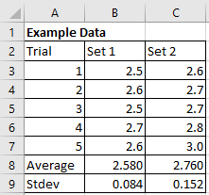
- Make sure the "Data Analysis" Package installed to conduct statistical tests. This can be done by opening File Options Add-ins. Make sure the Analysis ToolPak is enabled.
- Under the Data tab, select “Data Analysis”. A menu will open with several analysis tools. Select "F-test Two-Sample for Variances". Enter both data sets, making sure the data set with the larger standard deviation is put in variable range 1. An example is shown below:
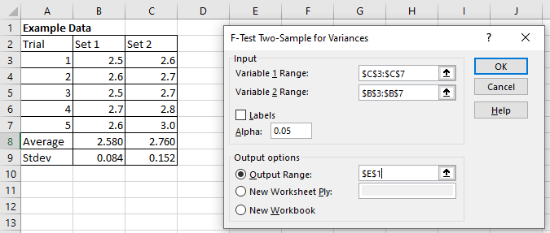
- The output will give an F value, which is $F_{exp}$ and an F Critical value, which is $F_{table}$,. In the example below $F_{exp}=3.285714$, which is less than $F_{table}, =6.388233$. Since $F_{exp}<F_{table}$, the standard deviations are not significantly different at a 95% confidence level (Alpha: 0.05).
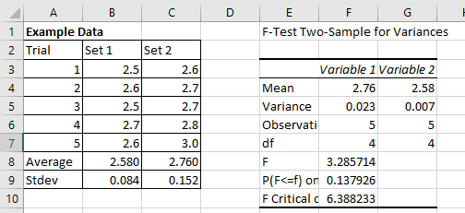

- Since $F_{exp}<F_{table}$, the standard deviations are not significantly different. Use the "t-test: Two sample assuming equal variance" under Data Analysis to compare the means. If the standard deviations are significantly different, use the "t-test: Two sample assuming unequal variance". Use the data set with the larger mean for variable range 1. An alpha (or p value) of 0.05 represents a 95% confidence level. This can be changed if a different confidence level is desired. For example, if the t-test was conducted at a 90% confidence level, change alpha to be 0.10. An example input for the t-test is shown below.
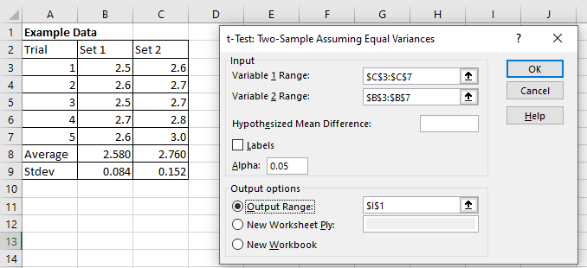
- The output will give a t Stat value, which is $t_{exp}$, and a t Critical two-tail value, which is $t_{table}$. It can be helpful to highlight the important values from the F-test and t-test output tables. In this example, $t_{exp}=2.32379$, which is greater than $t_{table}=2.306004$. In this example, the means of set 1 and set 2 are significantly different at the 95% confidence level.
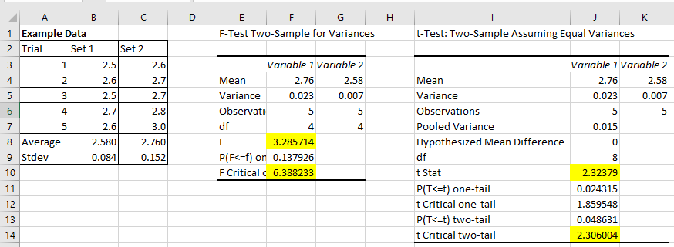
- Using Microsoft Excel, determine if the mean masses for the instructor and student 1 significantly different at a 95% confidence level? Compare your answer calculated in Excel to the one you calculated by hand in question 18.

- Using Microsoft Excel, determine if the mean masses for the instructor and student 2 significantly different at a 95% confidence level? Compare your answer calculated in Excel to the one you calculated by hand in question 19.
Active Learning Worksheets for Analytical Chemistry

#6 Analytical Foundations: Solution Preparation and Error Considerations

Before You Begin
- Read about concentration: 2.2: Concentration
- Read about preparing solutions: 2.5: Preparing Solutions
- Read about propagation of error: 4.3: Propagation of Uncertainty

What You Should Already Know
- Molarity, ppm, and mg/mL unit conversions
- Glassware tolerances and accuracy
- How to use volumetric pipets and flasks
- Understanding why acids are used to stabilize certain ions
- Safety protocols for handling concentrated acids

What You’ll Learn
- Convert between concentration units: ppm, molarity, and mg/mL
- Select appropriate glassware to minimize relative error
- Prepare stock and standard solutions using multiple methods
- Propagate error through multi-step dilution procedures
- Compare methods by speed, accuracy, waste, and practicality

What You’ll Practice
- Interpret procedural trade-offs when designing a solution protocol
- Identify sources of error and strategies for mitigation
- Apply green chemistry principles to lab-scale planning
- Justify method selection based on analytical context

Estimated Completion Time: 75-90 minutes

Author: Rebecca L. Sanders
Active Learning Worksheets for Analytical Chemistry, Version 1.0, 2026

Useful Equations

- $1 ppm = 1 mg/L$ for dilute, aqueous solutions
- $C_{1}V_{1} = C_{2}V_{2}$
- ${\% relative error}_{total} = \sqrt{{\left(\%{error}_{1}\right)}^{2}+{\left(\%{error}_{2}\right)}^{2}+…}$
- ${absolute error}_{total}= \sqrt{{error}_{1}^{2}+{error}_{2}^{2}+…}$

In this unit, you have explored how different pieces of glassware can be used for different purposes. You have learned that tolerance generally increases with glassware size, but percent relative tolerance decreases with glassware size. You’ve done calculations showing how error is propagated when making solutions and you have learned to select glassware, when appropriate, to limit percent relative error. In this worksheet, we will try these concepts together as you think about applying these skills to make solutions and sets of standards.

Preparing a Stock Solution

Hannah wants to measure the concentration of lead leaching from aging lead service lines and solder in a historic district’s water system using atomic spectroscopy. Aside from collecting and preparing samples, she will need to prepare standards from a stock solution. Hannah wants to purchase a 500 mL stock solution of lead (207.2 g/mol) standard solution that is 1 mg/mL ${Pb}^{2+}$ in 2% nitric acid ($HNO_{3}$) from ThermoFisher. However, the shipping time will take too long so she decides to make the stock solution instead.

- The stock solution should be 1 mg/mL ${Pb}^{2+}$. What concentration is that in units of ppm? What concentration is that in units of molarity? Hint: 1 ppm = 1 mg/L in dilute, aqueous solutions.

- Why is the unit of ppm likely used instead of molarity?

- She will have to use primary standard grade $Pb{\left(NO_{3}\right)}_{2}$ (m.w. 331.2 g/mol) to make the stock solution. What mass of $Pb{\left(NO_{3}\right)}_{2}$ is needed to make a 500 mL solution?

- The stock solution should contain 2-5% $HNO_{3}$. In Hannah’s lab, she has access to commercially available concentrated $HNO_{3}$, which is 68 wt.% $HNO_{3}$. How much $HNO_{3}$ will she need to use? Why is $HNO_{3}$ included in the stock solution?

- What tool should be used to measure the volume of $HNO_{3}$? Her labmate reminds her of the acronym “AAA”, which means “always add acid.” What does that mean and why is it important?

- Describe the steps needed to make the stock solution. Make sure to include the order and what tools must be used.

- After preparing the solution, the final concentration is 1000.0 + 0.4 ppm. The original stock solution Hannah wanted to order had a concentration of 997 to 1003 μg/mL of ${Pb}^{2+}$ in 2 to 5% $HNO_{3}$. Was she able to make a solution that is accurate as one that she could have purchased?

Preparing a Set of Standards

Now Hannah needs to make a set of five standards ranging from 0.1-1.0 ppm ${Pb}^{2+}$. She needs a minimum of 50 mL per standard. She is debating between two different methods. In her lab, she has access to 10, 25, 50, 100, 200, 250, and 500 mL Class A volumetric flasks and 1, 2, 3, 4, 5, 10, 15, 20, and 25 mL volumetric pipets. She also has access to micropipettes measuring 2-20, 20-200, and 100-1000 µL.

Method 1. Single Step Preparation of Standards
One option for Hannah is to take the 1000.0 ppm stock solution and use micropipettes and 50 mL volumetric flasks to make her standards. Below highlights five standards that can be prepared by micropipetting volumes of the 1000.0 + 0.4 ppm stock solution into different 50 mL volumetric flasks.
Table 1. Possible tools used to make five ${Pb}^{2+}$ standards from 0.1-1.0 ppm as well as the percent relative error in each standard.
Calibration Standard ${Pb}^{2+}$ Concentration (ppm) | Volume of ${Pb}^{2+}$ to Deliver with Micropipette (µL) | Volumetric Flask (mL) | % Relative Error
1.0 | 50 + 0.4 | 50 + 0.05 | 0.8
0.8 | 40 + 0.4 | 50 + 0.05 | 1.0
0.5 | 25 + 0.4 | 50 + 0.05 | 1.5
0.2 | 10 + 0.05 | 50 + 0.05 | 0.5
0.1 | 5 + 0.05 | 50 + 0.05

- Which micropipette should be used for each measurement?

- In the lab, Hannah realizes that there are no clean 50 mL volumetric flasks. She cleans several, but then is concerned that they won’t dry quickly. Does she need to wait for them to dry before she can use them? Why or why not?

- The percent relative error of the resulting solution concentration has been calculated for four of the five standards.
  - Calculate the missing percent relative error.

  - Which measurement is contributing most to the percent relative error (error in concentration, error in micropipette volume, or error in volumetric flask volume)?

Method 2: Multi-step Preparation of Standards
Hannah will use more than one step to prepare her standards. First, Hannah will make a 1:100 dilution of her stock solution, making a 10.00 ppm ${Pb}^{2+}$ solution. Then, she will use volumetric pipets and volumetric flasks to make the standards. She decides to keep the same five standard solution concentrations as she selected for Method 1.
- Propose how Hannah can make her 1:100 dilution of her stock solution.

- Now propose what combination of volumetric pipets and volumetric flasks can be used to prepare the following five standards. Be mindful of the size of the glassware she has access to when selecting each pipet and flask that will be used.

Table 2. Possible volumes and tools used to make five ${Pb}^{2+}$ standards from 0.1-1.0 ppm as well as the percent relative error in each standard.
Calibration Standard ${Pb}^{2+}$ Concentration (ppm) | Volume of 1:100 ${Pb}^{2+}$ to Deliver with Volumetric Pipets (mL) | Volumetric Flask (mL) | Percent Relative Error (%)
1.0
0.8
0.5
0.2
0.1

- Assign each group member one or two standards to calculate percent relative error using glassware tolerance data, then compile your results in the table.

- One of the volumetric pipets that Hannah needs to use appears to have a film dried on it. Can she still use it? Explain.

Comparing Method 1 and Method 2

Hannah must decide which method she will use to prepare her standards. Several factors can be considered when deciding between method 1 and method 2.

- Which method would be faster? Why?

- Which method would be more accurate? Why?

- Which method would require the least amount of cleanup?

- Which method would generate the least amount of waste?

- Which method would you select overall? Why?

- ${Pb}^{2+}$ is a toxic metal ion that requires proper disposal. After completing the experiment, Hannah realized she only needed about 10 mL of each standard. Consider the method you selected.

  - What total volume of waste was generated?

  - Are there ways to minimize waste generation for that method?
Active Learning Worksheets for Analytical Chemistry

#7 Equilibrium Chemistry: Solubility and Back Titration Problem Solving

Before You Begin
- Read about precipitation and solubility: 6.4 Equilibrium Constants for Chemical Reactions
- Read about the common ion effect and the method of successive approximations: 6.7 Solving Equilibrium Problems
- Read about back titrations: 9.2: Acid–Base Titrations

What You Should Already Know

- General stoichiometry and mole conversions
- Writing balanced chemical equations
- Acid-base neutralization reactions
- Understanding of pH and concentration units (${mol}/L$, ppm, ppb)

What You’ll Learn
- Write $K_{sp}$ expressions and solve for molar solubility
- Interpret solubility in real-world systems (antacids, water quality)
- Perform stoichiometric calculations for back titrations
- Convert between ppm/ppb and molarity in environmental chemistry contexts

What You’ll Practice
- Use equilibrium concepts to predict solubility outcomes
- Apply titration data to indirectly quantify analyte mass
- Justify assumptions and approximations in complex chemical systems
- Communicate multi-step calculations using standard conventions

Estimated Completion Time: 50-65 minutes

Author: Rebecca L. Sanders
Active Learning Worksheets for Analytical Chemistry, Version 1.0, 2026

Solubility Reactions and Calculations
- ${MgCO}_{3}$ is one ingredient used in antacids. While it is insoluble in water, it becomes soluble under acidic conditions.
  - Write the $K_{sp}$ reaction and expression for ${MgCO}_{3}$.

  - Find the concentrations of ${Mg}^{2+}$ and ${CO_{3}}^{2-}$ in a saturated solution of ${MgCO}_{3}$. The $K_{sp}$ of magnesium carbonate is $3.5*{10}^{-8}$.

Back Titrations
You could perform a titration to determine the amount of ${MgCO}_{3}$ in an antacid tablet. However, you could not do this titration directly because ${MgCO}_{3}$ is not soluble in water. Instead, a back titration must be performed, which is necessary when a direct titration is not possible. For example, with solids such as ${MgCO}_{3}$ or ${CaCO}_{3}$, the endpoint may be difficult to detect because the solid dissolves slowly. Another example involves volatile substances such as ammonia and iodine, where inaccuracy arises due to loss of the substance during titration. In back titration, a known excess of one reagent A is allowed to react with an unknown amount of B. The amount of unreacted A is then determined by titration with a reagent C of known concentration. From the titration results, the amount of unreacted A and the amount of B can be found by simple stoichiometric calculations.

- A 1.0131 g tablet containing ${MgCO}_{3}$(s) was dissolved in 100.0 mL of 0.2015 M HCl(aq). The excess HCl(aq) was back titrated with 15.68 mL of 0.1025 M NaOH(aq).
- Write the balanced reaction of ${MgCO}_{3}$(s) with HCl(aq).

- How many total moles of HCl were added?

- How many moles of HCl reacted with the carbonate? (Hint: Using the calculated total moles of HCl added, subtract the moles of NaOH used to neutralize the excess HCl. The difference is the amount of HCl that reacted with ${MgCO}_{3}$.)

- How many grams of ${MgCO}_{3}$ (m.w. 84.3139 $g/{mol}$) reacted with the HCl?

- What percent of the tablet was made up of ${MgCO}_{3}$?

$K_{sp}$ Calculations
- ${Pb}_{3}{({PO}_{4})}_{2}$ is highly insoluble. Write the $K_{sp}$ reaction and expression for ${Pb}_{3}{({PO}_{4})}_{2}$.

- Find the concentrations of ${Pb}^{2+}$ and ${{PO}_{4}}^{3-}$ in a saturated solution of ${Pb}_{3}{({PO}_{4})}_{2}$. The $K_{sp}$ of lead (II) phosphate is $3.0*{10}^{-44}$.

- Phosphate is added to municipal water to reduce the solubility of ${Pb}^{2+}$ (207.2 $g/{mol}$) that may have been released from lead pipes. If a municipal water supply contains 5.0 ppm ${{PO}_{4}}^{3-}$ (m.w. 94.97 $g/{mol}$), what is the maximum possible concentration of ${Pb}^{2+}$ (in ppb) in the water supply? (Hints: Assume $1 ppm=1 {mg}/L$ and $1 ppb=1 {µg}/L$.)

- $Ca{(OH)}_{2}$ can be used to remove impurities and suspended particles from water. What is the concentration of ${Ca}^{2+}$ at equilibrium when $Ca{(OH)}_{2}$ is dissolved in a solution with an initial pH of 13.00? The $K_{sp}$ of calcium hydroxide is $6.5*{10}^{-6}$. (Hint: Use the pH to determine the initial concentration of ${OH}^{-}$.)
Active Learning Worksheets for Analytical Chemistry

#8 Equilibrium Chemistry: Fundamentals of Acid–Base Reactions

Before You Begin
- Read about acid-base reactions: 6.4 Equilibrium Constants for Chemical Reactions
- Read about the method of successive approximations: 6.7: Solving Equilibrium Problems

What You Should Already Know
- General chemical equations and molarity
- pH, pOH, and the autoionization of water
- Definitions of acids, bases, and conjugates
- Equilibrium expressions and ICE tables

What You’ll Learn
- Identify strong and weak acids and bases from formulas
- Write dissociation and hydrolysis reactions
- Identify conjugate acid–base pairs
- Use $K_{a}$ to calculate equilibrium concentrations and pH
- Compare acid strength based on $K_{a}$ or $pK_{a}$

What You’ll Practice
- Translate word prompts into chemical equations
- Apply equilibrium concepts to real systems
- Evaluate strength of acids/bases using numerical data
- Communicate reasoning clearly in multi-step calculations

Estimated Completion Time: 45-60 minutes

Author: Rebecca L. Sanders
Active Learning Worksheets for Analytical Chemistry, Version 1.0, 2026

Useful Equations

- $pH = -log[H^{+}]$
- $pH + pOH = 14.00$
- $\left[H^{+}\right]*\left[OH^{-}\right] = K_{a}*K_{b} = K_{w} = 1.0* {10}^{-14}$
- $pK_{a} = -log⁡(K_{a})$
- $pK_{a} + pK_{b} = pK_{w} =14.00$

Strong Acids and Bases
- List the strong acids and bases.

- What is the $K_{a}$ for $HClO_{4}$?

- Find the pH and $\left[H^{+}\right]$ of a solution containing 0.010 M $HClO_{4}$.

- Barium hydroxide is typically classified as a strong base. However, it is not completely soluble with a $K_{sp}=3*{10}^{-4}.$ What is the pH of 0.035 M $Ba{\left(OH\right)}_{2}$, which is below the saturation limit for barium hydroxide?

Brønsted–Lowry Conjugate Acid-Base Pairs
- Label the Brønsted–Lowry acid and base on each side of the reaction and identify each conjugate acid/base pair.
  - ${CN}^{-}+HCO_{2}H ↔HCN+HCO_{2}^{-}$

  - ${HSO_{3}}^{-}+{OH}^{-} ↔{SO_{3}}^{2-}+H_{2}O$

Weak Acids and Bases
- $HSO_{4}^{-}$ is amphiprotic and can act as both an acid and a base. Write its conjugate acid and conjugate base.

- Write the reaction of HF(aq) and water.

- Write the reaction of NaF(aq) and water.

- Below lists $K_{a}$ values for several acids.
$CH_{3}CO_{2}H$ $1.75*{10}^{-5}$
$ClCH_{2}COOH$ $1.36*{10}^{-3}$
$HCO_{2}H$ $1.80*{10}^{-4}$
$HNO_{2}$ $7.1*{10}^{-4}$
  - Rank these acids from strongest to weakest based on $K_{a}$ values. Briefly explain your ranking.

  - What are the equilibrium concentrations of $\left[H^{+}\right]$, $\left[{OH}^{-}\right]$, $\left[HNO_{2}\right]$, and $\left[{NO}_{2}^{-}\right]$ in a 0.60 M solution of $HNO_{2}$? What is the pH of the solution? (Hint: You can write the anion, ${NO}_{2}^{-}$, as just $A^{-}$ in your reaction if you prefer. This is especially helpful for complicated or unknown anion of a weak acid.)

  - What are the equilibrium concentrations of $\left[H^{+}\right]$, $\left[{OH}^{-}\right]$, $\left[HNO_{2}\right]$, and $\left[{NO}_{2}^{-}\right]$ in a 0.060 M solution of $HNO_{2}$? What is the pH of the solution?

Active Learning Worksheets for Analytical Chemistry

#9 Equilibrium Chemistry: Designing and Evaluating Buffer Systems

Before You Begin
- Read about buffers: 6.8: Buffer Solutions

What You Should Already Know
- Using $pK_{a}$ and Henderson-Hasselbalch equation
- Writing and balancing acid–base reactions
- Understanding strong vs. weak electrolytes
- RICE tables and equilibrium reasoning

What You’ll Learn
- Design buffer systems using weak acid/base pairs and $pK_{a}$ values
- Perform quantitative buffer calculations (pH, composition, concentration)
- Interpret and apply speciation curves for polyprotic acids
- Evaluate buffer strategies using acid/base equilibrium concepts

What You’ll Practice
- Use mathematical models (e.g., Henderson–Hasselbalch) to solve real lab problems
- Sketch and interpret pH-dependent concentration plots
- Communicate acid-base reasoning using clear, quantitative language
- Justify buffer choices in experimental and environmental contexts

Estimated Completion Time: 60-90 minutes

Author: Rebecca L. Sanders
Active Learning Worksheets for Analytical Chemistry, Version 1.0, 2026
Useful Equations
- $pH = -log[H^{+}]$
- $pH + pOH = 14.00$
- $\left[H^{+}\right]*\left[OH^{-}\right] = K_{a}*K_{b} = K_{w} = 1.0* {10}^{-14}$
- $pKa = -log⁡(K_{a})$
- $pK_{a} + pK_{b} = pK_{w} =14.00$
- $pH = pK_{a} + log(base/acid)$

Making Buffers
- In the laboratory, you mix 4.5 g of solid sodium acetate (82.03 $g/{mol}$) with 500.0 mL of 0.100 M HCl. What is the pH of the solution? The $pK_{a}$ of acetic acid is 4.76.

- Suppose you want to make a buffer with a formal concentration of 0.28 M and a pH of 4.94. Calculate how much acetic acid and sodium acetate you would use to make 1 L of this buffer. Glacial acetic acid is 17.5 M. (Hint: the formal concentration is the sum of $\left[HA\right]$ and $\left[A^{-}\right]$ in solution.)

Understanding Species Distributions in Buffers

Figure 1. Distribution plot as a function of pH for a 0.10 M acetic acid-acetate buffer. The acetic acid concentration is plotted as a straight line and the acetate concentration is plotted as a dashed line.

- The concentration of acetic acid and acetate in a buffer containing 0.10 M total concentration is plotted as a function of pH in Figure 1.

  - Where is the $pK_{a}$ on this graph? What are the concentrations of acetic acid ($HA$) and acetate ($A^{-}$) at the $pK_{a}$?

  - When $pH=pK_{a}-1$, what are the concentrations of acetic acid ($HA$) and acetate ($A^{-}$) at the $pK_{a}$?

  - When $pH=pK_{a}+1$, what are the concentrations of acetic acid ($HA$) and acetate ($A^{-}$) at the $pK_{a}$?

  - Is acetic acid/acetate a suitable buffer system at pH 6.00? Why or why not?

- Ammonium (${NH_{4}}^{+}$) has a $pK_{a}$ of 9.244.
  - Name three ways you could make a buffer of ammonium (${NH_{4}}^{+}$) and ammonia (${NH}_{3}$).

  - Sketch $\left[{NH_{4}}^{+}\right]$ and $\left[{NH}_{3}\right]$ for a buffer with a formal concentration of 0.050 M in Figure 2.

Figure 2. Empty graph to plot the distribution of $\left[{NH_{4}}^{+}\right]$ and $\left[{NH}_{3}\right]$.

Figure 3. Distribution plot as a function of pH for 0.10 M 2-aminophenol, a diprotic acid. The acidic form ($H_{2}A$) concentration is plotted as a straight line, intermediate form (${HA}^{-}$) concentration is plotted as a long-dashed line, and the basic form ($A^{2-}$) concentration is plotted as a short-dashed line.

- These plots can be used to visualize the concentration of various species in solution using polyprotic acids and bases. For example, 2-aminophenol is a diprotic acid ($H_{2}A$). The acidic form is labeled $H_{2}A$, the intermediate form with one proton lost is labeled ${HA}^{-}$, and the basic form with both protons lost is labeled as $A^{2-}$.
  - Use the plot in Figure 3 to determine the approximate $pK_{a}$ values of 2-aminophenol where [H₂A] = [HA⁻] and $\left[{HA}^{-}\right]=\left[A^{2-}\right]$. $pK_{a1}$ represents the first proton lost from $H_{2}A$ and $pK_{a2}$ will represents the second proton lost from $H_{2}A$.

  - What pH ranges can 2-aminophenol be used to make a buffer? Why? What conjugate acid-base pair is present in each buffer?

  - A classmate suggests to make a buffer at pH 9.30 by mixing $H_{2}A$ and ${HA}^{-}$. Another classmate suggests mixing ${HA}^{-}$ with $NaOH$. Of the two strategies, which would you choose and why?

Figure 4. Distribution plot as a function of pH for 0.10 M oxalic acid, a diprotic acid. The acidic form ($H_{2}A$) concentration is plotted as a straight line, intermediate form (${HA}^{-}$) concentration is plotted as a long-dashed line, and the basic form ($A^{2-}$) concentration is plotted as a short-dashed line.

- Figure 4 depicts the speciation of 0.10 M oxalic acid as a function of pH. Oxalic acid has $pK_{a1}=1.252$ and $pK_{a2}=4.266$.
  - On the figure, the concentration of [$H_{2}A$] never reaches 0.10 M. Why?

  - On the figure, the concentration of [${HA}^{-}$] never reaches 0.10 M. Why?

- In Figure 5, sketch the concentrations of $\left[H_{3}PO_{4}\right]$, $\left[{H_{2}PO_{4}}^{-}\right]$, $\left[{HPO_{4}}^{2-}\right]$, and $\left[{PO_{4}}^{3-}\right]$ across pH if total concentration of all phosphate containing species is 0.10 M and $pK_{a1} = 2.148$, $pK_{a2} = 7.199$, and $pK_{a3} = 12.35$.

Figure 5. Empty graph to plot the distribution of $\left[{NH_{4}}^{+}\right]$ and $\left[{NH}_{3}\right]$.

- You have three possible conjugate pairs that could work for pH 7.4, which is needed for a biological study. One is toxic, one is expensive, and one has low solubility at 4 °C. Which do you choose for your study? List two questions you would ask your instructor before ordering the chemicals.
Active Learning Worksheets for Analytical Chemistry

#10 Equilibrium Chemistry: Titration Curve Calculations for Monoprotic Acids

Before You Begin
- Read about acid-base reactions: 6.4 Equilibrium Constants for Chemical Reactions
- Read about the method of successive approximations: 6.7: Solving Equilibrium Problems
- Read about buffers: 6.8: Buffer Solutions
- Read about acid-base titrations: 9.2: Acid–Base Titrations

What You Should Already Know
- Stoichiometry and limiting reagents
- Henderson-Hasselbalch equation
- $pH$, $pK_{a}$, and $K_{w}$ relationships
- Interpreting titration curves

What You’ll Learn
- Determine pH at various points during a titration
- Identify buffer regions and equivalence points
- Use moles and volumes to determine remaining acid/base concentrations
- Apply Henderson–Hasselbalch to buffer solutions

What You’ll Practice
- Translate titration steps into quantitative models
- Use appropriate acid/base theory at each titration stage
- Explain pH changes with clear reasoning and chemical evidence

Estimated Completion Time: 75-90 minutes

Author: Rebecca L. Sanders
Active Learning Worksheets for Analytical Chemistry, Version 1.0, 2026

Useful Equations

- $M_{A}V_{A} =M_{B}V_{B}$
- $pH = -log[H^{+}]$
- $pH + pOH = 14.00$
- $\left[H^{+}\right]*\left[OH^{-}\right] = K_{a}*K_{b} = K_{w} = 1.0* {10}^{-14}$
- $pKa = -log⁡(K_{a})$
- $pK_{a} + pK_{b} = pK_{w} =14.00$
- $pH = pK_{a} + log(base/acid)$

Weak Acid/Strong Base Titration Calculations

- Aspirin (acetylsalicylic acid) acts as a weak monoprotic acid. A 50.0 mL solution of 0.10 M aspirin was titrated with 0.10 M KOH. Verify the pH values on the graph by calculating the pH after 0.0, 25.0, 40.0, 50.0, and 70.0 mL of KOH was added to the aspirin solution. The $pK_{a}$ of aspirin is 3.50.
  - Equivalence volume

  - 0.0 mL KOH

  - 25.0 mL KOH

  - 40.0 mL KOH

  - 50.0mL KOH

  - 70.0 mL KOH

Weak Base/Strong Acid Titration Calculations

- Tris (tris(hydroxymethyl)aminomethane) is a weak base that accepts protons from HCl. Use the base form as $\left[A^{-}\right]$ and the conjugate acid as [HA]. A 50.0 mL solution of 0.10 M Tris base was titrated with 0.10 M HCl. Verify the pH values on the graph by calculating the pH after 0.0, 20.0, 25.0, 50.0, and 60.0 mL of HCl was added to the Tris base solution. The acidic form of Tris has $pK_{a}$ of 8.10.
  - Equivalence volume

  - 0.0 mL HCl

  - 20.0 mL HCl

  - 25.0 mL HCl

  - 50.0 mL HCl

  - 60.0 mL HCl

Active Learning Worksheets for Analytical Chemistry

#11 Equilibrium Chemistry: Polyprotic Acid and Base Reactions and pH Calculations

Before You Begin
- Read about acid-base reactions: 6.4 Equilibrium Constants for Chemical Reactions
- Read about the method of successive approximations: 6.7: Solving Equilibrium Problems
- Read about buffers: 6.8: Buffer Solutions

What You Should Already Know
- Acid/base equilibria and $K_{a}$/$K_{b}$ concepts
- Understanding of conjugate acid–base pairs
- Henderson-Hasselbalch equation
- Stoichiometry and ICE tables

What You’ll Learn
- Write equilibrium reactions and expressions for polyprotic systems
- Perform conversions between $K_{a}$ and $K_{b}$ conversions and $pK_{a}$ and ${pK}_{b}$ conversions
- Identify appropriate buffer systems for target pH ranges
- Calculate species concentrations at equilibrium for diprotic/triprotic acids

What You’ll Practice
- Translate chemical data into appropriate equations and models
- Apply equilibrium problem-solving strategies
- Evaluate buffer construction strategies under constraints
- Communicate speciation outcomes with precision

Estimated Completion Time: 60-90 minutes

Author: Rebecca L. Sanders
Active Learning Worksheets for Analytical Chemistry, Version 1.0, 2026

Useful Equations

- $pH = -log[H^{+}]$
- $pH + pOH = 14.00$
- $\left[H^{+}\right]*\left[OH^{-}\right] = K_{a}*K_{b} = K_{w} = 1.0* {10}^{-14}$
- $pKa = -log⁡(K_{a})$
- $pK_{a} + pK_{b} = pK_{w} =14.00$
- $pH = pK_{a} + log(base/acid)$

Acid and Base Dissociation Constants for Polyprotic Acids and Bases
Consider the triprotic acid, $H_{3}PO_{4}$. $H_{3}PO_{4}$ has $pK_{a1}=2.15$, ${pK}_{a2}=7.20$, and $pK_{a3}=12.38$.
- Write the $K_{a1}$, $K_{a2}$, and $K_{a3}$ reactions for $H_{3}PO_{4}$.

- Write the $K_{b1}$, $K_{b2}$, and $K_{b3}$ reactions for ${Na}_{3}{PO}_{4}$. (Use ${{PO}_{4}}^{3-}$ to write net ionic equations.)

- What is ${pK}_{b1}$?

- What is $K_{b3}$?

Making Buffers with Polyprotic Acids and Bases
- You need to make some buffers. In the lab, you have access to $HCl$, $H_{3}PO_{4}$, and ${Na}_{2}HPO_{4}$. For each target pH, suggest if you can make it with the chemicals available. If you can, suggest two ways it could be made. If it cannot be made, explain why it cannot be made.
  - You want to make a buffer with a pH of 6.80.

  - You want to make a buffer with a pH of 8.80.

  - You want to make a buffer with a pH of 11.80.

Calculating the pH of Polyprotic Acids and Bases
Sulfurous acid ($H_{2}SO_{3}$) is a diprotic acid with $pK_{a1}=1.91$ and $pK_{a2}=7.18$.
- What is the pH of 0.100 M of the acidic form of sulfurous acid? What are the concentrations of the acidic form, intermediate form, and basic form in this solution at equilibrium?

- What is the pH of 0.100 M of the intermediate form of sulfurous acid?

- What is the pH of 0.100 M of the basic form of sulfurous acid?

8-hydroxyquinoline is a diprotic acid with $pK_{a1}=4.9$ and $pK_{a2}=9.81$.
- What is the pH of 0.050 M of the acidic form of 8-hydroxyquinoline?

- What is the pH of 0.050 M of the intermediate form of 8-hydroxyquinoline?

- What is the pH of 0.050 M of the basic form of 8-hydroxyquinoline? What are the concentrations of the basic form, intermediate form, and acidic forms in this solution at equilibrium?
Active Learning Worksheets for Analytical Chemistry

#12 Equilibrium Chemistry: Plotting and Interpreting Polyprotic Titration Curves

Before You Begin
- Read about acid-base reactions: 6.4 Equilibrium Constants for Chemical Reactions
- Read about the method of successive approximations: 6.7: Solving Equilibrium Problems
- Read about acid-base titrations: 9.2: Acid–Base Titrations
- Acid dissociation constants: 16.11: Acid Dissociation Constants

What You Should Already Know
- Concepts of weak acid/base equilibria and ${pK}_{a}$
- Understanding of diprotic acid behavior during titration
- Reading and interpreting titration curves
- Familiarity with first and second derivative plots in titration analysis

What You’ll Learn
- Analyze titration curves of diprotic acids to identify equivalence and buffer regions
- Use first and second derivatives to more precisely identify titration endpoints
- Estimate ${pK}_{a}$ values and molar mass from experimental titration data
- Match experimental data to likely unknowns using a table of reference acids

What You’ll Practice
- Construct and interpret Excel-based titration and derivative plots
- Use critical reasoning to evaluate graphical data
- Practice identifying dominant species and ${pK}_{a}$ relationships in polyprotic systems

Estimated Completion Time: 60-75 minutes

Author: Rebecca L. Sanders
Active Learning Worksheets for Analytical Chemistry, Version 1.0, 2026

Interpreting a Diprotic Titration Curve
In lab, students were asked to track the pH during the titrations of unknown diprotic acids with a strong base, NaOH. The goal is for them to plot the titration curves and interpret those curves to identify their assigned unknown diprotic acid. In Table 1, a list of possible unknown diprotic acids is shown.
Table 1. Possible unknown diprotic acids
Name | Formula | Molar Mass | $pK_{a1}$ | $pK_{a2}$
Oxalic acid | $$C_{2}H_{2}O_{4}$$ | 90.03 | 1.252 | 4.266
Malonic acid | $$C_{3}H_{4}O_{4}$$ | 104.06 | 2.847 | 5.696
Maleic acid | $$C_{4}H_{4}O_{4}$$ | 116.07 | 1.910 | 6.332
Succinic acid | $$C_{4}H_{6}O_{4}$$ | 118.09 | 4.207 | 5.636
Malic acid | $$C_{4}H_{6}O_{5}$$ | 134.09 | 3.459 | 5.097
D-tartaric acid | $$C_{4}H_{6}O_{6}$$ | 150.09 | 3.036 | 4.366

Example 1
Jamie conducted a titration of 0.1940 g of an unknown diprotic acid dissolved in distilled water with 0.09801 M NaOH. Then Jamie plotted the pH of the titration as a function of the volume of 0.09801 M NaOH added (Figure 1).
- Describe the general features of the titration curve. Circle any buffer region(s) and roughly identify the endpoint volume from Figure 1.

- In a diprotic titration curve, you might expect two distinct buffer regions to be observed. In this example, the titration curve looks to only contain one buffer region even though it is one of the diprotic acids in Table 1. Why?

Figure 1. Titration curve of Jamie’s unknown diprotic acid with 0.09801 M NaOH.

Analyzing Derivatives to Find Endpoints
The rough endpoint that you identified in question 1 represents the second endpoint of the unknown diprotic acid because all of the unknown acids have two ${pK}_{a}$ values in the acidic pH region. While Figure 1 can be used to roughly identify the second endpoint of the titration, first and second derivatives of the titration curve can be calculated and plotted to more accurately identify the endpoint of the titration curve. Jamie prepared some additional figures to determine the second endpoint. They plotted the first derivative as a function of average volume of titrant added (Figure 2), the second derivative as a function of average of average volume of titrant added (Figure 3), and a zoom in on the x-axis of Figure 3 to see where the second derivative shows a local maximum or minimum, indicating the point of steepest slope (i.e., the inflection point) on the original titration curve (Figure 4). Instructions for how to make these graphs are included at the end of this worksheet.

Figure 2. First derivative of the titration curve of Figure 3. Second derivative of the titration curve an unknown diprotic acid with 0.09801 M NaOH. an unknown diprotic acid with 0.09801 M NaOH.

Figure 4. Zoom in of the second derivative of the titration curve of an unknown diprotic acid with 0.09801 M NaOH.

Identifying the Unknown Acid
To identify the second endpoint of the titration curve, look at Figure 4. Find where the biggest jump in second derivative crosses at y=0. Record this as your endpoint to the nearest tenth of a milliliter. For example, on Figure 4 the second equivalence volume is 36.79 mL. The first endpoint would be half the volume of the second endpoint (e.g. 18.40 mL).

- Use the first endpoint volume to calculate the molar mass of the unknown diprotic acid.

- Use the first endpoint and second endpoint volumes to determine the volumes at ${pK}_{a1}$ and ${pK}_{a2}$.
  - ${pK}_{a1}$ is equal to the pH at $½V_{e1}$. First, calculate the volume at $½V_{e1}$. Then, look at Figure 1 at that volume and estimate the pH at that volume, which is ${pK}_{a1}$.

  - ${pK}_{a2}$ is equal to the pH at $\frac{3}{2}V_{e1}$. First, calculate the volume at $\frac{3}{2}V_{e1}$. Then, look at Figure 1 at that volume and estimate the pH at that volume, which is ${pK}_{a2}$.

- Now, use the molar mass and ${pK}_{a}$ values of Jamie’s unknown diprotic acid and the information in Table 1 to identify Jamie’s unknown diprotic acid.

Practice with a Second Unknown
Shay conducted a similar experiment. However, Shay dissolved 0.7500 grams of unknown acid into 250.0 mL of water. A 50.00 mL aliquot of the unknown diprotic acid solution was titrated with 0.1000 M NaOH. The titration curve was plotted in Figure 5 and the second derivative was plotted in Figure 6.
- Using Figure 6, identify the second endpoint to the nearest hundredth of a milliliter.

- Calculate the first endpoint volume in milliliters. Then, use it to calculate the molar mass of the unknown diprotic acid.

- Use the first endpoint and second endpoint volumes to determine the volumes at ${pK}_{a1}$ and ${pK}_{a2}$ and then estimate ethe pH at those volumes from the titration curve (Figure 5).

- Now, use the molar mass and ${pK}_{a}$ values of Shay’s unknown diprotic acid and the information in Table 1 to identify Shay’s unknown diprotic acid.

Figure 5. Titration curve of Shay’s unknown diprotic acid with 0.1000 M NaOH.

Figure 6. Zoom in of the second derivative of the titration curve of an unknown diprotic acid with
0.1000 M NaOH.

Instructions for Excel Plotting
- Columns A and B are the raw data from the titration. Ensure that your volumes used start at 0.00 mL. If your first reading was not at 0.00 mL, subtract your starting volume from all measurements.
- Column C: Average volumes. Column C is the average of two volumes. For example, in cell C2, the volumes from A2 and A3 are averaged.
- Column D: First derivative. The first derivative is calculated as the change in pH over the change in volume. For example, cell D2 is calculated as “=(B3-B2)/(A3-A2)”.
- Column E: Average of average volumes. Column D is the average of two average volumes. For example, in cell E2, the volumes from C2 and C3 are averaged.
- Column F: Second derivative. The second derivative is calculated as the change in first derivative over the change in average volume. For example, cell F2 is calculated as “=(D3-D2)/(C3-C2)”.

Table 1. Example titration data and calculations for the titration of Jamie’s unknown diprotic acid with 0.09801 M NaOH.
 | A | B | C | D | E | F
1 | Volume 0.10 M NaOH (mL) | pH | Average 0.10 M NaOH Volume (mL) | ΔpH/ΔmL 1st Derivative | Average 0.10 M NaOH Volume (mL) | 2nd Derivative (Δ(ΔpH/ΔmL))/ΔmL)
2 | 36.28 | 6.69 | 36.36 | 1.5625 | 36.4575 | -0.209
3 | 36.44 | 6.94 | 36.555 | 1.5217 | 36.6325 | 50.666
4 | 36.67 | 7.29 | 36.71 | 9.3750 | 36.7475 | 130.238
5 | 36.75 | 8.04 | 36.785 | 19.1429 | 36.8325 | -142.732
6 | 36.82 | 9.38 | 36.88 | 5.5833 | 36.9525 | 2.468
7 | 36.94 | 10.05 | 37.025 | 5.9412 | 37.1950 | -14.533
8 | 37.11 | 11.06 | 37.365 | 1.0000 | 37.4925 | -2.715
9 | 37.62 | 11.57 | 37.62 | 0.3075 | 37.6200 | 0.008

Practice Preparing Titration Graphs in Excel
From the calculations in Excel, you will prepare four figures (examples on the next page).
- Figure 1. Plot pH as a function of volume of titrant added.
- Figure 2. Plot first derivative as a function of average volume of titrant added.
- Figure 3. Plot second derivative as a function of average of average volume of titrant added.
- Figure 4. Zoom in on the x-axis of Figure 3 to see where the volume changed the most in the second derivative. Your zoomed in figure will likely have the x-axis cover less than 1 mL in volume. For example, in Figure 4, the x axis is zoomed in on 36.50-36.95 mL.
Active Learning Worksheets for Analytical Chemistry

#13 Equilibrium Chemistry: Identifying Principal Species by pH

Before You Begin
- Read about ladder diagrams: 6.6: Ladder Diagrams
- Read about buffers: 6.8: Buffer Solutions

What You Should Already Know
- Definitions and behavior of weak acids and bases
- $pK_{a}$ and its relationship to pH
- Equilibrium expressions and ladder diagrams
- Basic stoichiometry and charge balancing

What You’ll Learn
- Identify and rank principal species of polyprotic acids and bases at given pH values
- Interpret and construct ladder diagrams to visualize dominant acid–base forms
- Sketch and interpret distribution plots of species across the pH scale
- Estimate fractional abundances using Henderson–Hasselbalch logic

What You’ll Practice
- Translate $pK_{a}$ values into visual and quantitative models
- Use equilibrium logic to justify species predominance
- Apply reasoning to unfamiliar acids and bases based on given data
- Communicate relative abundance and speciation clearly using diagrams and equations

Estimated Completion Time: 45-60 minutes

Author: Rebecca L. Sanders
Active Learning Worksheets for Analytical Chemistry, Version 1.0, 2026

Useful Equation
- $pH = pK_{a} + log(base/acid)$

Identifying Principal Species in a Diprotic System
Consider the diprotic acid, adipic acid ($H_{2}C_{6}H_{8}O_{4}$). It has ${pK}_{a1}=4.42$ and ${pK}_{a2}=5.42$.
  - Draw a ladder diagram for adipic acid.

  - What is the most abundant species at pH = 3.00?

  - What is the most abundant species at pH = 4.99?

  - What is the second most abundant species at pH = 4.99? Explain your answer.

Visualizing Speciation with Distribution Plots
  - Sketch the distribution of species across pH for 0.10 M adipic acid. Label curves for $\left[H_{2}A\right]$, $\left[{HA}^{-}\right]$, and $\left[A^{2-}\right]$. Ensure the total concentration sums to 0.10 M at each point.

Analyzing Complex Speciation in a Triprotic System
Consider the triprotic acid, $H_{3}PO_{4}$. $H_{3}PO_{4}$ has ${pK}_{a1}=2.15$, ${pK}_{a2}=7.20$, and ${pK}_{a3}=12.38$.
  - Draw a ladder diagram for phosphoric acid.

  - At pH 3.00, rank the four phosphate species from most to least abundant.

Quantitative Assessment of Abundance Ratios
  - What is the ratio of the two most abundant species at $pH = 3.00$?

  - At pH 5.00, rank the four phosphate species from most to least abundant.

  - At pH 11.00, rank the four phosphate species from most to least abundant.

  - What is the ratio of the two most abundant species at $pH = 11.00$?
Active Learning Worksheets for Analytical Chemistry

#14 Equilibrium Chemistry: Titration Curve Calculations and Analysis for Diprotic Systems

Before You Begin
- Read about acid-base reactions: 6.4 Equilibrium Constants for Chemical Reactions
- Read about the method of successive approximations: 6.7: Solving Equilibrium Problems
- Read about buffers: 6.8: Buffer Solutions
- Read about acid-base titrations: 9.2: Acid–Base Titrations

What You Should Already Know
- Titration fundamentals (equivalence points, mole tracking)
- ${pK}_{a}$, strong vs. weak acid/base behavior
- Conjugate acid–base pairs and species transitions
- How to use the Henderson–Hasselbalch equation
- Stoichiometry and molarity conversions

What You’ll Learn
- Identify equivalence points and buffer regions in diprotic acid/base titrations
- Determine the dominant species at various pH and titration stages
- Select appropriate indicators based on titration curve shape
- Sketch titration curves and label key chemical events

What You’ll Practice
- Apply mole and pH logic to multi-step neutralization reactions
- Translate titration data into visual and quantitative models
- Use the Henderson–Hasselbalch equation where appropriate
- Communicate species changes and pH shifts across titrations clearly

Estimated Completion Time: 90-115 minutes

Author: Rebecca L. Sanders
Active Learning Worksheets for Analytical Chemistry, Version 1.0, 2026

Useful Equations

- $M_{A}V_{A} =M_{B}V_{B}$
- $pH = -log[H^{+}]$
- $pH + pOH = 14.00$
- $\left[H^{+}\right]*\left[OH^{-}\right] = K_{a}*K_{b} = K_{w} = 1.0* {10}^{-14}$
- $pKa = -log⁡(K_{a})$
- $pK_{a} + pK_{b} = pK_{w} =14.00$
- $pH = pK_{a} + log(base/acid)$

Interpreting a Diprotic Acid Titration Curve with a Strong Base
Figure 1. Calculated titration curve of an unknown diprotic acid with 0.10 M KOH.
- Consider the figure of a diprotic acid ($H_{2}A$) titration curve. Label the following:
  - the first equivalence volume
  - the second equivalence volume
  - where there is excess strong base
  - where $H_{2}A$ is the principal species in solution
  - where ${HA}^{-}$ is the principal species in solution
  - where $A^{2-}$ is the principal species in solution
  - where $pH = {pK}_{a1}$
  - where $pH = {pK}_{a2}$
  - any buffer regions

- What pH range should an indicator change color to visualize the first equivalence point? The second equivalence point?

Diprotic Acid Titration Calculations with a Strong Base
- 100.0 mL of 0.250 M diprotic acid ($H_{2}A$) is titrated with 0.500 M KOH. What is the 1st equivalence volume? What is the 2nd equivalence volume?

- What is the pH after the following volumes of 0.500 M KOH have been added to 100.0 mL of 0.250 M diprotic acid ($H_{2}A$)? ${pK}_{a1}$ of $H_{2}A$ is 4.50 and ${pK}_{a2}$ is 10.00.
  - 0.00 mL

  - 15.0 mL

  - 25.0 mL

  - 50.0 mL

  - 75.0 mL

  - 85.0 mL

  - 100.0 mL

  - 125.0 mL

- Sketch the titration curve. Label
  - the first equivalence volume
  - the second equivalence volume
  - where there is excess strong base
  - where $H_{2}A$ is the principal species in solution
  - where ${HA}^{-}$ is the principal species in solution
  - where $A^{2-}$ is the principal species in solution
  - where $pH = {pK}_{a1}$
  - where $pH = {pK}_{a2}$
  - any buffer regions

pH
11
10
9
8
7
6
5
4
3
2
1
 | 0 |  |  |  | 20 |  |  |  | 40 |  |  |  | 60 |  |  |  | 80 |  |  |  | 100 |  |  |  | 120 |  | mL of 0.500 M KOH

Figure 2. Blank graph of pH vs. volume of 0.500 M KOH to plot titration curve of 100.0 mL of 0.250 M diprotic acid ($H_{2}A$) with ${pK}_{a1}=4.50$ and ${pK}_{a2}=10.00$.

Basic Form of a Diprotic Acid Titration Calculations with a Strong Acid
- 200.0 mL of 0.050 M $A^{2-}$ is titrated with 0.40 M HCl. What is the 1st equivalence volume? What is the 2nd equivalence volume?

- What is the pH after the following volumes of 0.40 M HCl have been added to 200.0 mL of 0.050 M $A^{2-}$? ${pK}_{a1}$ of $H_{2}A$ is 5.00 and ${pK}_{a2}$ is 8.50.
  - 0.00 mL

  - 10.0 mL

  - 12.5 mL

  - 25.0 mL

  - 30.0 mL

  - 37.5 mL

  - 50.0 mL

  - 60.0 mL

- Sketch the titration curve. Label
- the first equivalence volume
- the second equivalence volume
- where there is excess strong acid (or base)
- where $H_{2}A$ is the principal species in solution
- where ${HA}^{-}$ is the principal species in solution
- where $A^{2-}$ is the principal species in solution
- where $pH = {pK}_{a1}$
- where $pH = {pK}_{a2}$
- any buffer regions
- What pH range should an indicator change color to visualize the first equivalence point? The second equivalence point?

pH
11
10
9
8
7
6
5
4
3
2
1
 |  |  |  |  | 10 |  |  |  | 20 |  |  |  | 30 |  |  |  | 40 |  |  |  | 50 |  |  |  | 60 |  | mL of 0.40 M HCl
Figure 3. Blank graph of pH vs. volume of 0.40 M HCl to plot titration curve of 200.0 mL of 0.050 M basic form of diprotic acid ($A^{2-}$) with ${pK}_{a1}=5.50$ and ${pK}_{a2}=8.50$.

Summarizing Trends in Polyprotic Titration Curves
- You have now sketched two diprotic titration curves:
- A diprotic acid ($H_{2}A$) titrated with strong base (KOH)
- A diprotic base ($A^{2-}$) titrated with strong acid (HCl)
Complete the table below to compare and contrast these two titration curves. Think about the direction of the titration, species present at each stage, shape of the curve, and pH at key points.
Feature | Diprotic Acid ($H_{2}A$) + Strong Base | Diprotic Base ($A^{2-}$) + Strong Acid
Initial pH
General shape of curve
First equivalence point volume
Second equivalence point volume
Species progression
Location of buffer regions
pH at 1st equivalence point
pH at 2nd equivalence point
Where $pH = {pK}_{a1}$
Where $pH = {pK}_{a2}$
Final solution species

Active Learning Worksheets for Analytical Chemistry

#15 Equilibrium Chemistry: Charge Balance, Mass Balance, Ionic Strength, and Activity

Before You Begin
- Read 6.7: Solving Equilibrium Problems
- Read 6.9: Activity Effects

What You Should Already Know
- Familiarity with solution concentrations and ion notation
- Understanding of strong and weak electrolytes
- General equilibrium principles

What You’ll Learn
- Define and construct charge and mass balance equations for ionic solutions
- Calculate ionic strength from ionic concentrations and charges
- Apply activity coefficients to solve equilibrium problems involving solubility and water autoionization

What You’ll Practice
- Translate chemical descriptions into quantitative balance expressions
- Distinguish between concentration and activity
- Interpret activity coefficient tables and apply them to equilibrium calculations

Estimated Completion Time: 50-75 minutes

Author: Rebecca L. Sanders
Active Learning Worksheets for Analytical Chemistry, Version 1.0, 2026

Useful Equations

- $µ= \frac{1}{2}\sum{c_{i}z^{2}}$
- $A_{i}=γ_{i}[i]$

Mass and Charge Balance
A mass balance equation is a statement that matter is conserved during a chemical reaction. For example, a 0.10 M solution of ${Na}_{2}{CO}_{3}$ dissociates in water into 0.20 M ${Na}^{+}$ and 0.10 M ${CO_{3}}^{2-}$. We know the ${CO_{3}}^{2-}$ can gain a proton or two to form ${HCO_{3}}^{-}$ and ${CO_{3}}^{2-}$, therefore the sum of the carbonate species should equal 0.10 M:
$$[H_{2}{CO}_{3}] + [{HCO_{3}}^{-}] + [{CO_{3}}^{2-}] = 0.10 M$$
Because the concentration of ${Na}^{+}$ is also 0.20 M, we can set these two equal to one another by multiplying the carbonate species by 2:
$$[{Na}^{+}] = 2 \{[H_{2}{CO}_{3}] + [{HCO_{3}}^{-}] + [{CO_{3}}^{2-}]\}$$
A charge balance equation requires that the total positive charge from the cations equal the total negative charge from the anions. For a 0.10 M solution of ${Na}_{2}{CO}_{3}$, the charge balance equation would be:
$$[{Na}^{+}]+[H^{+}]=\left[{HCO_{3}}^{-}\right]+ 2\left[{CO_{3}}^{2-}\right]+[{OH}^{-}]$$
All positive ions are on one side of the equation and all negative ions are on the other side of the equation. Since carbonate has a -2 charge, those charges must be counted twice, which is why there is a coefficient of 2 in front of [${CO_{3}}^{2-}$]. $H_{2}{CO}_{3}$ is not included in this equation because it has no charge.

1. Write a charge balance for a solution of oxalic acid ($H_{2}{C_{2}O}_{4}$) in water if oxalic acid ionizes to ${HC_{2}O_{4}}^{-}$, and ${C_{2}O_{4}}^{2-}$.

2. Write a charge balance for a solution containing $H^{+}$, ${OH}^{-}$, ${Al}^{3+}$, ${Al(OH)}^{2+},$ ${Al{(OH)}_{2}}^{+}$, ${Al{(OH)}_{4}}^{-}$, ${NO_{3}}^{-}$, and ${Na}^{+}$.

3. Suppose that $Ca{\left(NO_{3}\right)}_{2}$ dissolves completely to give ${Ca}^{2+}$ and ${NO_{3}}^{-}$ in aqueous solution.
- Write a charge balance expression for this solution assuming only full dissociation.

- What is the charge balance expression if, in addition to ${Ca}^{2+}$ and ${NO_{3}}^{-}$, $Ca{NO_{3}}^{+}$ also forms in solution?

4. Suppose that $Ca{\left(NO_{3}\right)}_{2}$ dissolves completely to give ${Ca}^{2+}$ and ${NO_{3}}^{-}$ in aqueous solution.
- Write the mass balance expression for this solution assuming only full dissociation.

- Suppose you have a solution of 0.050 M $Ca{\left(NO_{3}\right)}_{2}$. If $\left[{Ca}^{2+}\right]=0.050 M$, what is the concentration of ${NO_{3}}^{-}$?

- Now suppose that $Ca{NO_{3}}^{+}$ is formed in addition to ${Ca}^{2+}$ and ${NO_{3}}^{-}$. Write the mass balance this
aqueous solution.

5. Write a mass balance for an aqueous solution of Al₂(CO₃)₃ if the species are ${Al}^{3+}$, ${Al\left(OH\right)}^{2+}$, ${Al{(OH)}_{2}}^{+}$, $Al{CO_{3}}^{+}$, ${CO_{3}}^{2-}$, and ${HCO_{3}}^{-}$.

Ionic Strength and Activity
6. What is the ionic strength of 0.42 M $Mn{Br}_{3}$?

7. What is the ionic strength of a solution of 0.20 M KCl and 0.30 M ${Li}_{3}{PO}_{4}$?

8. Define activity.

Table 1. Modified Table of Activity Coefficients
 | Ion | Ionic Strength (μ, M)
Ion | Size (pm) | 0.001 | 0.005 | 0.01 | 0.05 | 0.1
Charge = ±1 |  | Activity coefficient (γ)
$$H^{+}$$ | 900 | 0.967 | 0.933 | 0.914 | 0.86 | 0.83
$${Na}^{+}$$ | 450 | 0.964 | 0.928 | 0.902 | 0.82 | 0.775
$${OH}^{-}$$ | 350 | 0.964 | 0.926 | 0.900 | 0.81 | 0.76
${Cl}^{-}$, ${NO}_{3}^{-}$ | 300 | 0.964 | 0.925 | 0.899 | 0.805 | 0.755
$${Ag}^{+}$$ | 250 | 0.964 | 0.924 | 0.898 | 0.80 | 0.75

9. Find the concentration of ${Cl}^{-}$ in 0.10 M $AgNO_{3}$ saturated with $AgCl$. Include activity coefficients in the solubility-product expression, which are listed above. The $K_{sp}$ of $AgCl$ is $1.8*{10}^{-10}$.

10. If $K_{w} = 1.0 x {10}^{-14}$, use activities to determine $\left[H^{+}\right]$ in 0.10 M NaCl?
Active Learning Worksheets for Analytical Chemistry

#16 Spectroscopic Methods: Concepts and Calculations Associated with Light

Before You Begin
- Read 10.1: Overview of Spectroscopy
- Read 10.2: Spectroscopy Based on Absorption
- Read 10.5: Emission Spectroscopy
- Read 10.6: Photoluminescent Spectroscopy

What You Should Already Know
- Structure of the electromagnetic spectrum
- Relationship between wavelength, frequency, and energy
- Beer's Law and transmittance
- Units of molarity, absorbance, and dilution

What You’ll Learn
- Interpret the electromagnetic spectrum in terms of energy, wavelength, and frequency
- Use absorbance and transmittance relationships to calculate concentration and %T
- Perform dilution and spectroscopic calculations
- Identify physical processes on a Jablonski diagram

What You’ll Practice
- Apply Beer's Law to multi-step concentration problems
- Analyze spectral shifts and line broadening in molecular transitions
- Connect observed spectral data to underlying energy transitions

Estimated Completion Time: 60-75 minutes

Author: Rebecca L. Sanders
Active Learning Worksheets for Analytical Chemistry, Version 1.0, 2026

Useful Equations and Conversion Factors

- $E = hν$
- $h = 6.626*{10}^{-34} J · s$
- $c = λν = 2.998 * {10}^{8} m/s$
- $N_{A}=6.022* {10}^{23} molecules/mole$
- $A= εbc= -log⁡(T)$

Concepts and Calculations Associated with Light

- The electromagnetic spectrum contains x-rays, visible light, γ-rays, ultraviolet light, infrared, radio waves, and microwaves.
  - List these waves in order from lowest to highest energy.

  - List these waves in order from lowest to highest frequency.

  - List these waves in order from lowest to highest wavelength.

- What value of absorbance corresponds to 45.0% T?

- When the concentration of a solution is doubled, the absorbance is doubled. If a 0.010 M solution exhibits 45.0 %T at some wavelength what will be the percent transmittance for a 0.0200 M solution of the same substance?

- Determine the frequency ($s^{-1}$) and energy (${kJ}/{mol}$) for light with a wavelength of 340.0 nm.

- A compound with a formula mass of $292.16 g/{mol}$ was dissolved in solvent in a 5.00 mL volumetric flask and diluted to the mark. A 1.00 mL aliquot was withdrawn, placed in a 10.0 mL volumetric flask, and diluted to the mark. The absorbance measured at 340 nm was 0.427 in a 1.00 cm cuvette. The molar absorptivity for this compound at 340 nm is 6130 $M^{-1}{·cm}^{-1}$.

  - Calculate the concentration of compound in the cuvette.

  - Calculate the concentration of compound in the 5.00 mL flask.

  - How many milligrams of compound were used to make the 5.00 mL solution?

Jablonski Diagrams

- Fill out the table below about different physical processes represented on Jablonski diagrams.

Table 1. Different physical processes represented in a Jablonski diagram.
Physical processes | Describe the transition. | Is a photon absorbed, is a photon emitted, or is the process a radiationless transition?
Absorption | S₀ to higher energy state with same spin | A photon is absorbed
Fluorescence
Internal conversion
Intersystem crossing
Phosphorescence
Vibrational relaxation
- On this Jablonski diagram, label each physical process based on one of the six definitions on the previous page.
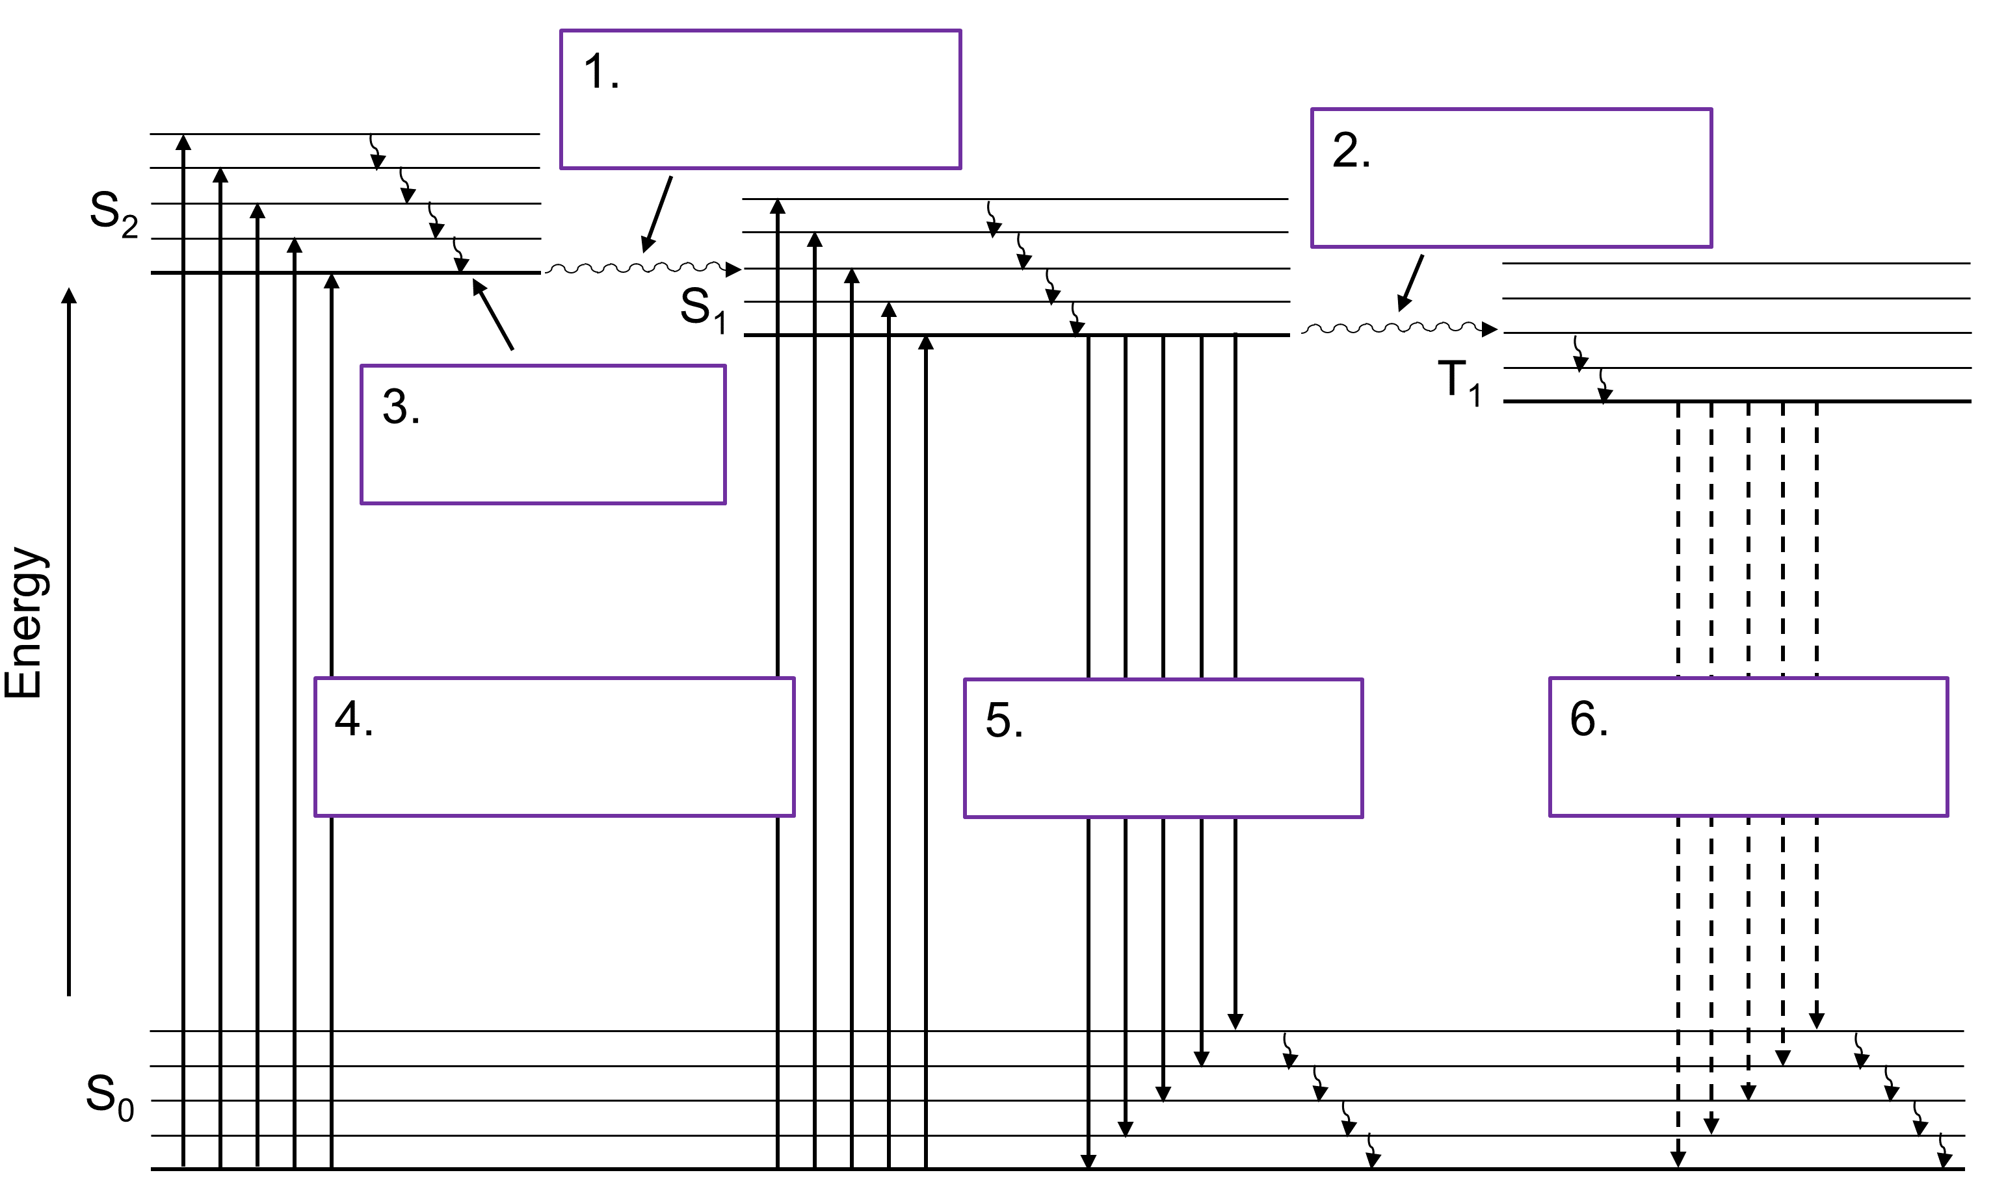
Figure 1. Jablonski diagram to be labeled with the physical processes from Table 1.

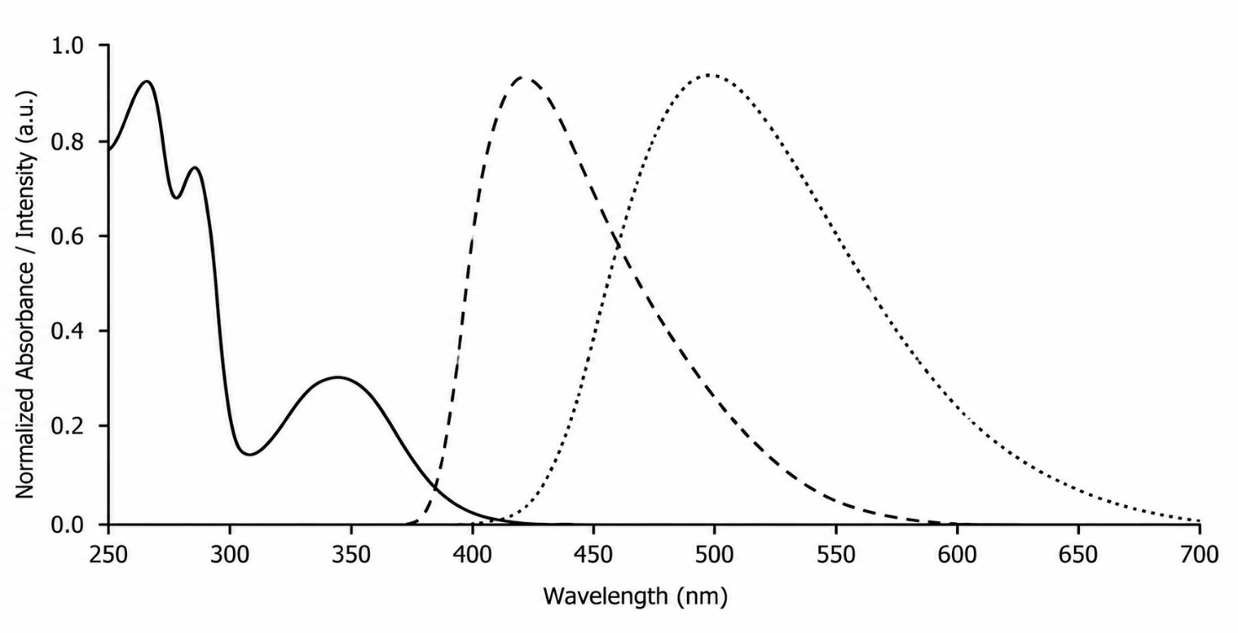
Figure 2. Representative absorbance, fluorescence emission, and phosphorescence emission spectra as a function of wavelength. Image created with ChatGPT (OpenAI).

- Consider Figure 2, representing spectra for absorbance, fluorescence, and phosphorescence and Figure 1, representing the energy transitions needed for different physical processes represented in a Jablonski diagram. What do you notice about the wavelengths of light from the three spectra associated with absorbance, fluorescence, and phosphorescence in Figure 2? How do these wavelengths correspond to the associated Jablonski diagram (Figure 1)?

- The peaks on the spectra are 10s of nm wide. Consider the Jablonski diagrams in this activity. Why do these spectral peaks spread out over several 10s of nanometers?

Active Learning Worksheets for Analytical Chemistry

#17 Spectroscopic Methods: Spectrophotometer Components and Comparisons

Before You Begin
- Read 10.1: Overview of Spectroscopy
- Read 10.2: Spectroscopy Based on Absorption
- Read 10.3: UV/Vis and IR Spectroscopy

What You Should Already Know
- General structure of electromagnetic radiation
- Relationship between absorbance and transmittance
- Concept of a blank in spectroscopic measurements

What You’ll Learn
- Identify and describe the components of a single- and double-beam spectrophotometer.
- Distinguish between continuum and line light sources.
- Explain the trade-offs involved with monochromator slit width selection.
- Compare photodiode arrays and photomultiplier tubes as detectors.
- Evaluate and compare instrument specifications based on real-world needs.

What You’ll Practice
- Interpret technical diagrams of instruments and identify components.
- Analyze how changes in experimental parameters affect measurement outcomes.
- Justify instrument choices based on cost, precision, and application.
- Synthesize data from specification tables to support analytical decisions.

Estimated Completion Time: 60-75 minutes

Author: Rebecca L. Sanders
Active Learning Worksheets for Analytical Chemistry, Version 1.0, 2026

Part I: Basic Instrument Flow Path
Figures 1 and 2 highlight the typical flow path of light in spectrophotometers, starting from the light source, and then to the monochromator, sample, detector, and display. This worksheet will work through the components of typical spectrophotometers.
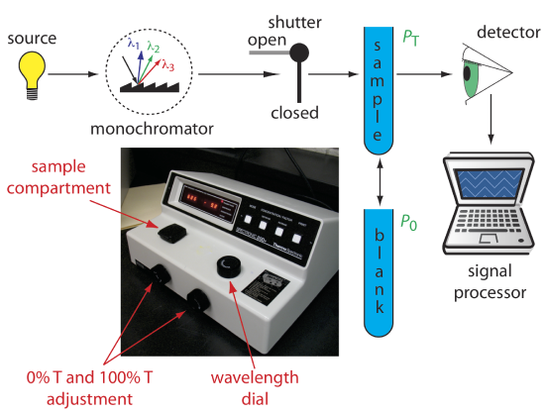
Figure 1. Schematic diagram of a fixed-wavelength, single-beam spectrophotometer. The photographic inset shows a typical instrument. The shutter remains closed until the sample or blank is placed in the sample compartment. The analyst manually selects the wavelength by adjusting the wavelength dial. From Figure 10.3.2 in David Harvey, Analytical Chemistry 2.1, licensed under CC BY-NC-SA 4.0.

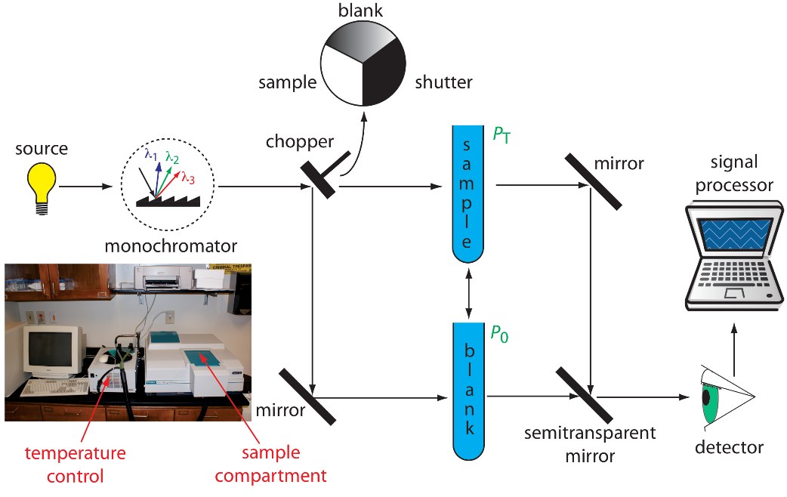
Figure 2. Schematic diagram of a scanning, double-beam spectrophotometer. A chopper directs the source’s radiation, using a transparent window to pass radiation to the sample and a mirror to reflect radiation to the blank. The chopper’s opaque surface serves as a shutter, which allows for a constant adjustment of the spectrophotometer’s 0%T. The photographic insert shows a typical instrument. The module in the middle of the photo is a temperature control unit that makes it possible to heat or cool the sample to a constant temperature. From Figure 10.3.3 in David Harvey, Analytical Chemistry 2.1, licensed under CC BY-NC-SA 4.0.

Part II: Light Sources
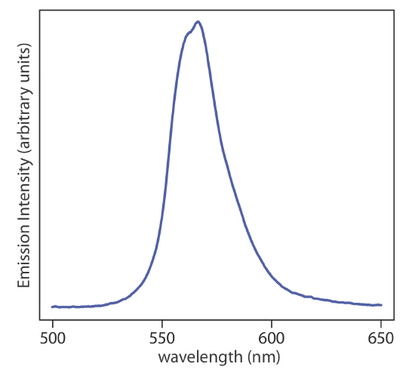
Figure 3. Spectrum showing the emission from a green LED, which provides continuous emission over a wavelength range of approximately 530–640 nm. From Figure 10.1.7 in David Harvey, Analytical Chemistry 2.1, licensed under CC BY-NC-SA 4.0.
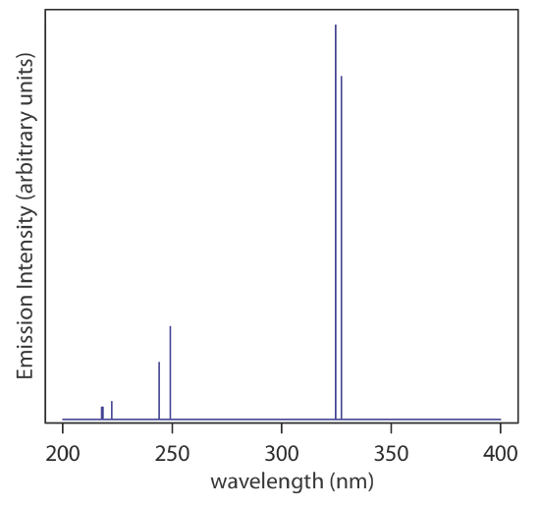
Figure 4. Emission spectrum from a Cu hollow cathode lamp. This spectrum consists of several distinct emission lines. Each emission line has a width of approximately 0.01 nm at one half of its maximum intensity. From Figure 10.1.8 in David Harvey, Analytical Chemistry 2.1, licensed under CC BY-NC-SA 4.0.

- Consider the spectra for two possible line sources used for different spectroscopic techniques (Figures 3 and 4). One is classified as a line source and the other is classified as a continuum source. Identify which figure represents which type of light source. Explain.

- There are many possible light sources. A few are summarized in the list on the next page. A visible spectrophotometer contains a tungsten lamp, which is a continuum light source. Why is it important for a visible spectrophotometer to contain a continuum light source?

- Why are both a tungsten halogen and a deuterium lamp included in a UV-Vis spectrophotometer, which is used for measurements in the wavelength range from 190-1100 nm?

Common Sources of Electromagnetic Radiation
Adapted from Table 10.1.3 in David Harvey, Analytical Chemistry 2.1, licensed under CC BY-NC-SA 4.0.
- $D_{2}$ lamp
  - Type: Continuum
  - Wavelength Range: 160–380 nm
  - Useful for: Molecular absorption
- Tungsten lamp
  - Type: Continuum
  - Wavelength Range: 320–2400 nm
  - Useful for: Molecular absorption
- Hollow cathode lamp
  - Type: Line
  - Wavelength Range: UV/Vis
  - Useful for: Atomic absorption
- Green LED
  - Type: Continuum
  - Wavelength Range: Visible
  - Useful for: Molecular fluorescence
- Laser
  - Type: Line
  - Wavelength Range: UV/Vis/IR
  - Useful for: Atomic and molecular absorption, fluorescence, and scattering

- A student wants to measure absorbance at 210 nm with a visible spectrophotometer, which typically only contains a tungsten lamp. Will their experiment work? Explain.

- Why doesn’t all of the light from the source reach the sample in Figure 1? Where does it go?

Part III: Selecting Wavelengths with a Monochromator

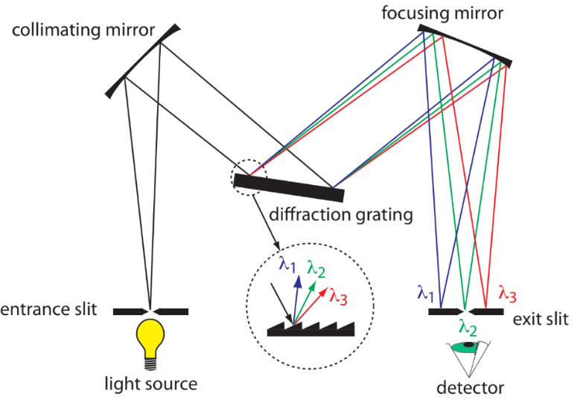
Figure 5. Schematic diagram of a monochromator that uses a diffraction grating to disperse the radiation. From Figure 10.1.12 in David Harvey, Analytical Chemistry 2.1, licensed under CC BY-NC-SA 4.0.

- Explain the purpose of each component of the monochromator.
  - Entrance slit

  - Collimating mirror

  - Diffraction grating

  - Focusing mirror

  - Exit slit
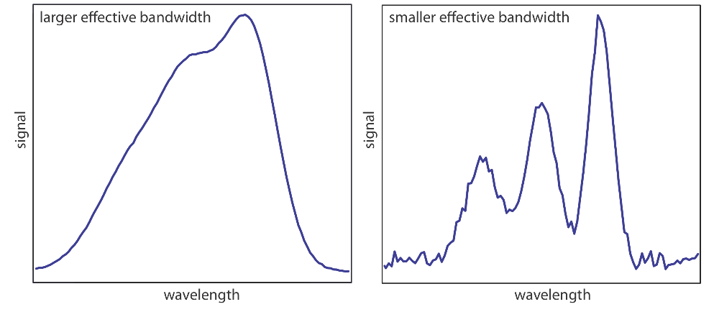
Figure 6. Example showing the effect of the wavelength selector’s effective bandwidth on resolution and noise. The spectrum with the smaller effective bandwidth is on the right and the spectrum with the larger effective bandwidth is on the left. From Figure 10.1.11 in David Harvey, Analytical Chemistry 2.1, licensed under CC BY-NC-SA 4.0.
- Slit widths associated with the monochromator have a direct impact on the spectra produced by the spectrophotometer. For example, examine the figure below and answer the following questions. The larger slit width is shown on the left and the smaller slit width is shown on the right.
  - Which slit width gives better resolution?

  - Which slit width allows more light to reach the detector?

  - Which slit width results in a noisier spectrum?

  - Summarize the trade-off between slit width size and resolution.

- In what scenarios would you prioritize intensity over resolution?

Part IV: Sample Considerations
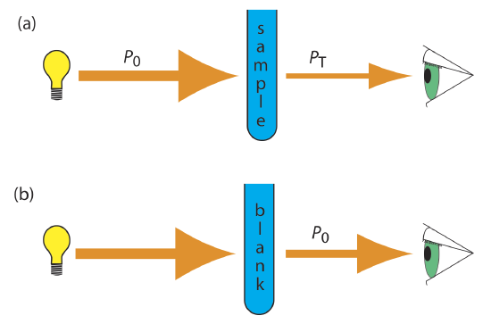
Figure 7. (a) Schematic diagram showing the attenuation of radiation passing through a sample; $P_{0}$ is the source’s radiant power and $P_{T}$ is the radiant power transmitted by the sample. (b) Schematic diagram showing how we redefine $P_{0}$ as the radiant power transmitted by the blank. From Figure 10.2.7 in David Harvey, Analytical Chemistry 2.1, licensed under CC BY-NC-SA 4.0.
- In the figure above, $P_{0}$ is the source’s radiant power and $P_{T}$ is the radiant power transmitted by the sample (a). However, in Figure 7b, $P_{0}$ as the radiant power transmitted by the blank.
  - Why is $P_{0}$ redefined as the radiant power transmitted by the blank rather than the source?

  - Does a spectrophotometer measure photons that are absorbed by the sample or transmitted through the sample?

  - Dante is conducting an experiment to measure the amount of iron in tap water using a colorimetric assay. To conduct this experiment, ${Fe}^{3+}$ standards are prepared by adding variable volumes of an iron stock solution to a volumetric flask and then adding fixed volumes of citrate to pH adjust the solution, hydroquinone to reduce ${Fe}^{3+}$ to ${Fe}^{2+}$, and o-phenanthroline to complex the ${Fe}^{2+}$. The volumetric flasks are filled to the mark with DI water. What would be an appropriate blank for this experiment?

  - Dante’s solutions have a reddish orange color. What wavelength of light would be best to measure absorbance of those solutions? Hint: Use the visible spectrum of light shown to the right to answer the question.
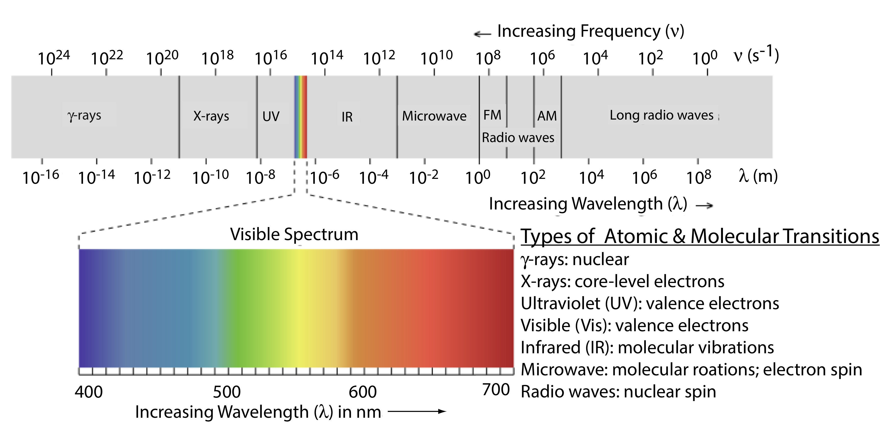
Figure 8. The visible spectrum of light. Adapted from Figure 10.1.3 in David Harvey, Analytical Chemistry 2.1, licensed under CC BY-NC-SA 4.0.

- Consider the path of light in a typical spectrophotometer. For each scenario, explain if the amount of light reaching the detector would increase, decrease, or stay the same.
- Increasing the sample’s concentration

- Using a longer path length cuvette

- Using a light source with lower intensity

- Using a scratched cuvette

Part V: Detectors
There are a few different detectors present in a spectrophotometer including a photomultiplier tube (PMT, Figure 9) and a photodiode array (PDA, Figure 10).

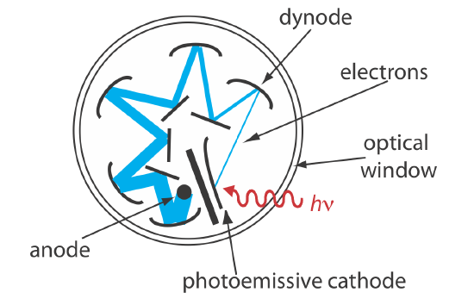
Figure 9. Schematic of a photomultiplier. A photon strikes the photoemissive cathode producing electrons, which accelerate toward a positively charged dynode. Collision of these electrons with the dynode generates additional electrons, which accelerate toward the next dynode. A total of ${10}^{6}$–${10}^{7}$ electrons per photon eventually reach the anode, generating an electrical current. From Figure 10.1.14 in David Harvey, Analytical Chemistry 2.1, licensed under CC BY-NC-SA 4.0.
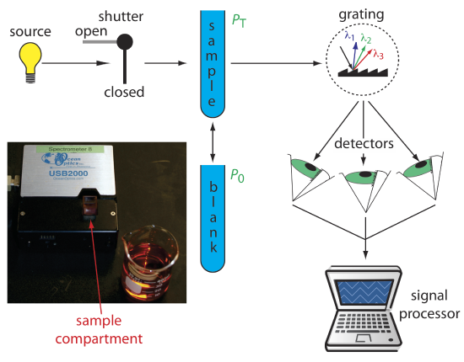
Figure 10. Schematic diagram of a diode array spectrophotometer. The photographic insert shows a typical instrument. Because the spectrometer is small and compact, it is easy to transport into the field. From Figure 10.3.4 in David Harvey, Analytical Chemistry 2.1, licensed under CC BY-NC-SA 4.0.

- A PMT converts photons into electrons and uses a cascade of dynodes to amplify the signal dramatically (×${10}^{6}$–${10}^{7}$ gain) before reaching the detector anode. Explain how the design of a PMT enables detection of extremely weak light signals.

- A PDA consists of a linear array of several hundred to a few thousand individual silicon photodiodes placed along the focal plane of a monochromator. What is the primary advantage of using a PDA over a single-element detector like a PMT in absorbance spectroscopy?

- Although PDAs are less sensitive than PMTs, they offer improved usability in modern spectrometers. List two benefits of PDAs related to speed and mechanical reliability.

Part VI: Comparing Spectrophotometers
Below lists the specifications for three different spectrophotometers: a simple visible-only spectrophotometer, an entry-level UV-vis spectrophotometer, and a more sophisticated UV-vis spectrophotometer. Use these lists to compare and contrast the different instruments:

V-1200 Visible-Only Spectrophotometer
- Light Source: Tungsten
- Wavelength Range: 325–1000 nm
- Beam Type: Single
- Accuracy: ±2 nm
- Reproducibility: ±0.8 nm
- Slit Width: 4 nm
- Detector: Silicon photodiode
- Cost: Low

UV-2650UV-Vis Spectrophotometer
- Light Source: Tungsten + $D_{2}$
- Wavelength Range: 190–1100 nm
- Beam Type: Single
- Accuracy: ±0.5 nm
- Reproducibility: ±0.2 nm
- Slit Width: 2 nm
- Detector: Silicon photodiode
- Cost: Medium

Cary 3500 UV-Vis Spectrophotometer
- Light Source: Xenon flash lamp
- Wavelength Range: 190–1100 nm
- Beam Type: Double
- Accuracy: ±0.2 nm
- Reproducibility: <0.025 nm
- Slit Width: 0.1–5.0 nm (adjustable)
- Detector: Silicon photodiode
- Cost: High

- Based on the specifications of three spectrometers listed above, two of the spectrophotometers are single beam and one is a double beam spectrophotometer. Using Figures 1 and 2, explain what the difference is between the two types of spectrophotometers.

- Which instrument is least expensive? Suggest why.

- Which instrument is most expensive? Suggest why.

- Which instrument would you recommend for quantitative trace analysis? Why?

- In which real-world scenarios would it make more sense to use the cheaper visible-only spectrophotometer instead of the Cary 3500? Provide two examples and justify your choices in terms of cost, speed, sensitivity, and ease of use.

Active Learning Worksheets for Analytical Chemistry #18

#18 Spectroscopic Methods: Beer's Law, Mixtures, and Deviations

Before You Begin
- Read 10.1: Overview of Spectroscopy
- Read 10.2: Spectroscopy Based on Absorption
- Read 10.3: UV/Vis and IR Spectroscopy

What You Should Already Know
- Beer’s Law and its derivation
- Concept of molar absorptivity and $λ_{max}$
- Linear regression and use of calibration curves
- Basic algebra for solving simultaneous equations

What You’ll Learn
- Define and interpret the variables in Beer’s Law.
- Identify and explain deviations from linearity.
- Use absorbance data at multiple wavelengths to determine concentrations in a mixture.
- Select appropriate cuvette material based on wavelength requirements.

What You’ll Practice
- Solve systems of equations derived from Beer's Law for multicomponent analysis.
- Analyze and troubleshoot real-world deviations from expected spectroscopic behavior.
- Interpret graphical representations of data (e.g., absorbance vs. concentration).
- Make evidence-based recommendations for experimental design (e.g., cuvette selection).

Estimated Completion Time: 45-60 minutes

Author: Rebecca L. Sanders
Active Learning Worksheets for Analytical Chemistry, Version 1.0, 2026

Useful Equations and Conversion Factors
- $A= εbc= -log⁡(T)$

Part I: Beer's Law Refresher and Limitations

- Define the terms in the equation $A=εbc$ and describe how each impacts absorbance.

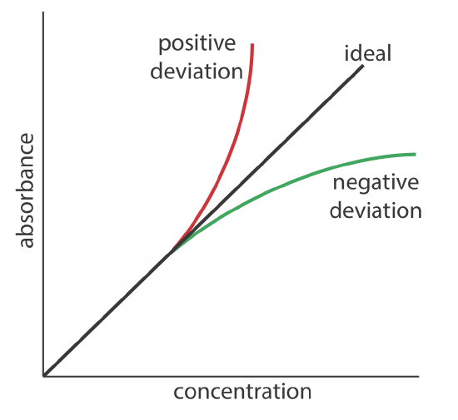
Figure 1. Plots of absorbance vs. concentration showing positive and negative deviations from the ideal Beer’s law relationship, which is a straight line. From Figure 10.2.9 in David Harvey, Analytical Chemistry 2.1, licensed under CC BY-NC-SA 4.0.
- There are several reasons why a Beer’s law might deviate from linearity (Figure 1). In which of the following cases is Beer's Law likely to fail?
- Highly concentrated solutions
- Polychromatic light
- Reaction between solutes
- Stray light reaches the detector
- Temperature changes throughout the experiment
- All of the above
Explain why each causes deviation:

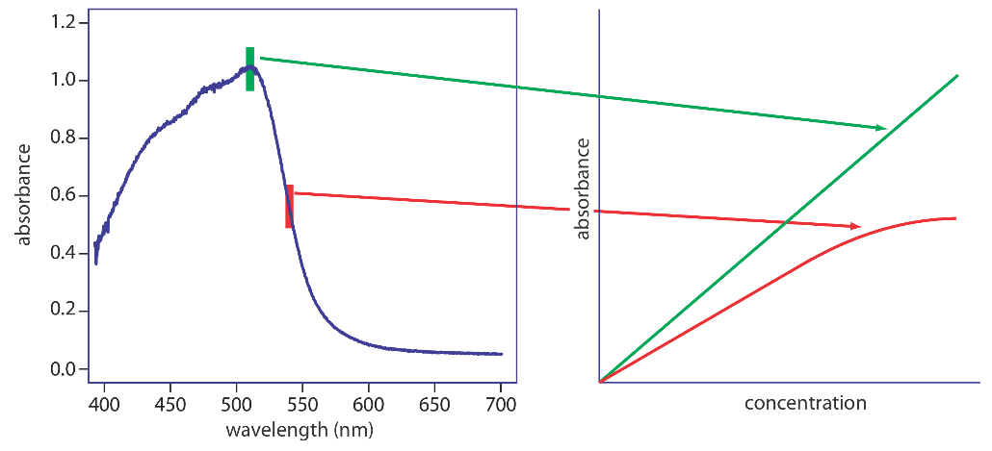
Figure 2. Effect of wavelength selection on the linearity of a Beer’s law plot. From Figure 10.2.10 in David Harvey, Analytical Chemistry 2.1, licensed under CC BY-NC-SA 4.0.

- Using Figure 2, explain why absorbance of a sample should be collected at its wavelength of maximum absorbance ($λ_{max}$).

- A student prepares five standards, and her highest concentration gives an absorbance of 2.8.
  - Calculate the percent transmittance (%T) for this standard. Based on this value, why might the detector have trouble producing a reliable reading?

  - As the designer of this experiment, do you: A) proceed with the measurement, B) dilute only the unknown, or C) redefine the concentration range of your standards? Justify your choice based on the relationship between stray light and %T.

Part II: Calculation of Components in a Mixture
- Molar absorptivities of compounds X and Y were measured with pure sample of each. The molar absorptivity constants for X were 16740 $M^{-1}{cm}^{-1}$ and 3890 $M^{-1}{cm}^{-1}$ at 230 and 273 nm, respectively. The molar absorptivity constants for Y were 3720 $M^{-1}{cm}^{-1}$ and 7420 $M^{-1}{cm}^{-1}$ at 230 and 273 nm, respectively.

  - A mixture of X and Y in a 1.000 cm cell had an absorbance of $A_{230}= 0.957$ and $A_{273}=0.559$. Find the concentrations of X and Y in the mixture.

  - The mixture measured in part a was a 1:200 dilution of an original sample. Calculate the original concentration of X and Y.

Part III: Cuvette Materials and Instrument Limitations
Cuvettes can only transmit light at certain wavelengths. Outside of those wavelengths, the cuvette absorbs too much light and cannot be used for spectroscopic measurements. Below is a list of common cuvette types and their measurement wavelength ranges:
- Glass cell (G cell): 320-2500 nm
- Quartz cell (S cell): 190-2500 nm
- Disposable polystyrene (PS) cell: 340-750 nm
- Disposable polymethylmethacrylate (PMMA) cell: 285-750 nm

- Examine the list of cuvettes.
- Which type of cuvette was likely used for the sample in Part II, which had $λ_{max}$ 230 and 273 nm? Why?

- Which cuvette(s) would be acceptable for visible measurements? Which is most likely to be used? Why?

- Your friend is conducting an experiment at 254 nm. They are making a set of standards and are confident they made their dilutions correctly, but the absorbance values they collected aren’t making sense. They are measuring transmittance using disposable PS cells. Explain what is going wrong with their experiment.
Active Learning Worksheets for Analytical Chemistry

#19 Spectroscopic Methods: Atomic Spectroscopy Part 1: Fundamentals and Flame AA Instrumentation

Before You Begin
- Read 4.7: Detection Limits
- Read 10.1: Overview of Spectroscopy
- Read 10.2: Spectroscopy Based on Absorption
- Read 10.3: UV/Vis Spectroscopy
- Read 10.4: Atomic Absorption Spectroscopy

What You Should Already Know
- Basic concepts of electromagnetic radiation and absorbance
- The difference between atomic and molecular species
- General components of a spectrophotometer (light source, sample holder, detector)
- Concepts like detection limit, linear range, and calibration

What You’ll Learn
- Differentiate between atomic and molecular absorption spectra
- Label and explain the function of key components in a flame atomic absorption spectrometer
- Compare a flame AA spectrometer with a typical UV/Vis instrument
- Describe how samples are introduced into flame AA and what sample prep may be required
- Interpret instrumental parameters (e.g., light source, slit width, wavelength selection) for Fe analysis

What You’ll Practice
- Use visual figures and schematics to interpret instrument design
- Compare experimental setups across different spectroscopic methods
- Evaluate detection limits and linear ranges based on manufacturer data
- Make evidence-based decisions about wavelength selection and sample preparation

Estimated Completion Time: 60-70 minutes

Author: Rebecca L. Sanders
Active Learning Worksheets for Analytical Chemistry, Version 1.0, 2026

Atomic Spectroscopy Compared to Molecular Spectroscopy
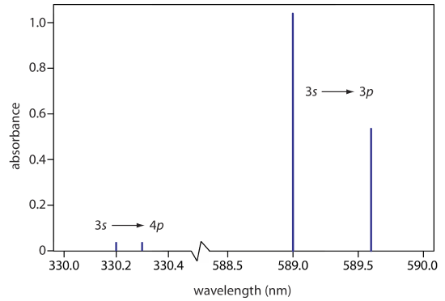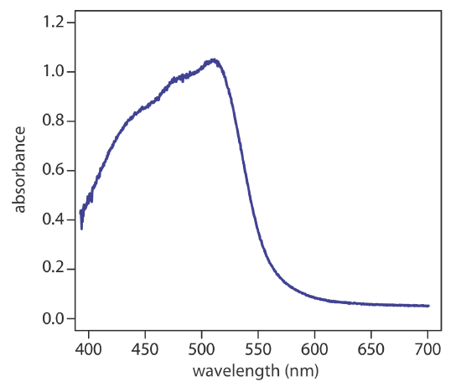
Figure 2. UV/Vis spectrum for the metal-ligand complex ${Fe{\left(phen\right)}_{3}}^{2+}$, where phen is the ligand o-phenanthroline. From Figure 10.2.4 in David Harvey, Analytical Chemistry 2.1, licensed under CC BY-NC-SA 4.0.
Figure 1. Atomic absorption spectrum for sodium. Note that the scale on the x-axis includes a break. From Figure 10.2.6 in David Harvey, Analytical Chemistry 2.1, licensed under CC BY-NC-SA 4.0.
- The figures above represent an atomic spectrum of sodium (left) and a molecular spectrum of the metal–ligand complex ${Fe{\left(phen\right)}_{3}}^{2+}$ (right). Fill out the table below to compare and contrast these spectra.

 | Atomic Spectrum | Molecular Spectrum
Graph’s y-axis
Graph’s x-axis
Types of light (UV, Vis, IR, etc)?
Width of absorbance peaks

- Why is there a difference in peak widths between atomic spectra and molecular spectra?

Figure 3. Flame atomic absorption spectrometer schematic. Adapted in part from Figure 10.3.2 in David Harvey, Analytical Chemistry 2.1, licensed under CC BY-NC-SA 4.0. Additional components and labels were added for this worksheet.

- Label the five numbered components on the flame AA spectrometer schematic above.

Figure 4. Schematic diagram of a fixed-wavelength, single-beam spectrophotometer. From Figure 10.3.2 in David Harvey, Analytical Chemistry 2.1, licensed under CC BY-NC-SA 4.0.

- Consider the schematic for a flame AA compared to the schematic for a UV/Vis spectrophotometer.
What’s similar? What’s different?

- How are samples introduced into these instruments?

Sample Considerations and Experimental Parameters for Atomic Spectroscopy
- What types of sample preparation steps are generally required for atomic spectroscopy techniques such as flame AA or ICP-AES?

Lucia wants to determine the amount of iron in tap water using flame atomic absorption spectroscopy. In her lab, she has access to an Agilent Technologies hollow cathode lamps and a flame atomic absorption spectrometer. She uses the manual for the instrument to set up her experiment.
- The flame is listed as air-$C_{2}H_{2}$. What purpose does the air serve? What is $C_{2}H_{2}$? What is it used for and why not another chemical?

- To look at Fe in a sample with flame AA spectroscopy, what kind of light source is needed? What would the cathode be made of?

- The handbook for the instrument states there are three possible wavelengths that can be used for Fe. They are at 248.3, 372.0, and 386.0 nm, with sensitivity ratios of 15%, 100%, and 50%, respectively. Which wavelength would be the best to start with when designing the experiment? Why?

- The suggested slit width for the experiment is 0.2 nm. Is this a small or large slit width? How does slit width affect resolution and signal-to-noise ratio? Why might that slit width be suggested for a flame AA spectroscopy experiment?

- For the experiment, $D_{2}$ background correction is suggested. Why is a $D_{2}$ lamp used for background correction?

- An AA handbook suggested a calibration curve including 0, 0.5, 1.0, 1.5, and 2 ppm Fe standards. The linear range of concentrations is fairly small (0-2 ppm). Why is this a challenge for flame AA experiments?

- Lucia wants to make a calibration curve using 0, 0.5, 1.0, 1.5, and 2 ppm Fe standards. The manual suggests starting with a 1000. mg Fe/L standard that can be prepared by measuring 1.000 g of pure iron (99.9%). Then, it is heated and dissolved with 20 mL of aqua regia, which is a 1:3 molar ratio of nitric acid to hydrochloric acid. Once cooled, the solution is diluted to 1.000 L accurately. Using the 1000. ppm Fe stock solution, propose how Lucia could make a set of standards for her experiment. Each standard, including the blank, should be prepared with the same acid concentration/matrix as the samples when possible.

Lucia prepared the tap water sample by diluting 1.00 mL of original sample with some DI water. Then, she added 1.00 mL concentrated nitric acid and filled to the line in a 100.0 mL volumetric flask with DI water. The diluted tap water’s absorbance was measured, resulting in diluted concentration measured as 0.08 ppm Fe.
- The handbook listed the limit of detection (LOD) of Fe as 0.06 ppm and the limit of quantification (LOQ) for Fe as 0.2 ppm. LOD and LOQ are determined as the standard deviation of the absorbance of several blank solution measurements times three or ten, respectively (e.g., LOD = 3σ and LOQ = 10σ). Lucia measured a diluted sample of tap water and calculated the diluted sample contained 0.08 ppm Fe. Is that measurement accurate? Why or why not?

- Since she only measured a concentration of 0.08 ppm Fe from this dilution, propose another way she could prepare the tap water sample to give a more accurate reading?

Active Learning Worksheets for Analytical Chemistry

#20 Spectroscopic Methods: Atomic Spectroscopy Part 2: Interferences, Calibration, and Sensitivity

Before You Begin
- Read 5.2: Calibrating the Signal
- Read 5.3: Determining the Sensitivity
- Read 5.4: Linear Regression and Calibration Curves
- Read 10.4: Atomic Absorption Spectroscopy
- Read 10.5: Emission Spectroscopy
- Read 10.7: Atomic Emission Spectroscopy

What You Should Already Know
- The basic operating principles of atomic absorption spectroscopy
- How to use calibration data to determine unknown concentrations
- What detection limits and interferences are, conceptually

What You’ll Learn
- Identify and describe common interferences in flame AA and how to mitigate them
- Explain how and when to use the method of standard additions
- Compare flame AA, furnace AA, and ICP-AES in terms of cost, sensitivity, and throughput
- Describe how temperature affects atom populations using the Boltzmann distribution
- Calculate analyte concentrations from standard additions or calibration data

What You’ll Practice
- Analyze real or simulated calibration data to extract meaningful quantitative results
- Apply correction strategies for chemical and spectral interferences
- Justify selection of atomic spectroscopy techniques based on experimental context
- Perform multi-step calculations using logarithms, calibration equations, and statistical tools

Estimated Completion Time: 60-90 minutes

Author: Rebecca L. Sanders
Active Learning Worksheets for Analytical Chemistry, Version 1.0, 2026

Useful Equations and Conversion Factors

- $E=hν$
- $h=6.626*{10}^{-34} J·s$
- $c=λν=2.998*{10}^{8} m/s$
- $\frac{S_{samp}}{C_{A}\frac{V_{o}}{V_{f}}}= \frac{S_{spike}}{C_{A}\frac{V_{o}}{V_{f}} + C_{std}\frac{V_{std}}{V_{f}}}$
- $\frac{N^{*}}{N}=\left(\frac{g^{*}}{g_{0}}\right)e^{-E_{i}/kT}$
- $k=1.381*{10}^{-23} J/K$

Interferences
A flame AA handbook gives information about each element that can be analyzed. For each remark, explain the type of interference and the purpose behind the suggested fix.
- Cesium: Addition of ~0.1-0.5% Na, K or Rb as ionization suppressant is recommended.

- Magnesium: Addition of ~0.1-0.5% $La{Cl}_{3}$ or $Sr{Cl}_{2}$ would prevent chemical interference by Al or Si or phosphoric acid.

- Zinc: Coexistence of several thousand ppm Fe would give spectral interference.

Method of Standard Addition
- What is the method of standard addition and why is it necessary?

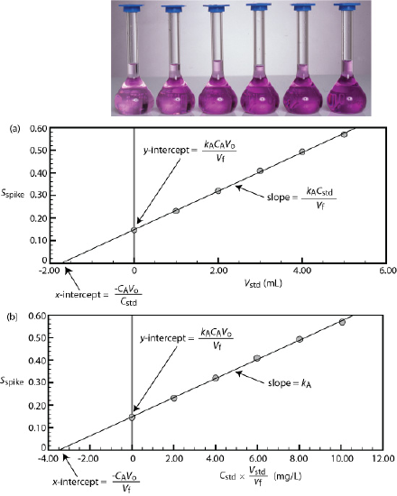
Figure 1. Shown at the top of the figure is a set of six standard additions for the determination of ${Mn}^{2+}$. The absorbance for each standard addition, S_{spike}, is shown by the filled circles. From Figure 5.3.6 in David Harvey, Analytical Chemistry 2.1, licensed under CC BY-NC-SA 4.0.

- Figure 1 shows a standard addition calibration curve for the quantitative analysis of ${Mn}^{2+}$. Each solution contains 5.00 mL of the original sample and either 0, 1.00, 2.00, 3.00, 4.00, or 5.00 mL of a 50.0 ${mg}/L$ external standard of ${Mn}^{2+}$. All standard addition samples were diluted to 25.0 mL with water before reading the absorbance. The equation for the calibration curve is $y=0.0425x+0.1478$. What is the concentration of ${Mn}^{2+}$ in this sample? Problem adapted from Exercise 5.3.3 in David Harvey, Analytical Chemistry 2.1, Section 5.3, licensed under CC BY-NC-SA 4.0.

- A spectrophotometric method for the quantitative analysis of ${Pb}^{2+}$ in blood yields an $S_{samp}$ of 0.136 when a 1.00 mL sample of blood is diluted to 10.00 mL. A second 1.00 mL sample of blood is spiked with 0.500 mL of a 250.0 ppb ${Pb}^{2+}$ external standard and diluted to 10.00 mL, yielding an $S_{spike}$ of 0.320. What is the concentration of ${Pb}^{2+}$ in the original sample of blood?
Hint: Use $\frac{S_{samp}}{C_{A}\frac{V_{o}}{V_{f}}}= \frac{S_{spike}}{C_{A}\frac{V_{o}}{V_{f}} + C_{std}\frac{V_{std}}{V_{f}}}$

Comparing Different Atomic Spectroscopy Techniques
Table 1. Features of flame and furnace atomic absorption (AA) spectroscopy and inductively coupled plasma atomic emission spectroscopy (ICP-AES).
Feature | Flame AA | Furnace AA | ICP-AES
Scale of Operation | Trace to major analytes; macro/meso samples; microsampling possible | Trace to ultratrace; very small sample volumes (micro/ultramicro) | Trace to ultratrace analytes; macro/meso samples
Accuracy | 0.5–5% if interferences are minimized | Typically worse than flame AA due to stronger matrix effects | 1–5% if interferences are minimal; stray radiation from overlapping lines can reduce accuracy
Precision (RSD) | 0.3–1% for absorbance > 0.1–0.2 | 1–5%; affected by sample injection consistency | 1–5%; affected by plasma/flame temperature stability; improved with internal standards
Sensitivity | Moderate; depends on flame conditions and matrix | Very high; optimized by temperature and time control in drying/ashing stages | High; less matrix-dependent than AA; optimized by plasma settings
Detection Limits | Moderate (trace level) | Very low (ultratrace level detection) | Low, but not as low as furnace AA
Dynamic Range / Flexibility | Moderate range; sample often diluted | Narrow range; optimized for trace analysis | Wide range; can handle trace to major analytes with dilution
Selectivity | Excellent due to narrow absorption lines | Excellent; same as flame AA | Good, but may suffer from spectral overlap due to many emission lines
Sample Throughput | Fast (250–350 samples/hour with automation) | Slower (20–30 samples/hour) | Very high (up to 3000/hour with multichannel ICP; ~300/hour for sequential)
Instrument Cost | $10,000–$50,000 | $18,000–$70,000 | $55,000–$300,000 depending on configuration; argon gas adds to operating cost

- Which technique is the most sensitive?

- Which technique is the least expensive? Most expensive?

- Which technique can detect the smallest concentrations of analyte?

- Which technique is most appropriate for measuring analytes present at a wide range of concentrations?

- Which technique allows for the fastest sample throughput?

- Which technique can measure the most elements at once?

- The table notes that ICP-AES can suffer from overlapping emission lines. Why might ICP-AES be more prone to spectral interference than atomic absorption techniques?

Note: Another important elemental analysis technique is inductively coupled plasma mass spectrometry, or ICP-MS. ICP-MS also uses a plasma, but instead of measuring light emitted from excited atoms and ions, it uses a mass spectrometer to separate ions by mass-to-charge ratio. ICP-MS is especially useful for measuring trace or ultratrace elements at very low concentrations, but it is typically more expensive and more complex than the atomic spectroscopy methods discussed here.

Effects of Temperature on Atomic Spectroscopy
Temperature determines how much of a sample breaks down and how much of the atom is found in the ground, excited, or ionized states. If you consider two states $E_{0}$ and three at $E^{*}$, the number of states at each energy is called degeneracy ($g_{0}$ and $g^{*}$ in this case). They are separated by $E_{i}$, the energy of the excited state relative to the ground sate energy, E₀. The Boltzmann distribution describes the relative populations of different states at thermal equilibrium is defined as: $\frac{N^{*}}{N}=(\frac{g^{*}}{g_{0}})e^{-E_{i}/kT}$
where $\frac{N^{*}}{N}$ is the relative population at any two states, T is temperature in K, k is the Boltzmann constant ($1.381*{10}^{-23} J/K$), and e is base of the natural log (2.718…).

- Consider an element that reaches its first excited state by absorption of 310.8 nm light.
- Determine the energy difference (J/atom) between the ground state and the first excited state.

- If the degeneracies of the two states for the element are $\frac{g^{*}}{g_{0}}=2$, determine $\frac{N^{*}}{N}$ at 2010 K.

- By what percentage does $\frac{N^{*}}{N}$ change if the temperature is raised by 50 K?

- Based on the $\frac{N^{*}}{N}$ values you calculated, are more atoms in the ground state or the excited state?

- The excited-state population increased by about 75% when the temperature increased by 50 K. Explain if this a large change in overall population distribution between the ground and excited states or not.

- How does this population distribution affect the signals measured in atomic absorption, atomic emission, and ICP-MS?
Active Learning Worksheets for Analytical Chemistry

#21 External Calibration, Standard Addition, and Uncertainty Calculations in Standard Curves

Before You Begin
- Read 5.4: Linear Regression and Calibration Curves

What You Should Already Know
- Explain the purpose of a calibration curve in quantitative analysis
- Distinguish between external calibration and standard addition
- Interpret a linear relationship in the context of analytical data
- Perform dilution calculations and apply dilution factors
- Calculate averages and recognize sources of experimental variability
- Use Excel to create plots and perform basic data analysis

What You’ll Learn
- Construct calibration curves using linear regression
- Use LINEST to obtain slope, intercept, and uncertainties
- Determine the concentration of an unknown using both calibration methods
- Calculate the uncertainty in concentration from a calibration curve
- Explain how matrix effects influence analytical results
- Compare the accuracy and precision of external calibration and standard addition

What You’ll Practice
- Use Excel to perform least-squares regression
- Analyze replicate measurements to obtain mean values
- Carry uncertainty through multi-step calculations
- Clearly organize and present calculations and results
- Interpret data and justify conclusions using chemical reasoning

Estimated Completion Time: 50-75 minutes

Author: Rebecca L. Sanders
Active Learning Worksheets for Analytical Chemistry, Version 1.0, 2026

Background

You are analyzing ${Pb}^{2+}$ in a drinking water sample collected from an older home. The sample may contain high levels of ${Ca}^{2+}$/${Mg}^{2+}$ (hardness), dissolved solids, and trace organics. These components can alter the analytical signal in flame atomic absorption (AA), leading to matrix effects. Two calibration approaches are used: external calibration (standards in DI water) and standard addition (standards added directly to the sample). Your goal is to determine the ${Pb}^{2+}$ concentration using both methods and evaluate which result is more reliable. You can use Microsoft Excel to analyze this data. A template Excel file has been provided with a file name of 21_LINEST_uncertainty_template.xlsx.

Part I. External Calibration

A set of ${Pb}^{2+}$ standards was prepared and then 10.00 mL aliquots of original water sample were diluted to 20.00 mL. Absorbance data is listed below.

 | ${Pb}^{2+}$ (ppb) | Absorbance
Standards | 0.0 | 0.001
Standards | 5.0 | 0.113
Standards | 10.0 | 0.222
Standards | 15.0 | 0.334
Standards | 20.0 | 0.454
Unknowns | 1:2 dilution of unknown 1 | 0.287
Unknowns | 1:2 dilution of unknown 2 | 0.294
Unknowns | 1:2 dilution of unknown 3 | 0.290

- Plot the standard curve of absorbance as a function of concentration.
- Using Excel, use the LINEST function to perform a linear regression of absorbance vs. concentration. Report:
- slope (m)
- intercept (b)
- standard deviation about the regression ($s_{y}$)
- calculate the mean absorbance of the diluted unknown samples

- Determine the concentration of ${Pb}^{2+}$ in the diluted unknown. Then use the following equation to find the uncertainty in the diluted concentration.
$$s_{x}= \frac{s_{y}}{|m|}\sqrt{\frac{1}{k}+\frac{1}{n}+\frac{{\left(y-\overline{y}\right)}^{2}}{m^{2}\sum_{i=1}^{n}{{\left(x_{i}-\overline{x}\right)}^{2}}}}$$
- $s_{y}$ = the standard deviation of y
- m = absolute value of the slope of the least-squares line
- K = number of replicates
- n = number of data points
- y = average unknown y measurement
- $\overline{y}$ = the mean value of y for the standards
- $x_{i}$ = the individual values of x for the standards
- $\overline{x}$ = the mean value of x for the standards

- Now determine the original concentration of ${Pb}^{2+}$ and its uncertainty in ppb.

Part II. Standard Addition

A second set of ${Pb}^{2+}$ standards was prepared using the method of standard addition with each containing 10.00 mL aliquots of original water sample. All samples were diluted to 20.00 mL. Absorbance data is listed below.

 | Added ${Pb}^{2+}$ (ppb) | Absorbance
Standards | 0.0 | 0.210
Standards | 5.0 | 0.300
Standards | 10.0 | 0.388
Standards | 15.0 | 0.475
Standards | 20.0 | 0.558

- Plot the standard curve of absorbance as a function of added concentration.
- Using Excel, use the LINEST function to perform a linear regression of absorbance vs. concentration. Report:
- slope (m)
- intercept (b)
- standard deviation about the regression ($s_{y}$)

- Determine the concentration of ${Pb}^{2+}$ in the diluted unknown. Then use the following equation to find the uncertainty in the diluted concentration.

$$s_{x}= \frac{s_{y}}{|m|}\sqrt{\frac{1}{n}+\frac{{\overline{y}}^{2}}{m^{2}\sum_{i=1}^{n}{{\left(x_{i}-\overline{x}\right)}^{2}}}}$$
- $s_{y}$ = the standard deviation of y
- m = slope of the least-squares line
- n = number of data points
- $\overline{y}$ = the mean value of y for the samples run
- $x_{i}$ = the individual values of x for the samples run
- $\overline{x}$ = the mean value of x for the samples run

- Now determine the original concentration of ${Pb}^{2+}$ and its uncertainty in ppb.

Part III. Comparison and Interpretation

- Compare your results:

External Calibration: __________________________

Standard Addition: ____________________________

Which method gives a higher concentration?

- Compare uncertainties: Which method has the smaller uncertainty? Why?

- Matrix Effects: Compare the slopes from Parts I and II. Are they the same or different? What does this indicate about matrix effects in this sample?

- Accuracy vs. Precision: Which method is more precise? Which method is more accurate for this sample? Why?

Part IV. Evaluating Accuracy

A second water sample from the same home is analyzed. The true ${Pb}^{2+}$ concentration (determined by ICP-MS) is 24.4 ppb. ICP-MS is often used as a highly sensitive reference technique for trace elemental analysis.

- Calculate percent error for each method. Which method produced a value closer to the true concentration?

- If you were analyzing a new unknown sample from this same source, which method would you choose? Provide a justification that includes matrix effects, uncertainty, and accuracy.

- Final Reflection. Support or refute this statement: External calibration is more precise because it uses cleaner standards and fewer experimental steps, which minimizes random error, but it can be less accurate if the sample matrix affects the signal.

Active Learning Worksheets for Analytical Chemistry

#22 Electrochemical Methods: Electrochemistry Basics

Before You Begin
- Review balancing redox reactions in acid and base, cell diagrams and line notation, and Nernst equation and Faraday’s laws: 17.1 Review of Redox Chemistry, 17.2 Galvanic Cells, 17.3 Electrode and Cell Potentials, 17.4 Potential, Free Energy, and Equilibrium

What You Should Already Know
- Assign oxidation states to atoms in compounds
- Balance simple redox reactions
- Use logarithms and basic algebra
- Understand the role of electrons in redox reactions

What You’ll Learn
- Identify oxidation and reduction components of a redox reaction
- Balance redox reactions in both acidic and basic media
- Use standard reduction potentials to determine spontaneity
- Write line notation for galvanic cells
- Calculate Gibbs free energy and equilibrium constants from electrochemical data
- Use Faraday’s Law to calculate plating mass and efficiency

What You’ll Practice
- Setting up and balancing redox half-reactions
- Interpreting and constructing line notation
- Applying thermodynamic and electrochemical equations
- Sketching and annotating electrochemical cells
- Analyzing data from electroplating experiments

Estimated Completion Time: 60-80 minutes

Author: Rebecca L. Sanders, Active Learning Worksheets for Analytical Chemistry, Version 1.0, 2026

Select Standard Reaction Potentials from Appendix 16.13: Standard Reduction Potentials.
- ${BrO_{3}}^{-}(aq) + 6H^{+}(aq) + 6 e^{-} {Br}^{-}(aq) + 3H_{2}O(l)$ 1.478 V
- ${{Cr}_{2}O_{7}}^{2-}(aq) + 14H^{+}(aq) + 6 e^{-} 2{Cr}^{3+}(aq) + 7H_{2}O(l)$ 1.36 V
- $I_{2}(s) + 2e^{-} + 2I^{-}(aq)$ 0.5355 V
- ${Cu}^{2+}(aq) + 2e^{-} Cu(s)$ 0.3419 V

Useful Equations
- $E_{cell}^{°} = \frac{RT}{nF}\ln{K}$
- At 25 ºC, $E_{cell}=E_{cell}^{°}-\frac{0.0592}{n}\log{Q}$
- At 25 ºC, $E_{cell}^{°}=\frac{0.0592}{n}\log{K}$
- $E_{cell}^{°}= E_{cathode}^{°}- E_{anode}^{°}$
- $R = 8.314 \frac{J}{mol·K}$
- $F = 96,485 \frac{C}{mol e^{-}}$
- $1 A = 1 \frac{C}{s}$

Part 1: Balancing Redox Reactions and Identifying Oxidation–Reduction Processes
- Determine the oxidation state of each element in the following reaction and then balance it in a base. What is being oxidized? Reduced? What is the oxidizing agent? Reducing agent?

$Cr(s) + {Cl}_{2}(g) {CrO}_{4}^{2-}(aq) + {Cl}^{-}(aq)$

- Determine the oxidation state of each element in the following reaction and then balance it in an acid. What is being oxidized? Reduced? What is the oxidizing agent? Reducing agent?

$${MnO}_{4}^{1-}(aq) + S^{2-}(aq) S(s) + {Mn}^{2+}(aq)$$

Part 2: Cell Notation and Electrochemical Reactions
- Write the line notation for the following reaction.

$$2 Cu(s) + O_{2}(g) + 2 H_{2}O(l) 2 {Cu}^{2+}(aq) + 4 {OH}^{-}(aq)$$

- Using the line notation below, derive a balanced redox reaction in acid. Determine $E_{cell}^{°}$ for the reaction and list if the reaction is spontaneous.

$$Pt(s) | I_{2}(s) | I^{-}(aq) || {{Cr}_{2}O_{7}}^{2-}(aq), H^{+}(aq), {Cr}^{3+}(aq) | Pt(s)$$

Part 3: Electroplating and Faraday's Law
- A current of 4.77 A is passed through a $SnSO_{4}$ solution for 2.00 hours.
  - Theoretically, how much tin is plated out of the solution? The atomic mass of Sn is 118.71 $g/{mol}$.

  - If 19.0 g of Sn was plated, what was the efficiency of plating in the experiment?

Part 4: Cell Potentials, Equilibrium, and Cell Design
- A voltaic cell is based on the reaction

$${BrO_{3}}^{1-}(aq) + 6 H^{+}(aq) + 3 Cu(s) 3 {Cu}^{2+}(aq) + {Br}^{1-}(aq) + 3 H_{2}O(l)$$

a. Calculate $E_{cell}^{°}$.

b. Calculate K for the reaction at 25 °C.

c. If $[{Cu}^{2+}]$ = 0.100 M, $[{BrO_{3}}^{1-}]$ = 0.600 M, [$H^{+}$] = 0.800 M, and [${Br}^{1-}$] = 0.0500 M, what is $E_{cell}$?

- Sketch the cell of the reaction listed above, and label the anode and cathode, the direction of electron flow in the external circuit, and the direction of flow of cations and anions through the salt bridge. Is it an electrolytic or galvanic cell?

Active Learning Worksheets for Analytical Chemistry

#23 Electrochemical Methods: Exploring Ion-Selective Electrodes

Before You Begin
- Read 11.2: Potentiometric Methods

What You Should Already Know
- The concept of electrochemical cells and how potentials are measured
- The role of reference electrodes (e.g., Ag/AgCl)
- Basic understanding of equilibrium and concentration gradients
- The relationship between ion charge, mobility, and diffusion
- General acid–base chemistry, including the definition and measurement of pH

What You’ll Learn
- Explain how junction potentials arise and how they impact electrochemical measurements
- Describe the structure and function of a pH electrode, including the role of the glass membrane
- Explain how ion-selective electrodes (ISEs) generate a measurable potential
- Interpret instrument specifications (e.g., concentration range, pH range, precision) for ISEs
- Identify and explain the impact of interfering ions on ISE measurements
- Compare different electrochemical methods (e.g., ISE vs. flame AA) for real-world analysis

What You’ll Practice
- Interpreting tables and figures to extract chemical meaning
- Applying conceptual understanding to predict electrochemical behavior
- Evaluating instrument performance and limitations
- Making evidence-based comparisons between analytical techniques
- Connecting instrument design to function and measurement outcomes

Estimated Completion Time: 55-70 minutes

Author: Rebecca L. Sanders
Active Learning Worksheets for Analytical Chemistry, Version 1.0, 2026

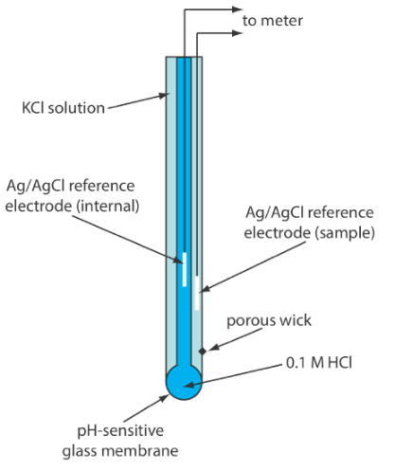
pH electrode
Figure 1. Schematic diagram showing a combination glass electrode for measuring pH. From Figure 11.2.10 in David Harvey, Analytical Chemistry 2.1, licensed under CC BY-NC-SA 4.0.

A combination pH electrode (Figure 1) contains two electrochemical cells housed within a single probe. One serves as a reference electrode with a stable potential, while the other contains a glass membrane that responds selectively to $H^{+}$. A porous wick serves as a salt bridge between the sample and its reference electrode. The meter measures the potential difference between these two electrodes and relates that potential to pH. Use Figure 1 to connect each physical part of the probe to its role in the measurement.
- What parts of this probe act as reference electrodes?

- What part responds to $H^{+}$?

- Why does the electrode contain an internal HCl solution with a fixed H+ activity?

- Why do we calibrate with buffers?

- How must the probe be stored? Why?

- The typical range a pH probe can measure is from pH 0 to 14. Why is this range sufficient for most aqueous acid–base systems?

Ion-Selective Electrodes
- A pH electrode responds selectively to $H^{+}$ because of its membrane. If you wanted to build an electrode that measured a different ion, such as chloride or calcium, which component of the electrode would most likely need to change? Explain your reasoning.

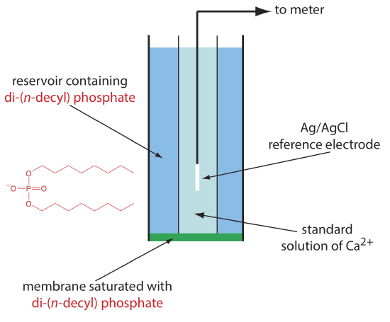
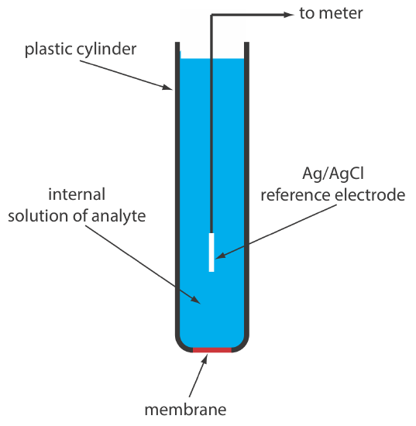Figure 2. Schematic diagram of a solid-state electrode for ions such as ${Cl}^{-}$. The internal solution contains a solution of analyte of fixed activity. From Figure 11.2.11 in David Harvey, Analytical Chemistry 2.1, licensed under CC BY-NC-SA 4.0.
Figure 3. Schematic diagram showing a liquid-based ion-selective electrode for ${Ca}^{2+}$. The structure of the cation exchanger, di-(n-decyl) phosphate, is shown in red. From Figure 11.2.12 in David Harvey, Analytical Chemistry 2.1, licensed under CC BY-NC-SA 4.0.

- Compare Figures 1, 2, and 3. Each shows a different ion-selective electrode.
  - Do all three ISEs have reference electrodes?

  - Do all three electrodes contain an internal solution?

  - What type of membrane is used in each ISE?

  - What ion does each electrode measure?

  - Does your answer to Question 7 appear to be supported by these examples? Explain.

- Some ISEs are designed to measure monatomic ions (e.g. $H^{+}$, ${Ca}^{2+}$, $K^{+}$, and ${Cl}^{-}$) while other ion-selective electrodes can measure polyatomic ions (${NH_{4}}^{+}$ and ${NO_{3}}^{-}$). Why might it be especially useful to have ISEs that can measure polyatomic ions (e.g., ${NH_{4}}^{+}$, ${NO_{3}}^{-}$) in environmental or biological systems?

- Based on Figures 1–3, what would need to be different about a nitrate ISE compared with a pH electrode? What parts would likely remain the same?

Ion-Selective Electrodes and Concentration
Figure 4. The electrode response of an ISE is represented by the Nernst equation with potential plotted as a function of natural log of concentration.
The potential measured by an ISE changes predictably with the logarithm of ion concentration. An example of this relationship is plotted in Figure 4.
- Is the electrode potential linear with concentration or linear with the natural log of concentration?

- Why is a logarithmic response advantageous when measuring concentrations that span several orders of magnitude?

The Pros and Cons of Ion-Selective Electrodes
Below are some specifications about the Vernier Ion-Selective Electrodes:
Table 1. Specifications for individual ion-selective electrodes from Vernier.
Ion | $$K^{+}$$ | $${Ca}^{2+}$$ | $${Cl}^{-}$$ | $${NO_{3}}^{-}$$ | $${NH_{4}}^{+}$$
Concentration range (ppm) | 1-39000 | 1-40000 | 1-35000 | 1-14000 | 1-18000
Reproducibility (precision) | ±11% of full scale (calibrated 10 to 1000 mg/L) | ±10% of full scale (calibrated 10 to 1000 mg/L) | ±10% of full scale (calibrated 10 to 1000 mg/L) | ±10% of full scale (calibrated 1 to 100 mg/L) | ±10% of full scale (calibrated 1 to 100 mg/L)
pH range | 2-12 | 2–8 | 2-12 | 2-11 | 4-7.5
Interfering ions | ${Cs}^{+}$, ${NH_{4}}^{+}$, $H^{+}$, ${Ag}^{+}$, ${Li}^{+}$, ${Na}^{+}$ | ${Pb}^{2+}$, ${Hg}^{2+}$, ${Fe}^{2+}$, ${Cu}^{2+}$, ${Ni}^{2+}$, $NH_{3}$, ${Tris}^{+}$, $K^{+}$, ${Ba}^{2+}$, ${Zn}^{2+}$, ${Mg}^{2+}$ | ${CN}^{-}$, ${Br}^{-}$, $I^{-}$, ${OH}^{-}$, $S^{2-}$, $NH_{3}$ | ${ClO_{4}}^{-}$, $I^{-}$, ${ClO_{4}}^{-}$, ${CN}^{-}$, ${BF_{4}}^{-}$, | $K^{+}$, ${Li}^{+}$, ${Na}^{+}$, ${Cs}^{+}$, ${Mg}^{2+}$, ${Ca}^{2+}$, ${Sr}^{2+}$, ${Ba}^{2+}$

- In table 1, concentration ranges for each ISE are listed.
  - For example, a potassium electrode measures approximately 1–39,000 ppm. Over how many orders of magnitude does this measurement range extend?

  - Is this broader or narrower than most Beer's Law calibrations?

- Some ISEs operate over broad pH ranges, while others are limited to narrower pH ranges. Based on Table 1, identify one ISE with a broad pH range and one with a narrow pH range. What factors might explain these differences, and how would pH limitations affect practical use?

- Each ion-selective electrode has interfering ions. Based on the list of interfering ions, what general properties appear to predict whether an ion will interfere with the measurement.

- A chloride ion-selective electrode has interfering ions such as $I^{-}$, ${Br}^{-}$, and ${OH}^{-}$. The selectivity coefficients for these three interfering ions are ${10}^{6}$, 100, and 0.01, respectively. Which of the three ions interferes the most?

- Based on Table 1, why might chemists prefer an ISE, such as the ones listed in Table 1, for some measurements? What limitations would they need to consider before choosing this method?

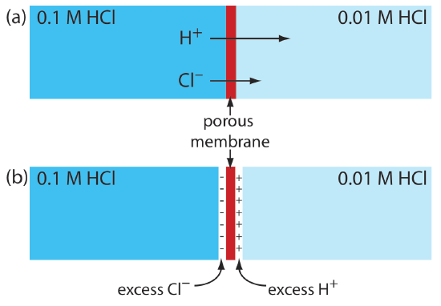
One limitation of ion-selective electrodes is the presence of junction potentials. Junction potentials arise whenever two ionic solutions of different composition come into contact. Because ions move at different rates through solution, a small electrical potential can develop at the interface (Figure 5). Consider a porous membrane separating 0.1 M HCl from 0.01 M HCl. Both $H^{+}$ and ${Cl}^{-}$ diffuse from the more concentrated solution toward the less concentrated solution. However, $H^{+}$ moves through water much faster than ${Cl}^{-}$, as shown in Table 2.
Figure 5. Origin of the junction potential between a solution of 0.1 M HCl and a solution of 0.01 M HCl. From Figure 11.2.3 in David Harvey, Analytical Chemistry 2.1, licensed under CC BY-NC-SA 4.0.

- Consider the liquid junction of made of $0.1 M KNO_{3}|0.1 M KBr$. Assume the first solution is on the left side of the junction and the second solution is on the right side.
  - You can ignore the potassium cation on each side because they will diffuse at the same rates. Using Table 2, which anion diffuses more rapidly across the junction?

Table 2. Mobility of common ions in water at 298 K.
Ion | Mobility $\left(m^{2}s^{-1}V^{-1}\right)$
$H^{+}$ | $36.23*{10}^{-8}$
$K^{+}$ | $7.62*{10}^{-8}$
${NO_{3}}^{-}$ | $7.41*{10}^{-8}$
${Br}^{-}$ | $8.09*{10}^{-8}$
${Cl}^{-}$ | $7.92*{10}^{-8}$

  - Which side of the liquid junction becomes positive as diffusion begins? Justify your response based on ion mobilities.

- In practice, junction potentials are usually small and often remain nearly constant during a measurement. A junction potential introduces a small systematic error into a pH measurement. Why does this error affect the absolute pH value measured by a pH electrode but have little effect on locating the endpoint of an acid-base titration?

- You have two days to measure calcium concentration in 50 lake samples and a limited budget. You could use flame AA spectroscopy or a ${Ca}^{2+}$ ISE. Compare and contrast flame AA spectroscopy and a ${Ca}^{2+}$ ISE in terms of cost, detection limits, selectivity, portability, and sample preparation.

Active Learning Worksheets for Analytical Chemistry

#24 Chromatographic Methods: Chromatography Basics

Before You Begin
- Read 12.1: Overview of Analytical Separations
- Read 12.2: General Theory of Column Chromatography

What You Should Already Know
- Types of intermolecular forces and general polarity trends
- Partitioning behavior between two phases
- Basic understanding of physical separation techniques (e.g., filtration, distillation)
- Familiarity with interpreting simple plots or experimental data

What You’ll Learn
- Define and apply key chromatographic terms including retention time, void time, retention factor, resolution, and number of theoretical plates
- Explain the impact of stationary and mobile phase polarity on analyte separation
- Describe how experimental parameters influence separation efficiency and speed
- Classify chromatography methods by mechanism (e.g., partition, ion exchange, affinity)

What You’ll Practice
- Interpret chromatographic data to calculate and compare separation parameters
- Predict elution order based on molecular structure and stationary/mobile phase polarity
- Propose experimental changes to improve resolution or decrease retention time
- Compare different chromatographic setups based on separation goals

Estimated Completion Time: 50-65 minutes
Author: Rebecca L. Sanders
Active Learning Worksheets for Analytical Chemistry, Version 1.0, 2026

Useful Equations

- $k= \frac{t_{r}-t_{m}}{t_{m}}$

- $R_{s}= \frac{Δt_{r}}{w_{av}}=\frac{0.589 Δt_{r}}{w_{1/2av}}$
- $N= \frac{5.55t_{r}^{2}}{w_{1/2}^{2}}$
- $H=L/N$

Chromatography Basics

Figure 1. In chromatography, we pass a mobile phase over a stationary phase. When we inject a sample into the mobile phase, the sample’s components both move with the mobile phase and partition into the stationary phase. The solute that spends the most time in the stationary phase takes the longest time to move through the system.
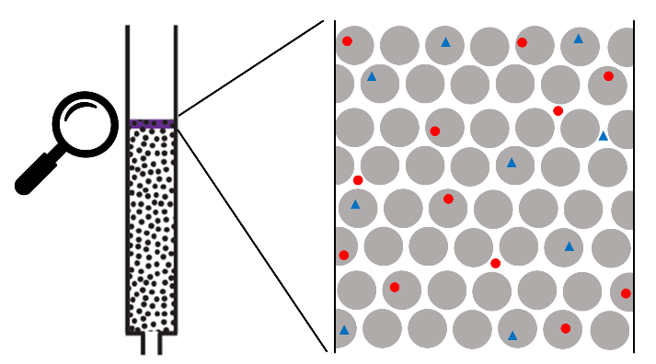
Figure 2. Example of a column with a microscopic view of the packed stationary phase (grey circles) and mobile phase (white space). In the microscopic snapshot, two solutes (red circles and blue triangles) are either associated with the mobile phase or stationary phase.

In chromatography we pass a sample-free phase, which we call the mobile phase, over a second sample-free stationary phase that remains fixed in space (Figure 1). We inject or place the sample into the mobile phase. As the sample moves with the mobile phase, its components partition between the mobile phase and the stationary phase. A component whose distribution ratio favors the stationary phase requires more time to pass through the system. Given sufficient time and sufficient stationary and mobile phase, we can separate solutes even if they have similar distribution ratios. One common method for bringing the mobile phase and the stationary phase into contact is column chromatography, where the stationary phase is packed into a narrow column and the mobile phase passes through the column using gravity or by applying pressure. The stationary phase is a solid particle or a thin liquid film coated on either a solid particulate packing material or on the column’s walls. In adsorption chromatography, solutes separate based on their ability to adsorb, or stick, to a solid stationary phase (Figure 2).

- Using Figure 1, do solutes move through the column when attached to the stationary phase?

- Using Figure 1, do solutes move through the column when dissolved in the mobile phase?

- In Figure 2, a microscopic view of a column chromatography experiment is given shortly after a mix of red and blue solutes are added to the column. In this snapshot, there are nine blue solute molecules. One of the blue solute molecules is on the white space, representing it being dissolved in the mobile phase and eight of the blue solute molecules are on grey circles, representing them being associated with the stationary phase.
  - Consider the red solute molecules. In the snapshot, how many are associated with the mobile phase? The stationary phase?

Figure 3. Progress of a column chromatographic separation of a two-component mixture. Adapted from Figure 12.2.1 in David Harvey, Analytical Chemistry 2.1, licensed under CC BY-NC-SA 4.0.
  - How long it takes for solute molecules to make their way through the column depends on how much time they are retained on the stationary phase over how much time they move with the mobile phase. This ratio is referred to as a retention factor. In the microscopic snapshot, we can estimate this retention factor by dividing the number of molecules on the stationary phase by the number of molecules dissolved in the mobile phase. Estimate the retention factors of the red and blue solute molecules.

  - The larger the retention factor, the longer it takes for the solute to come out of, or elute from, the column. Based on your estimated retention factors, predict which solute molecules will elute from the column first.

- We can now explore a simple view of the liquid–solid column chromatography experiment started in Figure 2. The sample containing red and blue solute molecules is introduced as a narrow band at the top of the column (a) (Figure 3).
  - Why is it important for all the solute to be introduced at once as a narrow band at the top of the column?

  - Some solutes may not interact with the column. Even without interacting with the column, nonretained solutes still have to travel through the column, moving at the same rate as the mobile phase. The time required to elute the nonretained solutes is called the column’s void time, t_{m}. In Figure 3, what is the void time for the column?

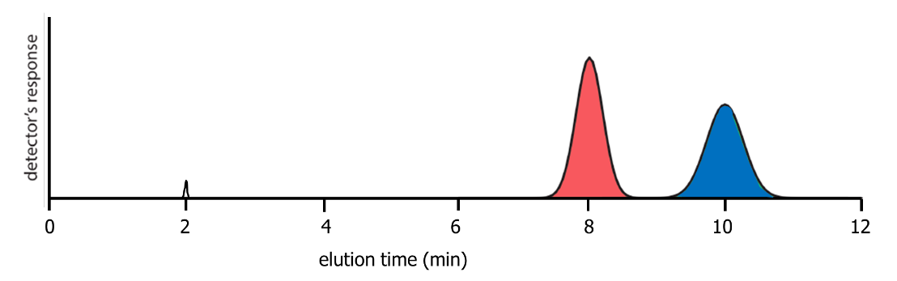
Figure 4. Chromatogram for the separation shown in Figure 3, showing the detector response as a function of elution time. Adapted from Figure 12.2.3 in David Harvey, Analytical Chemistry 2.1, licensed under CC BY-NC-SA 4.0.
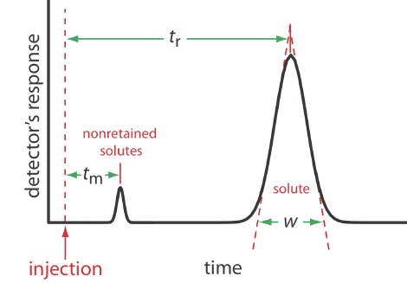
Figure 5. Chromatogram showing a solute’s retention time, t_{r}, and baseline width, w, and the column’s void time, t_{m}, for nonretained solutes. From Figure 12.2.4 in David Harvey, Analytical Chemistry 2.1, licensed under CC BY-NC-SA 4.0.

  - What happens to the colored solutes in the column in steps b-d?

  - What happens to the size of the colored bands as time progresses?

  - The red band at 6 mins is in a similar location in the column as the blue band at 8 min. Which band is wider? Why?

  - We can follow the progress of the separation by collecting fractions as they elute from the column or by placing a suitable detector at the end of the column. What time does the red solute elute? What time does the blue solute elute?

- A plot of the detector’s response as a function of elution time, or as a function of the volume of mobile phase, is known as a chromatogram, and consists of a peak for each solute. An example from the experiment in Figure 3 is shown in Figure 4. We can characterize a chromatographic peak’s properties in several ways, two of which are shown in Figure 5. Retention time, $t_{r}$, is the time between the sample’s injection and the maximum response for the solute’s peak.
- What is the retention time for each colored solute in Figure 4? How does the correspond to Figure 3?

- Why is the peak maximum used to determine the retention time and not another time point on each solute peak?

- Label the void time peak on the chromatogram in Figure 4 and list the void time below.

- Retention factor (k) can be calculated as the time spent in the stationary phase divided by time spent in the mobile phase. Because retention time is the sum of the time spent with both phases, the time spent in the stationary phase is found between the difference between retention time and void time:
$$k= \frac{t_{r}-t_{m}}{t_{m}}$$
Calculate the retention factors for the red and the blue solution. Compare your results to the theoretical retention factors calculated in question 3b.

- A chromatographic peak’s baseline width, w, as shown in Figure 5, is determined by extending tangent lines from the inflection points on either side of the peak through the baseline. We can report $t_{r}$ and w using units of time. Estimate the baseline width for each colored solute from Figure 4 in units of minutes.

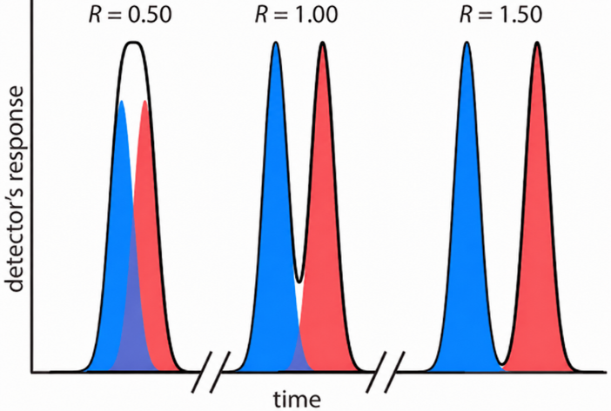
Figure 6. Three examples showing the relationship between resolution and the separation of a two-component mixture. The blue peak and the red peak are the elution profiles for the two components. The chromatographic peak, which is the sum of the two elution profiles, is shown by the solid black line.

- The goal of chromatography is to separate a mixture into a series of chromatographic peaks, each of which constitutes a single component of the mixture. The resolution between two chromatographic peaks, R_{S}, is a quantitative measure of their separation, and is defined as the difference between retention time divided by the average baseline width
$$R_{s}= \frac{Δt_{r}}{w_{av}}$$
- Compare Figures 4 and 6. Predict if the resolution of the two peaks in Figure 4 less than, equal to, or greater than 1.5?

- Using the retention times and baseline widths from Figure 4 of the two-colored peaks, calculate their resolution.

- Alternatively, if baseline width is difficult to estimate, the widths at half the maximum peak height can be estimated instead and used to calculate resolution.
$$R_{s}= \frac{Δt_{r}}{w_{av}}=\frac{0.589 Δt_{r}}{w_{1/2av}}$$
If the red peak had a $w_{1/2}$ of 0.50 min and the blue peak had a $w_{1/2}$ of 0.70 min, calculate resolution.

- Calculate the number of theoretical plates for the red solute. What does the number of theoretical plates represent? Is it better for the number to be large or small?

- Calculate the plate height assuming the column was 10.0 cm long. What does plate height represent? Is it better for plate height to be large or small?

- The stationary phase from Figure 3 was made of $SiO_{2}$.
- Is this column a polar or nonpolar column?

- The solvent used for the experiment was 95:5 hexane:ethyl acetate? Is this mobile phase relatively polar or nonpolar?

- Normal phase chromatography has a stationary phase that is relatively polar and a mobile phase that is relatively nonpolar whereas reverse phase chromatography has a stationary phase that is relatively nonpolar and a mobile phase that is relatively polar. Is this experiment normal or reverse phase chromatography?

- Which solute in the experiment – the red or the blue – was more polar? Explain how you know.

- Suppose the mobile phase was changed to 50:50 hexane:ethyl acetate. How would that change the retention time of the solutes? Why?

- Suppose you wanted to shorten the experiment from Figures 3 and 4. Propose three changes that could be made to speed up the reaction while ensuring the two peaks are still resolved.

Identifying Chromatography Type and Elution Orders
For each experiment, identify the type of chromatography being used from the following options: adsorption chromatography, size exclusion chromatography, ion exchange chromatography, partition chromatography, and affinity chromatography. Then, predict the elution order of the compounds or proteins involved, from first to last.
- A mixture of small organic compounds – caffeine (a relatively nonpolar compound), acetone (a polar compound), and benzene (a nonpolar compound) – is loaded onto a column packed with a $C_{18}$ stationary phase. The mobile phase is 50:50 water:methanol.

- A mixture of proteins – insulin (a small peptide hormone), albumin (a large, abundant protein), and glucagon (another peptide hormone with structural similarities to insulin) – is loaded onto a column with a stationary phase containing insulin receptors. The mobile phase is a buffer solution that helps elute the proteins by competing for binding sites on the stationary phase.

- A mixture of small metal ions – ${Ca}^{2+}$ (a divalent cation), ${Na}^{+}$ (a monovalent cation), and ${Mg}^{2+}$ (a divalent cation) – is loaded onto a column with a charged stationary phase. The mobile phase is a buffered solution that helps elute the metal ions by competing for binding sites on the column.

- A mixture of small organic compounds — acetone (a polar solvent), benzene (a nonpolar solvent), and ethanol (a moderately polar solvent) – is loaded onto a column with a stationary phase made of water that is coated on a solid support. The mobile phase is a solvent mixture of 50:50 hexane:ethyl acetate that moves through the column, carrying the sample with it.

- A mixture of three proteins – albumin (a large protein), lysozyme (a medium-sized protein), and insulin (a small protein) – is loaded onto a column packed with porous beads that separates solutes based on size. The column is then eluted with a buffer solution.

Active Learning Worksheets for Analytical Chemistry

#25 Chromatographic Methods: Comparison of GC and HPLC

Before You Begin
- Read 12.4: Gas Chromatography
- Read 12.5: High-Performance Liquid Chromatography

What You Should Already Know
- General structure and function of chromatographic systems
- Concepts of polarity, volatility, and intermolecular forces
- Purpose of stationary and mobile phases
- Basics of detector types (UV-Vis, MS)

What You’ll Learn
- Describe and compare the instrumentation and theory behind GC and HPLC
- Identify key parameters that influence retention, resolution, and sample compatibility
- Distinguish between when GC and HPLC are appropriate based on compound properties
- Analyze experimental setups to interpret how columns, mobile phases, and detection vary

What You’ll Practice
- Interpret schematics and instrument components for GC and HPLC systems
- Synthesize reading and experimental data to complete a comparison table
- Apply chromatographic principles to real-world analytical problems
- Justify technique selection based on sample type, compound properties, and method limitations

Estimated Completion Time: 50-65 minutes

Author: Rebecca L. Sanders
Active Learning Worksheets for Analytical Chemistry, Version 1.0, 2026

Gas Chromatography (GC) and High-Performance Liquid Chromatography (HPLC)
GC and HPLC are both widely used techniques for separating and analyzing mixtures. While both methods involve a stationary phase and a mobile phase, they differ in their phases and sample types. GC typically uses a gas as the mobile phase and is ideal for analyzing volatile compounds, while HPLC uses a liquid mobile phase to analyze a broader range of compounds. Both techniques are widely used in areas such as environmental testing, pharmaceutical analysis, and food analysis. In this worksheet, you will compare GC and HPLC.

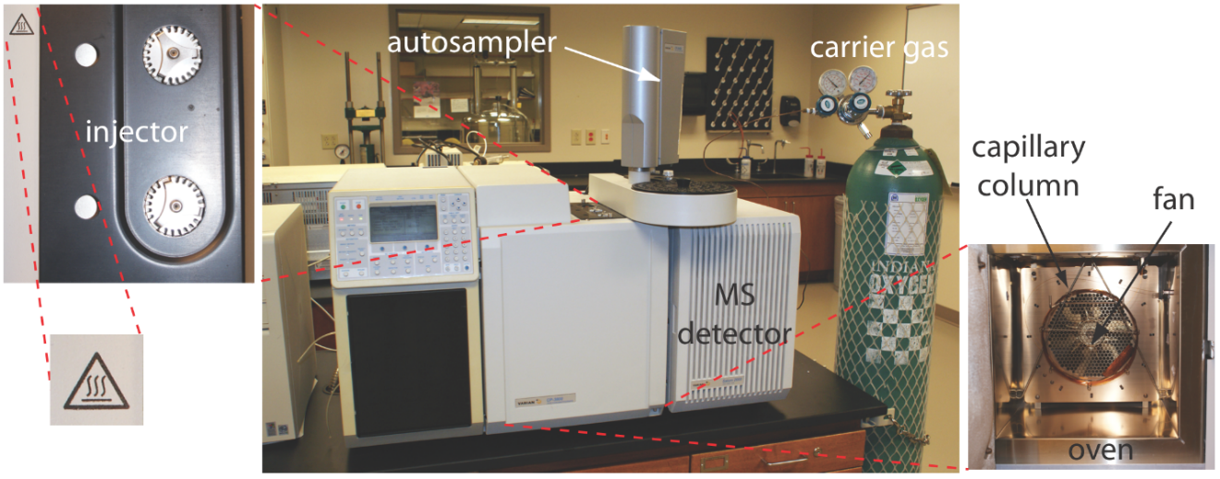
Figure 1. Example of a typical gas chromatograph, with insets showing the heated injection ports and the oven that houses the column. This instrument is equipped with an autosampler for injecting samples, a capillary column, and a mass spectrometer as the detector. From Figure 12.4.1 in David Harvey, Analytical Chemistry 2.1, licensed under CC BY-NC-SA 4.0.

Figure 2. Schematic diagram of a gas chromatograph.

- Consider the image of a GC in Figure 1. Identify each component on the picture of the gas chromatograph in Figure 2.
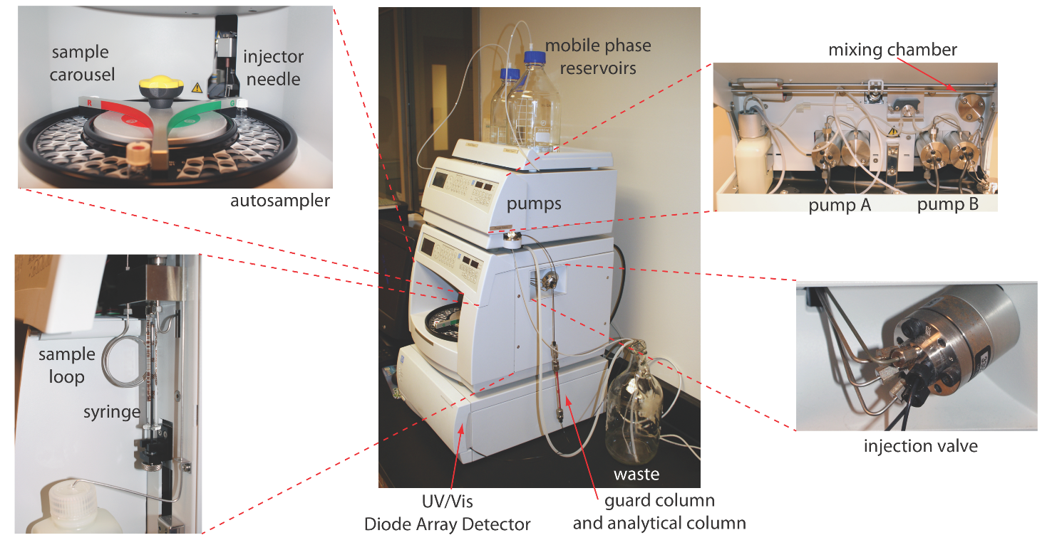 Figure 3. Example of a typical high-performance liquid chromatograph, with insets showing the pumps that move the mobile phase through the system and the plumbing used to inject the sample into the mobile phase. From Figure 12.5.1 in David Harvey, Analytical Chemistry 2.1, licensed under CC BY-NC-SA 4.0.
Figure 4. Schematic diagram of a high-performance liquid chromatograph.

- Consider the image of a HPLC in Figure 3. Identify each component on the picture of the high-performance liquid chromatograph in Figure 4.

- Examine the schematics of the GC (Figures 1 and 2) and the HPLC (Figures 3-4). Discuss with your group some similarities and differences between GC and HPLC.

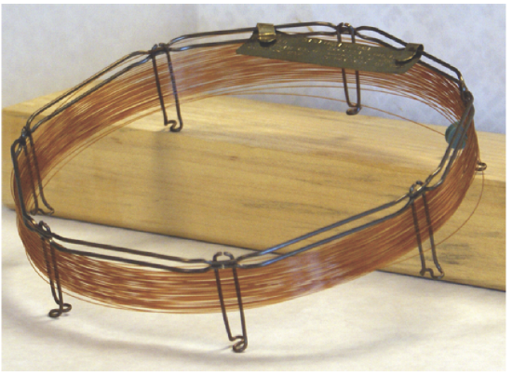
Figure 5. Typical example of a capillary column for gas chromatography. This column is 30 m long, has an internal diameter of 247 μm, and has a 0.25 μm coating of liquid stationary phase on its interior surface. From Figure 12.4.3 in David Harvey, Analytical Chemistry 2.1, licensed under CC BY-NC-SA 4.0.
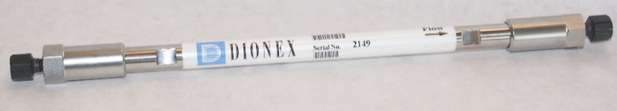
Figure 6. Typical packed column for HPLC. This column has an internal diameter of 4.6 mm, is 150 mm long, and is packed with 5 μm particles coated with stationary phase. From Figure 12.5.2 in David Harvey, Analytical Chemistry 2.1, licensed under CC BY-NC-SA 4.0.

- At the heart of all chromatography experiments is the column used for separation. Compare and contrast a capillary column for GC and a packed column of HPLC.

- There are many similarities and differences between GC and HPLC experiments. Read the two sections on Gas Chromatography and High-Performance Liquid Chromatography from the LibreTexts website: 12.4: Gas Chromatography and 12.5: High-Performance Liquid Chromatography. You can also consult the example experimental parameters on the next page. Based on your readings, fill out the table below comparing the key components and features of each technique. Make sure to include the following in your answers:

Table 1. Gas Chromatography (GC) vs. High-Performance Liquid Chromatography (HPLC)
Feature | GC | HPLC
Mobile phase
Stationary phase
Types of samples analyzed
Sample injection
Experiment temperatures
Detection method
Separation mechanism

Example Experiments with Experimental Parameters for GC and HPLC

Gas Chromatography-Mass Spectrometry Method for Analysis of Fatty Acid Methyl Esters (FAMEs) in Biodiesel

1. Sample Preparation:
- Sample Type: Biodiesel (fatty acid methyl esters from vegetable oils or animal fats)
- Preparation:
  - Dilute biodiesel sample (1:10) in hexane
  - Pass through 0.45 µm filter to remove particulates
  - Inject directly into GC-MS

2. GC-MS Experimental Parameters:
- Injection Parameters:
  - Injection Mode: Split 50:1 (to prevent column overload)
  - Injection Temperature: 250 °C
  - Injection Volume: 1 µL
  - Carrier Gas: Helium
  - Flow Rate: 1.2 mL/min
- Column Parameters:
  - Column Type: Capillary column
  - Stationary Phase: 5% Phenyl / 95% Dimethylpolysiloxane
  - Column Length: 30 m
  - Internal Diameter: 0.25 mm
  - Film Thickness: 0.25 µm
- Oven Temperature Program:
  - Initial Temperature: 50 °C, hold for 1 min
  - Ramp Rate: 10 °C/min
  - Final Temperature: 320 °C, hold for 5 min
  - Total Run Time: ~30 min

3. Mass Spectrometry (MS) Detection Parameters:
- Ionization Mode: EI at 70 eV
- Mass Range: 50–550 m/z

4. Expected Retention Times for Common FAMEs:
Compound Retention Time (min)
- Methyl Palmitate (C16:0) 16.5
- Methyl Stearate (C18:0) 18.0
- Methyl Oleate (C18:1) 18.5
- Methyl Linoleate (C18:2) 19.0
- Methyl Linolenate (C18:3) 19.5

5. Data Analysis:
- Identification: Compare spectra with NIST MS library
- Quantification: Calibration Curve: FAME standards in hexane at 1–100 mg/mL

HPLC Method for Analysis of Pharmaceutical Compounds in Pain Relief Tablets (Paracetamol, Caffeine, and Ibuprofen)

1. Sample Preparation:
- Sample Type: Commercial pain relief tablets
- Preparation Steps:
  - Weigh and finely grind the tablet
  - Dissolve in methanol:water (50:50, v/v)
  - Filter through a 0.45 µm membrane filter before injection

2. HPLC Experimental Parameters:
- Mobile Phase Parameters:
  - Solvent A: 0.1% formic acid in water
  - Solvent B: Acetonitrile
  - Gradient Elution:
  - 0 min: 5% B
  - 10 min: 50% B
  - 20 min: 95% B
  - 25 min: 95% B (hold)
  - 30 min: 5% B (re-equilibration)
  - Flow Rate: 1.0 mL/min
- Column Parameters:
  - Column Type: C18 (Octadecyl Silica, ODS)
  - Column Length: 150 mm
  - Internal Diameter: 4.6 mm
  - Particle Size: 5 µm
  - Pore Size: 100 Å
  - Injection Volume: 10 µL
- Detection Parameters:
  - Detector Type: UV-Vis or Diode Array Detector (DAD)
  - Detection Wavelengths:
  - 254 nm
  - Flow Cell Path Length: 10 mm
- Column Temperature: 30–40°C

3. Expected Retention Times:
- Compound Retention Time (min)
Paracetamol 4.5
Caffeine 7.0
Ibuprofen 13.5

4. Data Analysis:
- Identification: Compare retention times with reference standards
- Quantification with calibration curve: Standard solutions in 1–100 µg/mL range

- Summarize
- What are 2-3 advantages of GC? Of HPLC?

- What are 2-3 disadvantages of GC? Of HPLC?

- Based on the table, when would you use GC versus HPLC? What factors would influence your decision?

- What are some limitations of each technique in terms of sample size, type, and sensitivity?

- Real-World Scenarios: Identify whether GC or HPLC would most likely be used to analyze the sample, and explain why in 1-2 sentence(s).
- Environmental Monitoring of Air Pollution: A laboratory is tasked with analyzing volatile organic compounds (VOCs) in air samples to assess pollution levels.

- Pharmaceutical Quality Control: A pharmaceutical company needs to analyze a new drug product for residual organic solvents remaining from the manufacturing process before it goes to market.

- Food and Beverage Industry: A food manufacturer wants to quantify the amount of caffeine in a line of energy drinks.

- Forensic Science: A forensic lab needs to analyze blood samples to detect alcohol content.

- Biotechnology Research: Researchers are working to purify proteins and peptides from a complex mixture for further studies.

Active Learning Worksheets for Analytical Chemistry

#26 Chromatographic Methods: HPLC Simulations

Before You Begin
- Read 12.3: Optimizing Chromatographic Separations
- Read 12.5: High-Performance Liquid Chromatography

What You Should Already Know
- Define retention time, retention factor (k), and resolution ($R_{s}$)
- Explain general principles of chromatographic separation
- Describe the differences between normal and reverse phase chromatography
- Interpret Gaussian peak shape and related parameters (e.g., σ, $w_{1/2}$)

What You’ll Learn
- Identify key parameters influencing resolution in HPLC
- Analyze how flow rate affects efficiency using van Deemter relationships
- Predict elution order in reverse phase HPLC based on polarity and structure
- Optimize separations using changes in mobile phase composition and gradient programming

What You’ll Practice
- Using an interactive simulator to explore chromatographic method development
- Reading and interpreting chromatograms and output tables
- Applying critical thinking to optimize multivariable experimental conditions
- Collaborating to evaluate trade-offs in method performance

Estimated Completion Time: 75-90 minutes

Author: Rebecca L. Sanders
Active Learning Worksheets for Analytical Chemistry, Version 1.0, 2026

Useful Equations

- $R_{s}= \frac{Δt_{r}}{w_{av}}=\frac{0.589 Δt_{r}}{w_{1/2av}}$
- $N= \frac{5.55{t_{R}}^{2}}{w_{1/2}^{2}}= \frac{16{t_{R}}^{2}}{w^{2}}$
- $H= \frac{L}{N}$

HPLC Simulations
High-performance liquid chromatography (HPLC) is a powerful analytical tool. However, optimizing experiments can be time consuming. To experience this, we will use an online HPLC simulator to learn how different experimental parameters influence chromatograms and a chemist’s ability to identify and quantify components of a sample. Visit http://www.multidlc.org/hplcsim/hplcsim.html. This website hosts a Multi-Dimensional Separations HPLC Simulator.

- First, the default setting in the simulator is a $C_{18}$ column as the stationary phase and a mobile phase made of 60% water and 40% acetonitrile ($CH_{3}CN$) as the mobile phase. Is this default setting representative of normal phase or reverse phase chromatography? Explain.

- The default setting has six compounds included in the simulator: uracil, phenol, benzonitrile, p-chlorophenol, acetophenone, and nitrobenzene. You will see a chromatogram with only five peaks. Below the simulated chromatogram, a table lists important variables for each component such as k (retention factor), $t_{R}$ (retention time), and σ (variance).
  - If there are six components in the mixture, why are only five peaks observed in the chromatogram?

  - As retention time increases (t_{R}), variance (σ) also increases. Variance is related to peak width. Assuming the peak is a Gaussian shape, the width at the baseline (w) equation is $w=4σ$ and the width at half the maximum peak height ($w_{1/2}$) is $w_{1/2}=2.35σ$. Why does variance increase with longer retention times?

  - Click on “Manage Compounds.” Adjust the concentration of uracil by making it 25, 50, and 100. What happens to the peak height and peak area as concentration increases? What happens to the retention time as concentration increases?

  - Deselect p-chlorophenol. Then, set the remaining five compounds to a concentration of 100. While all five compounds have the same concentration, they have different peak heights. Why? How do their peak areas compare, and why is peak area generally preferred over peak height for quantitative analysis?

Flow Rate
One variable that can be optimized in an HPLC experiment is flow rate. Under “Manage Compounds”, deselect all compounds and add anisole (concentration defaults as 80.16). Under “Chromatographic Properties”, the flow rate can be changed to rate between 0.05 and 8 mL/min. Experimental variables are shown in Table 1 for a 5 µL injection of anisole in a 100x4.6 mm $C_{18}$ column with a 3.0 µm particle size using a 40% water/60% acetonitrile mobile phase at 40 °C at variable flow rates.
Table 1. Retention time, variance, peak width at half height, number of plates, and plate height for 5 µL of anisole injected at variable flow rates into a 100x4.6 mm $C_{18}$ column with a 3.0 µm particle size using a 40% water/60% acetonitrile mobile phase at 40 °C.
Flow rate ($mL/min$) | $t_{R}$ (min) | Variance (σ) | $w_{1/2}$ (s) | $w_{1/2}$ (min) | N (number of plates) | Calculated Plate Height H (mm)
0.1 | 77.6104 | 75.6763 | 177.8 | 2.964 | 3805 | 2.628E-02
0.5 | 15.5221 | 8.4074 | 19.76 | 0.3293 | 12332 | 8.109E-03
1.0 | 7.761 | 3.6974 | 8.689 | 0.1448 | 15941 | 6.273E-03
1.5 | 5.174 | 2.4078 | 5.658 | 0.09431 | 16706 | 5.986E-03
2.0 | 3.8805 | 1.8211 | 4.280 | 0.07133 | 16427 | 6.087E-03
3.0 | 2.5870 | 1.2722 | 2.990 | 0.04983 | 14960 | 6.684E-03
4.0 | 1.9403 | 1.0096 | 2.373 | 0.03954 | 13363 | 7.483E-03
5.0 | 1.5522 | 0.8541 | 2.007 | 0.03345 | 11949 | 8.369E-03
6.0 | 1.2935 | 0.7504 | 1.763 | 0.02939 | 10750 | 9.302E-03
7.0 | 1.1087 | 0.6758 | 1.588 | 0.02647 | 9738 | 1.027E-02
8.0 | 0.9701 | 0.6191 | 1.455 | 0.02425

- Calculate theoretical plates (N) and plate height (H) for the $8.0{mL}/{min}$ flow rate.

Figure 1. van Deemter graph of 5 µL of anisole in a 100x4.6 mm $C_{18}$ column with a 3.0 µm particle size using a 40% water/60% acetonitrile mobile phase at 40 °C at variable flow rates.
- To select the optimal flow rate, a van Deemter graph of plate height as a function of flow rate was made (Figure 1).
- Why does the graph never reach a plate height of 0.000 mm?

- What mechanism caused an increase of plate height at very low flow rates? Using the Figure, list the range of flow rates where this is occurring.

- What mechanism caused an increase of plate height at very fast flow rates? Using the Figure, list the range of flow rates where this is occurring.

- What flow rate is optimal for anisole based on Figure 1?

Mobile Phase Composition
Consider the chemical structures for anisole, ethylbenzene, and benzophenone where anisole consists of a benzene ring attached to a methoxy group (–OCH₃), benzophenone contains two benzene rings connected by a carbonyl group (C=O), and ethylbenzene consists of a benzene ring attached to an ethyl group
(–CH₂CH₃).
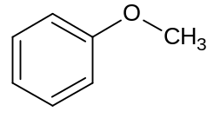 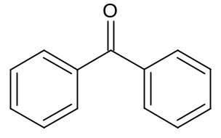 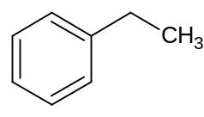
anisole benzophenone ethylbenzene

- Predict the elution of the three components sketched above based on a reverse phase chromatography.

- Under “Manage Compounds”, select the three compounds (anisole, ethylbenzene, and benzophenone). Set the concentration to 100 for all three compounds. Make sure the flow rate is set to $2.0 {mL}/{min}$ under “Chromatographic Properties.” Look at the retention times for the three compounds. Did they elute in the order that you predicted? If not, explain why your prediction may have differed from the simulated result.

- The default has the mobile phase composition of 60% water (solvent A) and 40% (solvent B: either acetonitrile or methanol) that stays constant throughout the experiment. Using the simulator, compare 60% water/40% acetonitrile with 60% water/40% methanol. Which is the better choice for solvent B for this separation? Explain using the simulated chromatograms and retention times.

- Set solvent B to acetonitrile for isocratic elution mode. Increase and decrease the fraction of acetonitrile to observe its effect on the separation.
- As the fraction of acetonitrile is increased, what happens to the polarity of the mobile phase? What happens to the retention times and the distance between peaks?

- As the fraction of acetonitrile is decreased, what happens to the polarity of the mobile phase? What happens to the retention times and the distance between peaks?

- What is an ideal percentage of water and acetonitrile? Why?
Table 2. Retention times, variance, and widths as half maximum peak height for a three-component separation.
Compound | $t_{R}$ (min) | Variance (σ, s) | $w_{1/2}$ (s) | $w_{1/2}$ (min)
Anisole
Benzophenone
Ethylbenzene

- Set the mobile phase to the ideal percentage of water and acetonitrile you identified in the previous question. Make sure all three components have concentrations of 100. Record the retention times and variance for each compound in the table above. Then, calculate $w_{1/2}$ in seconds and minutes using the equation: $w_{1/2}=2.35σ$. Record the $w_{1/2}$ in seconds and minutes in the table above.

- Calculate the resolution between anisole and benzophenone.

- How does your calculated resolution compare to the $R_{s}$ value listed in the simulator for anisole and benzophenone?

- Is your calculated resolution representative of a quantitative separation between the two peaks? Explain.

Column Properties
Set the mobile phase conditions to 70% acetonitrile in isocratic elution mode. Next, examine the conditions under the heading “Column Properties.”
- The default particle size is 3 µm. Reduce the particle size to 1.5 µm. Then, increase it to 6.0 µm.
  - What happens to the three peaks in the chromatogram as particle size changes?

  - What happens to the back pressure (listed under “Chromatographic Properties”) when the particle size is changed?

- Decrease and increase the column length. What is the advantage of a shorter column? A longer column?

Complex Mixture Separations
HPLC can be used to separate complex mixtures. For your final section, you will attempt to identify a set of successful experimental parameters that can separate a complex mixture.
Refresh the website to reset all components. Under “Manage Compounds”, select the following seven compounds: anisole, benzophenone, ethylbenzene, butylparaben, propiophenone, butyrophenone, and heptanophenone. You’ll notice immediately that the default settings in the simulator lead to a long experiment time (almost 30 minutes). Your goal is to find a set of parameters that can quantitatively separate all components, ideally in less than 8 minutes if possible.
There are a range of changes that can be made to try to achieve this goal:
- Altering the mobile phase composition in isocratic elution mode (acetonitrile vs. methanol as solvent B)
- Using gradient elution mode. In the previous activities associated with this worksheet, the mobile phase was set to isocratic elution mode, where the mobile phase composition stays the same throughout the separation. Gradient elution mode offers an alternative where the mobile phase composition changes over time to increase the fraction of solvent B. This helps speed up the elution of compounds that stick to the column. Select “Gradient Elution Mode” under “Mobile Phase Composition.” You can change the starting and ending fractions of solvent B as well as the duration of time with which the fraction of solvents changes in the experiment.
- Changing the flow rate
- Changing the column length
- Changing the particle size of the stationary phase.

- Were you able to achieve quantitative separation of the seven components? Report the final experimental parameters you used and the total amount of time the experiment would take. Continue to tweak the parameters to see if you can shorten the experiment anymore while still maintaining quantitative separation.

Active Learning Worksheets for Analytical Chemistry #27

#27 Comparing Methods: Selecting an Instrument

Before You Begin
- Review previous worksheets on spectroscopy, electrochemistry, and chromatography. Focus on the types of analytes and samples each technique can measure, as well as major strengths, limitations, interferences, and practical considerations.
- Read 11.2: Potentiometric Methods
- Read 11.3: Coulometric Methods
- Read 11.4: Voltammetric and Amperometric Methods

What You Should Already Know
- Distinguish between qualitative and quantitative analysis.
- Explain the basic operating principles of spectroscopy, chromatography, and electrochemistry.
- Recognize the types of analytes that different techniques can measure.
- Recall detection limits and sample type compatibility for key instruments discussed in earlier weeks.

What You’ll Learn
- Differentiate between different types of electrochemical methods
- Match an analytical problem to the most suitable instrumental method.
- Identify alternate viable techniques for a given analysis and explain trade-offs.
- Explain the type of sample each major technique can analyze.
- Recognize when a separation step is needed before analysis.

What You’ll Practice
- Applying knowledge of instrument capabilities to real-world sample scenarios.
- Comparing multiple analytical approaches to determine the most appropriate one.
- Justifying your choice of method based on sensitivity, selectivity, and sample constraints.
- Collaborating with peers to critically evaluate different analysis strategies.

Estimated Completion Time: 60-80 minutes

Author: Rebecca L. Sanders
Active Learning Worksheets for Analytical Chemistry, Version 1.0, 2026

Quick Review: Additional Electrochemical Methods

Throughout the semester, you have worked with a range of spectroscopic, chromatographic, and electrochemical methods. Before comparing all of these techniques, use the table below to review several electrochemical methods that were covered in less detail earlier in the course and to help decide when an electrochemical method is appropriate for a particular analytical problem.

Table 1. Summary of common electrochemical methods.
Technique | What is controlled or varied? | What is measured? | What does the signal tell us? | Common examples or uses
Potentiometry | The cell is measured under static conditions; little or no current flows. | Potential, (E) | The potential is related to the activity or concentration of an analyte through the Nernst equation. | pH electrodes, ion-selective electrodes
Electrogravimetric analysis | A potential is applied so the analyte is deposited on an electrode. | Change in electrode mass | The mass gained by the electrode is used to determine the amount of analyte. | Deposition of metals such as copper onto an electrode
Voltammetry | The applied potential is varied with time. | Current as a function of applied potential | The current can be related to concentration, while the potential where current changes can help identify the analyte or redox process. | Polarography, stripping voltammetry, cyclic voltammetry
Amperometry | The potential is held constant. | Current | The current is related to the concentration of an electroactive species. | Dissolved oxygen sensors, glucose sensors

- A dissolved metal ion can be reduced and plated onto an electrode. After the experiment, the electrode is dried and weighed, and the increase in mass is used to determine how much metal was originally present. Which electrochemical technique does this describe? What is the main analytical signal?

- A sensor is placed in a flowing stream and gives a current that changes as the analyte concentration changes. Which electrochemical technique does this most closely match? What is being held constant, and what is being measured?

- In another experiment, the applied potential is changed over time while the current is measured. The potential where the current changes gives information about the redox behavior of the analyte, and the size of the current can be related to concentration. Which electrochemical technique does this describe?

Review of Techniques Learned Throughout the Semester
- Throughout the semester, you have used or discussed the following analytical techniques. Complete the missing information in the table to summarize the types of analytes each technique is best suited for and whether the technique provides a separation. Information about sample requirements and typical sensitivity is provided to help you compare the methods.
Technique | Best suited for… | Sample requirements / form | Typical sensitivity / concentration | Separates components?
UV-vis Spectroscopy |  | Usually a solution; analyte must absorb at an appropriate wavelength | Depends strongly on analyte and molar absorptivity; generally less sensitive than fluorescence
Fluorescence Spectroscopy |  | Usually a solution; analyte must fluoresce or be derivatized/tagged | Generally high sensitivity; depends strongly on analyte
Flame Atomic Absorption (AA) Spectroscopy |  | Sample must be introduced as a solution; solid samples generally require dissolution/digestion | Typically ppm
ICP-AES |  | Usually a liquid solution; solid samples generally require dissolution/digestion | Typically ppm–ppb
ICP-MS |  | Usually a liquid solution; solid samples generally require dissolution/digestion | Typically ppb–ppt
Electrogravimetric Analysis |  | Analyte must be in solution and capable of electrodeposition | Best suited for concentrations large enough to produce a measurable mass change
Affinity Chromatography |  | Sample must be compatible with the binding system and mobile phase | Depends on analyte and detection method
Ion Exchange Chromatography |  | Sample is generally in solution; analyte must carry charge under the separation conditions | Depends on analyte and detector
Molecular (Size) Exclusion Chromatography |  | Sample must be dissolved and compatible with the column/mobile phase | Depends on analyte and detector
Gas Chromatography (GC) |  | Sample must be volatile or able to be vaporized without decomposition | Depends strongly on detector and analyte
High-Performance Liquid Chromatography (HPLC) |  | Sample must be soluble in an appropriate solvent/mobile phase | Depends strongly on detector and analyte
Ion-Selective Electrode (ISE) |  | Ion must be dissolved; an appropriate selective electrode must exist | Depends on the ion and electrode
Amperometry |  | Usually in solution; analyte must be electroactive at the selected potential | Depends on analyte, electrode, and conditions
Voltammetry |  | Usually in solution; analyte must undergo an accessible redox process | Can be sensitive, but depends strongly on analyte and voltammetric method

Select a Technique for Analysis
- Using the information summarized in Question 4, select the analytical technique from Question 4 you think would be most appropriate for each scenario below. More than one technique may be reasonable. For each scenario:
  - Select the technique you would use.
  - Identify one additional piece of information about the sample or analysis that would help you determine whether this is the best choice.
  - Identify one advantage or trade-off associated with your choice.
- You want to measure chloride concentrations in the DuPage River.

- You want to separate one protein in a large mixture of proteins.

- You want to analyze the concentrations of various drugs in a blood sample.

- You want to measure the concentration of Vitamin C in grapefruit juice.

- You want to determine how much chromium is in a sample of stainless steel.

- For each of the following analytical problems, select the technique you think would be most appropriate. More than one answer may be reasonable depending on the analytical conditions.
- You want to quantify the concentration of Na⁺ in salt water.

- You want to measure parts per trillion concentrations of mercury in Lake Michigan.

- You want to measure the concentration of several common metal ions in soil.

- You want to measure the concentration of greenhouse gases in the atmosphere.

- You want to determine the concentration of ammonium ions in fertilizer.

- You want to determine an unknown number of waters of hydration after 0.4902 g of
$Cu{Cl}_{2}·xH_{2}O$ are dissolved in 100.0 mL of water.

- You want to test the blood sugar for a woman with gestational diabetes.

- You want to determine the concentration of tin found in canned tuna.

- You want to determine the concentration of ${Li}^{+}$ in brine from an oil field.

- You want to quantify the amount of nicotine in a smoker’s urine.

- You want to detect and quantify chlorophyll concentrations in algae samples from a lake.

Guglielmi, G. Rapid Coronavirus Tests: A Guide for the Perplexed. Nature 2021, 590 (7845), 202–205. https://doi.org/10.1038/d41586-021-00332-4.
Anderson, D. Oreo: Original vs. Double vs. Mega. Recursive Process. http://blog.recursiveprocess.com/2013/03/03/oreo-original-vs-double-vs-mega/ (accessed July 2, 2025).
Shoichet, C. E. Teacher and Students Say Double Stuf Oreos Are Not Double Stuf. CNN. https://www.cnn.com/2013/08/21/us/oreo-high-school-experiment/ (accessed July 2, 2025).
Truth in Advertising. Double Stuf Oreos. https://truthinadvertising.org/articles/double-stuf-oreos/ (accessed July 2, 2025)
Thermo Fisher Scientific. Lead standard solution, for AAS, 1 mg/ml Pb in 2-5% HNO₃. https://www.thermofisher.com/order/catalog/product/196075000 (accessed July 1, 2025).
Thermo Fisher Scientific. Lead standard solution, for AAS, 1 mg/ml Pb in 2-5% HNO₃. https://www.thermofisher.com/order/catalog/product/196075000 (accessed July 1, 2025).
Activity Coefficients for Aqueous Solutions at 25 °C. ChemPendix. https://sites.google.com/site/chempendix/activity-coefficients-for-aqueous-solutions-at-25-c (accessed July 3, 2025).
VWR International, LLC. VWR V-1200 & UV-1600PC Spectrophotometers: Basic VIS or UV/VIS; Avantor. https://www.avantorsciences.com/us/en/product/12243123/vwr-v-1200-uv-1600pc-spectrophotometers-basic-vis-or-uv-vis (accessed July 23, 2025).
Labomed, Inc. Spectro UV-2650 UV-VIS Scanning Spectrophotometer, Model UV-2650. http://www.spectrophotometer.com/pdf/UV-2650.pdf (accessed September 3, 2026).
Agilent Technologies. Cary 3500 Flexible UV-Vis Spectrophotometer Specifications; Publication No. 5994-5844EN; August 2023. https://www.agilent.com/en/product/molecular-spectroscopy/uv-vis-uv-vis-nir-spectroscopy/uv-vis-uv-vis-nir-systems/cary-3500-flexible-uv-vis-spectrophotometer (accessed September 3, 2026).
Shimadzu Scientific Instruments. What Is the Light Transmittance of Glass, Quartz, and Plastic Cuvettes? https://www.ssi.shimadzu.com/service-support/faq/uv-vis/cuvettes/3/index.html (accessed July 23, 2025).
Agilent Technologies. Hollow Cathode Lamp Operating Conditions; Agilent Technologies. https://www.agilent.com/Library/posters/Public/31-725_Hollow_Cathode_Lamp_Operating_Conditions.pdf (accessed 2026-05-11).
Agilent Technologies. Flame Atomic Absorption Spectroscopy: Method Development ePrimer; Agilent Technologies: Santa Clara, CA, 2023. https://www.agilent.com/cs/library/brochures/AA-5991-8145EN-methods-primer.pdf (accessed 2026-06-08).
Vernier Software & Technology. Nitrate Ion-Selective Electrode. https://www.vernier.com/product/nitrate-ion-selective-electrode/ (accessed July 18, 2025). Vernier Software & Technology. Chloride Ion-Selective Electrode. https://www.vernier.com/product/chloride-ion-selective-electrode/ (accessed July 18, 2025). Vernier Software & Technology. Ammonium Ion-Selective Electrode. https://www.vernier.com/product/ammonium-ion-selective-electrode/ (accessed July 18, 2025). Vernier Software & Technology. Potassium Ion-Selective Electrode. https://www.vernier.com/product/potassium-ion-selective-electrode/ (accessed July 18, 2025). Vernier Software & Technology. Calcium Ion-Selective Electrode. https://www.vernier.com/product/calcium-ion-selective-electrode/ (accessed July 18, 2025).

